SIGHT READING EXERCISES – KASSU 2022
GUITAR
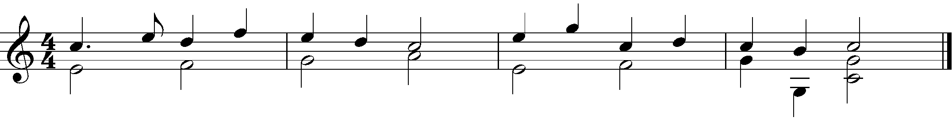
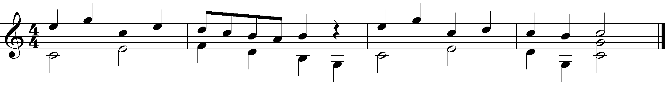

ALTO SAXOPHONE/ TENOR SAXOPHONE

TUBA/ TROMBONE/ EUPHONIUM/ CELLO

