NAME:…………………………………………….. ADM NO: …………CLASS:………

INDEX NO:………… SIGNATURE:……………

312/2
GEOGRAPHY
Paper 2
JUNE 2022
Time: 2¾ hours

KASSU-JET JOINT EXAMINATION
Kenya Certificate of Secondary Education
312/2
Paper 2
GEOGRAPHY
INSTRUCTIONS TO STUDENTS
- This paper has two sections A and B
- Answer ALL the questions in section A. In section B answer questions 6 and any other TWO questions.
FOR EXAMINERS’ USE ONLY
SECTION | CANDIDATE’S SCORE
SECTION A
QUESTION 6
QUESTION 7
QUESTION 8
QUESTION 9
QUESTION 10
TOTAL

SECTION A
Answer all the questions in this section.
1 (a) Define the term forestry. (2 marks)
(b) State three problems facing forestry in Kenya. (3 marks)
2 (a) Apart from irrigation, identify two other methods of reclaiming land in Kenya. (2 marks)
(b) State three advantages of sprinkler irrigation method. (3 marks)
3 (a) Give two reasons why nomadic pastoralists keep large herds of animals. (2 marks)
(b) State three physical factors that favour dairy farming in the Kenya highlands. (2 marks)
4 (a) Name two forms of wildlife in East Africa. (2 marks)
(b) State three reasons why wildlife should be conserved. (3 marks)
5 (a) Study the map of the Ruhr industrial region provided below and use it to answer the questions that follow.
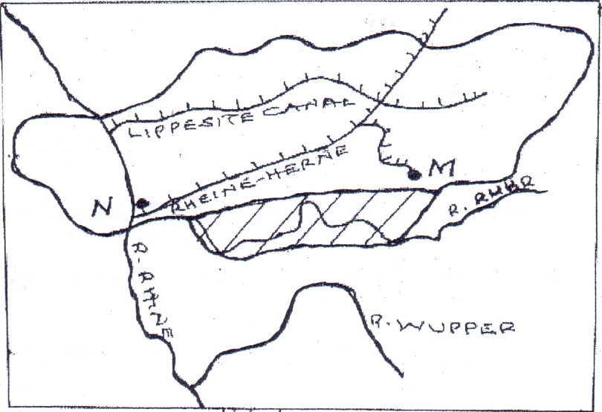
Y
X
Dortmund - Ems Canal

R. Rhine
R. Wupper
(i) Name the River marked X. (1 mark)
(ii) Name the Canal marked Y. (1 mark)
(iii) Apart from iron and steel industries, name one other industries in the Ruhr region. (1 marks)
(b) State two characteristics of Jua Kali industries in Kenya (2 marks)

SECTION B
Answer question 6 and any other TWO questions from this section.
6. The table below shows various modes of transport used by domestic tourists visiting national parks and game reserves in Kenya between the years 2017 and 2020. Use it to answer the following questions.
Mode of transport | 2017 | 2018 | 2019 | 2020
Road | 100000 | 50000 | 150000 | 100000
Air | 600000 | 650000 | 700000 | 800000
Water | 200000 | 150000 | 100000 | 50000

(a) (i) Calculate the percentage increase in the number of tourists between 2019 and 2020 who used air transport. (2marks)
(ii) Using a vertical scale of 1 cm to represent 100000 tourists, draw a compound bar graph to represent the above data. (8marks)
(iii) List two disadvantages of using compound bar graph to represent statistical data. (2marks)

(b) (i) Define the term eco-tourism (2marks)
(ii) Name three tourist attractions found in the rift valley region of Kenya. (3marks)
(c) Explain four measures that the county governments in Kenya should take in order to promote tourism. (8marks)
7 (a) (i) What is mining? (2marks)

(ii) Give two ways in which mineral ores occur. (2marks)

(b) Explain how the following factors influence the exploitation of minerals;

(i) Quality of the ore. (2marks)

(ii) Level of technology. (2marks)

(c) Describe the dredging mining method. (4marks)

(d) (i) State three uses of soda ash. (3marks)

(ii) Explain two problems facing soda ash mining at Lake Magadi in Kenya. (4marks)

(e) Explain three ways in which diamond mining has contributed to the economy of South Africa. (6marks)

8 (a) (i) What is out grower farming? (2marks)
(ii) Identify four characteristics of plantation farming. (4marks)

(b) Give five physical factors that influence the growing of sugarcane in Kenya.
(5marks)
(c) Describe the stages involved in processing of sugarcane at the factory. (6marks)

(d) Explain four challenges facing sugarcane farming in Kenya. (8marks)

9 (a) (i) Name two types of fishing. (2marks)
(ii) State three reasons why marine fisheries are under developed in Kenya. (3marks)

(iii) Identify four solutions to the problems facing the fishing industry in Kenya. (4marks)

(b) (i) Give two modern methods of fish preservation used in Kenya. (2marks)

(ii) Describe the basket method of fishing. (5marks)
(c) (i) Name three countries bordering the North West Atlantic fishing ground. (3marks)
(ii) Compare fishing in Kenya and Japan under the following subheadings
- Continental shelf. (2marks)
- Coastline. (2marks)
- Ocean Currents. (2marks)
10 (a) (i) Define retail trade. (2 marks)
(ii) Name three major imports from Europe to Kenya. (3 marks)
(b) State four factors that influence internal trade in Kenya. (4 marks)
(c) Explain four ways through which Kenya benefits from COMESA. (8 marks)
(d) Explain how the future of international trade in Kenya can be improved. (8 marks)

