NAME…………………………………………………… CLASS………ADM…………..

DATE……. ……………………. SIGN…….…………………….

231/3
BIOLOGY PRACTICAL
PAPER 3
June 2022
Time: 1 ¾ Hours

KASSU JET EXAMINATION 2022
(Kenya Certificate of Secondary Education)

INSTRUCTIONS TO CANDIDATES
- Answer all the questions in the spaces provided.
- You are required to spend the first 15 minutes of 1 ¾ hours allowed for this paper reading the whole paper carefully before commencing your work.
- Candidates may be penalized for recording irrelevant information and for incorrect spelling especially of technical terms.
FOR EXAMINER’S USE ONLY
Question | Max Score | Candidate’s Score
1 | 12
2 | 13
3 | 15
TOTAL | 40

This paper consists of . printed pages. Candidates should check the question paper to ensure that all pages are printed as indicated and no questions are missing.

- You are provided with a nutritional supplement labelled S, distilled water and a boiling tube. Put about 6ml of the distilled water in the boiling tube and add the nutritional tablet to dissolve it. Use the reagents provided to find out the food substances present in the tablet. (12 mks)
Food substance | Procedure | Observation | Conclusion

- a) (i) You are provided with a pestle, mortar, scapel, specimen Q and R. Cut from each a cube, each measuring 1cm by 1cm. put them each in a different test tube having 10mls of solution X. Record the observations in the table below? (2 marks)

Specimen | Observation
Specimen Q
Specimen R

(ii) Account for the observations in the experiment involving specimen Q and R? (2 marks)
……………………………………………………………………………………………………………………………………………………………………………………..……………………………………………………………………………………………………………………………………………………………………………………..
- i) Using the remaining portion of specimen Q, Cut 2 other pieces measuring 1cm by
1cm ,Crush them separately to form a paste and put them in boiling tubes labelled A and B.

To the paste in boiling tube labelled A, add 5mls of solution X. Record the
observation in the table below.

To the paste in boiling tube labeled B add 10mls of distilled water and boil for
5 minutes then allow it cool then add 5mls of solution X. Record the observation
in the table below. (2 marks)

BOILING TUBE | OBSERVATION
A
B

ii) Account for the observations in the experiment involving boiling tube A and B
(4 marks)
Boiling tube A ……………………………………………………………………………………………………………………………………………………………………………………………………………………………………………………………….
Boiling tube B ………………………………………………………………………………………………………………………………………………………………………………………………………………………………………………………………
iii) Name the biological substance being investigated and its significance to the living tissues (2 marks)
Biologicalsubstance………………………………………………………………
Significance……………………………………………………………………….…………………………………………………………………………………………………………………………………………………………………………
iv) Name the factor being investigated in question 2(b) above (1mark)
……………………………………………………………………………………

- The diagrams below show a method of reproduction.
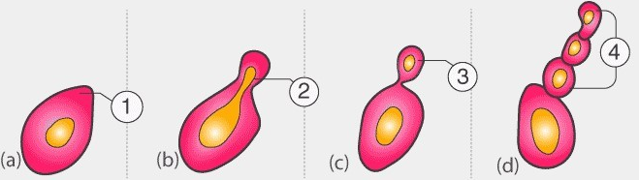

(a).Name the mode of reproduction above and give an example of organism where it occurs . (2mks)
……………………………………………………………………………………………………………………………………………………………………………………………………

(b).Briefly explain how the process occurs (4mks)
……………………………………………………………………………………………………………………………………………………………………………………………………………………………………………………………………………………………………………………………………………………………………………………………………………………………………………………………………………………………………………..

(c) Study the following photograph and answer the questions that follow

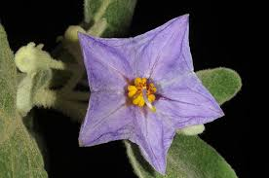
(d)Describe the features of the above photograph with respect to the following (3mks)
(i) Androecium
……………………………………………………………………………………………………………………………………………………………………………………………………………………………………………………………………………………………………………………………………………………………………………………………………………………………………………………………………………………………………………
(ii) Gynoecium (3mks)
………………………………………………………………………………………………………………………………………………………………………………………………………………………………………………………………………………………………………………………………………………………………………………………………………………………………………………………………………………………………………………………………………………………………………………………………………………
(e) (i)Suggest the agent of pollination of the flower (1mk)
……………………………………………………………………………………………………………………………………………………………………………………………………
(ii)Explain how it is adapted to pollination agent you have named in (b)(i)above (2mks)
………………………………………………………………………………………………………………………………………………………………………………………………………………………………………………………………………………………………………

