Marking scheme
231/2
BIOLOGY
(THEORY)

PAPER 2

TIME: 2 HOURS

KASSU JET EXAMINATIONS, 2022

INSTRUCTIONS TO CANDIDATES
- Write your name, school and index number in the spaces provided above.
- Write the date of examination and sign in the spaces provided above.
- Answer ALL the questions in section A by filling in the spaces provided.
- In section B, answer question 6 (compulsory question) and any other one question from the remaining two questions. (i.e. 7 or 8)
- Candidates may be penalized even wrong spellings of technical terms.
- This paper consists of 12 printed pages.
- Candidates should check to ensure that all pages are printed as indicated and no questions are missing.

FOR OFFICIAL USE ONLY
 | Questions | Maximum score | Candidate’s score
Section A | 1 | 8
 | 2 | 8
 | 3 | 8
 | 4 | 8
 | 5 | 8
Section B | 6 | 20
 | 7 | 20
 | 8 | 20
 | Total Score | 80

SECTION A ( 40 MARKS)

- The diagram below shows a pictomicrogram of an animal cell. Study it and answer the questions that follow.

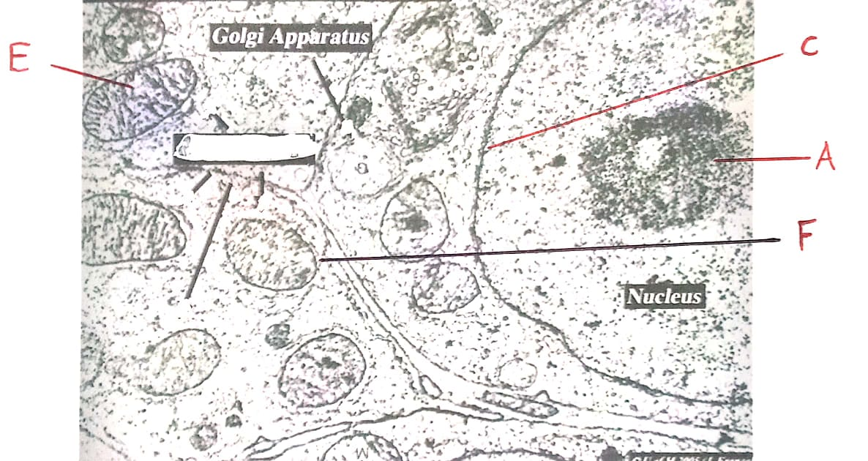

- Identify the structures labeled A and C (2 marks)
A Nucleolus;
C Nuclear membrane;
- (i) Identify the organelle labeled E (1 mark)
Mitochondrion; rej. Mitochondria
(ii) State the adaptations of the structure identified in b (i) above (2 marks)
The inner membrane is highly folded into cristae to increase the surface area for attachment of respiratory enzymes;
The matrix is a fluid medium containing respiratory enzymes/site for respiratory reactions;
- Using a ruler, measure of the longest side of organelle labeled F, Hence calculate the actual length of the structure if the magnification used is X4000. (3 marks)
Light of cell =1.7 cm magnification=Drawing length;
Actual length
1mm=1000um Actual length=Drawing length =17000 =42.5um;
17mm= X magnification 4000
17000um;

- An experiment was set up as shown below. Study the diagram and answer the questions that follow.
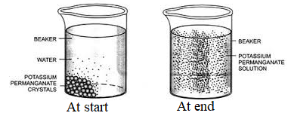
- Name the physiological process being investigated. (1 mark)
Diffusion
- Account for the observation at the end of the experiment (3 marks)
The purple colour of potassium permanganate solution had spread evenly throughout the water in the beaker; due to the random motion/movement of Potassium manganate (VII) molecules; which causes them to move from a region of high concentration to a region of low concentration.
- Account for the observation made if hot water was used at the start of the experiment. (2 mark)
Hot water causes an increase in kinetic energy of molecules; this causes faster spread of purple colour to the areas of low concentration.
- Name the property of the cell membrane that enables it detect changes in the environment ( 1 mark)
It has electric charges
- How is the process named in a above important in predation
It enables the prey detect presence of predators through smell/ Enables predators to detect presence of prey through smell

- The graph below shows the growth pattern of an organism.
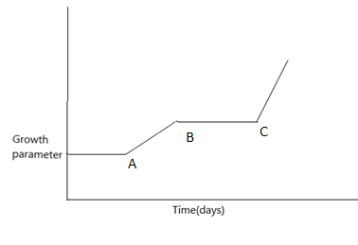
(a)Name the type of growth curve shown above. (1mrk)
Discontinuous/intermittent curve
(b)Name the phylum where organisms shows the above curve (1mrk)
Arthropoda
(c)Name the hormones that influences the growth above. (2mks)
Juvenile hormone
Ecdysone hormone
(d)Give reasons for the shape of the graph between:
(i) A and B ( 2mks)
Rapid growth due to the shedding off the hard exoskeleton initiated by secretion of ecdysone hormone
(ii) B and C (2mks)
Constant growth due to hardening of the exoskeleton initiated by juvenile hormone.

- (a) Mrs Akili is blood group B and her husband is of blood group A. They had two daughters and two sons .one of the sons is blood group O.

- What were the parental genotypes? (1 mark)
Father - AO; Mother – BO ;
- Illustrate the above using a genetic cross. (3 marks)

Parental genotype AO X BO ;
Gamates A O B O ;

Fusion
F1 genotypes AB AO BO OO ;
(b) In a class of 50 pupils, the heights were distributed as follows:

Height in cm | 130 | 133 | 136 | 139 | 142 | 145 | 148 | 151 | 154 | 157 | 160
Number of students | 1 | 3 | 5 | 6 | 8 | 9 | 7 | 5 | 4 | 2 | 0

- Identify the type of variation illustrated in the above table. (1 mark)
Continuous;
- Predict the type of curve produced if the number of students is plotted against height. (1 mark)

Normal distribution;
- Other than genes, name one other factor that influences the expression of characteristics exhibiting the variation named in (i) above. (1 mark)

Environmental conditions / Environment;
- Give one other characteristic in animals which show the same kind of variation as height. (1 mark)

Weight, coat or skin colour;

- Below is a diagram showing part of human digestive system.
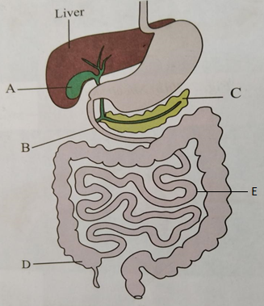

(a)Name the parts labelled B and C. (2mks)
B Duodenum;
C Pancreas;
b (i)Name the substance produced by the part labelled A. (1mk)
Bile;
(ii) State the functions of the substance named in b(i) above. (1mk)
Emulsifies fat;
Neutralizes acidic chyme;
c) What is the functional relationship between the part labelled A and the liver (1mk)
The liver synthesizes bile which is stored in organ A;
d) Give any three adaptations of part labelled E to its functions (3mks)
- Long to provide a large surface area for absorption of digested food;
- Narrow to bring digested food into close contact with the walls of the ileum for easier absorption;
- Highly coiled in order to slow down movement of food and thus allowing more time for digestion and absorption to take place;
-- Large number of villi and microvilli which increases the surface area for absorption of end products of digestion;
-Presence of thin layer of cells through which digested food diffuses;
- Presence of dense network of blood capillarie in the villi into which amino acids, sugars, vitamins, mineral salts are absorbed;
- Presence of lacteals in the villi for the absorption of fatty acids and glycerol;

SECTION B ( 40 MARKS)
- The table below shows the relative population of two herbivores M (capra aegagrus hircus and N (Ovis aries) in a small game reserve in Sokoke forest. The herbivores are closely related and have nearly overlapping niches. Over the study period, a predatory species to the herbivores was introduced into the reserve.

Time (month) | 0 | 2 | 4 | 6 | 8 | 10 | 12 | 14
Population of M | 64 | 64 | 70 | 72 | 120 | 130 | 132 | 134
Population of N | 50 | 54 | 60 | 78 | 59 | 40 | 30 | 22

- On the grid provided below, plot the graph of population of M (capra aegagrus hircus and N (Ovis aries) against time on the same axes. (8 marks)
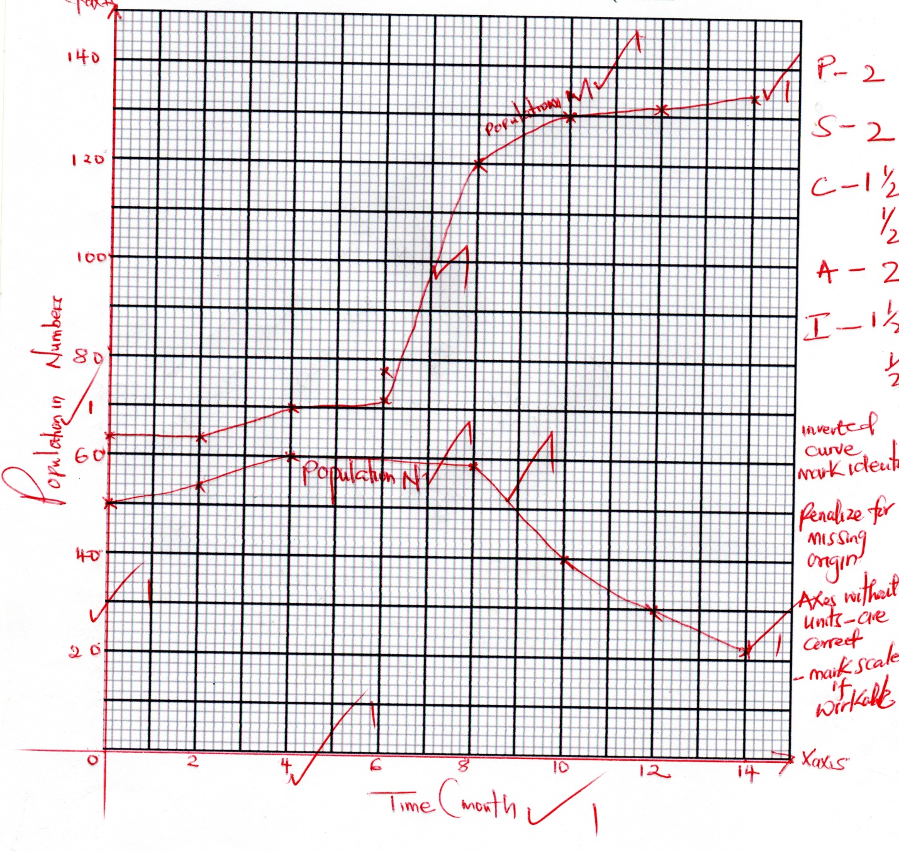
- At what time was the predatory species most likely introduced? (1 mark)
6 month
- Account for the shape of the graphs between:
- 6th – 8th month of species capra aegagrus hircus (M) (2 marks)
The population of M rises rapidly; due to reduced competition by species N; accepts species M has an adaptive advantage over species N
6th – 10th month of species ovis aries (N). (2 marks)
The population of N declines gradually; due to predation; accepts N has less adaptive advantage over M

- State one predatory characteristics of the predator introduced in the ecosystem that enabled it to locate the prey. (1 mark)

Acute sense of smell and sight; powerful limb muscle for agility; camouflage;
- Name the methods that could have been used to estimate the population of M.
(1 mark)
Direct counting
- Zebras and gazelles can occupy the same ecological habitat without depleting the available resources. Explain. (2 marks)
Zebras are mainly grazers; while gazelles are browsers; they occupy different ecological niches
- Name three human activities that can affect the population of organisms in the game reserve (3 marks)
Forest fires
Deforestation
Mining
Farming
Poaching

7. a) Discuss how xerophytes are structurally adapted to their habitat. (12 marks)
b) Describe five factors affecting breathing rate in humans (8 marks)
8. a) Describe how the following supports the theory of evolution
i) Comparative anatomy (6mrks)
ii) Geographical distribution of organisms (4mrks)
b) How is the proximal convoluted tubule adapted to it’s function (10mrks)
7 a)– In some leaves are reduced in size or are modified to spines to reduce surface area over which transpiration occurs;
- Some shed their leaves during draught to reduce surface area exposed to transpiration;
- Some have thick waxy cuticle to minimise the rate of cuticular transpiration;
- Some leaves are folded to reduce rate of transpiration by not exposing stomata to environmental factors;
- Some have sunken stomata which accumulate moisture in substomatal air spaces leading to low diffusion gradient;
- Most show reduced number of stomata that lowers the rate of transpiration;
- Some experience reduced stomatal rhythm to prevent excessive loss of water by transpiration;
- Some plants have deep roots to absorp water from deep in the soil;
- Other plants have superficial roots which grow horizontally close to the soil surface to absorb water after after a short or light shower of rain;
- Some plants store water in parenchyma cells found in succulent stems;
7b. Age; young people breath faster than the old because they have a higher demand for oxygen;
Temperature; in higher temperature, the breathing rate increases but in too high temperature the rate increases;
Health; increase of fever increases metabolism hence high breathing rate;
Exercise; during vigorous exercise the rate of breathing increases to supply more oxygen to meet the demand and also remove the extra CO2 produced during respiration;
Altitude; at high altitude, Oxygen concentration is low thus faster rate of breathing to supply tissues with sufficient Oxygen;
Emotions; affect production of hormone adrenaline which increases metabolism hence more rate of breathing e.g in anxiety, fright;

8a) i) comparative anatomy Based on the comparison of different structures; Homologous structures; are those having a common ancestral or embryological origin but perform different functions; e.g. pentadactyl limb plan of vertebrates; (which has evolved in class mammalian into using for flying in bats, long fast running legs in horse and flipper for swimming in whales) divergent evolution;
Analogous structures having different ancestral/embryological origin but have evolved to perform similar functions; (due to exploitation of similar ecological habitats) e.g. wings of insects; - Convergent evolutions; (4mks)

- Geographical distribution
- Based on the theory that before the continental drift; there was a single land mass/pangea; with continental drift, members of the population of originally the same species became separated and isolated; by (geographical barriers such as seas/oceans).
- They separated into different continents. The result of the isolation was evolution of different species; examples are members of the cat family in different continents such as the panthers and jaguars in South American Amazon Forest; (Leopards and Cheetahs in African Congo Forest, Tigers in Asian Forests)

8 b) Long to provide large surface area for efficient selective re-absorption;
It is coiled to reduce the speed of the flow of the filtrate to provide more time for maximum re- absorption;
Cells lining the tubules have numerous mitochondria which provide ATP energy that is used in the selective reabsorption since it is an active process;
The cells of the tubule have micro villi which increases the surface area for faster rate of reabsorption;
The tubule is highly vascularized for faster reabsorption and transportation of reabsorbed substance;

