231/1
BIOLOGY
PAPER 1
JUNE 2022

KASSU JET EXAMINATION 2022
BIOLOGY PAPER 1
MARKING SCHEME

- The study of biology enhances international cooperation, as countries work together to solve environmental problems. Name 2 biology related international conventions that help solve environmental problems. (2 marks)

Kyoto Protocol; Convention on International Trade in Endangered Species.

- A zebra is observed to be grazing at a grassland. Apart from nutrition, name one other characteristic of living things observed on the zebra as it grazes. (1 mark)

Irritability; Movement; Gaseous Exchange ;

- The diagram below represents an organism. Study it and answer the questions that follow.
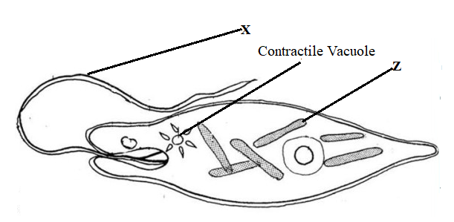
- Identify the kingdom to which the organism belongs (1 mark)

Protoctista

- Name the structures labelled X (1 marks)

Flagellum rj Flagella

- Identify the type of nutrition carried out by the organism and give a reason (2 marks)

Type of Nutrition: Photosynthesis/ acc. Autotrophic
Reason: The organism has chloroplasts

- The diagram shown represents part of a cell.
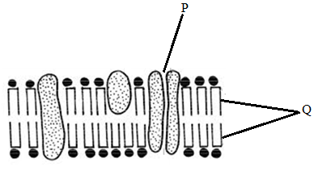
- Identify the structure (1 mark)
Cell membrane
- Label the following parts: (2 marks)
P. Pore
Q Phospholipid bilayer/ acc Lipid bilayer
- Name the following organelles. (3 marks)
- Contains chromatin material Nucleus
- Forms spindle fibres Centriole
- Digests pathogens that enter the cell Lysosome

- The bacterium that causes typhoid is known as salmonella typhi.

- Write the scientific name correctly (1 mark)
Salmonella typhi (to follow rules for handwritten scientific name/ underline
separately)

- State the main mode of transmission of the above organism. (1 mark)

Ingestion of contaminated water and food

- Three stems of tradescantia of equal length were placed in three solutions of different concentrations. The set ups were left to stand for 30 minutes. The results were recorded in the table below.

Solution | Initial length of cylinder (mm) | Final length of cylinder (mm)
A | 37 | 37
B | 37 | 35.2
C | 37 | 39.7

- Describe the nature of solution A in relation to the final length of the tradescantia stem. . (1mark)
Isotonic solution

- Explain the observation that was made on the tradescantia stem which was put in solution B. (2marks)

Solution B was hypertonic to tradescantia cells. The cells lose water to solution B by osmosis and became plasmolysed hence the reduction in length

- State what would happen to red blood cells if they were placed in solution C.
(1mark)
The cells would burst / haemolysed

- A KASSUME researcher found out that oxygen concentration, sugar consumption is directly related to potassium ion uptake in wheat roots. Name the process by which potassium ions is taken by the roots. Give a reason for your answer. ( 2marks)

Active transport
Oxygen breakdown sugar to produce energy for active uptake of potassium ions

- The diagram below is an experiment that was carried out to investigate a certain biological process. Study it an answer the questions below.
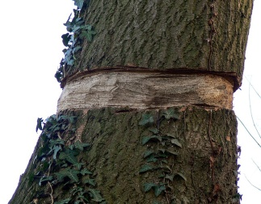

a) What is the aim of the experiment? ( 1mark)

To investigate translocation of food substance;

- Which specialised tissue was removed in the above experiment? ( 1mark)

Phloem;

- How is the tissue named above adapted to perform its function? ( 1mark)

Companion cells have numerous mitochondria which generate energy for translocation;
Cytoplasmic filaments run continuously to allow passage of food
Perforated sieve tubes to allow continuous flow of substances;

- Predict in diagrammatic form the fate of the trunk after 3 weeks? ( 1 mark)

- Two potted plants A and B that had been kept in dark for 48 hours were placed in polythene bags.

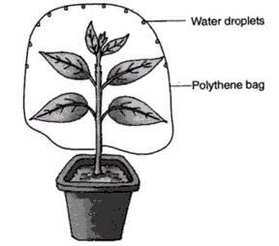
NaOH pellets
NaHCO₃

set up A Set up B

Into set up A, a dish of potassium hydroxide was placed inside the polythene bag. In the set up of plant B, a dish of sodium hydrogen carbonate was similarly placed. The plants were then placed in sunlight for six hours. After six hours a leaf from each plant was tested for starch.

- What is the expected results for set up A (1 mark)
Starch absent;
- What was the purpose of:
- Potassium hydroxide (1 mark)
Absorb all CO₂ inside the polythene bag
- Sodium hydrogen carbonate. (1 mark)
Release CO₂ inside the polythene bag
- What would have been the case if neither sodium hydroxide nor sodium hydrogen carbonate were placed in the set up? (1 mark)

Less starch will be formed as CO₂ will be limited.
- Explain how the teeth of a lion are adapted to carnivorous mode of feed. (3 marks)
- Carnassial teeth with smooth sides and sharp edges to slice through flash and crush ones.
- Premolars and molars small with sharp edges to crush bones.
- Canines long and conical, served to hold / kill the prey.
- Incisor chisel shaped & closely tilted to seize the prey / grip & strip flesh from bones.

- Explain how emotional state of the body affect heart beat rate. (1 mark)
Emotional lead to increased adrenaline secretion. Increased levels of adrenaline in
blood increases heartbeat,
- (i) What is meant by immune response? (1 mark)
Production of antibodies against foreign antigens in the body;
(ii) Name one cell responsible for immune response in a human being. (1 mark)
Lymphocyte;

- Describe the mechanism of closing the stomata on the basis of photosynthetic theory. (3 marks)

During the night ,no photosynthesis takes place, glucose is not produced ; osmotic pressure of the guard cell is lowered and water is lost to surrounding cells by osmosis ;the guard cell become flaccid and stoma closes;

- Explain how the floating aquatic plants are adopted of gaseous exchange.
- Arenchyma has large air spaces for storage of gases

- The chart below shows a summarised process that occurs in animals.

Lactic acid + N
Reactions
in cytoplasm
Process X
Substance A + ATP
Glucose

Reactions
Product B + water + ATP
in matrix

- Name the: (3 marks)
- Process X - Glycolysis;
- Substance A - Pyruvic acid / pyruvate;
- Product B - carbon (IV) oxide;
- State the condition necessary for the reactions in matrix to occur. (1 mark)
Oxygen gas;

- Explain the roles of the following plant hormones
- Gibberellins (3 marks)

Promotes cell division and elongation; promotes parthenocarpy; breaks bud dormancy and leads to formation of lateral buds; breaks seed dormancy; inhibits growth of adventitious roots; induces ovary wall to form fruit after fertilization (any 3)

- Ethylene (2 marks)

Causes flower development, causes abscission of leaves and fruits; stimulates thickening of stem; promotes apical dominance; (any 2)

- (a) Define the first law of heredity as postulated by Gregor Mendel (1 mark)

Characteristics of an organism are determined by internal factors; which occur in pairs; only one of a pair of such factors can be represented in a single gamete;

(b) A common species of rats has individuals with white, black or grey coats. During a study, a rat with white coat was crossed with a rat with black coat. Both parents were pure lines. All the offspring in F1 generation had grey coats. The F1 offspring were selfed to get F2. Using letter B to represent the gene for black coat and W for white coat, work out the phenotypic ratio of F2 offspring. Show your working (4 marks)

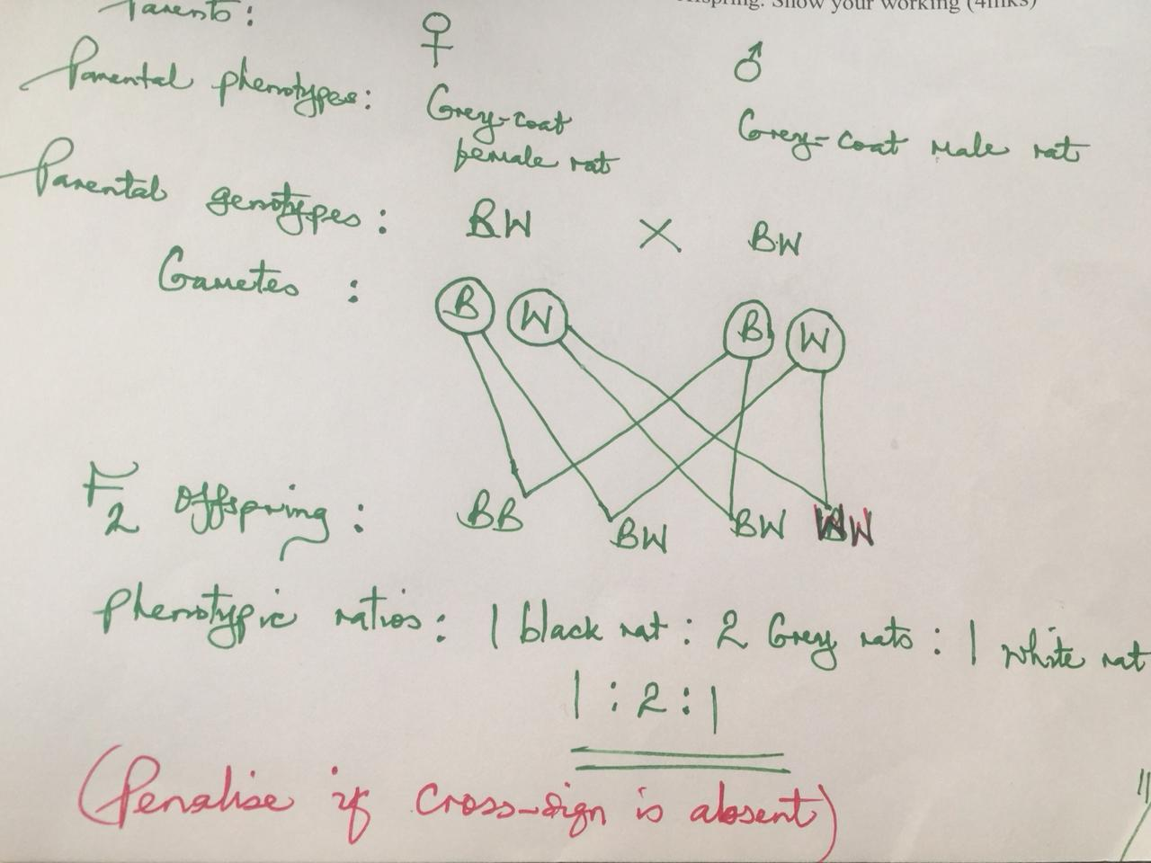
17. What is meant by the following terms

(a) Natural selection (2 marks)

This is a mechanism by which beneficial variations in a population are perpetuated; while the disadvantageous variations are eliminated; (Owtte)

(b) Struggle for existence

This is where members of a population are constantly competing with each other in an effort to survive; (owtte)

18. Despite the best efforts to make and use the most effective pesticides, bedbugs have not been eradicated from most homes. Give an explanation for this observation. (2 marks)

This is because the bedbugs undergo mutations; that gives them resistance against the pesticides;(accept existence of variance)

19. The diagram below illustrates the mechanism of blood glucose concentration
Corrective mechanism A

Excess

Normal glucose level Normal glucose level

Deficiency
Corrective mechanism B

(a)What principle of homeostasis is illustrated in the diagram? (1mk)
Feedback mechanism;
(b)Name the condition that may result from further excess (1mk)
Diabetes mellitus;
(c)State how the corrective mechanism B restores blood glucose to normal level (2mks)
Pancreas is stimulated to secrete glucagon into bloodstream On reaching the liver glucagon: .Stimulates liver cells to convert glycogen into glucose;. Stimulates liver cells to decrease oxidation of glucose into water, carbon (IV) oxide and energy;
20 . The diagram below shows a stage in cell division
(a)State whether it is a stage in mitosis or meiosis (1mark)
Meiotic stage/A stage in meiosis;
(b)Give two reasons for your answer in (a) above (2marks)
Homologous chromosomes pair up to form bivalents/Synapsis;
Occurrence of crossing over/Chiasma formation; (a & b are tied)
(c)State two differences between the end products of mitosis and meiosis (2mks)
Mitosis Meiosis
(i)Daughter cells diploid | (i)Daughter cells haploid
(ii)Two daughter cells  iii)Daughter cells identical | (ii)Four daughter cells  Daughter cells show variation to mother cell

21. Study the diagram below and use to answer the questions that follow;
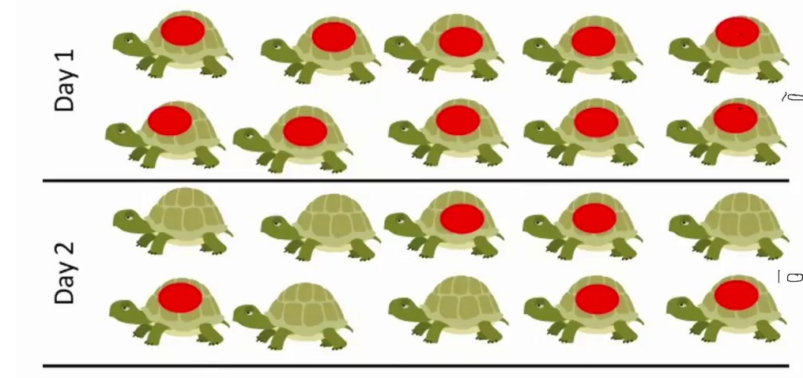
- Identify the sampling method illustrated. (1mrk)
Capture- recapture method
b) Describe how the sampling method above was used to estimate the population of organisms (4marks) Select the study area with organism to be studied and determine it’s size; study organism should be highly mobile e.g fish, birds; using appropriate apparatus, capture organisms; count, mark and release them back to their habitat; after a time interval of 24-48 hours, make a second capture( recapture) in the study area and record the number; and not the number of organisms marked and record their number; use the formula below to calculate the population
Population = First marked X Second Capture ;
Marked recapture
c) Give any two assumptions that would be made when estimating the population the named organism in (a) above (2marks)
No organism moves in or out of the area between the two counts;The released animals mix freely with the remaining population;The mark does not alter the animals’ behaviour;The marked animals will have enough time mix with the rest;The population number does not vary during the study period;
d) Differentiate between the terms; habitat and ecological niche (1mark)
Habitat is the specific locality with a particular set of conditions where an organism lives; Ecological niche is the position of organism occupies ia a habitat in terms of physical space where an organism is found and its role in that habitat in terms of feeding relationships and other interactions with other species;

22. Study the food relationship below and answer the the questions
Nile perch

Frog Tilapia Gray fish

Mosquito larva

Green algae

a) State the ecosystem from which the above food web was obtained (1 mark) Aquatic ecosystem;
b) What will be the effect of increased fishing of nile perch on the number of malaria cases.
(2 marks)
The number of malaria cases will reduce; increased number of tilapia that will feed and reduce the number of mosquito larvae thus reducing malaria cases;
c) How is malaria transmitted from infected person to a healthy person (1mark)
Plasmodium is transmitted when female anopheles mosquito bites infected person and suck blood containing the parasites;
d) What will be the benefit of controlling malaria in the above ecosystem using biological control (1mark)
Reduced pollution

