TERM 2 2022 OPENER EXAM FORM 3
PHYSICS PAPER 2 FORM 3
NAME:…………………………………………………ADM NO:……….CLASS:………
SECTION A: (25 MARKS)
- (a) Figure 1 shows an image formed in a plane mirror.
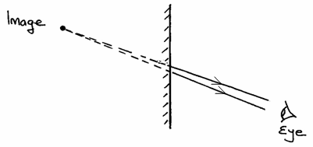

By drawing incident rays for the rays shown, locate the position of the object.(2 marks)
- Explain how an enlarged hole in a pin hole camera produces a blurred image. (1 mark)

- The figure 2 below shows an electroscope being charged by induction.
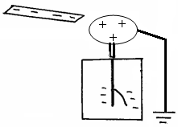
Metal cab
Earth wire

(i) State the reason why the cap of the electroscope is made circular.(1 mark)

- On the same diagram, show the direction of the flow of electrons on the earth wire. 1mk
- (a) the figure below shows a current carrying conductor placed perpendicularly between the poles of a magnet. Show on the diagram The direction of net force on the conductor. (1 mark)

- Using domain theory, describe how a nail can be magnetised through hammering. (2 marks)

- State two properties of an image formed by a concave mirror that makes it suitable for use by barbers. (2 marks)

- State two defects of a simple cell and how each can be corrected. (2 marks)

7. An object is placed 20cm in front of a concave mirror of focal length 10cm and another identical object is place 20cm infront of a plane mirror
(i) Give one similarity of the image formed. (1mk)

(ii) Give one difference between the image formed. (1mk)

- Figure 1 show a method used to charge conductors. The procedure follows steps a, b and c
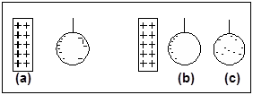

Fig 1

i)State the method of charging above. (1 mark)

ii) Explain what happens in step (b) above. (1 mark)

- The figure below shows the object O and its image O1 formed by a concave mirror. Locate theposition of the principle focus. (2marks)
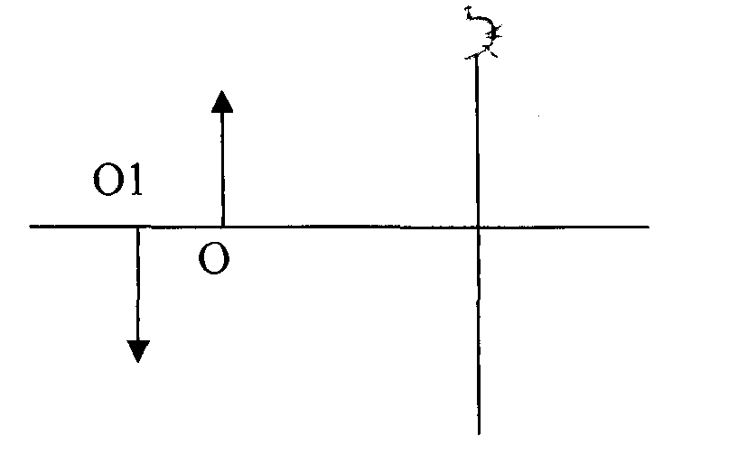

- A current of 0.8A flows through an electric circuit. Determine the quantity of charge that passes a point in the circuit in 6 minutes. (2 marks)
- A mine worker stands between two vertical cliffs 500m from the nearest cliff. The cliffs are xmetres apart. Every time he strikes the rocks, he hears the echoes. The first one comes after 2.5.s while the other comes 3s later. Calculate the distance between the cliffs. (3 mks)

- Figure below show a Leclanche cell
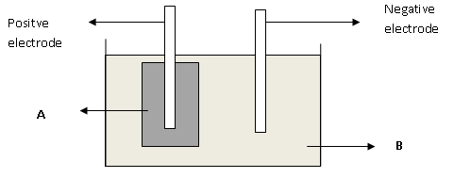

Name the chemical substances in the parts labeled (2mks)
A..............................................................................................................................................
B.............................................................................................................................................

SECTION B:55 MARKS

- The figure below represents an oscillation taking place at a particular point when a sound wave in a gas passes the point. The vertical axis represents displacement.
1.0 2.0 3.0 Time(s)
Displacement
2.0

1.0

1.0

2.0

(i)Explain what is meant by displacement in this context. (1 mark)

(ii) From the graph, determine.
(i) Amplitude (1mk)

(ii) Period (1mk)

(iii) Frequency (2mks)

(iii) Calculate the wavelength of the sound wave in the figure above. (Speed of sound in gas is 340m/s). (3 marks)

- State two factors that increases the speed of sound in solids.(2 marks)

- Distinguish between transverse and longitudinal waves. (2mks)

- (a) A ray of light makes a glancing angle of incidence i=60º with a flat glass surface as shown below

Refracted ray
Glass
i
Air
N
r

Given that the critical angle for glass is 42º determine;
(i) The angle of refraction r (3mks)

(ii) Given that speed of light in air 3.0 x 10⁸ m/s, find the speed of light in glass (2mks)

(b) A microscope is focused on a mark on a horizontal surface. A rectangular glass block 30mm thick is placed on the mark. The microscope is then adjusted 10mm upwards to bring the mark back to focus. Determine the refractive index of the glass. (3mks)

c) State the conditions to be satisfied for total internal reflection to occur. (2mks)

(d) A ray of light traveling in the direction EO in air enters a rectangular block at an
angle of incidence 30⁰. The resulting angle of refraction is 18⁰.
E

A o 60⁰ B

18⁰

C D
Find:-
  - The refractive index of the block. (2mks)

  - The critical angle C of the block. (3mks)

- (a) Define the term principal focus in relation to convex mirror (1mk)

(ii) Distinguish between real and virtual image (2mks)

(b) The table below shows the object distance u, and the corresponding image distance V for an object placed infront of a concave mirror
U(cm) | 20 | 25 | 30 | 35 | 40 | 45
V (cm) | 60.0 | 37.5 | 30.0 | 26.3 | 24.0 | 22.5
^{I}/_{U} cm⁻¹
^{I}/_{V}cm⁻¹

(i) Complete the table (2mks)
(ii) Plot a graph of ^{I}/_{V} against ^{I}/_{U} (5mks)

(iii) From the graph determine the focal length (2mks)

- a) The set up in figure 4 below can be used in a laboratory for lifting and releasing a steel ball.
i) State the material which is suitable for use in the core. (1 mark)

ii) If a slightly larger ball is to be lifted, it is necessary to make an electromagnet stronger.
Name two ways of increasing the strength of the magnet. (2 marks)

b)Figure 4 shows a rectangular coil in a magnetic field rotating in a clockwise direction. The direction of induced current is as shown by the arrows.
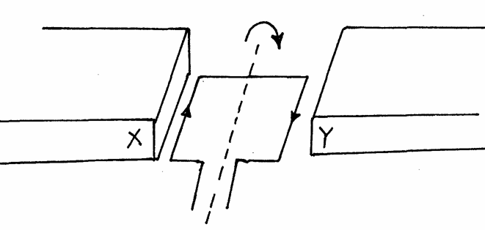
Fig. 4
i) Indicate the poles X and Y of the magnets (2 mark) X ____________________ Y ____________________

ii) Suggest one way of increasing the magnitude of the force in such a coil (1mark)

c) What is meant by the term ‘direction of a magnetic field’ (1mk)

- State one property of magnets. (1mk)

- ) Repulsion is the surest test for polarity of a magnet. Explain (1mk)

- State the difference between magnetic properties of steel and soft iron (1mk)

- A steel bar was being magnetized by electrical method. It was noted that the strength of the magnet depended on the amount of current. The current was increased steadily until it was noted that the strength of the magnet could not increase further .Explain the observation (2mks)

- State two ways of demagnetizing a magnet (2mk)

