**TERM 2 2022 OPENER EXAM FORM 2**

**PHYSICS FORM TWO**

**Time 1hr 45mins**

**NAME…………………………………………………ADM NO:……………..CLASS……….**

1. A spherical ball bearing of mass 0.0024 kg is held between the anvil and spindle of a micrometer screw gauge. Use this information and the position of the scale in the figure below to answer the questions **(a)** and **(b)** below:

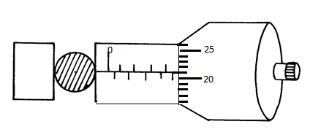

1. What is the diameter of the ball bearing? (1 mk)
2. Find the density of the ball bearing correct to 3 significant figures (3 mks)
3. Explain why it is dangerous for a bus to carry standing passengers. ( 2 mks)
4. Differentiate between cohesive and adhesive forces. (2mks)
5. Explain the cause of random motion of smoke particles as observed in Brownian motion experiment using a smoke cell. (2mks)
6. The Figure 2 shows two identical thermometers. Thermometer **A** has a blackened bulb while thermometer **B** has a silvery bulb. A candle is placed equidistant between the two thermometers

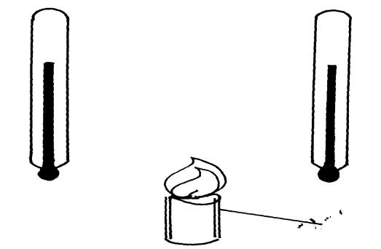

Candle

B

A

State with a reason the observations made after sometime (2 mks)

1. Give a reason why water is not suitable as a barometric liquid. (1 mk)
2. A uniform metre rule is balanced as shown below.

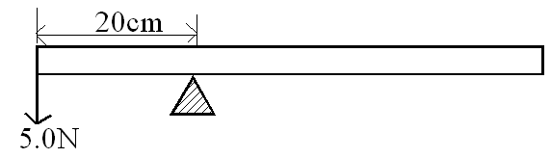

Find the weight of the metre rule (3mrks)

1. State the difference between a soft magnetic material and a hard magnetic material.(1 mk)
2. The Figure shows a scale of part of a vernier calliper.

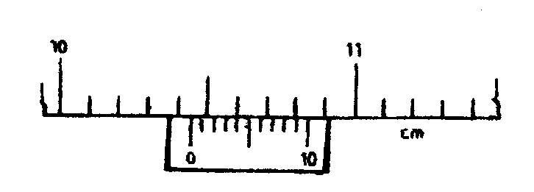

What is the actual reading indicated by the scale if the vernier caliper has a zero of +0.02cm. (2mks)

1. A uniform plank of wood is pivoted at its centre. A block of wood of mass 2 kg is balanced by a mass of 1.5 kg placed 30 cm from the pivot as shown in the diagram below.

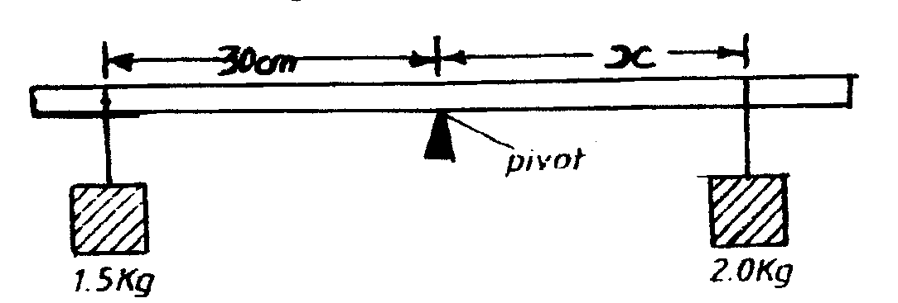

Calculate the distance X. (3mks)

1. A highly negative charged rod is gradually brought close to the cap of a positively charged electroscope. It is observed that the leaf collapses initially and the leaf diverges. Explain this observation (2mks)
2. State the right hand grip rule.(2maks)
3. The figure below shows an object O and its image I formed by a concave mirror.

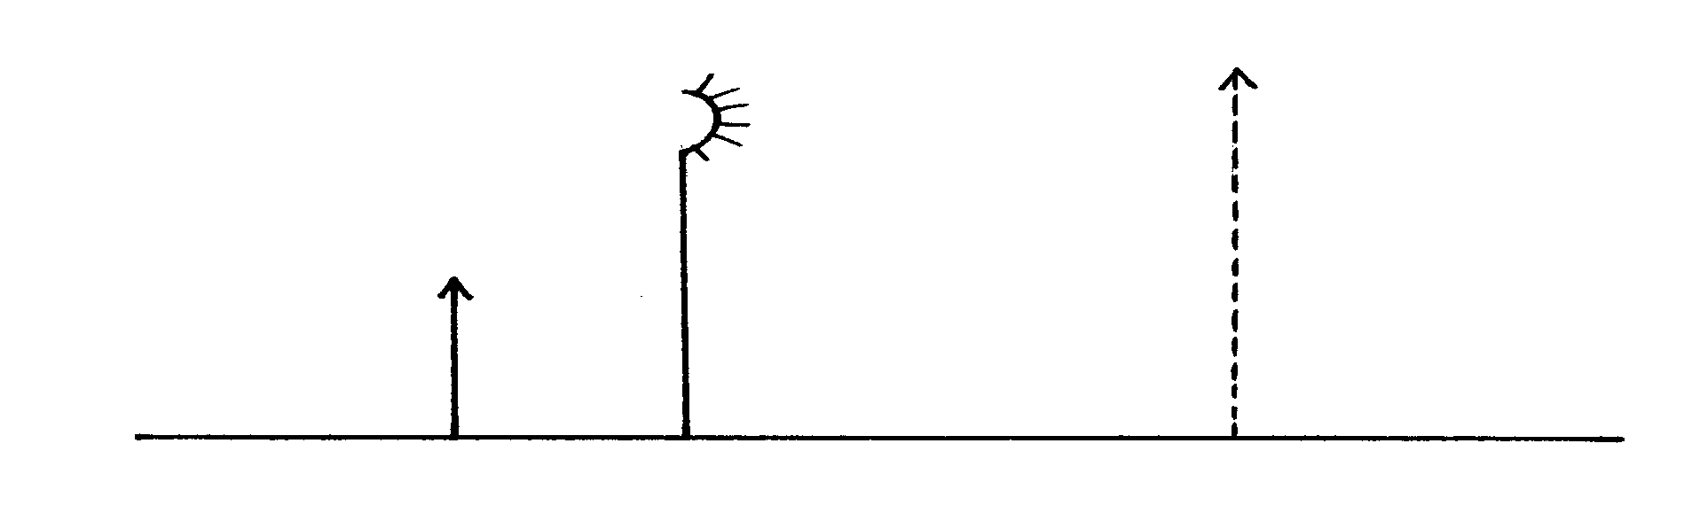

Using suitable rays, to locate the focal length of the mirror. (3mks)

1. The figure **below** shows a uniform rectangular lamina.

Locate and indicate the centre of gravity of lamina. (3mks)

1. Use the information below to answer questions below

In an experiment to determine the density of a liquid, the following readings were made.

Mass of empty density bottle = 20g

Mass of bottle filled with water = 70g

Mass of bottle filled with a liquid = 695g

1. Find the density of the liquid, given that density of water is 1000kgmˉ³. (4mks)
2. Find the mass of the liquid. (2mks)
3. In an attempt to make a magnet, a student used the double stroke method as shown below.

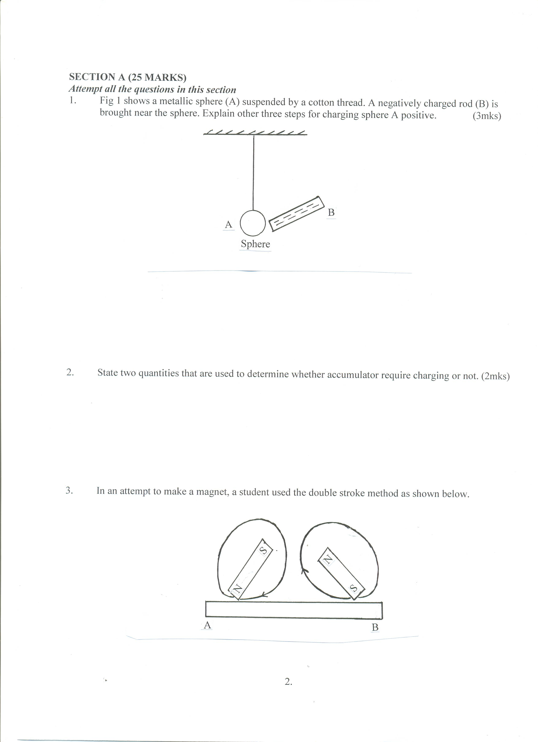

State the polarities at the ends A and B (2mks)

A………………………………………B……………………………………

1. An object is placed 30cm in front of a concave mirror of focal length 20cm. Determine
   1. Size of the image. (3mks)
   2. Magnification (2mks)
   3. Name two applications of concave mirrors (2mks)
2. A metre rule is balanced by masses 18g and 12g suspended from its ends. Find the position of its pivot. (3mks)
3. Explain the function of constriction present in a clinical thermometer. (1mrk)
4. Define the term moment of force. (2mrks)
5. State the two laws of reflection (4mks)
6. Give that the diameter of an oil drop is 0.15cm and the diameter of a circular patch formed by the same drop on water is 35.35cm.Calculate the thickness of the oil molecule. (4mks)
7. State two differences between mass and weight.(2mks)
8. Name two factors that affect stability of a body(2mrks)
9. The figure 2, below, U-tube contains two immiscible liquids P and Q. If the density of Q is 900kg/m³ and that of P is 1200kg / m³, Calculate the height of liquid Q. (3 marks)



1. State two defects of a simple cell (2mks)