NAME;. …………………………………………………………….ADM NO;………….
TERM 2 2022 OPENER EXAM FORM 2
CHEMISTRY
TIME: 1 ½ HOURS
INSTRUCTIONS
Attempt All Questions.
- (a) When the air-hole is fully opened, the Bunsen burner produces a non-luminous flame.
Explain (2 mark)

(b) Draw a labelled diagram of a non-luminous flame. ( 3 marks)

- The diagram below shows some parts of a Bunsen burner
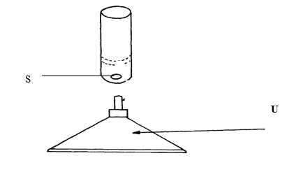

Name parts S and U and state their functions. ( 4 marks)

- A mixture of hexane and water was shaken and left to separate as shown in the diagram below:

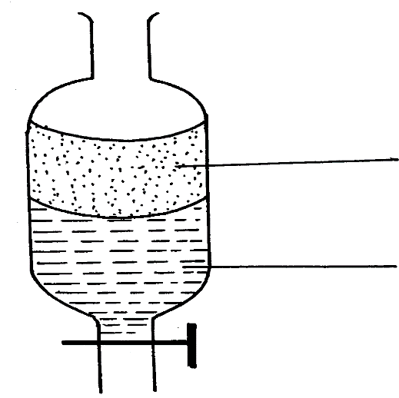
P
W

Name the above method of separation. 1 mark

- The set-up below is used to investigate the properties of hydrogen.
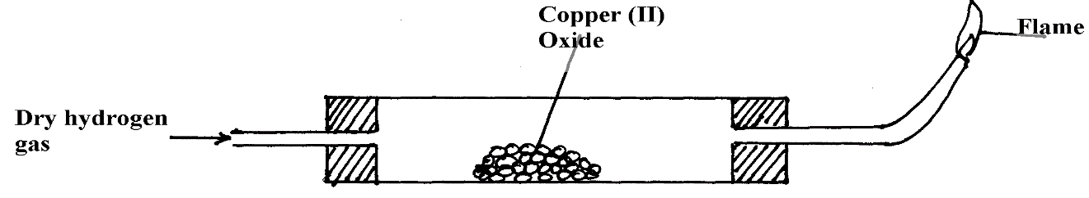

- On the diagram, indicate what should be done for the reaction to occur ( 1 mark)

ii) Hydrogen gas is allowed to pass through the tube for some time before it is lit. Explain ( 2mark)

iii) Write a chemical equation for the reaction that occurs in the combustion tube. ( 1 mark)

iv) When the reaction is complete, hydrogen gas is passed through the apparatus until they
cool down . Explain ( 2mark)

v) What property of hydrogen is being investigated? ( 1 mark)

vi) What observation confirms the property stated in (v) above? ( 2mark)

vii) Why is zinc oxide not used to investigate this property of hydrogen gas? ( 1mark)

- Explain why an atom is said to be electrically neutral. ( 2 marks)

- The table below gives the atomic numbers of elements W, X, Y, and Z. The letters do not represent the actual symbols of the elements.

Element | W | X | Y | Z
Atomic Number | 4 | 10 | 11 | 12

a) Which one of the elements is least reactive? Explain. (1mark)

b)i) Which two elements belong to the same group? (1mark)

ii) Give the formula of the Z sulphate. (1mark)

iii) give two pairs of elements that belong to the same period (2mks)

7. In an experiment to separate a mixture of ethanol and water. Ethanol boils at 78⁰C and water 100ºC. A student set up the apparatus shown below.

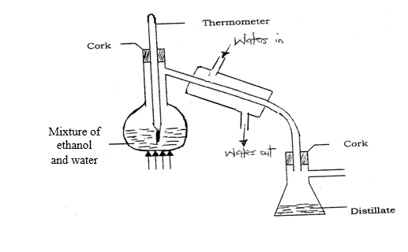

a) Identify two mistakes in the set – up. (2marks)

b) What method would the student use to test the purity of the distillates obtained? (1mark)

c)Name the above method of separation. (1mark)

d)State the two applications of the above process. (2 marks)

e. Which liquid will distill off first. Explain. (2 marks)

8.The grid below shows part of the periodic table. Use it to answer the question that follows. (Letters are not actual symbols of elements.)

P
 | M |  |  |  |  | E | F
G | W |  | H | I |  |  | J | K
Q | L
- Write the electronics configuration of the following element. (2mk)
- E

- L

- Give the formula of one stable ion with an electron arrangement of 2:8 which is; (2mark)
- Negatively charged.

- Positively charged

- Select two alkali metals from the above periodic table (2 mark)

- Compare the atomic radius of G and Q, give a reason. (2mark)

- Write the chemical equation between W and oxygen. ( 1 mark)

- (i). State three observations made when a piece of element G is placed on water, (3marks)

(ii). Write a chemical equation between element G and water. (2mark)

8. (a) What is meant by the terms?
- Atom; (2mk)

- Isotopes? (2mk)

(b) The formula for a sulphate of titanium is Ti₂ (SO₄)_{3.} Write the formula of its chloride?
(1mk)

(c) Calculate the relative atomic mass of Neon given that it exist as;
90.92% ²⁰₁₀Ne , 0.26% ²¹₁₀Ne , 8.82% ²²₁₀Ne, ( 3 marks)

9. The diagram below shows students set-up for the preparation and collection of oxygen gas
X
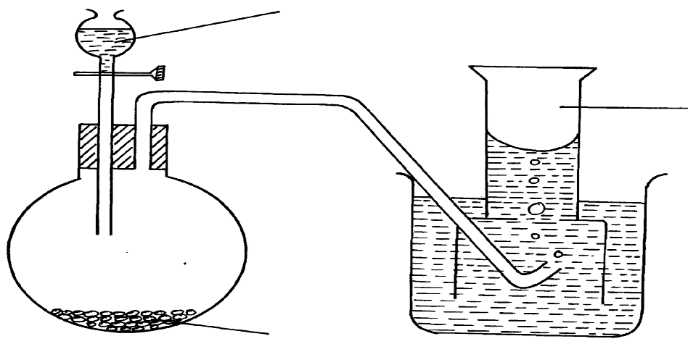

Oxygen gas

Sodium peroxide

- Name substance X used ( 1 mark)

(b) Write an equation to show the reaction of sodium peroxide with the substance named in 1(a) (1 mark)

( c)state 3 uses of oxygen gas. ( 3 marks)

(d) Name the method of collection shown above ,explain. ( 2marks)

10. The following table shows solutions with their pH values. Use it to answer the questions that follow.

Solution | A | B | C | D | E
pH | 1 | 7 | 14 | 9 | 5

- Identify a solution which ( 2marks)
strong acid

strong base.

- Which solution is used in the manufacture of anti acid tablets (1 marks)

- State a commercial indicator that cannot be used to classify the solutions into, acids, base or neutral. Explain your answer. ( 2marks)

- Identify any two solution that react to form salt and water only. (1 marks)

