NAME…………………………………………………………..ADM………CLASS………
BIOLOGY
FORM THREE
TERM 2 2022 OPENER EXAM FORM 3
TIME: 2HRS 30 MINS
INSTRUCTION TO STUDENTS
- Answer all Questions
- State two functions of centrioles in an animal cell. (2mks)

- Name two classes of phylum Arthropoda that have a cephalothorax. (2mks)

- Other than having common characteristics state the main features of a species. (2mks)

- The diagram below represents a transverse section of a plant organ.

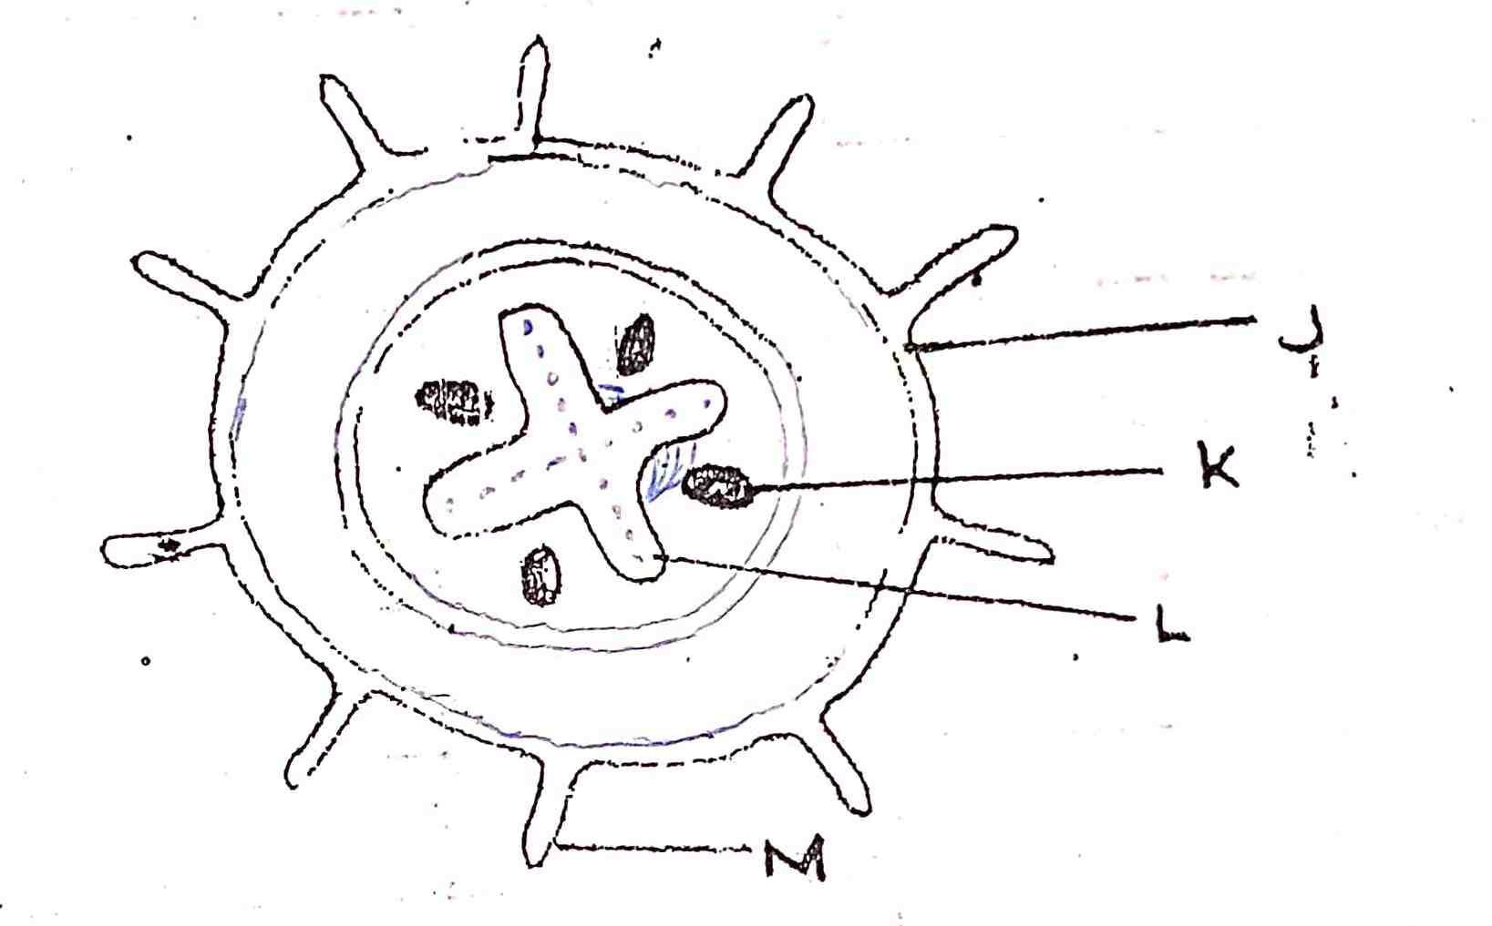

- From which plant organ was the section obtained. (1mk)

- Give two reasons for your answer in (a) above. (2mks)
- Name the parts labeled. (3mks)
J
K
L
- State function of the part labeled M. (1mk)

- Name the class from which this section was obtained. (1mk)

- The diagram below shows an organelle that is found in most cells. Study it and answer questions that follow.

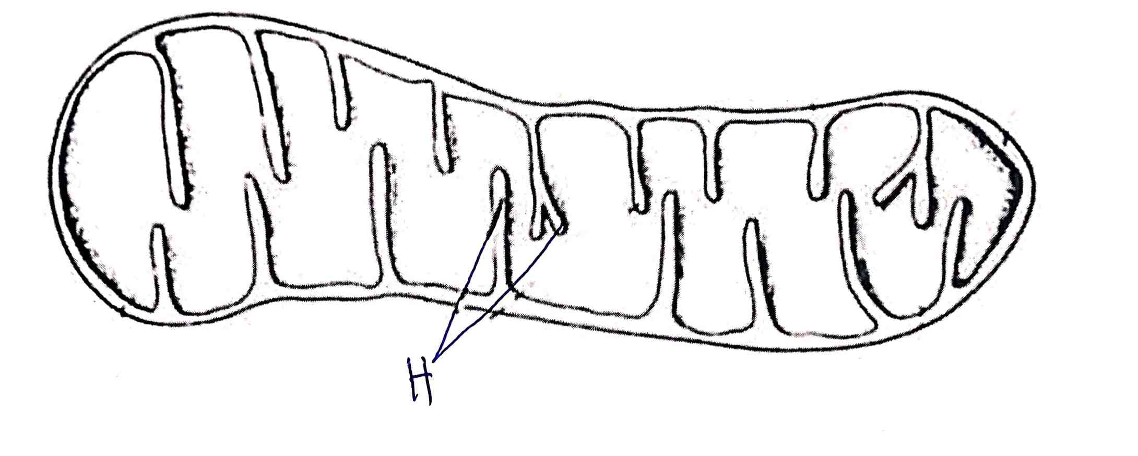

- Name the organelle. (1mk)

- State the function of the organelle named in (a) above. (1mk)

- Give the full name of the major chemical compound that is found in the organelle. (1mk)

- Identify the gas that is required in order to form the compound you have stated in (c) above. (1mk)

- Give the name of the structures labeled H and give their function. (2mks)

- Name the gaseous exchange structure in the following organisms.
a. i. Amoeba 1mk

ii. Grasshopper 1mk

iii. Frog 2mks

b. The diagram below illustrates the structure of a gill from a bony fish.

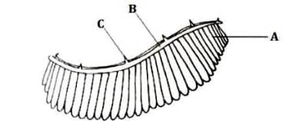

- Name the parts labeled (3mks)
A
B
C
- State the function of the part labeled C. (1mk)

- How is part B adapted to its functions? (2mks)

- During a biological practical lesson, the teacher provided students with the following apparatus: pooter, scapel, specimen bottle a pair of forceps, sweep net, chloroform.
- Give three precautions the biology teacher gave to the students before the practical when collection of specimen began. (3mks)

- What was the function of the following apparatus. (3mks)
- Pooter

- Sweep net

- Chloroform

- Other than observation, give other two scientific skills developed by studying biology. (2mks)

- An investigation was performed by a group of students as shown in the set up below.

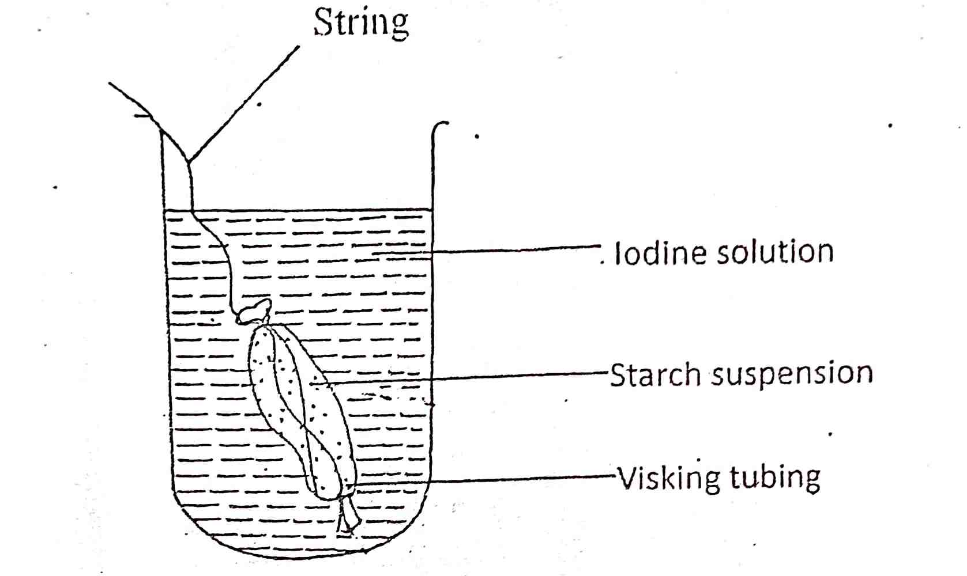

After 30 minutes, the starch suspension had turned blue-black while iodine solution retained its brown color.
- Name the physiological process that was being investigated. (1mk)

- Account for the results observed after 30 minutes. (3mks)

- Explain what would happen to the red blood cells when placed in distilled water and left to stand for the same duration as for the experiment above. (3mks)

- Define cell physiology. (1mk)

- Observe the photographs of the specimens shown below and answer questions that follow.

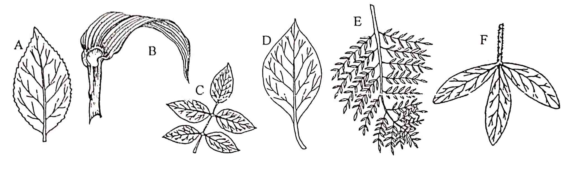

1. a. Leaf simple………………………………………………. Go to 2
b. leaf compound…………………………………………... go to 4
2. a. Leaf parallel veined ……………………………………. Maize
b. Leaf network veined…………………………………… go to 3
3. a. Leaf margin smooth……………………………………. Bougainvillea
b. Leaf margin serrated …………………………………… Hibiscus
4.a. Trifoliate compound leaf………………………………... crotalaria
b. Pinnately compound leaf………………………………… go to 5
5. a. Bipinnate………………………………………………… Jacaranda
b. Unipinnate………………………………………………. Rose
Use the above steps to identify the specimen. (7mks)

Leaf | Steps followed | Identify
A
B
C
D
E
F

- After an ecological study of feeding relationship students constructed a food web shown below.

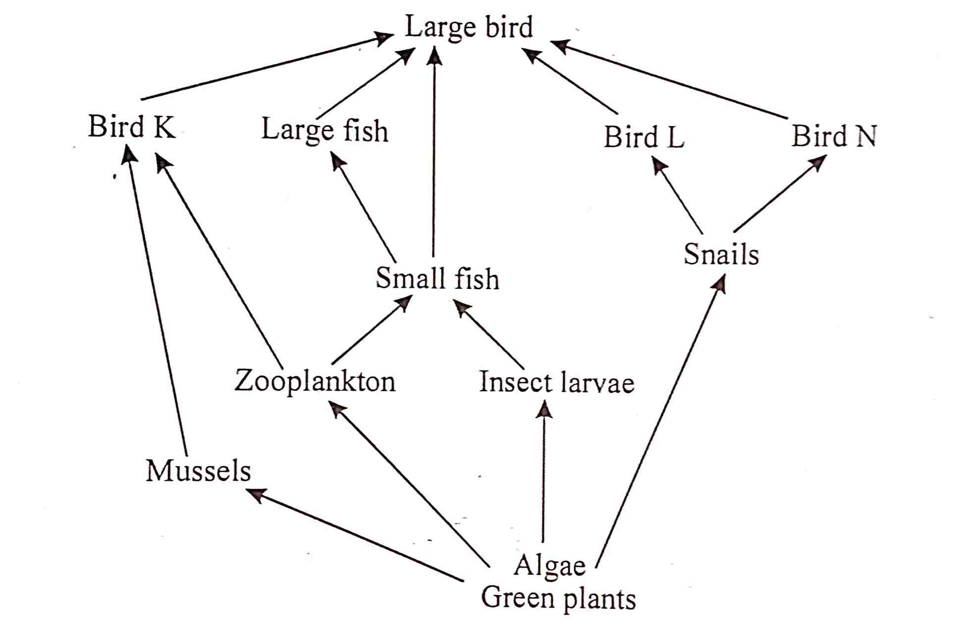

- Name the process by which energy from the sun is incorporated into the food web. (1mk)

- The biomass of producers in this ecosystem was found to be grater than that of primary consumers. Explain. (1mk)

- From the information in the food web, construct a food chain with large fish as tertiary consumers. (1mk)

- What would happen to the organisms in the food web of bird L migrated. (2mks)

- Name an organism with the least biomass. (1mk)

- State three human activities that would negatively affect the population of organisms in the above food web. (3mks)

- The diagram below illustrates a nephron from a mammalian kidney.

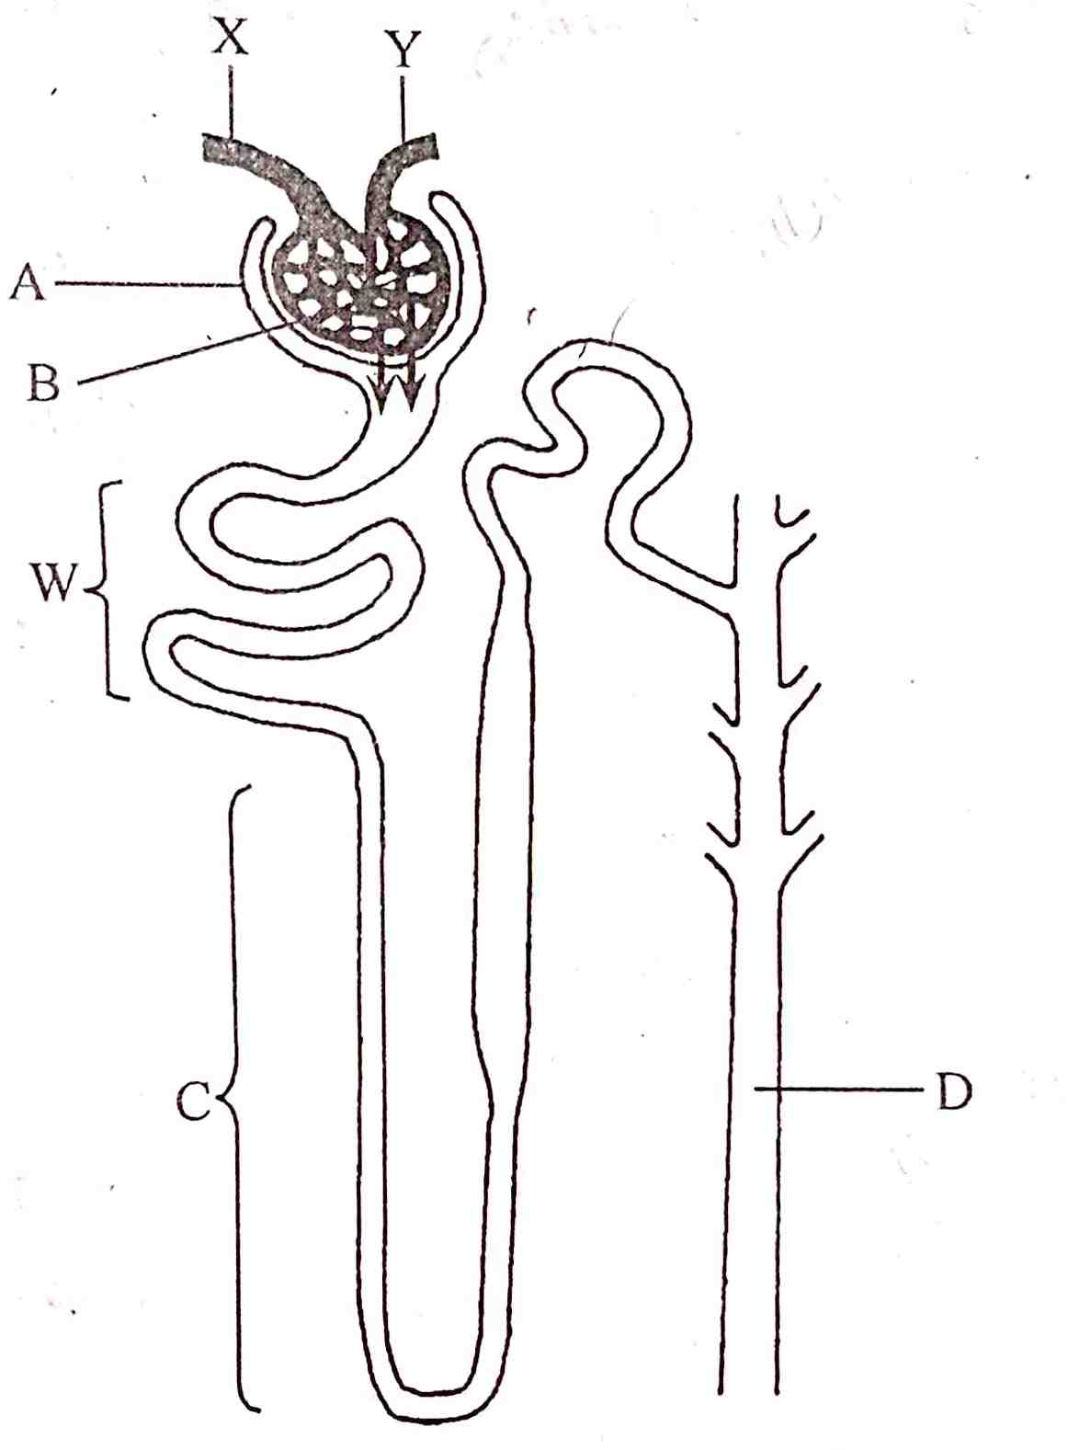

- Name the parts labeled: (3mks)
A
B
C
D
- Name the process represented by the arrows. (1mk)

- Name one substance that remains at part B. (1mk)

- How does the part labeled C of camel compare with that of a hippo. (2mks)

- An experiment was carried out to investigate the effect of temperature on the rate of a reaction catalyzed by salivary amylase. The pH was maintained slightly alkaline. The results are as shown in the table below.
Temperature | Rate of reaction
5 | 0.3
10 | 0.5
20 | 1.3
25 | 2.0
30 | 3.5
35 | 4.8
38 | 4.8
45 | 2.5
50 | 0.8

- On the graph paper provided plot a graph of the rate of reaction against temperature. (7mks)

- What is the optimum temperature of this enzyme? (1mk)

- At what temperature was the rate of reaction 1.4? (2mks)

- Account for the shape of the graph between:
- 5ºC and 35ºC (2mks)

- 30ºC and 50ºC (2mks)

- How is HCl from the stomach neutralized and where does it occur? (2mks)

- Name one digestive enzyme that works best in acidic conditions. (1mk)

- In an attempt to estimate the number of weaver birds, in a small wood land 435 were captured, marked and released. Three days later, 620 were captured 75 of which were marked.
- What is the name of the population estimation method described above? (1mk)

- Calculate the approximate size of the weaver birds population in the wood land. (2mks)

Answer only one question between qn 13 and qn 14

- Describe how the mammalian skin is adapted to its functions. (20mks)

- Describe how a leaf from a terrestrial habitat is adapted to its photosynthetic functions. (20mks)

………………………………………………………………………………………………………………………………………………………………………………………………………………………………………………………………………………………………………….………………………………………………………………………………………………………………………………………………………………………………………………………………………………………………………………………………………………………………………………………………………………………………………………………………………………………………………………………………………………………………………………………………………………………………………………………………….……………………………………………………………………………………………………………………………………………………………………………………………………………………………………………………………………………………………………………………………………………………………………………………………………………………………………………………………………………………………………………………………………………………………………………………………………………….……………………………………………………………………………………………………………………………………………………………………………………………………………………………………………………………………………………………………………………………………………………………………………………………………………………………………………………………………………………………………………………………………………………………………………………………………………….……………………………………………………………………………………………………………………………………………………………………………………………………………………………………………………………………………………………………………………………………………………………………………………………………………………………………………………………………………………………………………………………………………………………………………………………………………….……………………………………………………………………………………………………………………………………………………………………………………………………………………………………………………………………………………………………………………………………………………………………………………………………………………………………………………………………………………………………………………………………………………………………………………………………………….……………………………………………………………………………………………………………………………………………………………………………………………………………………………………………………………………………………………………………………………………………………………………………………………………………………………………………………………………………………………………………………………………………………………………………………………………………….……………………………………………………………………………………………………………………………………………………………………………………………………………………………………………………………………………………………………………………………………………………………………………………………………………………………………………………………………………………………………………………………………………………………………………………………………………….……………………………………………………………………………………………………………………………………………………………………………………………………………………………………………………………………………………………………………………………………………………………………………………………………………………………………………………………………………………………………………………………………………………………………………………………………………….……………………………………………………………………………………………………………………………………………………………………………………………………………………………………………………………………………………………………………………………………………………………………………………………………………………………………………………………………………………………………………………………………………………………………………………………………………….……………………………………………………………………………………………………………………………………………………………………………………………………………………………………………………………………………………………………………………………………………………………………………………………………………………………………………………………………………………………………………………………………………………………………………………………………………….……………………………………………………………………………………………………………………………………………………………………………………………………………………………………………………………………………………………………………………………………………………………………………………………………………………………………………………………………………………………………………………………………………………………………………………………………………….……………………………………………………………………………………………………………………………………………………………………………………………………………………………………………………………………………………………………………………………………………………………………………………………………………………………………………………………………………………………………………………………………………………………………………………………………………….……………………………………………………………………………………………………………………………………………………………………………………………………………………………………………………………………………………………………………………………………………………………………………………………………………………………………………………………………………………………………………………………………………………………………………………………………………….……………………………………………………………………………………………………………………………………………………………………………………………………………………………………………………………………………………………………………………………………………………………………………………………………………………………………………………………………………………………………………………………………………………………………………………………………………….………………………………………………………………………………………………………………………………………………………………………………………………………………………………………………………………………………………………………………………………………………………………………………………………………………………………………………………………………………………………………………………………………………………………………………………………………..

