NAME………………………………………ADM.NO………………CLASS……

TERM 2 2022 OPENER EXAM FORM 4
231/3
BIOLOGY, FORM IV
PAPER 3 (PRACTICAL)
TIME: 1³/₄ Hours

INSTRUCTIONS TO CANDIDATES
- Write your name, Admission number and CLASS in the spaces provided above
- This paper consists of three questions
- Answer all the questions in the spaces provided.
- You are required to spend the first 15 minutes of the 1³/₄ Hours allowed for this paper reading through all the questions before commencing your work.
- This paper consists of 6 printed pages.
- Candidates should check to ascertain that all pages are printed as indicated and that no questions are missing.

For Examiners Use Only
Question | Maximum score | Candidate’s score
1 | 16
2 | 11
3 | 13
Total Score | 40.

- You are provided with a suspension labelled M.
a) Using the reagents provided only, test for the food substances present in the suspension. In the table below, record the food tested, procedure, observation and conclusions.
12 marks.
Food TEST | Procedure | Observation | Conclusion

b) Name two enzymes that may be required to digest suspension M in the alimentary canal in human. (2mark)

c) State role of the following in the experiment. (2marks)
sodium hydrogen carbonate

Dilute hydrochloric acid

- Experimental evidence shows that most mutations results to variations among organisms. The illustrations I, II, III and IV below show different possible types of chromosome mutations. Study them keenly.
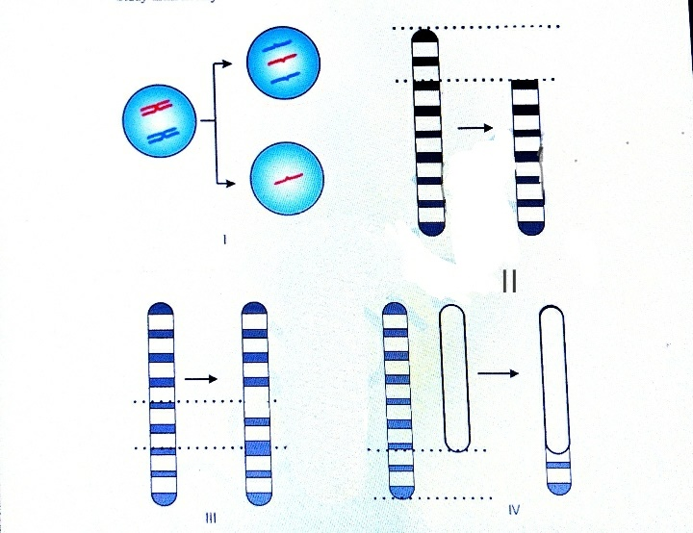

a) Identify the types of chromosome mutations illustrated. (4 marks)

Illustration Name of mutation
I
II
III
IV

b) State the effect of the mutation illustrated in III. (1 mark)

c) In most cases, the mutation in II could be lethal. Explain. (2 marks)

d) During which stage of mitosis does the mutation in I above occur? (1 mark)

e) i) Define a mutation (1 mark)

ii) Give two possible environmental mutagens. (2marks)

- The diagrams below represent body parts of some organisms (animals). Study them and answer the question that follow

- (i) Suggest the type of food eaten by organisms with the parts labeled A, B, C and F
Food Reason
A

B

C

F (4mks)
(ii) With reasons, suggest the likely habitat of the organism from which the parts labeled D and E were obtained
Part Habitat Reason
D

E

(4mks)

- (i) Suggest the type of evolution that is exemplified by the organisms labeled D, E and F. Give reason for your answer
The type of evolution (2mks)

Reason

(ii) Suggest the significance of the above named type of evolution for the organism (1mk)

- (i) Explain briefly the meaning of analogous structures (1mk)

(ii) Give one example of analogous structure (1mk)

