Name____________________________________________________ Index No. ______________
Candidate’s signature ______
Date __________________
TEACHER.CO.KE SERIES 9

232/3
PHYSICS
PAPER 3
PRACTICAL

2 ½ HOURS

INSTRUCTIONS TO CANDIDATES
- Answer all the questions in the spaces provided in the question paper
- You are supposed to spend the first 15 minutes of the 2 ½ hours allowed for this paper reading the whole paper carefully before commencing your work.
- Marks are awarded for a clear record of the observations made, their suitability then accuracy and for the use made of them
- Candidates are advised to record their readings as soon as they are made
- Mathematical tables and electronic calculators may be used.

FOR EXAMINER’S USE ONLY
Question |  | Question 2 |  | Total
Max score |  | Max score
Candidate score |  | Candidate score

1. You are provided with the following
- A spiral spring
- A retort stand, boss and clamp
- 6 masses of 100g each
- A stop watch
- A vernier calipers
(a) Measure the length and the diameter of the spiral spring provided.

(i) Length _______________________ cm (1mk)

(ii) Diameter _____________________ cm (1mk)

(b) (i) Attach the spiral spring on the stand and clamp as shown in the figure below

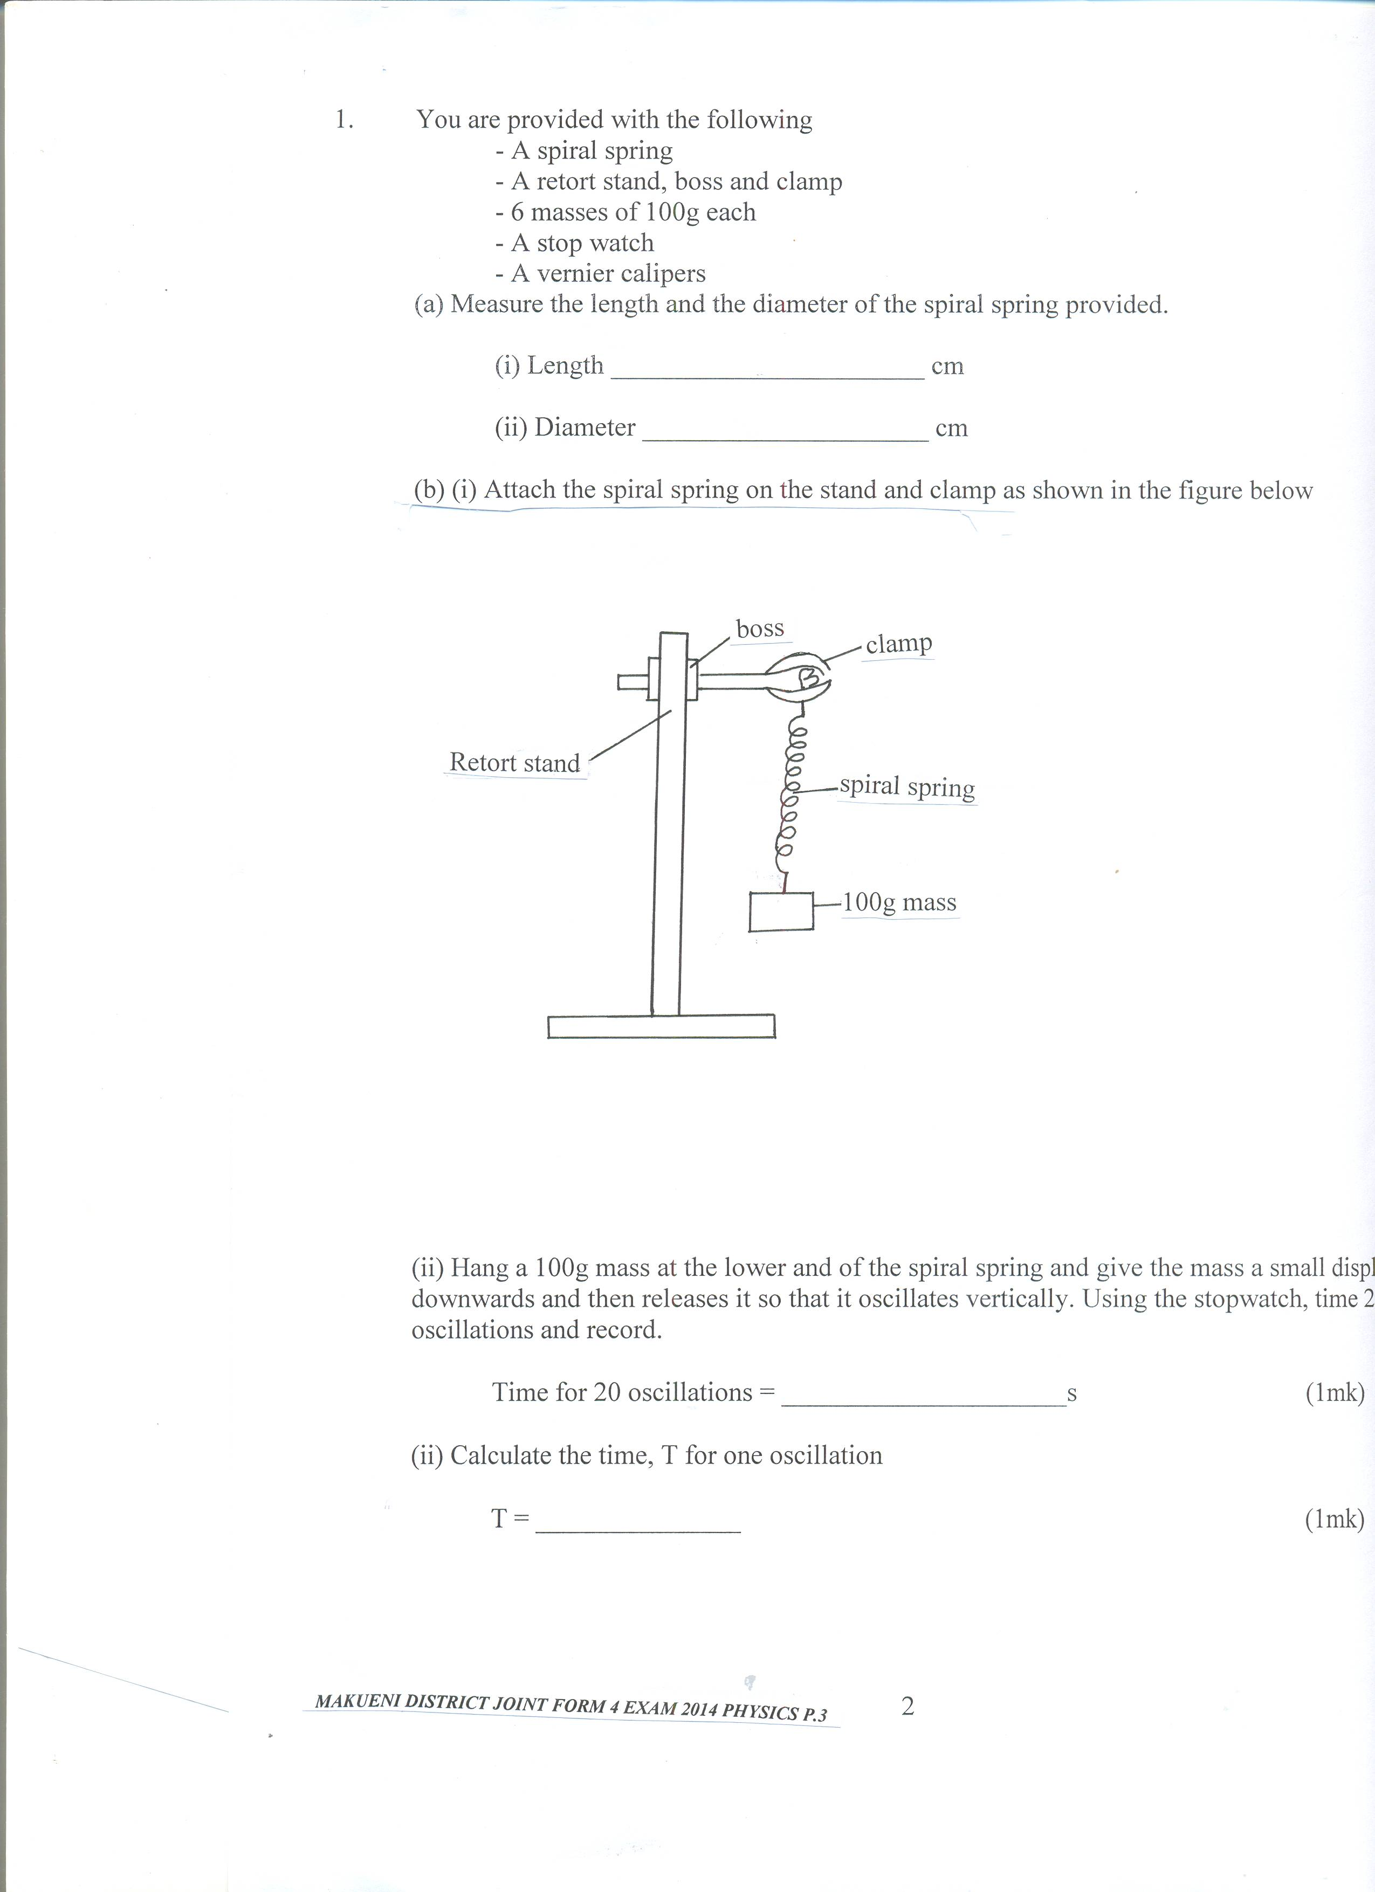

(ii) Hang a 100g mass at the lower and of the spiral spring and give the mass a small displacement downwards and then releases it so that it oscillates vertically. Using the stopwatch, time 20 oscillations and record.

Time for 20 oscillations = _____________________s (1mk)

(ii) Calculate the time, T for one oscillation

T = _______________ (1mk)

2
(v) Repeat the same procedure using different masses as in the table below. Fill the table.
Maas, M(kg) | Time for 20 oscillations (s) | Periodic time T (s) | T²(S²)
0.1
0.2
0.3
0.4
0.5
0.6
(6mks)
I (i) On the grid provided plot a graph of T² against M. (5mks)

(ii) Determine the slope of the graph (2mks)

(d) Given that T² = 4π²Mn and that n = 0.3m/kg. Find the value of g. (3mks)
g

2. PART 1
You are provided with the following
- Two dry cells
- One ammeter
- One voltmeter
- A variable resistor
- A switch
- 6 connecting wires
Proceed as follows:
(a) Set up the apparatus provided as in the diagram below.

A
S

V

3

(b) Close the switch and adjust the variable resistor until the voltmeter reads 2.9V. Record this value of voltage V and the corresponding value of current I in the table below.

V (V) | 2.9 | 2.8 | 2.7 | 2.6 | 2.5 | 2.4 | 2.2
I A

(c) Repeat the procedure (b) above for the other values of V and complete the table.
(d) Plot a graph of V(axis) against I. (5mks)
(e) From the graph determine the emf, E and internal resistance, r of the battery given that
E = V + rI

E (1mk)

r (3mks)

PART 2
You are provided with the following
- A candle
- A lens and a lens holder
- A screen
- A metre rule
- A match box (can be shared)

- Set up the apparatus as shown below.

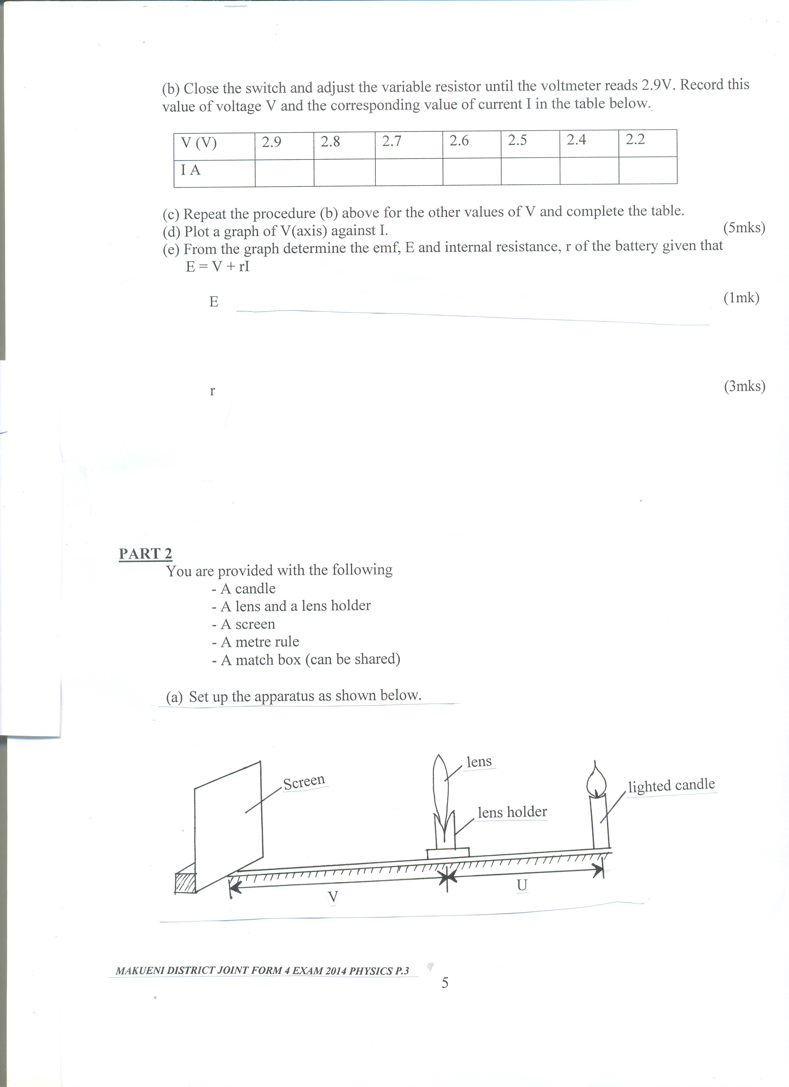

4
Ensure that the candle flame and the centre of the lens lie in a horizontal straight line.

(b) Place the lens so that it is 40cm from the candle (u = 40cm). Adjust the position of the screen until a sharp image of the candle is obtained on the screen. Measure the distance V between the lens and the screen. Record in the table.

U (cm) | 40 | 45 | 50
V (cm)
M = ^{V}/_{U}

(c) Repeat (b) above the values of V in the table and record your results. (3mks)
(d) (i) Given that f = V
M + 1 , where f is the focal length of the lens, use the results in the table above to determine the average value of f . (3mks)

5

