Name…………………………………………………………………………… Index No……………..
School………………………………………………………………………….. Date………………….
Candidate’s signature…………………………………..
TEACHER.CO.KE SERIES 35
232/3
PHYSICS
PAPER 3
(PRACTICALS)

INSTRUCTIONS TO THE CANDIDATES:

-Write your name and index number in the spaces provided above.
-Sign and write the date of the examination in the spaces provided above.
-You are advised to spend the first 15 minutes of the 2 ½ hours given reading the entire question paper.
-Marks are given for clear record of observations actually made for their suitability and accuracy for the use of them.

For Examiners’ Use Only

 | A | B | C | D | E | Total
Max Score | 1 | 7 | 7 | 4 | 1 | 20
Candidate’s Score

 | A | B | C | D | PART B | Total
Max Score | 1 | 11 | 2 | 2 | 4 | 20
Candidate’s Score

GRAND TOTAL

This paper consists of 12 Printed pages. Candidates should check to ascertain that all pages are printed as indicated and that no questions are missing.
QUESTION 1
You are provided with the following:
- a 30 cm rular
- an optical pin.
- A cork
- Stop watch / clock
- One complete retort stand.
- a circular cardboard.
Proceed as follows:
a) Measure the radius, r of the cardboard provided and record this value (Use your ruler)
Radius, r = …………………………………………………………M ( 1mk)

b) Arrange the apparatus as shown in fig. (i) below.
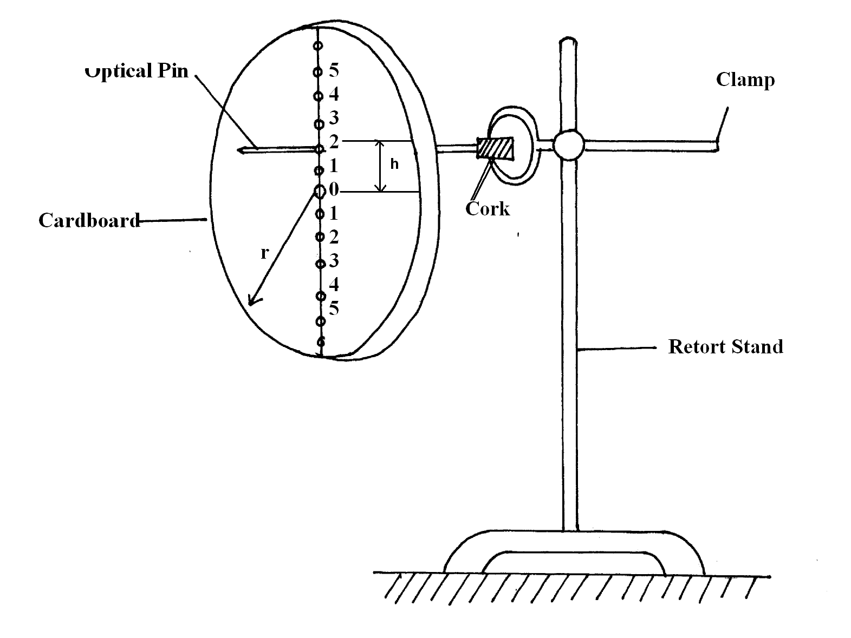
The holes 0 to 8 are spread at distance of 1 cm from each other. Set the cardboard into oscillation of small amplitude in it’s plane starting from hole1 and record time t for 10 oscillations, for each hole ( 1-8). H is the distance of each hole from the central hole O. For accurate results suspend the cord again from the corresponding opposite hole and record the average valve for t in the table below.

H (m)
Time t for 10 Oscillations (s)
Periodic Time, (T) (s)

T² (S²)

T²h(S²m) x 10 ⁻³

h² (m²) x 10 ⁻⁴

Note: that the values of T²h and h² are recorded. In the table raised to 10⁻³ and 10⁻⁴ respectively.
c) i) Plot a graph of T²h ( vertical axis) against h². (5mks)

ii) Determine the slope of your graph. (2mks)
d) Given that the equation for the period of Oscillations is given by:
T²h ⁼
Determine using your graph the:
i) Value of p ( 2mks)
ii) Value of R ( 2mks)

e) Hence determine the value of G where:
G = (1mk)
QUESTION 2
PART A (16 MARKS)
You are provided with the following
A micrometer screw gauge ( to be Shared)
A voltmeter ( 0 – 3 or 0 -5 v)
Ammeter ( 0 -1A)
Nichrome wire mounted on a mm scale, AB.
A switch.
A jockey / long wire with crocodile clip attached.
One dry cell.
8 new connecting wires with clips attached to one end.

Proceed as follows:
a) Set up the circuit below. ensure that when the switch is open, both meters read zero. Keep the switch open when readings are not being taken.
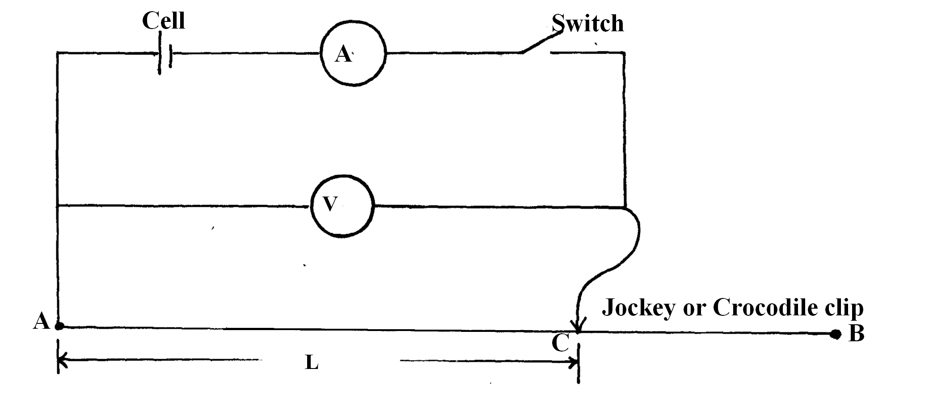

i) Measure and record the diameter d of the nichrome wire AB Using the micrometer screw gauge.
d = …………………………………………………………m ( ½ mk)

ii) Disconnect the jockey from wire AB and close the switch. Record the value E of the voltmeter reading.
E = ……………………………………………………………( ½ mks)
b) Now, connect the Jockey on AB at a distance L = 2.5 cm. Close the switch and record the voltmeter and ammeter readings, V and I respectively in the table below.
L (cm) | 2.5 | 5.0 | 7.5 | 10 | 15 | 18 | 20 | 30 | 40 | 50
P.d V ( Volts)
Current, I ( A)
IV ( Watts)

i) Complete the table for values of IV.
ii) Plot a graph of IV ( Vertical axis) against L. (5mks)

iii) Using your graph, Find the value L0 where your graph cuts, the horizontal axis.
L₀ =…………………………………………………….m (1mk)

C) i) Now, place the jockey on wire AB such that length L is equal to the value of L₀ Obtained in (iii) above. Close the switch and record both the voltmeter reading, V and the ammeter reading I.
V = …………………………………………………………………………….( ½ mk)
I = ……………………………………………………………………………..( ½ mk)

ii) Work out the value r where:
r = ( 1mk)

d) Work out the value of e where
e = (2mks)
PART B
You are provided with the following requirements.
A Candle
A white screen
A metre rule
A concave mirror
Procedure

a) Arrange the apparatus as shown
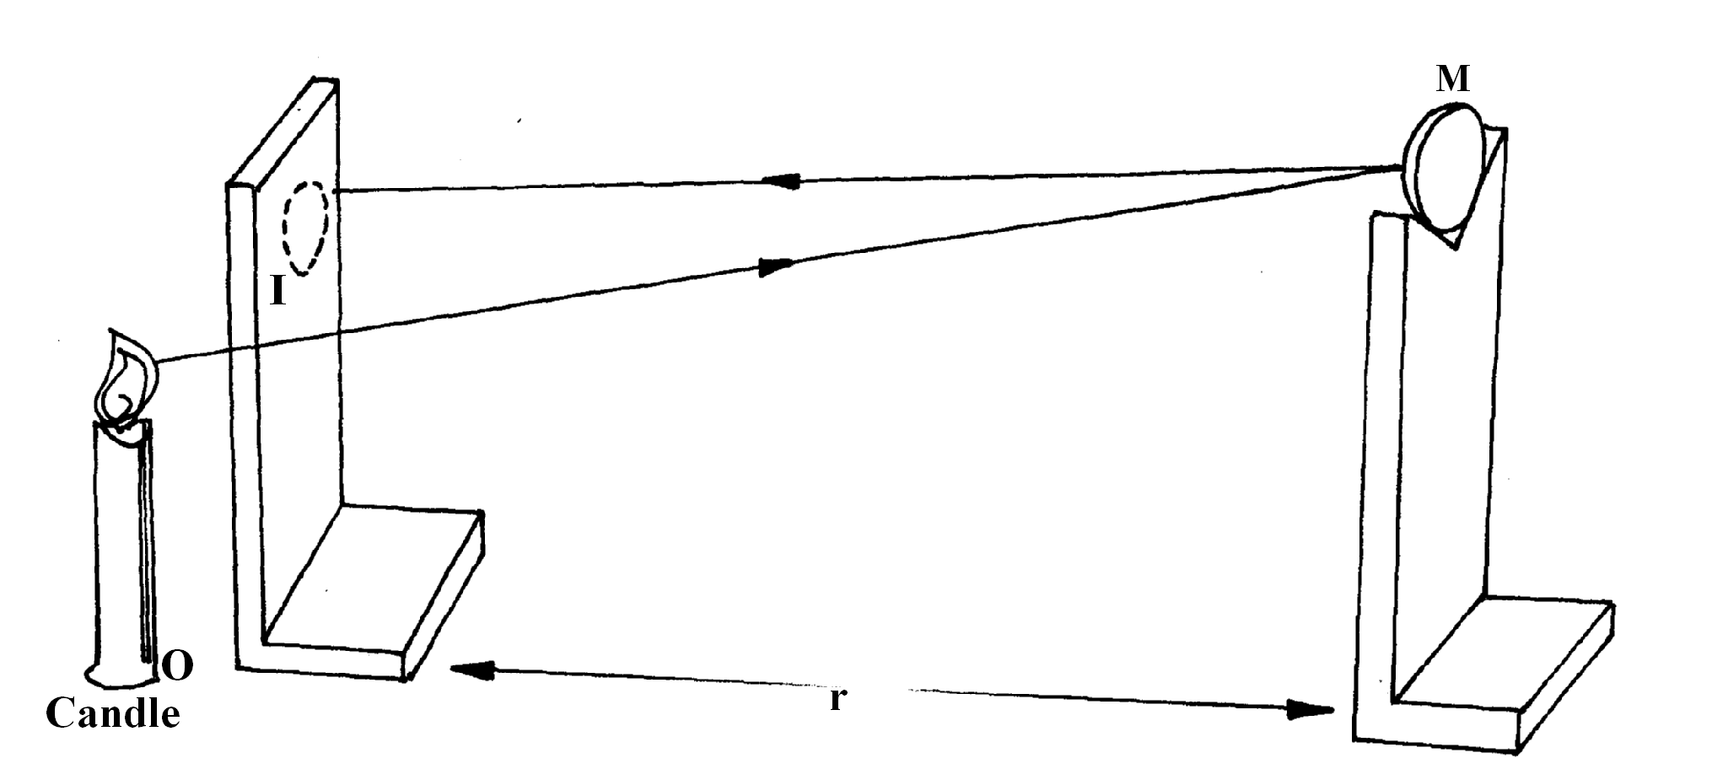
NB: Ensure that the candle and the screen are placed exactly at the same mark on the metre rule.

b) Support a concave mirror m in front of the screen so that an image, I, of the object, O, is seen on the screen.

c) Move the mirror towards and away from the screen until
A sharp image is formed on the screen. Make sure that the size of the image, I, is the same as that the object, O.

d) Measure the distance MI.
MI = ………………………………………………………………………………………(1mk)

e) What does MI in (d) above represent? (1mk)

f) Find the value of Q where
Q = ( 2mk)
PART B ( 4MKS)
You are provided with the following.
Metre rule
A conves lens
A lens holder
A candle
A white screen.
a) Set up your apparatus as shown below:
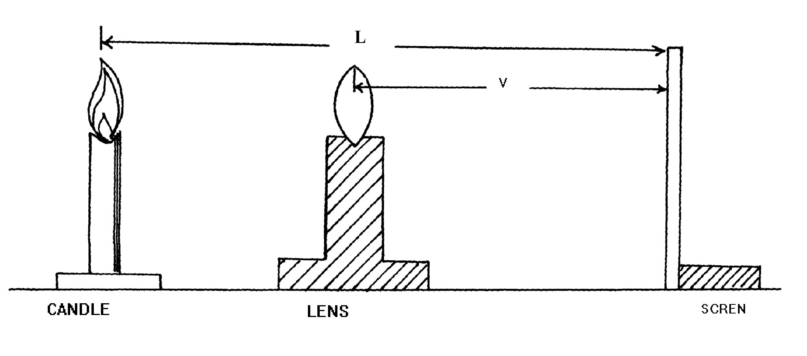
b) Place the candle at a distance L = 80 cm from the screen,
Move the lens Away from the candle until a sharp image of the candle is seen on the screen. Measure the distance V between the screen and the lens
V₁ = ……………………………………………………………( 1mk)
c) Repeat steps (a) and b) above but this time, move the lens towards the candle and measure the distance V₂ between the screen and the lens.
V₂ = ………………………………………………………………….(1mk)
d) i) Determine the focal length of the lens from:
f = L² – ( V₂ – V₁₎² ( 2mks)
4 L
End

