NAME: …………………………………………………….…………… INDEX NO. ……..……………
SCHOOL: ………………………………….………………………….. DATE:…………………………
CANDIDATE’S SIGN. …………………………………………...........
TEACHER.CO.KE SERIES 34
232/3
PHYSICS
PAPER 3

INSTRUCTIONS TO CANDIDATES:
- Write your name and index number in the spaces provided above.
- Sign and write the date of the examination in the spaces provided above.
- You are supposed to spend the first 15 minutes of the 2 ½ hours allowed for this paper reading the whole paper carefully.
- Marks are given for a clear record of the observations actually made, their suitability, accuracy and the use made of them.

For Examiners’ Use Only
Question 1
PART | A |  |  |  |  | B
Marks Score | b | c | e | f | g | h | i
 | 1 | 1 | 5 | 5 | 3 | 2 | 3
Candidate’s score
Question 2
PART | A |  |  | B
Marks Score | a | b | c | d | e(i) | e(ii) | e (iii) | e (iv) | f
 | 1 | 1 | 1 | 1 | 5 | 5 | 3 | 2 | 1
Candidate’s score

This paper consists of 8 printed pages. Candidates should check to ascertain that all pages are printed as indicated and that no questions are missing.

1. This question consists of two parts A and B attempt both parts
PART A
You are provided with the following:
- two pieces of wooden blocks
- a retort stand, boss and clamp
- a glass marble
- a piece of cotton thread
- a square piece of polythene paper
- a half-metre rule
- a 20 grammes metal mass
- some water
- a 250 ml beaker
- some tissue paper
Proceed as follows:
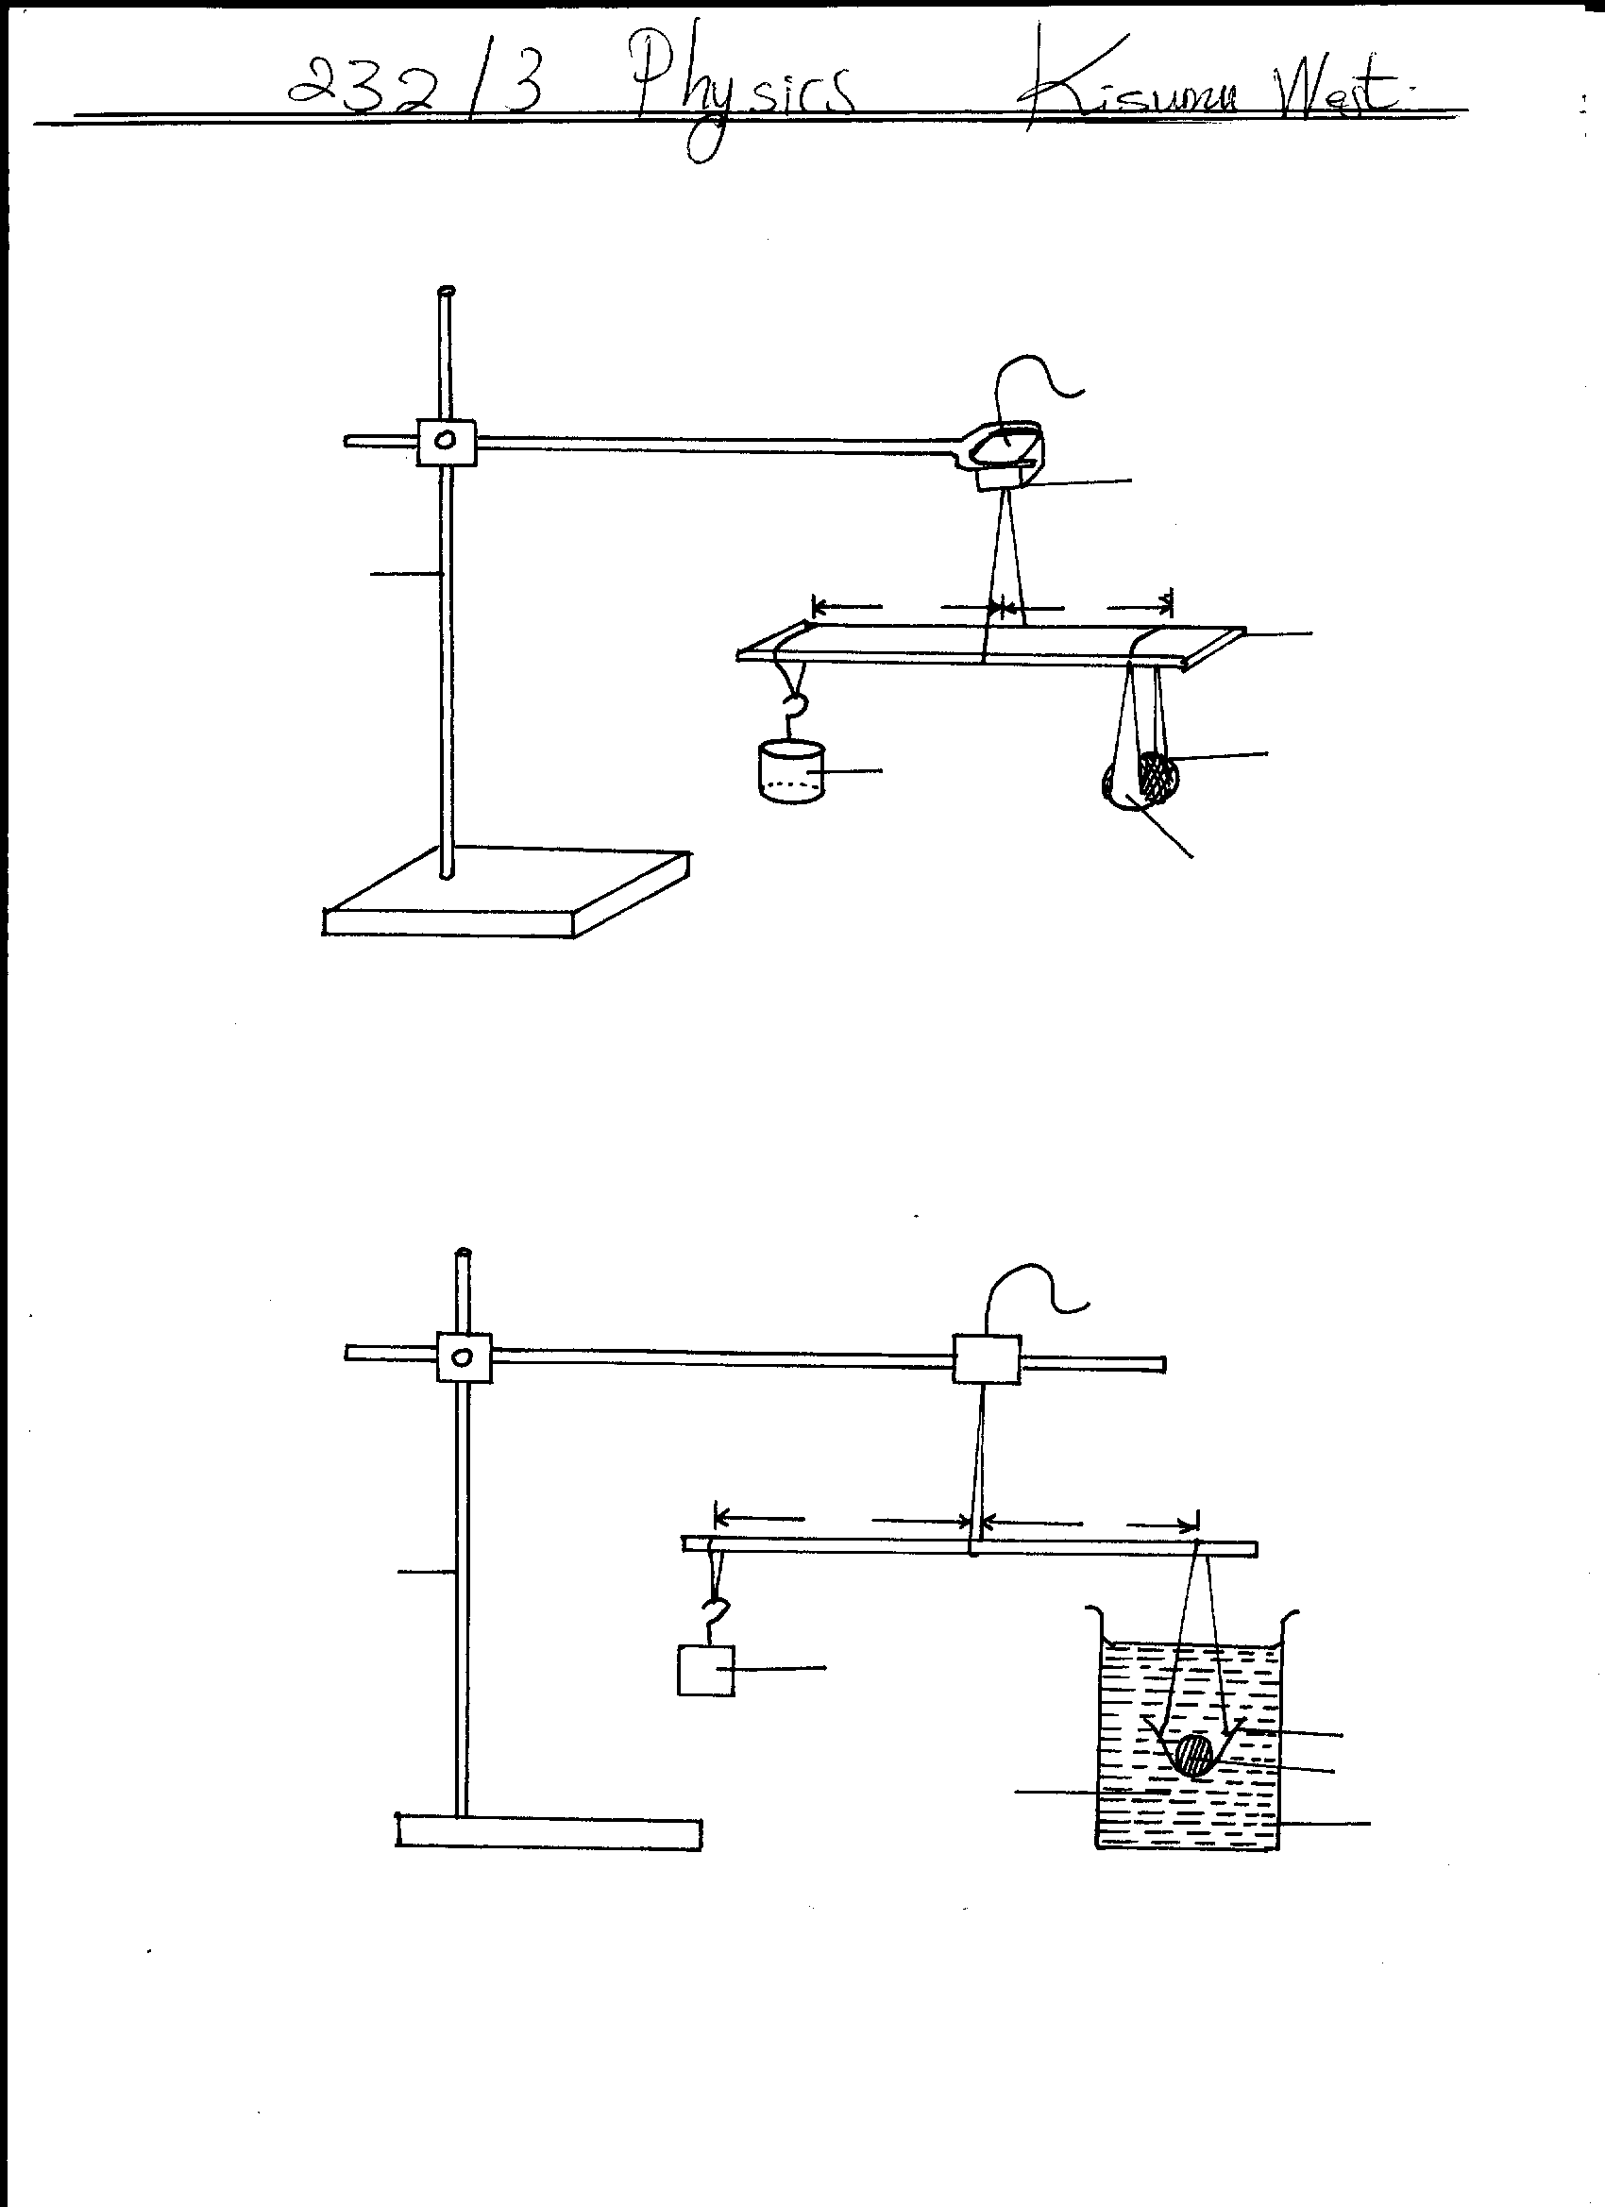
(a) Cut two pieces of cotton thread measuring 60cm and 30cm respectively. Use the threads to make two loops. Suspend the half-metre rule freely at its centre of gravity, P using the longer loop.

Fig. 1(b)

(b) Suspend the glass marble using threads and the square polythene paper at a distance X₀ = 15cm from the point of suspension, P. Also use the shorter thread loop to suspend the 20g metal mass on the opposite side and adjust its position till the half-metre rule is horizontal as in figure 1(a) above. Record the corresponding distance X₁ of the 20g mass from P

X₁ = ……………………………………………….cm (1mk)

(c) Fill the beaker with water up to about three quarters capacity. Maintain the distance X₀ invariant as you immerse the glass marble in water and slide the thread holding the 20g metal mass, till the half-metre rule is horizontal again. Note the new corresponding distance X₂
(i.e distance between point of suspension of 20g mass and P)
X₂ = ………………………………………… cm (1mk)

(d) Repeat the procedure in (b) and (c) for increased values of X₀ as given in table 1 below.
NB:- After every attempt, wipe the polythene paper and marble dry with the tissue paper provided.
- Ensure this experiment is done in a draught free area.
(e) Complete the table 1 (5mks)
Table 1
Distance of marble in air X₀ (cm) | 15 | 17 | 19 | 21 | 23 | 24.5
Distance of 20g metal mass, X₁ (cm)
Distance of 20g metal mass, X₂ (cm)
When marble is in water
X₁ - X₂ (cm)

(f) On the grid provided, plot a graph of X₁ – X₂ (y-axis) against X₁ (5mks)

(g) Determine the slopes, S of the graph (3mks)

PART B
You are provided with the following:
- vernier callipers
- glass marble
Proceed as follows
- Using the vernier callipers, measure the diameter of the glass marble
1st attempt; diameter D₁ = …………………………………cm
2nd attempt (after spinning the glass marble)
Diameter D₂ = ……………………………… cm (1mk)

Determine the value of D in the expression:
D = D₁ + D₂
2
= …………………………………….cm (1mk)

(i) Find the volume of the glass marble in m³
Volume = ………………………………………………………………. (3mks)

This question consists of two parts; A and B
Attempt both parts and attach the two plain papers used in this question
2. PART A
You are provided with the following:
- a soft board
- a white plain paper
- Four (4) optical pins
- a mounted plane mirror labeled XY
- Some plasticine (or 4 drawing pins)

Figure 2(b)
Figure 2(a)

∝

Proceed as follows:
(a) Use small lumps of plasticine (or drawing pins) to stick the white plain-paper provided onto the soft
board and draw a straight line MN on the paper.
- Draw another straight line M’N’ which intercepts the line MN at point O.
- The two lines MN and M’N’ make a vertical acute angle of 25⁰ with each other at O
- Draw a third line OT which makes an angle of 40⁰ with OM’. Fix two pins; P₁ and P₂ along the
line OT. OT is representing the approaching ray of light. See figure 2(a) (1mk)
(b) Place the plane mirror XY lengthwise along line MN. Fix pins P₃ and P₄ in line with the images of P₁
and P₂ as they appear through the mirror.
- Remove the pins P₃ and P₄, then draw line OP₃P₄.
- Line OP₃P₄ is representing the reflected ray of light. (1mk)
(c) (i) Rotate the plane mirror XY through the angle of 25⁰ about point O such that it lies along the line
M’N’.
- Using two pins again, repeat step (b) above to obtain the new position of the reflected ray. Label
the marks of the two pins P₅ and P₆ respectively.
- Line OP₅P₆ is representing a new position of the reflected ray after rotation.
See figure 2 (b).
(ii) Measure the size of a cute angle ∝ between the lines OP₃P₄ and OP₅P₆
Angle ∝ = ………………………………………………………………… (1mk)
PART B
You are provided with the following:
- a soft board
- a white plain paper
- 4 optical pins
- 4 drawing pins or (some plasticine)
- a mounted plane mirror labelled XY

(d) (i) Proceed as follows

Use small lumps of plasticine (or drawing pins) to stick the white plain paper onto the soft board. (Use the second paper provided).
- Draw a straight line MN
- Draw another straight line ON which is perpendicular to MN at O. Line ON is representing the normal, see figure 3 above.
Draw a third line OT which intercepts MN at O and makes acute angle Ө₁ = 10⁰ with the normal to the left.
Fix pins P₁ and P₂ onto line OT. Line OT is representing the approaching ray of light.
Measure the acute angle Ө₁ = 10⁰ between the approaching ray and the normal.
- Place the plane mirror XY lengthwise along the line MN and observe from the opposite side of the normal to locate the images of P₁ and P₂ as they appear in the mirror
- Fix pins P₃ and P₄ such that they are in line with the images of P₁ and P₂ as they appear in the mirror.
(ii) Remove the mirror, join P₃ and P₄ and produce it to meet at O so as to obtain the reflected ray.
Measure angle Ө₂, the angle between the normal, PO and OP₃P₄
Angle Ө₂ = …………………………………………………………………….. (1mk)
- Repeat step (d) above for the values of Ө₁ given in table 2.
i) Complete table 2
Table 2 (5mks)
Ө₁ | 10 | 20 | 30 | 40 | 45 | 55
Ө₂
Cos Ө₁
Cos Ө₂

(ii) Plot a graph of cos Ө₂ (y-axis) against cos Ө₁ (5mks)

(iii) Determine the slope S of the graph in e(ii) above. (3mks)

(iv) Find the value of Φ in the expression 27 = Φ (2mks)
S

- State the physical law that is verified by the results of question 2 part B. (1mk)

