Name: …………………………………………………………… Index No. …………………………
School: …………………………………………………………. Candidate’s Sign. …………............
Date: ………………………………............................................

232/3
PHYSICS
PAPER 3

Physics
Practical

INSTRUCTIONS TO THE CANDIDATES:

- Write your name and index number in the spaces provided above.
- Sign and write the date of the examination in the spaces provided above.
- You are supposed to spend the first 15 minutes of the 2 ½ hours allowed for this paper reading the whole paper carefully.
- Marks are given for a clear record of the observation actually made, their suitability, accuracy and the use made of them.

For Examiners’ Use Only
 | Maximum marks | Candidates score
Question 1 | 20
Question 2 | 20
Total score | 40

This paper consists of 4 printed pages. Candidates should check to ascertain that all pages are printed as indicated and that no questions are missing.

1. You are provided with the following:
- a metre rule;
- vernier callipers;
- A 300gmass;
- two knife edges;
- some thread.
Proceed as follows:
- Place the metre rule on the knife edges such that each knife edge is 45 cm from the 50 cm mark
(centre of the rule). See figure 1. Ensure that the millimetre scale of the metre rule is facing upwards.
The distance L between the knife edges is now 900 mm.
Place the vernier callipers vertically against the metre rule at the 50 cm mark with the depth gauge
lowered to touch the bench as shown in figure 1.
Record the height h₀, of the upper edge of the metre rule at the 50 cm mark.
(see figure 1).
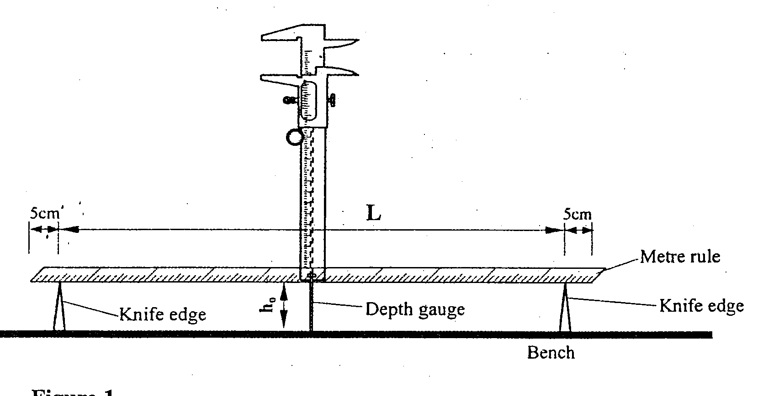
Fig 1.

h₀ = ………………………………………….mm (1mk)

- Using the thread provided, hang the 300g mass at the 50 cm mark of the metre rule. Ensure that the
mass does not touch the bench. Measure and record in table 1, the height h of the edge of the metre
rule at the 50 cm mark.

- With the 300g mass still at the 50 cm mark, adjust the position of the knife edges so that L is now
800 mm. (The knife edges should be equidistant from the centre of the metre rule). Measure and
record in table 1 the height h of the edge of the metre rule at the 50 cm mark.

(d) Repeat the procedure in (c) for other values of L shown in table 1. Complete the table.
Table 1
Length L (mm) | 900 | 800 | 700 | 600 | 500
Height h (mm)
Depression d(h_{o}-h)mm

(e) Plot a graph of L (y-axis) against d. (5mks)

(f) (i) Determine the slopes of the graph. (3mks)
……………………………………………………………………………………………………………
……………………………………………………………………………………………………………
……………………………………………………………………………………………………………

(ii) Evaluate y = 1
s
Y =………………………… (2mks)

(iii) Determine G, the value of log L, when d =0. (2 mks)

G =…………………………….

log k
y
(iv) Given that G= determine the value of k. (2 mks)

k………………………..

2 Part A
You are provided with the following
- A dry cell and a cell holder
- A resistor P
- A set of mounted resistors Q
- A milliameter
- Connecting wire
- A switch
Proceed as follows:
a) Set up the apparatus as shown in the circuit diagram
P

mA

Close the switch. Measure and record the current I_{o}
I_{o} = …………………………..MA

Dismantle the set up.

b) Set up apparatus as shown in the circuit diagram in figure

Q

Each of the connecting wires from points T₁ and T₂ should have a crocodile clip at one end

c) Connect the crocodile clips across the 10Ω resistor on Q. Close the switch and record in Table 2 the
current I, through the milliameter. Open the switch.

d) Repeat the procedure in (c) for the other values of resistance R
shown in table 2 (some values of R may be obtained by combining suitable resistors on Q)
Complete the table

RΩ | 10 | 22 | 32 | 39 | 61 | 71 | 82 | 121 | 150
I(mA)
I(A)

e) Plot the graph of I (A) y-axis against R.

f) From the graph determine R_{o}, the value of R when the current I is equal to Io_{/2} (3mks)
(i.e when I = Io_{/2} )

R_{o}= ……………………………………

Part B
You are provided with the following
- Watch glass
- A class marble
- Plasticine
- Stop watch
- Micrometer screw gauge

a) Place the watch glass on a flat table and hold it firmly using plasticine.

b) Roll the marble and count five oscillations
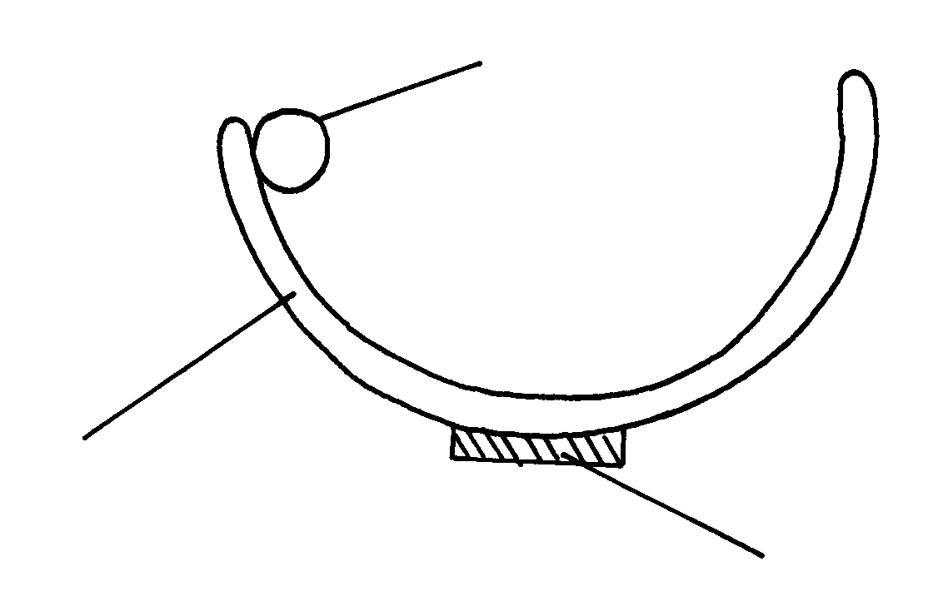

Marble

Watch glass

Plasticine

(i) Time for five Oscillations, t
t = ______________________________

(ii) Repeat three times and find the average (1mk)
t₁________________________________
t₂________________________________
t₃________________________________

(iii) Find the periodic time of the marble ( 1mk)
T_________________________

T²_________________________

(c) Measure the diameter, d of the marble using micrometer screw gauge
d____________________________ (1mk)

(d) You are given the following equation

√
T = 2π 7(b-r)
5g

Where r is the radius of the marble, g is acceleration due to gravity, b is a constant of the system.
Determine the value of b. (2mks)

