NAME………………………………………………………….. INDEX NO…………………………….

SCHOOL……………………………………………………….. CANDIDATES SIGNATURE……….

DATE…………………….……………

TEACHER.CO.KE SERIES 3
232/3
PHYSICS(PRACTICAL)
PAPER 3
TIME: 2¹/₂HOURS

INSTRUCTIONS TO CANDIDATES
-Answer ALL the questions in the spaces provided in the question paper.
-You are supposed to spend the first 15 minutes of the 2¹/₂ hours allowed for this paper reading the whole paper carefully before commencing with your work.
-Marks are given for a clear record of the observations actually made, their accuracy and suitability and the use made of them.
-Candidates are advised to record their observations as soon as they are made.
-Mathematical tables and Electronic calculators may be used.
FOR EXAMINER’S USE ONLY
Question | Maximum score | Candidate’s score
1 | 20
2 | 20
Total | 40

- You are provided with the following apparatus :
-Resistance wire mounted on a scale labelled MN
-Switch
-Voltmeter
-Ammeter
-Two dry cells in a cell holder
- Seven connecting wires

i) Set up the apparatus as shown in the figure below:
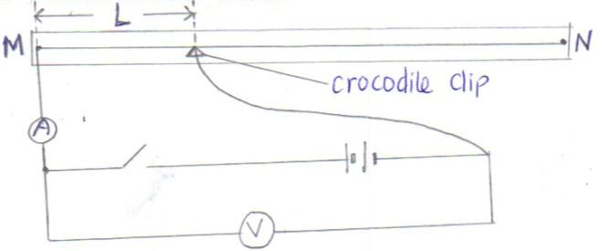

ii) Remove the crocodile clip from the resistance wire MN and close the switch. Record the voltmeter reading.
Y = ……………………………V (1mk)
iii) Attach the crocodile clip to the resistance wire such that L =10cm.
iv) Record the voltmeter and the ammeter readings in table 1.
v)Repeat procedures (iii) and (iv) for L=20cm , 30cm, 40cm, 50cm, 60cm, 70cm, and 80cm .

vi) Complete table 1

Table 1
Length (cm) | 10 | 20 | 30 | 40 | 50 | 60 | 70 | 80
Current I(A)
p.d. (V)

Y-V(v)

$$\frac{V}{\left(Y-V\right)}(V)$$

R=$\frac{V}{I}$ ( Ω)

(9mks)

vii) a) Plot a graph of $\frac{V}{Y-V}$(y-axis) against R. (5mks)

b) Determine the slope of your graph. (3mks)

c)Given that the law relating V, Y and R is
$\frac{V}{Y-V}$ =$\frac{MR}{5}$+ d,determine the values of M and d. (3mks)

2)You are provided with the following:
- A glass block
-soft board
-a plane paper
-four optical pins
-four paper pins
- a protractor
- a 30cm plastic ruler
a)Fix the plane paper on the soft board using the four paperpins .
b)Place the glass block on the plane paper. Let the glass block rest on the paper from the broader face.
c)Trace the glass block using a pencil
d) Remove the glass block.
Mark a point X on one of the longer side of the traced glass block as shown in figure 2. Point X should be 2cm from edge A.

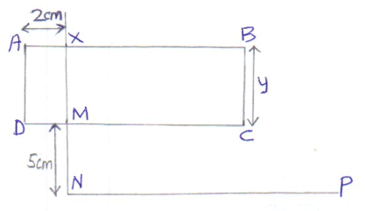

e)Construct a normal at X to emerge through line DC. Let this normal meet line DC at point M.
f)Mark point N along the emergent normal 5cm from M.
g)Construct the line NP to meet the normal at N at 90⁰. Line NP can be about 10cm.
h)Using a protractor, construct an incident ray RX at an angle of incidence = 10⁰. Fix two pins P₁ and P₂ along RX.
i)Replace the glass block to the traced figure.
j)View the path of the incident ray RX through the glass block using the other two pins P₃ and P₄. This can be done by ensuring that the images of P₁ and P₂ are in a straight line with the pins P₃ and P₄.
k)Remove the glass block and draw the emergent ray through P₃ and P₄.
l)Measure the distance,d of the emergent ray from point N along line NP as shown in figure 3.
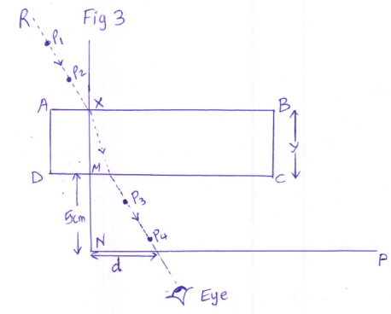
m)Record the corresponding values of d in table 2
Table 2
Angle of incidence i | 10⁰ | 20⁰ | 30⁰ | 40⁰ | 50⁰ | 60⁰
Distance ,d (cm)
Sin i

Sin² i

n)Repeat the procedure for other values of i. (12mks)
o)Plot a graph of sin² i (y-axis) against d (5mks)
p)Calculate the gradient of the graph. (3mks)

