Name: ………………………………………………………………… Admission No: ……………………...................

Date: ……………….…………..…................................................. Candidate’s Signature:…………………………….

TEACHER.CO.KE SERIES 25

232/3
PHYSICS
Paper 3 (Practical)
Time: 2 ½ Hours

Kenya Certificate of Secondary Education (K.C.S.E)
Physics
Paper 3

INSTRUCTIONS TO THE CANDIDATES:
- Write your name and index number in the spaces provided above.
- Sign and write the date of the examination in the spaces provided above.
- You are supposed to spend the first 15 minutes of the 2 ½ hours allowed for this paper reading the whole paper carefully.
- Marks are given for a clear record of the observation actually made, their suitability, accuracy and the use made of them
.

FOR EXAMINER’S USE ONLY

Question | Maximum Score | Candidate’s Score
1 | 20
2 | 20
TOTAL | 40

This paper consists of 7 printed pages. Candidates should check to ascertain that all pages are printed as indicated and that no questions are missing.
QUESTION ONE
You are provided with the following;
- A 40ml glass beaker
- A Bunsen burner
- A thermometer
- A stop watch
- A tripod stand and a measuring cylinder 100ml
- A wire gauze
- A source of heat
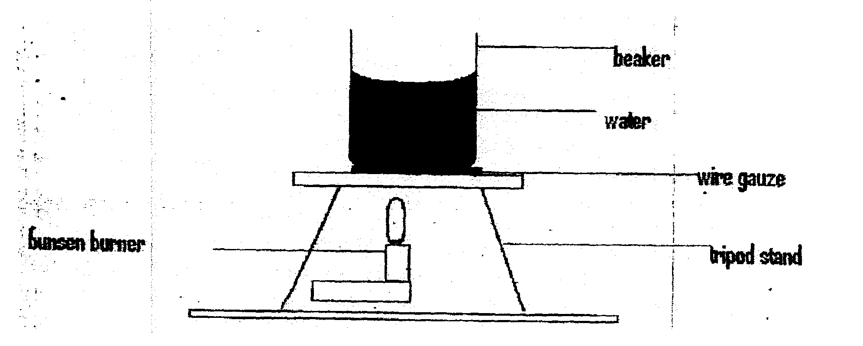
Set up the apparatus as shown in the diagram below.
Beaker
Water
Wire gauze
Tripod stand
Burnsen burner

Measure 100cm³ of water and pour it into the beaker. Take the initial temperature of the water.
T₀…………………………………………….. (1 mark)

Now heat the water to a temperate of 90°C. Switch off the gas tap and place a thermometer into the beaker and start the stop watch when the temperature is 65ºC. Take the temperature T°C of water every two minutes.

Record your results in the table below.

Time (t) (min) | 2 | 4 | 6 | 8 | 10 | 12 | 14
Temperature (T) ºC
(T-T₀)⁰
Log (T-T₀)

(i) Plot a graph of Log (T - To) against Time (t). (5mks)

(ii) Find the value K of log(T — To) when t =0 (2mks)
……………………………………………………………………………………………………….
……………………………………………………………………………………………………….
Determine the antilog of K. (2mks)
……………………………………………………………………………………………………….
……………………………………………………………………………………………………….

(iii)Calculate the temperature of the surrounding T_{R} using the expression
Antilog K =65 - T_{R}. (3mks)

QUESTION TWO
This question has two parts A and B. answer both parts.

PART A

You are provided with the following:
- A meter rule
- Two identical l00g masses
- About 200m1 of liquid L in 250m1 beaker
- Three pieces of thread, each about half metre long
- Stand with clamps
- Tissue paper.

Proceed as follows:
(a) Using a stand and one piece of thread, suspend the metre rule in air such that it balances
horizoally. Record the position of the centre of gravity. G.

G=_________________________________mm

NOTE: The mere rule should remain suspended at this point through out the experiment.

(b) Set up the apparatus as in figure 2 below.
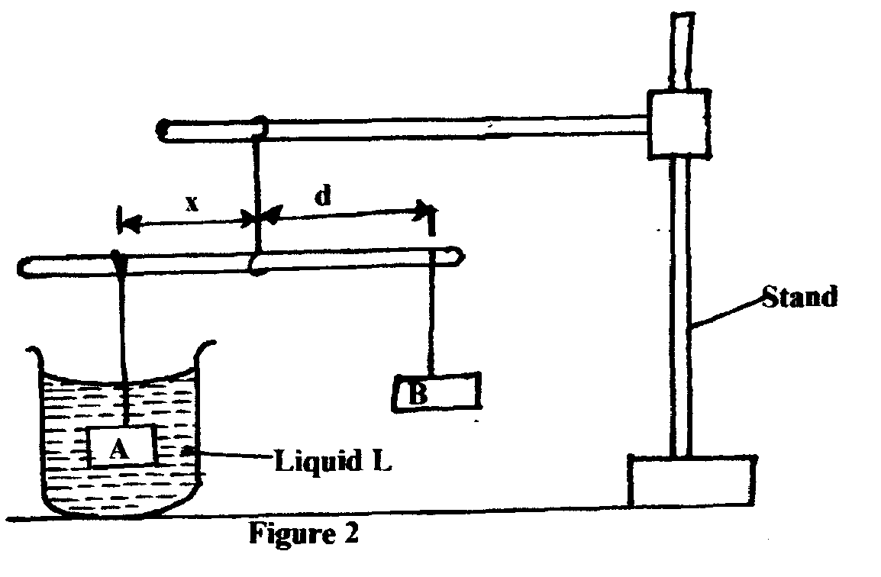

Liguid L
Stand
Figure 2

Suspend the mass A at a distance x = 50mm. Adjust the position of mass B until it balances mass
A immersed in liquid L.
Record the distance d, of mass B from the pivot.

Repeat the same process for other values of x in table 2 below and
complete the table.
x(mm) | 50 | 100 | 150 | 200 | 250 | 300
d(cm)
(3 mks)

(c) Plot a graph of d (y axis) against x. (5mks)

(d) Determine the slope, S of the graph. (2mks)
……………………………………………………………………………………………………….
……………………………………………………………………………………………………….
(e) Given $S=\frac{F}{W}$ , where F is the apparent weight of object A in the liquid L and W is the actual

weight of A, find:

(i) The value of F (2mks)
……………………………………………………………………………………………………….
……………………………………………………………………………………………………….
(ii) The up thrust U, Using the equation U= W-F. (3mks)
……………………………………………………………………………………………………….
……………………………………………………………………………………………………….
PART B

You are provided with the following:

- A concave mirror with holder
- A screen
- A meter rule
- A candle
- A match box (to be shared)

Proceed as follow:
(f) Set up the apparatus as in figure 3 below.
Candle
Screen
Mirror
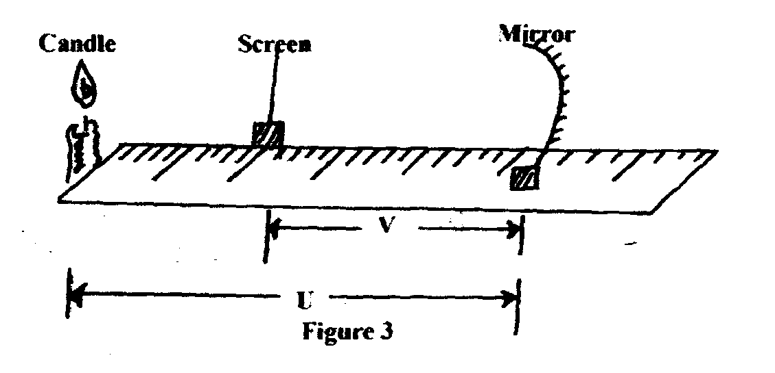
Figure 3
U

(g) Put the object at a distance u = 30cm from the mirror. Adjust the position of the screen until a
sharp image is formed on the screen. Record the distance V.

(h) Repeat procedure (b) above for the distance u = 40cm and record the new distance V. complete the table 3 below.
U(cm) | V(cm) | m=^{V}/_{U} | (m+1)
30

40

(i) Given $f=\frac{V}{(m+1)}$ , calculate the values of f hence determine the average value f_{av} (3mks)

……………………………………………………………………………………………………….
……………………………………………………………………………………………………….
……………………………………………………………………………………………………….

