Name: …………………………………………………………… Index No. …………………………
School: …………………………………………………………. Candidate’s Sign. …………............
Date: ………………………………............................................
TEACHER.CO.KE SERIES 23

232/3
PHYSICS
PAPER 3
TIME: 2 ½ HOURS

Kenya Certificate of Secondary Education (K.C.S.E.)

INSTRUCTIONS TO THE CANDIDATES:

- Write your name and index number in the spaces provided above.
- Sign and write the date of the examination in the spaces provided above.
- You are supposed to spend the first 15 minutes of the 2 ½ hours allowed for this paper reading the whole paper carefully.
- Marks are given for a clear record of the observation actually made, their suitability, accuracy and the use made of them.

For Examiners’ Use Only
Question 1
 | (b) | (d) | (e) | (f) | (g) (i) | (ii) | Total
Marks Score | 1 | 8 | 5 | 3 | 1 | 2 | 20
Candidate’s score
Question 2
Section | A |  |  |  | B
 | (a) | (b) | (c) | (e) | (d) | (e) | (f) | (g) | Total
Marks Score | 1 | 2½ | 1 | 2½ | 6 | 5 | 1 | 1 | 20
Candidate’s score

This paper consists of 4 printed pages. Candidates should check to ascertain that all pages are printed as indicated and that no questions are missing.

1. You are provided with the following apparatus;
- Two metre rules
- Two stands and two clamps
- Two bosses
- Three pieces of thread(at least 30cm each).
- One optical pin
- A piece of cello tape(and or plasticine)
- A spring
- One mass of 200g
- A stop watch
- Set the apparatus as shown in diagram I below: Attach the pin (to act as the pointer) at one end
of the metre rule using a cellotape;
Diagram 1
Spring
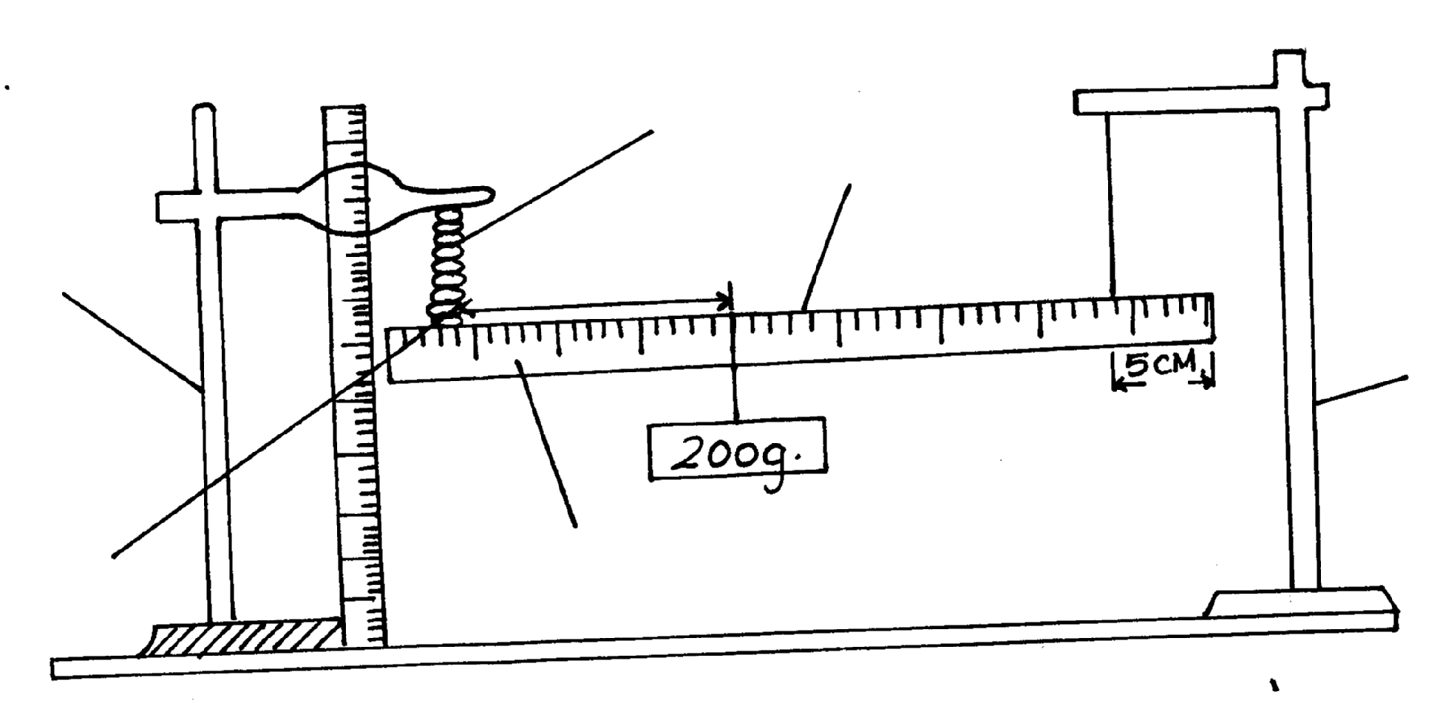
Stand

Metre rule
Stand

Optical pointer (pin)

L

b. Suspend one end of the metre rule with at 5 m mark from the end.
c. Suspend the other end with a spring also 5cm from the end so that the metre rule is horizontal.
d. Hold the other rule (with spring) vertical on the bench that it is near the end with a pointer as
shown in the diagram
e. Read the pointer position, L_{o……………………………………} cm, (1mk).
f. Hang on the horizontal meter rule, the 200g mass at a t length, L= 10cm from the spring. Record the
extension, e, of the spring In the table below.
g. Displace the mass slightly downward and released it to oscillate vertically. Take time for 20
oscillations and record in the table below,
h. Repeat for other position of L, of the mass.
N/B before taking the reading, ensure the oscillation is steady.

L (cm) | Extension e (cm) | Time(t) for 20 oscillations(s) | Periodic time,T(s) | T²(s²)
10
20
30
40
50

i. Plot a graph of extension, e, (m) (y-axis) against T²(s²) (8mks)

j. Calculate the gradient of the graphs (5mks).

k. Given that e= RT²/4π² + c, determine the value of R (3mks)

2. You are provided with the following:
- An ammeter r( 0-2.5A) ,A voltmeter(0- 3 V or 0-5V), Two dry cells (size D), A mounted resistance wire on a metre rule , Seven Connecting wires, A bulb and bulb holder
Cell holder, A switch, Jockey or crocodile clip.Micrometer screw gauge.

a. (i).Connect apparatus provided as shown in the circuit diagram blow

(ii). With the crocodile clip at P take the voltmeter reading and the ammeter reading. Record V and I.
repeat the readings for 1=80,60,40,20 and 0cm respectively. complete the table below.

Length L(cm) | 100 | 80 | 60 | 40 | 20 | 0
Voltage V (v).
Current I (A)
(4mks.)
(iii). What changes do you observe on the bulb as L decreases from P? (l mk)
…………………………………………………………………………………………………..………
……………………………………………………………………………………………………....….
(iv). Plot a graph of the ammeter reading (y-axis) against voltmeter reading, (5mks).

(v). Determine the slope of your graph V = 1 volt (3mks).

(vi). What physical quantity is represented by the slope of the graph point? (l mk).

b. (i). Given the apparatus in a (i). above, draw a diagram of the circuit you would use to determine
the current through the resistance wire and potential difference cross it. (l mk).

(ii). Set up the circuit you have drawn. Record the ammeter reading I and voltmeter reading V,
when L= 100cm. (2mrk)
V = ………………………………………………
I =…………………………………………………
(iii) Using a micrometer screwgauge, measure the diameter d of the wire (1mk).

(iv) Calculate the quality, ρ = 0.785 V d² and give its units, where L is one metre. (2mk)
I L

