231/3
BIOLOGY
PAPER 3
PRACTICAL

QUESTION 2. PHOTOGRAPHS

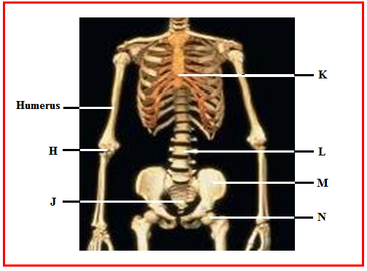

QUESTION 3. PHOTOGRAPHS
