Name_________________________________________________________ Index No. ______________
Candidate’s signature ______
Date __________________

231/3
BIOLOGY
PAPER 3
PRACTICAL
1 ¾ HOURS

INSTRUCTIONS TO CANDIDATES
1. Write your name and index number in the spaces provided.
2. Sign and write the date of the examination in the spaces provided above
3. Answer all questions in the spaces provided
4. You are required to spend the first 15 minutes of the 1 ¾ hours allowed for this paper reading the whole paper carefully before commencing your work.,

FOR EXAMINER’S USE ONLY
Questions | Maximum score | Candidates score
1 | 14
2 | 15
3 | 11
Total score | 40

This paper consists of 6 printed pages

Turn Over
1. You are provided with solution R. Use the solution provided to carry out food tests shown in the table below (14mks)
Test for | Procedure | Observation | Conclusion

2. (a) Photographs B, C and D below represent support structures in pants. Use them to answer the questions that follow.

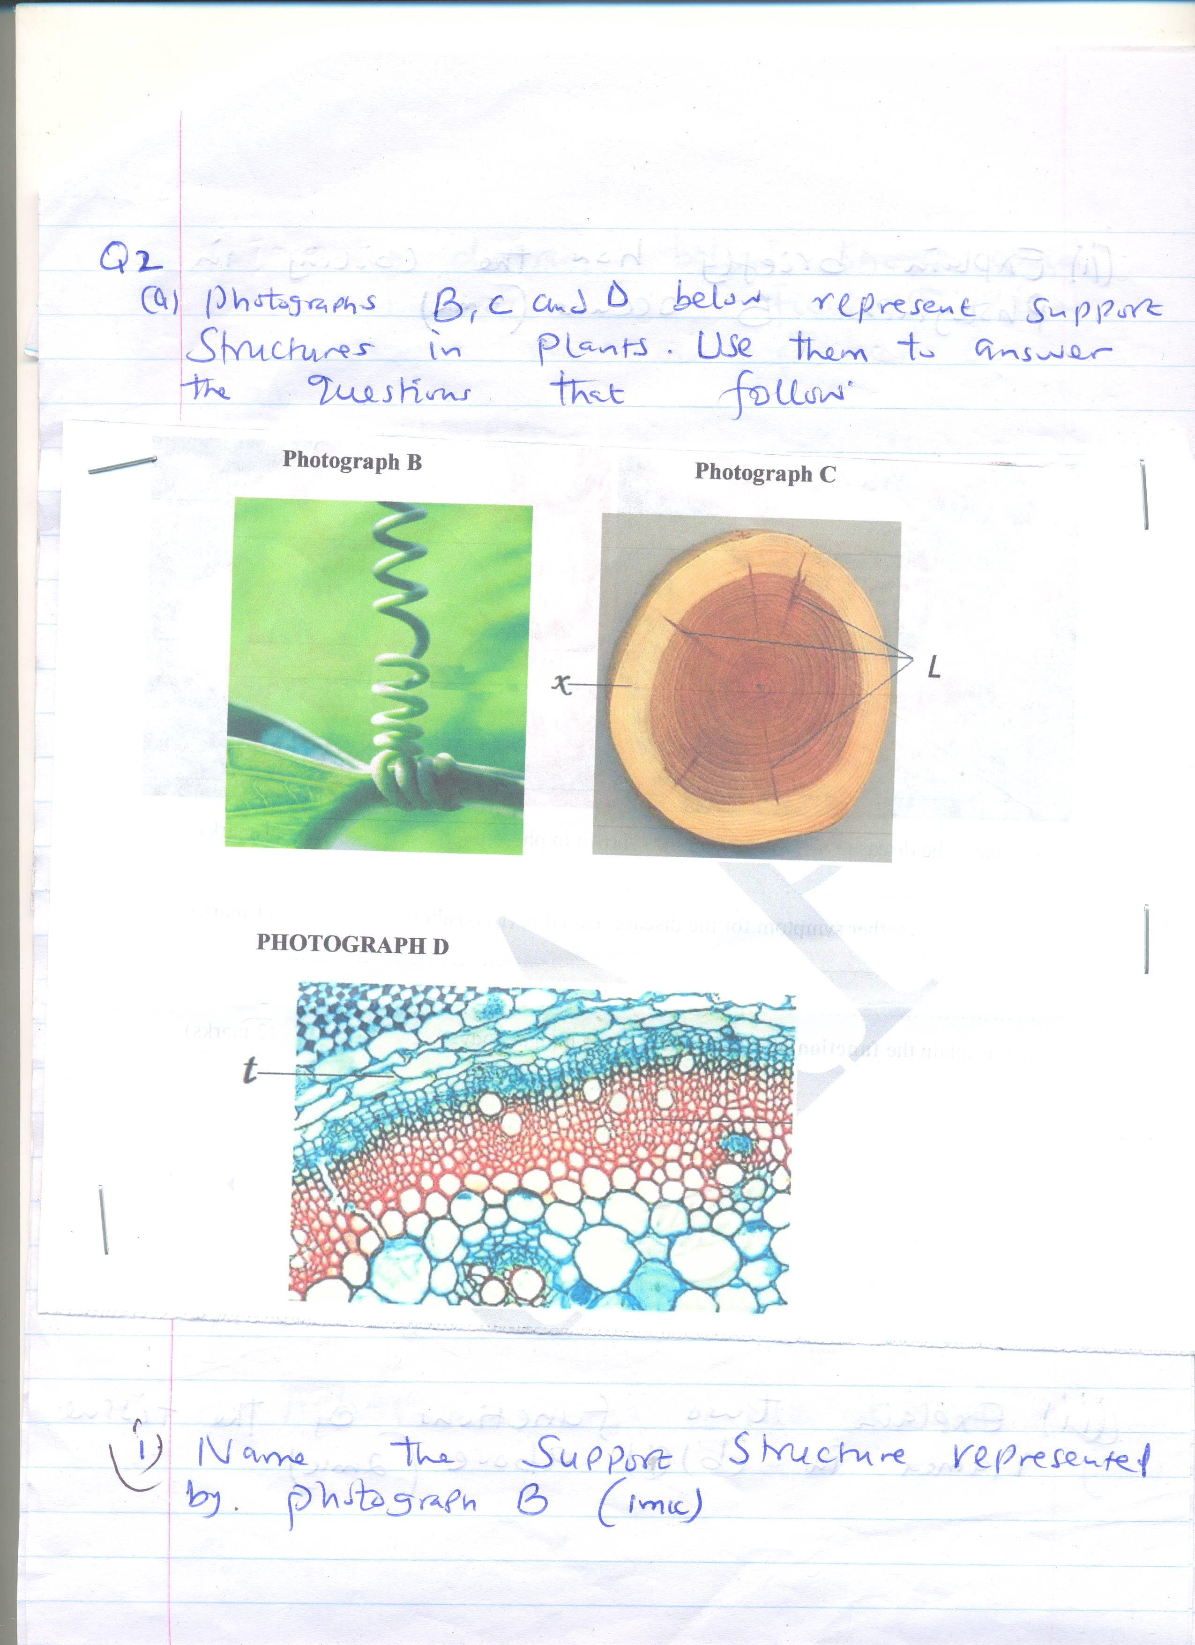

(i) Name the support structure represented by photograph B (1mk)
_________________________________________________________________________________
_________________________________________________________________________________
_________________________________________________________________________________
(ii) Explain briefly how the coiling in photograph B occurs (3mks)
_________________________________________________________________________________
_________________________________________________________________________________
_________________________________________________________________________________
_________________________________________________________________________________
(iii) Name the structures labeled L on photograph C. (1mk)
_________________________________________________________________________________
_________________________________________________________________________________
_________________________________________________________________________________

(iv) Explain two functions of the structures named (a) (iii) above. (2mks)
_________________________________________________________________________________
_________________________________________________________________________________
_________________________________________________________________________________
_________________________________________________________________________________
(b) Photograph D is a magnified photomicrograph of support tissues found in part x of
photograph C.
(i) Give the name of the tissue labeled t. (1mk)
_________________________________________________________________________________
_________________________________________________________________________________
_________________________________________________________________________________
(ii) Describe the structure of the cells of the tissue named in (b) (i) above (2mks)
_________________________________________________________________________________
_________________________________________________________________________________
_________________________________________________________________________________
_________________________________________________________________________________
(iii) Explain two functions of the tissue named in (b) (i) above. (2mks)
_________________________________________________________________________________
_________________________________________________________________________________
_________________________________________________________________________________
_________________________________________________________________________________
(c) The diagram below shows onion epidermal cells in a field of view seen under medium power objective lens

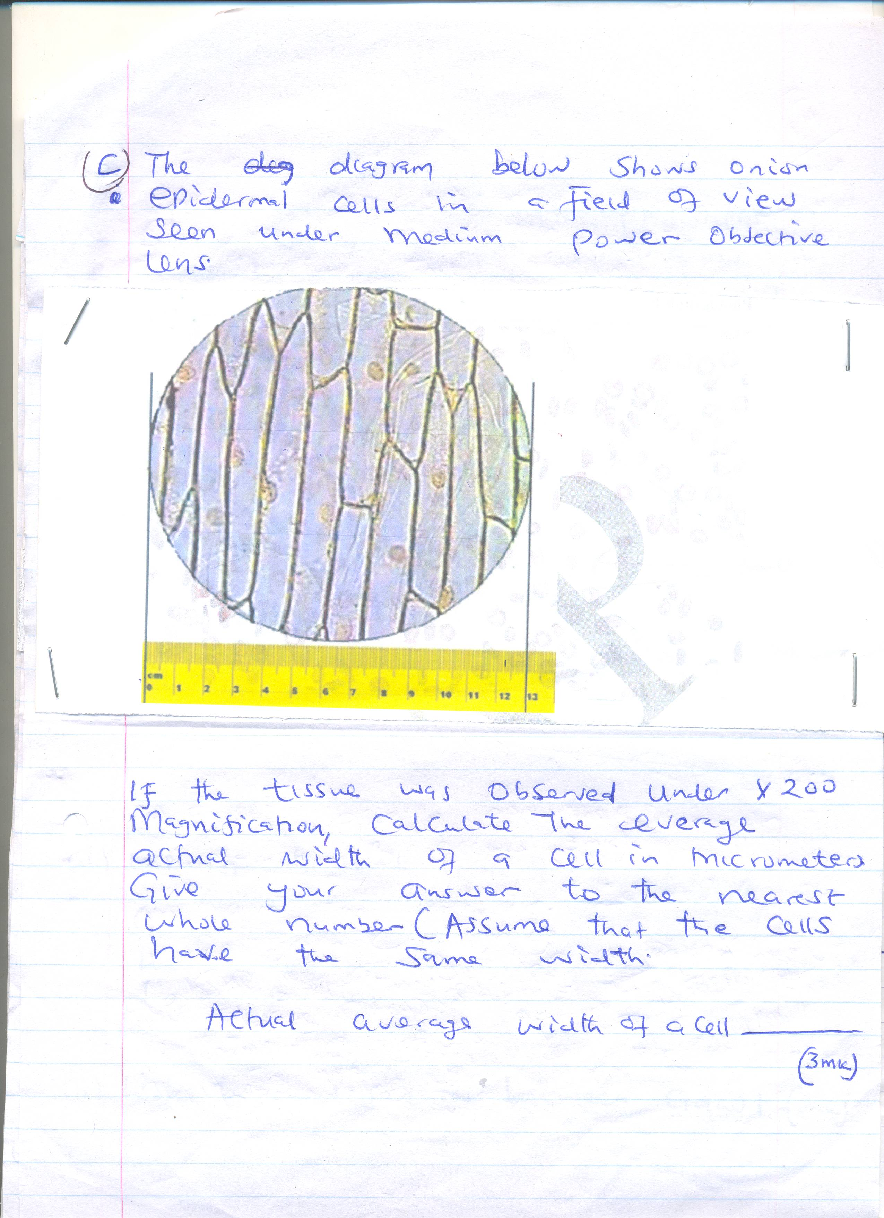

If the tissue was observed under x200 magnification, calculate the average actual width of a cell in micrometers. Give your answer to the nearest whole number (Assume that the cells have the same width.) (3mks)

3. (a) The figure below shows feet of various birds. Study the diagram and answer the questions that follow.
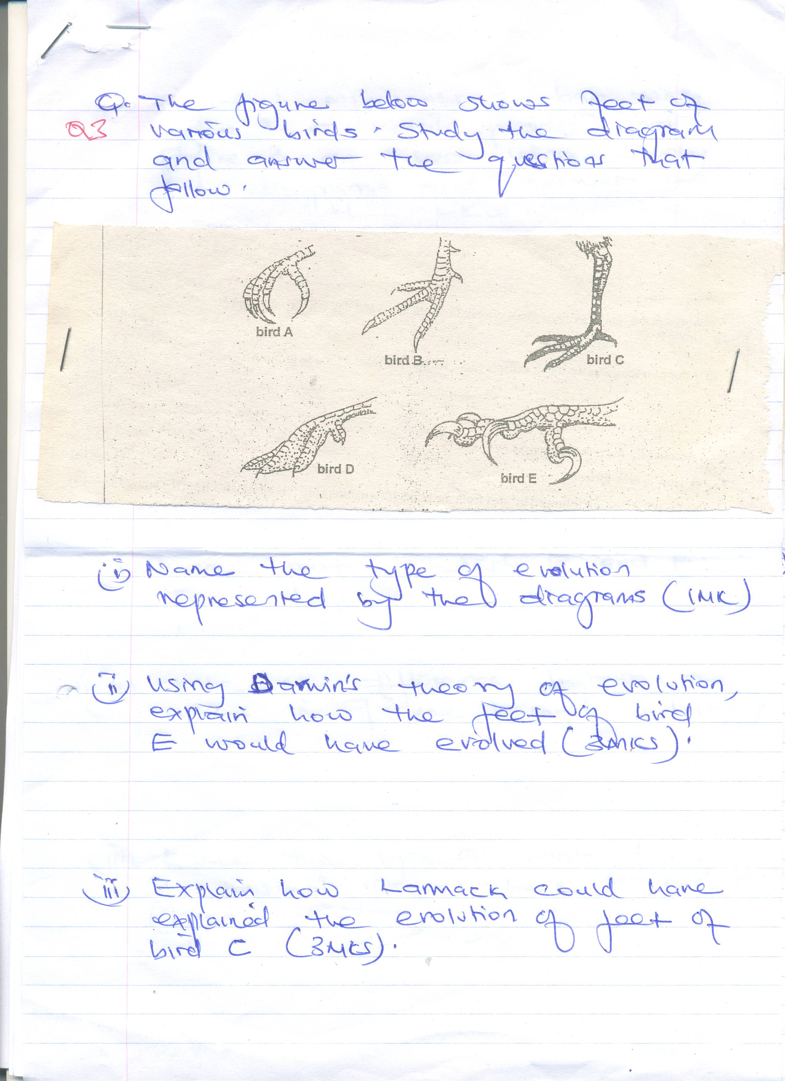

(i) Name the type of evolution represented by the diagrams (1mk)
_________________________________________________________________________________
_________________________________________________________________________________
_________________________________________________________________________________
(ii) Using Darwini’s theory of evolution, explain how the feet of bird E would have evolved (3mks)
_________________________________________________________________________________
_________________________________________________________________________________
_________________________________________________________________________________
_________________________________________________________________________________
(iii) Explain how Lanmack could have explained the evolution of feet of bird C (3mks)
_________________________________________________________________________________
_________________________________________________________________________________
_________________________________________________________________________________
_________________________________________________________________________________

(b) Figure 1 represents a bat wing, Figure 2 a whale paddle and Figure 3 an insect wing. Study the diagrams and answer the questions that follow

Figure 1
Figure 2
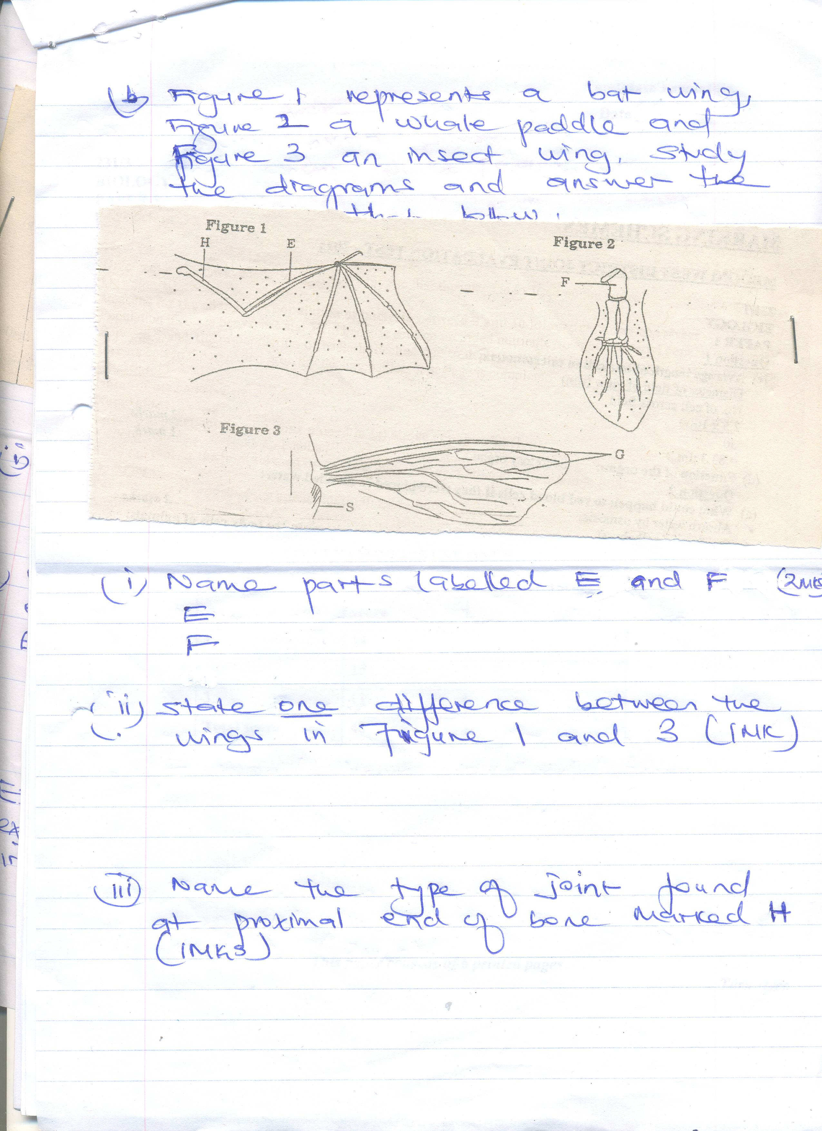
Figure 3

(i) Name parts labeled E and F (2mks)
E ________________________________________________
F ________________________________________________
(ii) State one difference between the wings in figure 1 and 3. (1mk)
_________________________________________________________________________________
_________________________________________________________________________________
_________________________________________________________________________________
_________________________________________________________________________________
(iii) Name the type of joint found at proximal end of bone marked H. (1mk)
_________________________________________________________________________________
_________________________________________________________________________________
_________________________________________________________________________________
_________________________________________________________________________________

