NAME:…………………………………………………... INDEX NO……………………………….
SCHOOL:…………………………………………….….. CANDIDATE’S SIGN …………………..

DATE ……………………………………..

231/3
BIOLOGY
Paper 3
PRACTICAL
Time: 1 ¾ Hours

Kenya Certificate of Secondary Education (K.C.S.E)

INSTRUCTIONS TO CANDIDATES
(a) Write your name and Admission number in the spaces provided above.
(b) Answer ALL the questions in the spaces provided.

For Examiners use only

Question | Max Score | Candidates Score
1
2
3
Total | 40

This paper consists of 8 printed pages.
Candidates should check the question paper to ensure that all pages are printed as indicated and no questions are missing.

1. Using the provided photographs; answer the following questions.
1. Photographs;
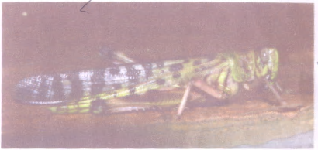

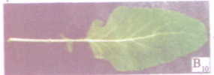

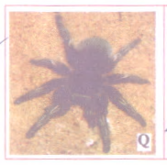
a) With reasons, state the kingdom to which specimen F and J belongs.
F……………………………………………………………………………………… (1mk)
J……………………………………………………………………………………….. (1mk)
Reasons
F……………………………………………………………………………………………………………………………………………………………………………………………………………………………………………………………………………………………………………………
(1mk)
J………………………………………………………………………………………………………………………………………………………………………………………………………………
(1mk)
b) Using observable features only; state the;
i) Phylum to which specimens J and F belong
………………………………………………………………………………………………………
ii) Class to which specimens J and F belong.
J…………………………………………………………………………………………….. (1mk)
F……………………………………………………………………………………………. (1mk)
iii) Give reasons for your answer in
(ii) Class for J above. (3mks)
……………………………………………………………………………………………………………………………………………………………………………………………………………………………………………………………………………………………………………………………………………………………………………………………………………………………………………………………………………………………………………………………………………………………………………………………………………………………………………………………………………………………..
c) (i) Name the division from which specimen K and L were obtained from. (2mks)
………………………………………………………………………………………………………………………………………………………………………………………………………………………………………………………………………………………………………………………………………………………………………………………………………………………………………………………………………………………………………………………………………………………………………………

ii) Give two observable differences between members from which specimen K and L were obtained from. (2mks)
………………………………………………………………………………………………………………………………………………………………………………………………………………………………………………………………………………………………………………………………………………………………………………………………………………………………………………………………………………………………………………………………………………………………………………

d) You are provided with photographs A, B and C, use them to answer questions that follow.

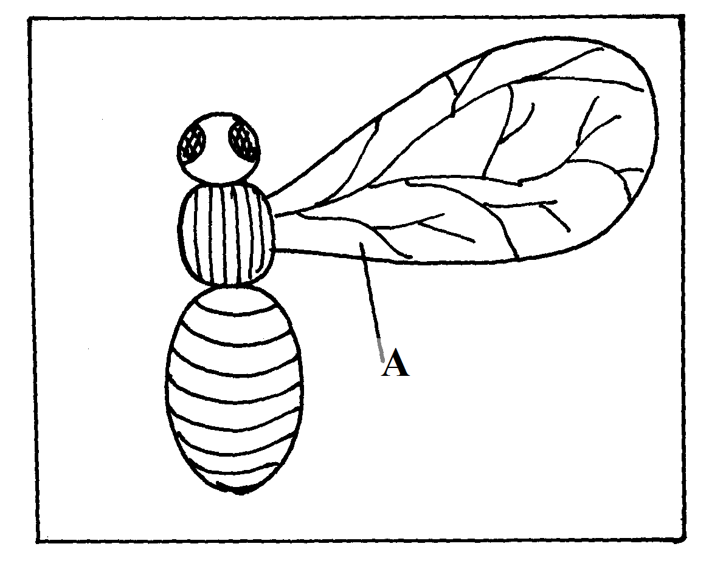

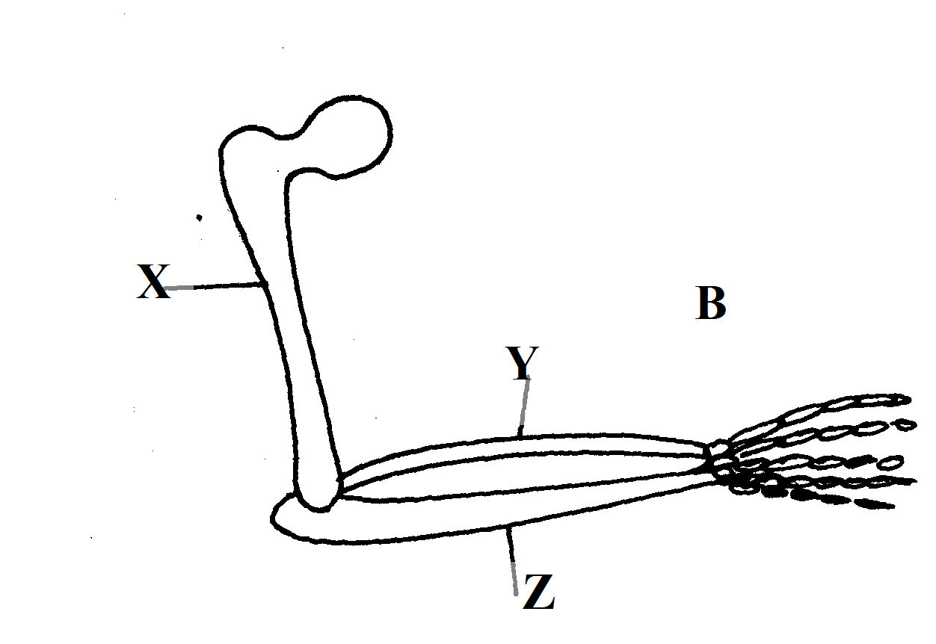

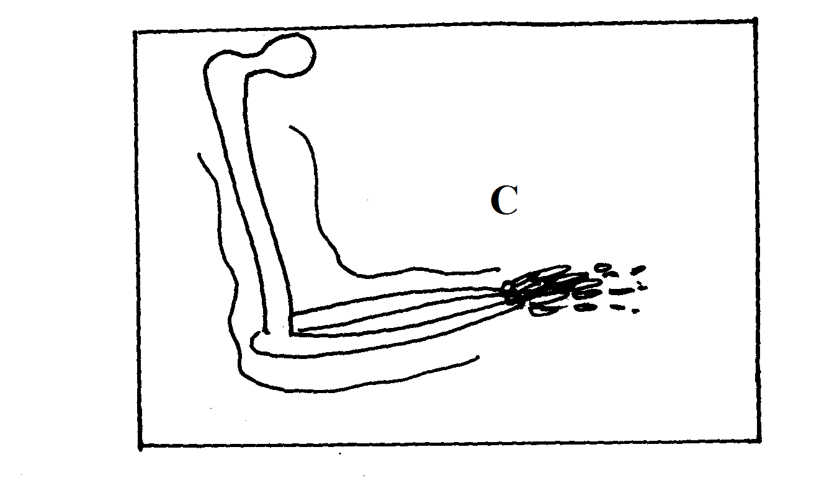

2. (a) Identify the parts labeled X,Y and Z. (3mks)
X………………………………………………………………………………………….
Y……………………………………………………………………………………………
Z…………………………………………………………………………………………..
(b) What common name is given to structure ref?
(i) A and C…………………………………………………………………… (1mk)
(ii) B and C……………………………………………………………………. (1mk)
(c) Give a reason for your answer in b (i) and (ii) above. (2mks)
………………………………………………………………………………………………………………………………………………………………………………………………………………………………………………………………………………………………………………………………………………………………………………………………………………………………………………………………………………………………………………………………………………………………………………
d) State the type of evolution that leads to emergence of structures named in 2 b (i) and (ii) above. (2mks)
………………………………………………………………………………………………………………………………………………………………………………………………………………………………………………………………………………………………………………………………………………………………………………………………………………………………………………………………………………………………………………………………………………………………………………
e) Identify two differences between structures A and C. (2mks)
………………………………………………………………………………………………………………………………………………………………………………………………………………………………………………………………………………………………………………………………………………………………………………………………………………………………………………………………………………………………………………………………………………………………………………

f) What is a vestigial structure? (1mk)
………………………………………………………………………………………………………………………………………………………………………………………………………………………………………………………………………………………………………………………………………………
3. You are provided with solution W.Using the provided reagents; carryout possible food tests to identify food substances present in solution. W

Food substance | Procedure | observation | Conclusion

End

