Name: ………………………………………………………………… Index No: ……………………..……………
Candidate’s Signature:…………………………….
Date: ……………….…………..…
231/3
BIOLOGY PRACTICAL
Paper 3
Time: 1 ¼ Hours

INSTRUCTIONS TO CANDIDATES:
- Write your name and index number in the spaces provided at the top of this page.
- Sign and write date of examination in the spaces provided above
- Answer all the questions
- You are required to spend the first 15 minutes of the 1 ¼ hours allowed for this paper reading the whole paper carefully before commencing your work.
- Answers must be written in the spaces provided in the question paper.
- Additional page must not be inserted.

For Examiner’s Use Only:

QUESTIONS | MAXIMUM SCORE | CANDIDATES SCORE
1 | 14
2 | 13
3 | 13
TOTAL | 40

This paper consists of 4printed pages. Candidates should check to ascertain that all pages are printed as indicated and that no question is missing

1 You are provided with several specimens N and indicator D, which is Bromolthymol blue. Study them and answer the questions that follow:
- (i) Identify the part of plant represented by specimen N. (1mk)
…………………………………………………………………………………………………
(ii) Give a reason for your answer in a) i) above. (1mk)
…………………………………………………………………………………………………
- i) Name the physiological process which is taking place in specimen N. (1mk)
…………………………………………………………………………………………………
ii) Describe the two changes which occurred to specimen N during the process named in b)
i) above. (2mks)
…………………………………………………………………………………………………
…………………………………………………………………………………………………
- i) State two internal factors which would promote the physiological process exhibited by specimen N, (2mks)
…………………………………………………………………………………………………
…………………………………………………………………………………………………
ii) State two external conditions which would inhibit the process demonstrated by specimen N. (2mks)
…………………………………………………………………………………………………
…………………………………………………………………………………………………
- Take a small piece of cotton wool and insert into a test tube. Use a wooden splint to push it to the bottom. Add two drops of indicator marked D, and spread it uniformly in the cotton wool by pressing using the wooden splint. Drain the excess indicator and then add 10 pieces of specimen N into the test tube. Close the mouth of the test tube tightly using the remaining cotton wool. Leave the set up to stand on the tube rack for 20 minutes.
- Record your observation after 20 minutes (1mk)
…………………………………………………………………………………………………
- Account the observation in d) i) above (3mks)
…………………………………………………………………………………………………
…………………………………………………………………………………………………
…………………………………………………………………………………………………
- Suggest a control for his experiment. (1mk)
…………………………………………………………………………………………………

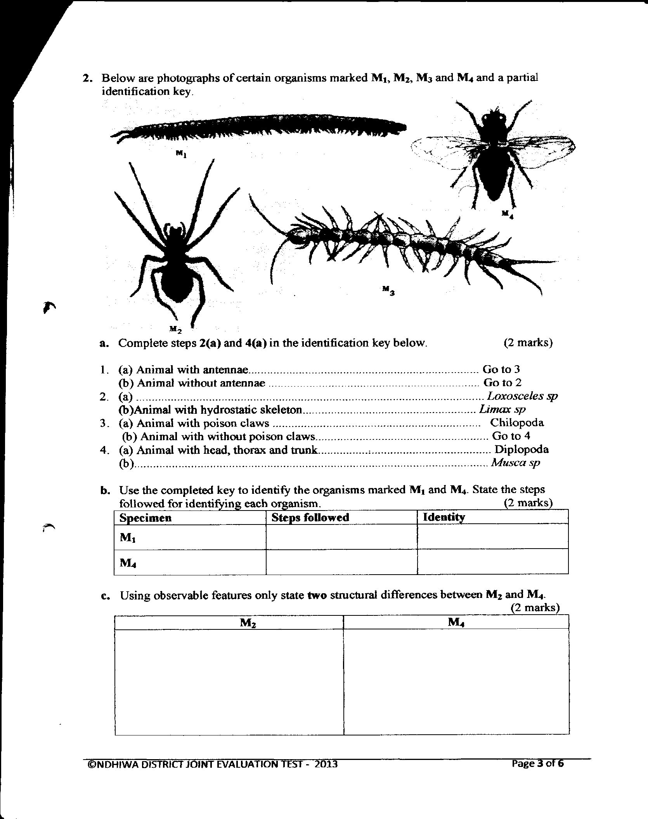
2. Below are photographs of certain in organisms marked M₁, M₂, M₃, and M₄ a partial identification key.

a). Complete steps 2(a) and 4(a) in the identification key below. (2mks)
1. (a) Animal with antennae……………………………………Go to 3
(b) Animals without antennae……………………………….Go to 2
2. (a) ……………………………………………………………Loxosceles sp
(b) Animals with hydrostatic skeleton……………………….Limax sp
3. (a) Animals with poison claws………………………………Chilipoda
(b) Animals with without poison claws ……………………..Go to 4
4. (a) Animals with head, thorax and trunk …………………….Diplopoda.
(b) …………………………………………………………….Musca sp
(b) Use the completed key to identify the organisms marked M₁ and M₄. State the steps followed for identifying each organism. (2mks)
Specification | Steps followed | Identity
M₁
M₄
(c) Using observable features only, state two structural differences between M₂ and M₄. (2mks)
M₂ | M₄

(d) You are provided with specimen P and R, which are parts of the same animal.
i. Make a large well labelled drawing of specimen P and state the magnification of your drawing

ii. State two adaptations of specimen R to its function. (2mks)
………………………………………………………………………………………………… ………………………………………………………………………………………………… iii. State the types of joint formed at the proximal end of the specimen R. (1mk)
…………………………………………………………………………………………………
iv. Name the specialized cell which forms the basic structural unit of specimen P. (1mk)
…………………………………………………………………………………………………
3. You are provided with specimen S. Using distilled water make a 4 ml food solution using a piece of specimen S.
(a) Use the chemical reagents and filter paper provided to analyze the food substances present in S.
Record your work in the table below. (6mks)
Food substance | Procedure | Observation | Conclusion

(b) State the type of fruit represented by specimen S. (1mk)
…………………………………………………………………………………………………
(c) State two ways in which specimen S is adapted to its mode of dispersal. (2mks)
………………………………………………………………………………………………………
…………………………………………………………………………………………………………..…………………………………………………………………………………………………
- Below is a photograph of a section of a mammalian alimentary canal. Study it and answer the following questions.
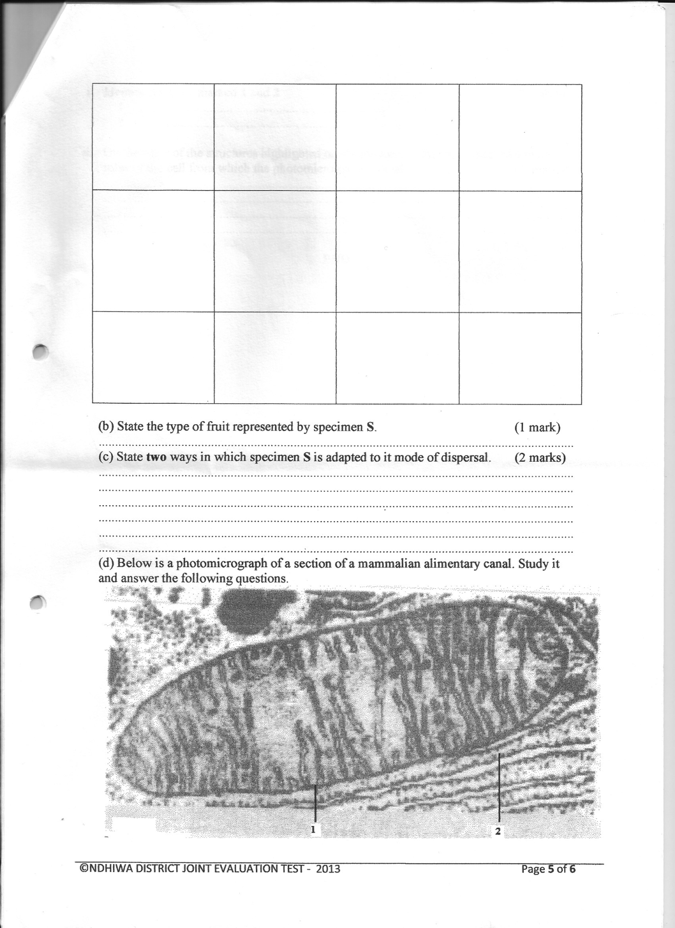

(i) Identify the part marked 1 and 2 (2mks)
1 ………………………………………………………..
2 ………………………………………………………
(ii) On the basis of the structures highlighted on the photomicrograph, suggest two main roles of the cell from which the photomicrograph was taken. (2mks)
…………………………………………………………………………………………………………..…………………………………………………………………………………………………………..…………………………………………………………………………………………………………..

