Name……………………………………………………………. Index No……………………………..
School…………………………………………………………… Candidate’s sign…………………….
Date………………………………….

231/3
BIOLOGY
Paper 3
(PRACTICAL)
1 ¾ hours

INSTRUCTIONS TO CANDIDATES.
- Write your name and admission number in the spaces provided
- Sign and write the date of examination in the spaces provided above
- Answer all the questions in the spaces provided
- You are required to spend the first 15 minutes of the 1 ¾ hrs allowed for this paper reading the whole paper carefully.

For examiners use only:

QUESTION | MAX.SCORE | CANDIDATES SCORE
1 | 12
2 | 15
3 | 13
TOTAL

This paper consists of 2 printed pages. Candidates should check the question paper to
Ensure that all the pages are printed as indicated and no questions are missing.

- You are provided with an electron micrograph which shows a part of a cell highly magnified.
(a) Name the structure labeled A,C and D
A_________________________ (1mk)
C_________________________ (1mk)
D________________________ (1mk)
(b) State the functions of B,E,F
B_______________________ (1mk)
E________________________ (1mk)
F________________________ (1mk)
(c) State one way in which the structures labeled A and D are suited to their function
A________________________________________________________________ (1mk)
D________________________________________________________________ (1mk)
(d) Calculate the actual length (x-y) of the organelle labed Dic microns show your working (2mks)

(e) From the micrograph suggest one cell activity that is taking place and support it with evidence from the micrograph.
Cell activity____________________________________________________ (1mk)
Reason _______________________________________________________ (1mk)

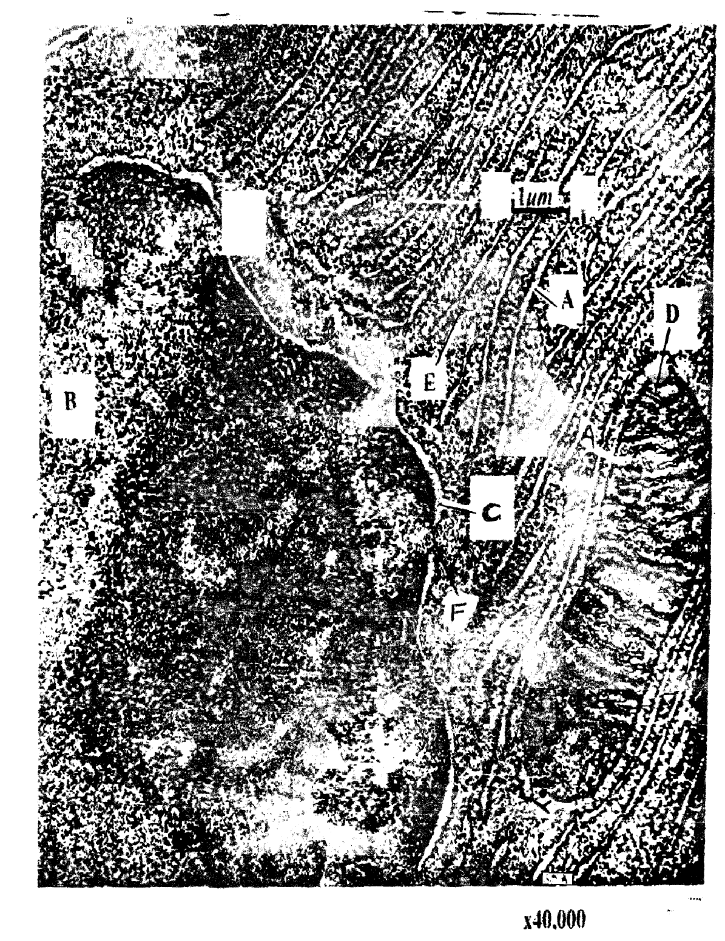

2. During a field study ,a student took a photograph of a flower as shown below.
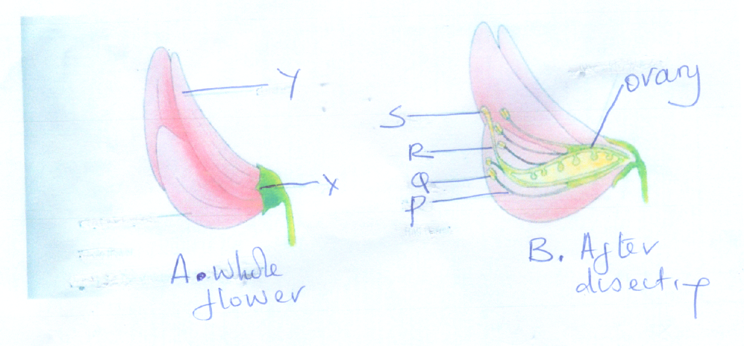
(a) Name the parts marked Q,R,S and X
Q___________________________________________________ (1mk)
R ___________________________________________________ (1mk)
S___________________________________________________ (1mk)
X__________________________________________________ (1mk)
(b) State the functions of parts X and R
X________________________________________________________________ (1mk)
R_______________________________________________________________ (1mk)
(c) Briefly describe the nature of the corolla of the flower above (1mk)
………………………………………………………………………………………………………………………………………………………………………………………………….
(d) Briefly describe the nature of the calyx of the flower above (1mk)
………………………………………………………………………………………………………………………………………………………………………………………………….
(e) What type of ovary does the flower have (1mk)
……………………………………………………………………………………………………
(f) (i) With reference to part labeled Q state the class of the plant from which the student
took the flower
class (1mk)
……………………………………………………………………………………………………
(ii) Give a reason to support your answer in f(i) above (1mk)
………………………………………………………………………………………………………………………………………………………………………………………………….
(g) Giving reasons state the agent of pollination in this flower
(i)Agent__________________________________________________________ (1mk)
(ii)Reasons
…………………………………………………………………………………………………………………………………………………………………………………………………
h) Name the type of placentation in the ovary of this flower
Type of placentation__________________________________________________(1mk)

3. You are provided with a sample of food labeled N in solution form. Using the apparatus and reagents provided, carry out the various food tests in order to determine the composition of solution N (12mks)
(a)
Food substance | Procedure | Observation | Conclusion

(b) A student ate a lot of beef, As a learner of Biology was this wise? Explain (1mk)
………………………………………………………………………………………………………………………………………………………………………………………………….

