Name_________________________________________________________ Index No. ______________
Candidate’s signature ______
Date __________________

231/3
BIOLOGY
PAPER 3
PRACTICAL
1 ¾ HOURS

INSTRUCTIONS TO CANDIDATES
Answer ALL the questions in the spaces provided in the question paper.
You are supposed to spend the first 15 minutes to read the whole paper carefully before commencing your work

FOR EXAMINERS USE ONLY
Questions | Total marks | Candidates score
1 | 12
2 | 17
3 | 11
Total score | 40

This paper consists of 5 printed pages
Turn Over

Q1. You are provided with specimen Q. Cut into two halves. Squeeze juice from one half into a boiling tube. Using the reagents provided, test the food substances present in the extract from specimen Q
Record down the food substance being tested, procedure, observation and conclusion in the table below.
Food substance | Procedure | Observation | Conclusion

(12mks)

2
Q2. You are provided with photographs of specimens labeled K and L. examine them and answer the questions that follow.

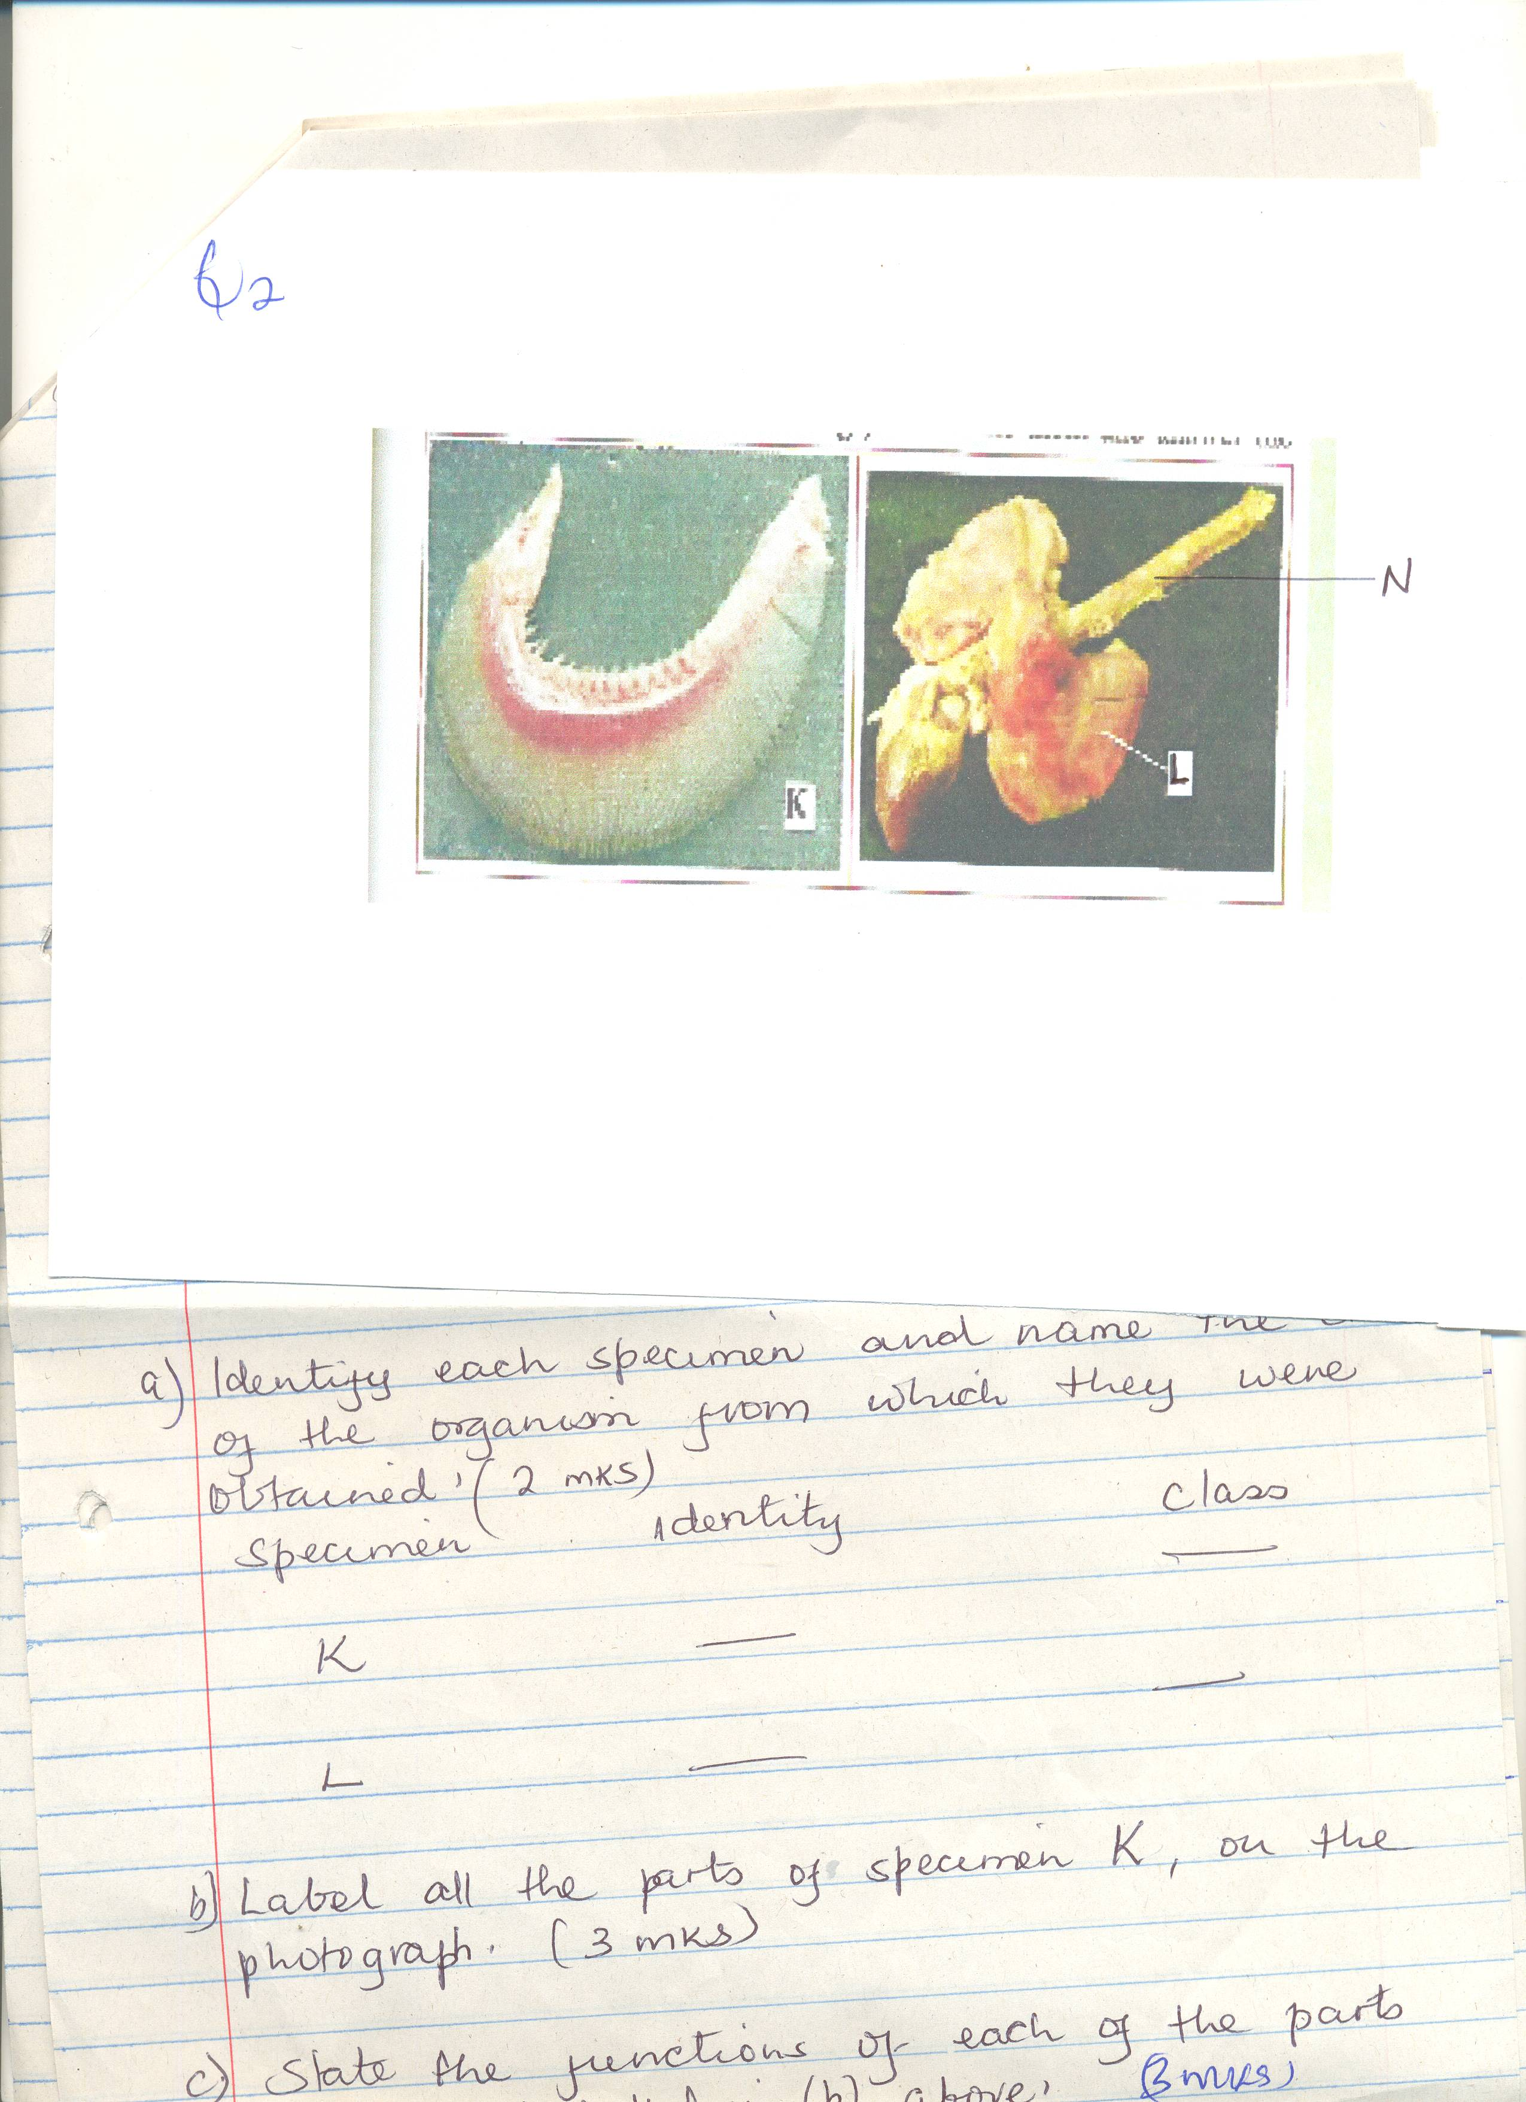

(a) Identify each specimen and name the class of the organism from which they were obtained. (2mks)

Specimen Identity Class

K ___________________ ______________

L ___________________ ______________

(b) Label all the parts of specimen K, on the photograph. (3mks)
____________________________________________________________________________________________________________________________________________________________________
__________________________________________________________________________________
__________________________________________________________________________________

(c) State the functions of each of the parts you have labeled in (b) above. (3mks)
____________________________________________________________________________________________________________________________________________________________________
__________________________________________________________________________________
__________________________________________________________________________________
__________________________________________________________________________________

3
(d) State three ways in which the part labeled L is adapted to its functions. (6mks)
____________________________________________________________________________________________________________________________________________________________________
__________________________________________________________________________________
______________________________________________________________________________________________________________________________________________________________________________________________________________________________________________________
__________________________________________________________________________________
(e) State the functional relationship between
(i) Specimen K and L (1mk)
____________________________________________________________________________________________________________________________________________________________________
__________________________________________________________________________________
(ii) State two adaptations of the part labeled N to its function. (2mks)
____________________________________________________________________________________________________________________________________________________________________
__________________________________________________________________________________
__________________________________________________________________________________

Q3. You are provided with photographs of specimens labeled D1, D2, D3, D4. Study them

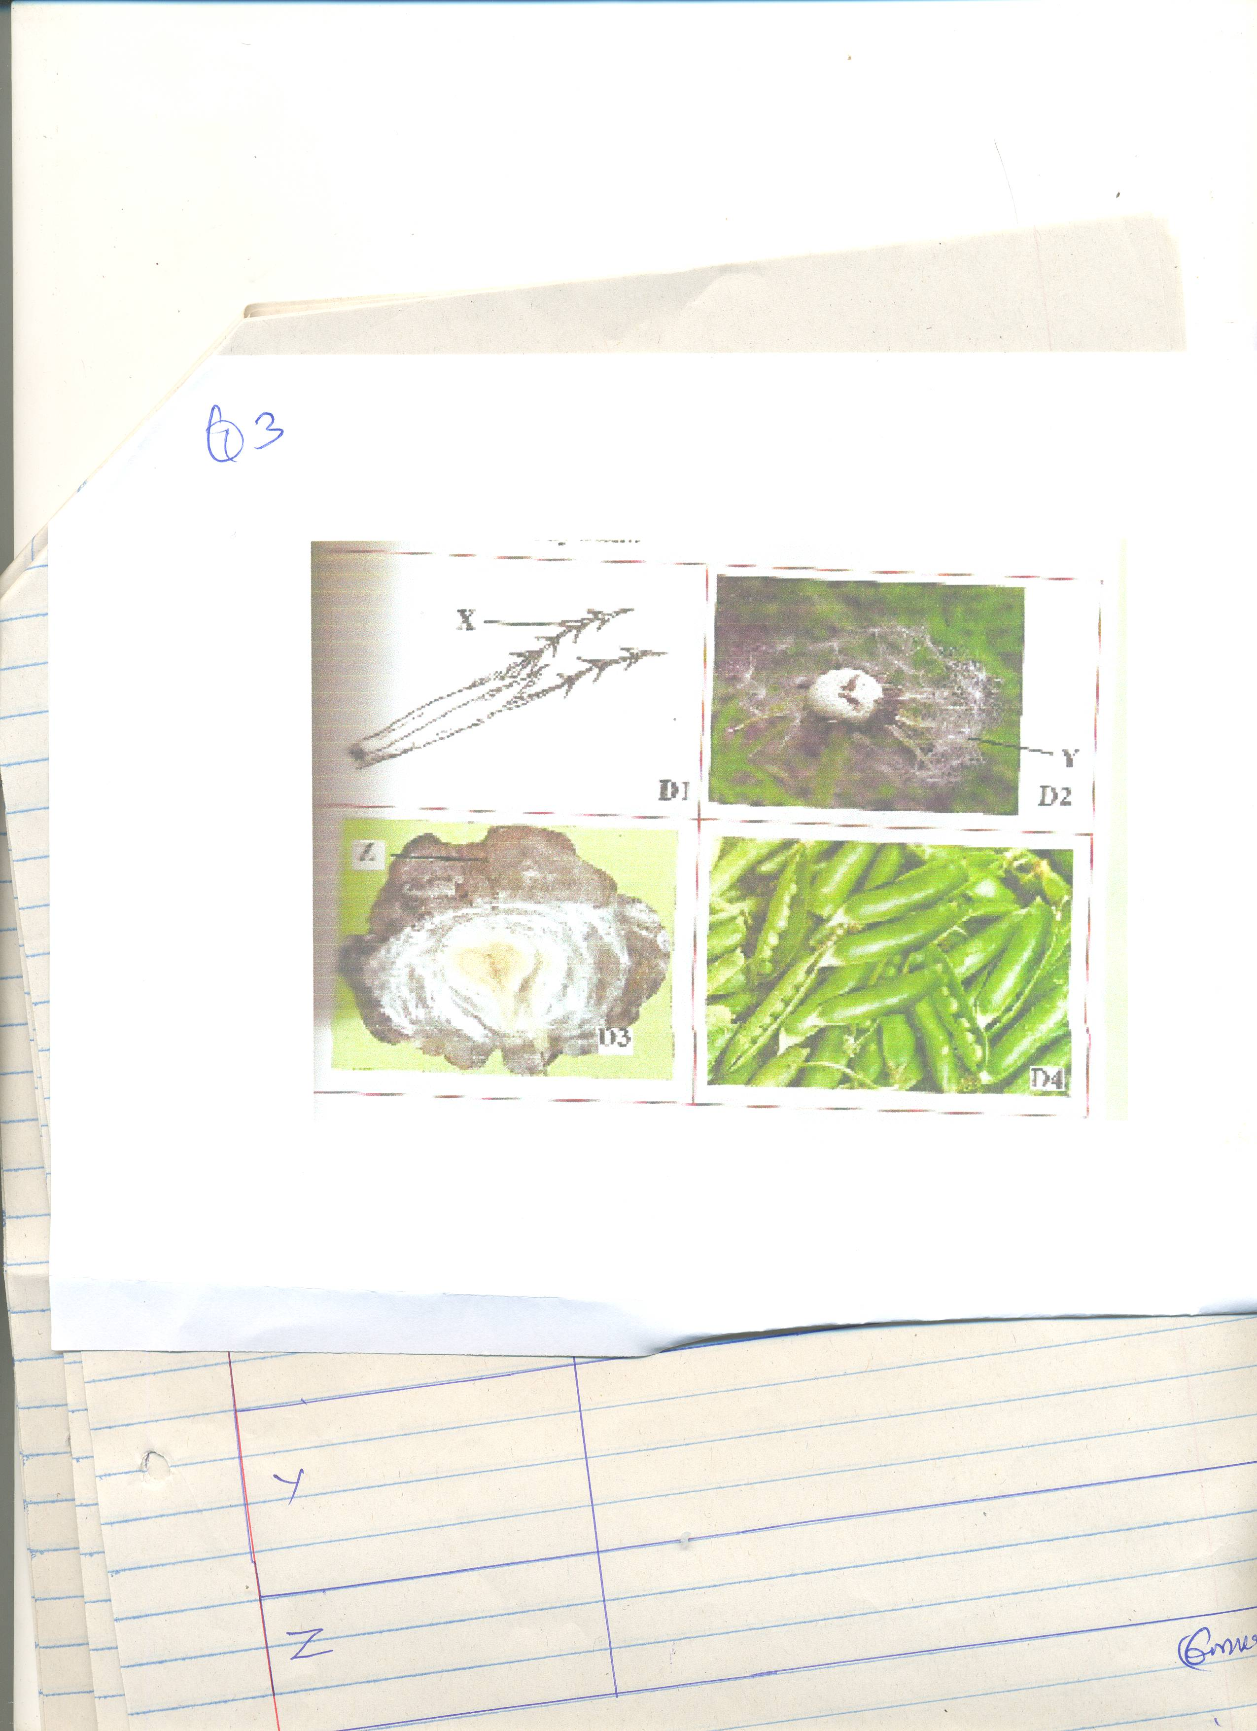

4
(a) Name the parts labeled X, Y and Z on the photographs and give the function of each.

Part | Function
X
Y
X

(6mks)
(b) State the method of dispersal of specimen D4 and give the reason for you answer. (3mks)
____________________________________________________________________________________________________________________________________________________________________
__________________________________________________________________________________
(c) Name the type of gynoecium and placentation found in the specimen D4 (2mks)
____________________________________________________________________________________________________________________________________________________________________
__________________________________________________________________________________

5

