NAME:……………………………………………………… INDEX NO:…………………………
SCHOOL:………………………………………………….. DATE:……………………………….
SIGN:………………………………..

231/3
BIOLOGY
PAPER 3
(PRACTICAL)
TIME: 1³/₄ HOURS

Kenya National Examination Council (K.C.S.E)

INSTRUCTIONS TO CANDIDATES

1. Write your name and index number in the spaces provided.
- Sign and write the date of the examination in the spaces provided above
- Answer all the questions
- You are required to spend the first 15 minutes of 1³/₄ hours allowed for this paper reading the whole paper carefully before commencing your work.
- Answers must be written in the spaces provided in the question paper.
- Additional pages should not be inserted candidates may be panelized for recording irrelevant information and for incorrect spellings especially of technical terms.

FOR EXAMINERS USE ONLY.

QUESTIONS | MAXIMUM SCORE | CANDIDATE’S SCORE
1 | 16
2 | 11
3 | 13
SCORE | 40

This paper consists of 8 printed pages.
Candidates should check the question paper to ensure that all pages are printed as indicated and that no questions are missing.

1. The diagrams below are bones obtained from different mammals
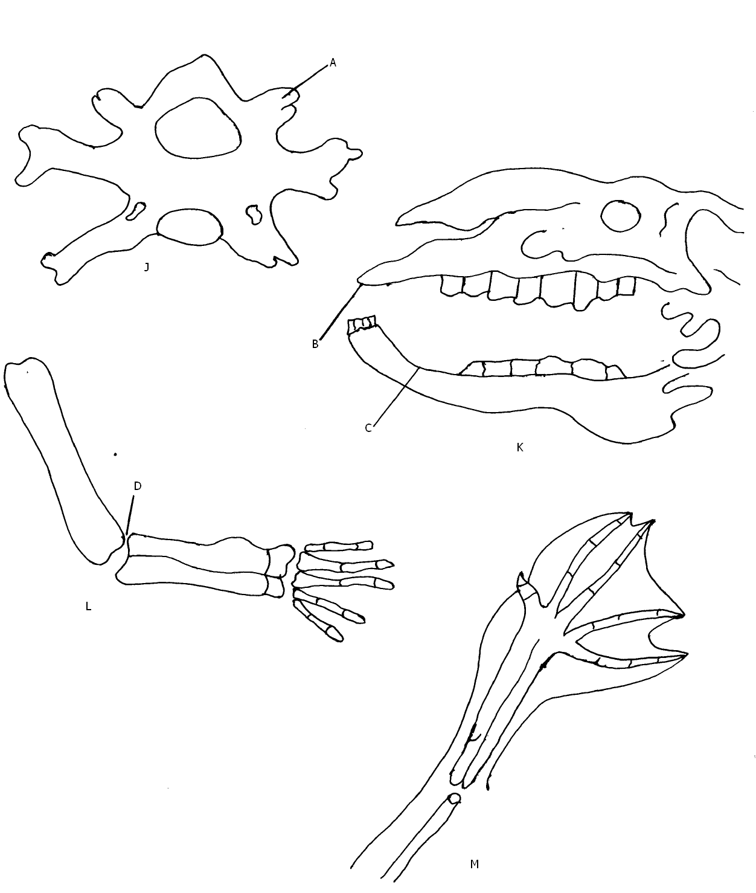
a) Identify bone J. (1 mark)
………………………………………………………………………………………………………………………………………………………………………………………………
b) Name the parts labeled A. (1 mark)
………………………………………………………………………………………………………………………………………………………………………………………………
c) Give the names of the cartilage that seperates specimen J from another vertebra
(1 mark
………………………………………………………………………………………………………………………………………………………………………………………………
d) State two functions of the cartilage named in c above. (2 marks)
………………………………………………………………………………………………………………………………………………………………………………………………
………………………………………………………………………………………………………………………………………………………………………………………………
e) State two structural differences between atlas vertebra and specimen J (2 marks)
Atlas | Specimen J
f) i) State the diet of the mammal whose skull is illustrated in drawing K. Explain your
answer.
Diet (1 mark)
………………………………………………………………………………………………………………………………………………………………………………………………
Explanation (1 mark)
………………………………………………………………………………………………………………………………………………………………………………………………
ii) Name the parts labeled B and C. (2 marks)
B
………………………………………………………………………………………………………………………………………………………………………………………………
C
………………………………………………………………………………………………………………………………………………………………………………………………
iii) State the functions of the part labeled B. (1 mark)
………………………………………………………………………………………………………………………………………………………………………………………………
g) i) Give the name of the fluid found at the part labeled D in drawing L (1 mark)
………………………………………………………………………………………………………………………………………………………………………………………………
………………………………………………………………………………………………………………………………………………………………………………………………
ii) State the function of the fluid named in g(i) above. (1 mark)
………………………………………………………………………………………………………………………………………………………………………………………………
………………………………………………………………………………………………
iii) What is the name given to the structures L and M in comparative anatomy.
(1 mark)
………………………………………………………………………………………………………………………………………………………………………………………………
iv) Give a reason for your answer in g(iii) above. (1 mark)
………………………………………………………………………………………………………………………………………………………………………………………………
2. a) You are provided with substances labeled R,S,T, U and V. R is a food substance while S
is a dilute sodium hydrogen carbonate. T is dilute hydrochloric acid, U is Benedict solution and V Dichlorophenol indophenol. Carry out tests to determine the food substance(s) in R. (9 marks)
Food substance being tested | Procedure | Observations | conclusion

b) State the function of the solution S and T in the food test.
S (1 mark)
………………………………………………………………………………………………………………………………………………………………………………………………………………………………………………………………………………………………………………………………………………………………………………………………
T (1 mark)
………………………………………………………………………………………………………………………………………………………………………………………………
………………………………………………………………………………………………………………………………………………………………………………………………
3. The diagrams A, B and C show parts of a flower while diagram D show a plant
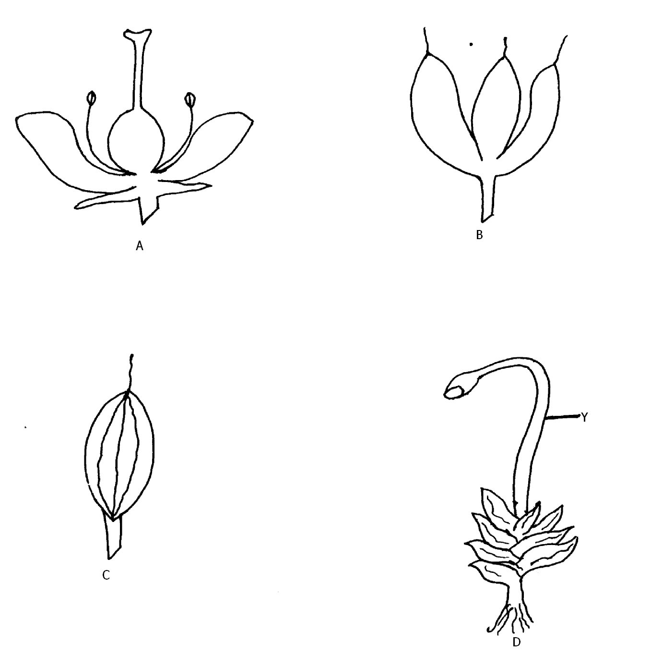

a) Name the condition exhibited in drawing A which hinder self-fertilization. (1 mark)
………………………………………………………………………………………………………………………………………………………………………………………………
b) Explain how the above condition hinders self-fertilization. (1 mark)
………………………………………………………………………………………………………………………………………………………………………………………………
c) With reasons give the tern given to gynoecium B and C
B (1 mark)
………………………………………………………………………………………………………………………………………………………………………………………………
Reason (1 mark)
………………………………………………………………………………………………………………………………………………………………………………………………………………………………………………………………………………………………………………………………………………………………………………………………

C (1 mark)
………………………………………………………………………………………………………………………………………………………………………………………………
Reason (1 mark)
………………………………………………………………………………………………………………………………………………………………………………………………
………………………………………………………………………………………………………………………………………………………………………………………………
d) With reason, name the type of ovary shown in the diagram A
Type (1 mark)
………………………………………………………………………………………………………………………………………………………………………………………………
Reason (1 mark)
………………………………………………………………………………………………………………………………………………………………………………………………
………………………………………………………………………………………………………………………………………………………………………………………………
e) i) State the division where plant in diagram D belong and give reason for your
answer.
Division (1 mark)
………………………………………………………………………………………………………………………………………………………………………………………………
Reason (1 mark)
………………………………………………………………………………………………………………………………………………………………………………………………
ii) State the type of nutrition exhibited by specimen D. (1 mark)
………………………………………………………………………………………………………………………………………………………………………………………………

iii) Give the function of the structure labeled Y. (1 mark)
………………………………………………………………………………………………………………………………………………………………………………………………

iv) Using letter T, indicate on diagram D where the female sex organ is found.
(1 mark)

END

