NAME...............................................................................INDEX NO....................................
SCHOOL..........................................................................DATE.............................................
SIGN.............................................
231/3
Biology paper 3
(Practical)
1 ¾ HRS

INSTRUCTIONS TO CANDIDATES
- Write your name and index number in the spaces provided at the top of this page.
- Answer all the questions in the spaces provided.
For examiner’s use only

Question | Maximum score | Candidate’s score
1 | 13
2 | 15
3 | 12
Total score | 40

- Below are photographs of specimens obtained from plants. Examine the photographs
(See the attached photographs)
- For each of the specimens, name the mode of pollination and the features that adapt the specimen to the mode of pollination.
Specimen R
-Mode of pollination (1mrk)
.........................................................................................................................................
-Adaptive features. (2mrks)
i)................................................................................................................................................................................................................................................................................
ii)...............................................................................................................................................................................................................................................................................
Specimen S1
-Mode of pollination (1mrk)
.........................................................................................................................................
-Adaptive features (2mrks)
i)................................................................................................................................................................................................................................................................................
ii)...............................................................................................................................................................................................................................................................................
b) Label any four parts on specimen R (2mrks)
c). Name the structure labeled X on specimen S1. (1mrk)
............................................................................................................................................................................................................................................................................................
d).Using observable features, only state two differences between R and S. (2mrks)
.............................................................................................................................................. .............................................................................................................................................. ............................................................................................................................................................................................................................................................................................
e).With a reason, name the class of the spermatophyta to which specimen R belongs. (2mrks)
Class...........................................................................................................................................
Reason............................................................................................................................................................................................................................................................................................
- The photographs labeled R, S, T and V are of bones obtained from a mammal. Examine them. (see the attached photographs)
- Identify the bones and name the part of the mammalian body from which each bone was obtained. (4mrks)
Bone | Identify | Where found
R
S
T
V

- i). Name the joint formed between bones S and T at point marked X. (1mrk)
....................................................................................................................................................
ii) Give the characteristics of the joint named in (b) (i) above. (1mrk)
........................................................................................................................................................................................................................................................................................................
c). i).Name the bone structure labeled Y. (1mrk)
....................................................................................................................................................
ii). State one function of the bone structure named in C (i) above. (1mrk)
........................................................................................................................................................................................................................................................................................................
d).i). Using observable features give two adaptations of the bone labeled R. (2mrks)
............................................................................................................................................................................................................................................................................................................................................................................................................................................................
ii). On the bone in photograph V, draw a diagram of bone R to show the articulation
between the two bones. (2mrks)
e). Name the part labeled Z in the photograph 5 and state its function. (2mrks)
Part Z..............................................................................................................................
Function...................................................................................................................................................................................................................................................................

f). Name the joint formed by bone T with adjacent bones at its distal end. (1mrk)
....................................................................................................................................................
- a). You are provided with a sample of food labeled P in solution form. Using the
reagents provided, carry out tests on the food sample to identify the type of food
substances present. (6mrks)
Food substance | Procedure | Observation | Conclusion

b). Suggest the regions of the human digestive system where the foods tested are
digested. (2mrks)
....................................................................................................................................................................................................................................................................................................................................................................................................................................................................................................................................................................................................................................................................................................................................................................
c).State enzyme involved in the digestion of the foods tested. (2mrks)
............................................................................................................................................................................................................................................................................................................................................................................................................................................................
d). Name the deficiency diseases of each of the food tested. (2mrks)
........................................................................................................................................................................................................................................................................................................

Photographs for question 1

R
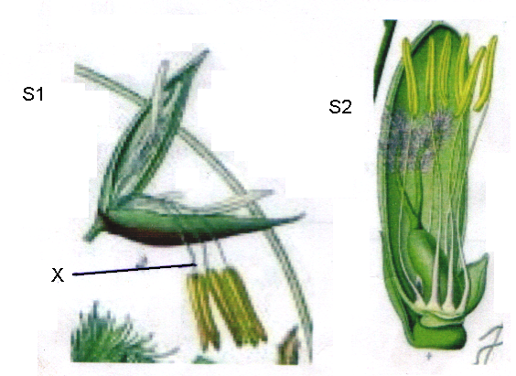

Photographs for question 2
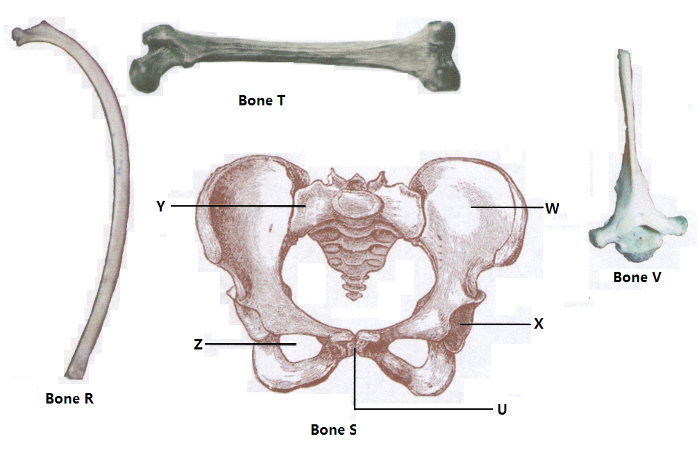
Photographs for question 2

Photographs for question 1

R

