Name ……………………………..………...…………. Index No……………………….….………….
School ………………………………………………... Candidate’s Signature ……………………… Date ………………...........................………..

231/3
BIOLOGY
PAPER 3
(PRACTICAL)
TIME: 1³/₄ HOURS

INSTRUCTIONS TO CANDIDATES
- Write your name and index number in the spaces provided
- Answer ALL the questions in spaces provided in this question paper.
- You are required to spend the first 15 minutes of the 1 hours allowed for this paper reading the whole paper carefully before commencing your work.
- Additional pages must not be inserted.

FOR EXAMINER’S USE ONLY
Question | Max. Score | Candidate’s score
1 | 15
2 | 13
3 | 12
40
TOTAL SCORE

This paper consists of 5 printed pages.
Candidates should check to ensure that all pages are printed as indicated and no questions are missing.

- a) You are provided with solution X, Y and Z. Using some of solution X, carry out food tests shown in the table below. (6 marks)
Food substance | Procedure | Observations | Deductions
Starch
Reducing sugar

b) Divide the remaining solution X into three equal parts using a measuring cylinder and transfer separately each into test-tubes labelled 1, 2 and 3.
- Into test tube 1, add 1cm³ of solution Y and 4cm³ of solution Z.
- Into test tube 2, add 1cm³ of solution Y and boil for 5 minutes.
- In test-tube 3, add 1cm³ of solution Y.
Leave the set-up for 40 minutes and carry out food tests in each test tube. Record your observations in the table below. (3 marks)
 | Observations
Test tube | Starch | Reducing sugar
1
2
3
c) Account for the results in test tube;
- 2 (2 marks)
……………………………………………………………………………………………………..
……………………………………………………………………………………………………..
……………………………………………………………………………………………………..
……………………………………………………………………………………………………..
- 3 (2 marks)
……………………………………………………………………………………………………..
……………………………………………………………………………………………………..
……………………………………………………………………………………………………..
……………………………………………………………………………………………………..
d) What was the effect of solution Z on solution X? (1 mark)
……………………………………………………………….………………………………………..
……………………………………………………………….………………………………………..
……………………………………………………………….………………………………………..
e) State one part in human body where the process under investigation may take place. (1 mark)
……………………………………………………………….………………………………………..
……………………………………………………………….………………………………………..
- You are provided with four bones taken from a mammal labelled A, B, C and D. Study them carefully and answer the questions below.
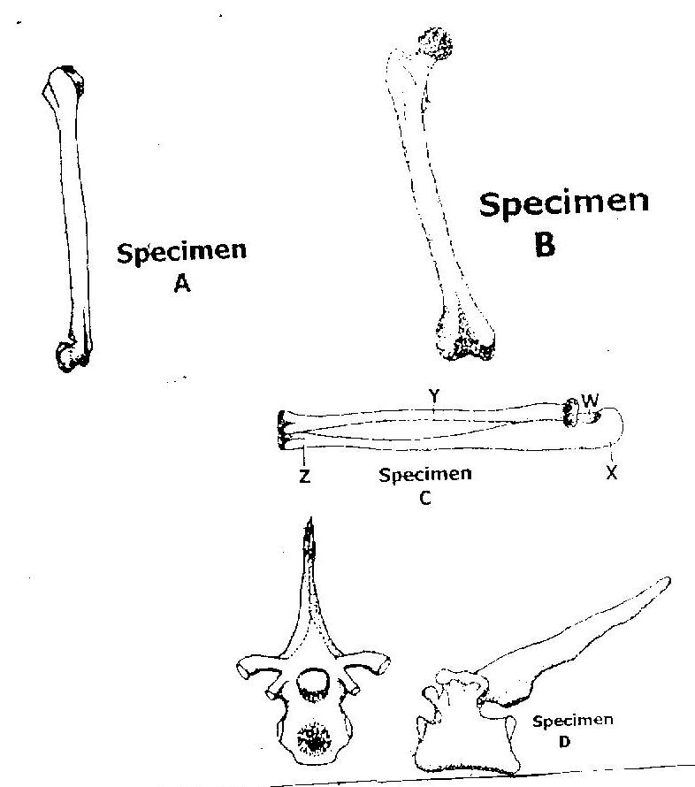
Y
Z
W
X
Specimen D
Specimen C
Specimen B
Specimen A
- Identify specimens labelled A, B and C. (3 marks)
A………………………………………………………….…………
B………………………………………………………….…………
C………………………………………………………….…………
- Name parts of bone C labelled W, X and Y. (3marks)
W………………………………………………………….…………
X………………………………………………………….…………
Y………………………………………………………….…………
- Name the type of joint found between points of articulation on bone B at the posterior and anterior ends with other bones. (2 marks)
Anterior end
……………………………………………………………….………………………………………..
Posterior end
……………………………………………………………….………………………………………..
- Identify the parts of skeleton from where specimen B and D were obtained. (2 marks)
B………………………………………………………….…………
D………………………………………………………….…………
- State three structural adaptations of specimen D to its functions. (3 marks)
……………………………………………………………….………………………………………..
……………………………………………………………….………………………………………..
……………………………………………………………….………………………………………..
……………………………………………………………….………………………………………..
……………………………………………………………….………………………………………..
- Below are photographs of specimens from plants. Study them and answer the questions that follow.
A
R
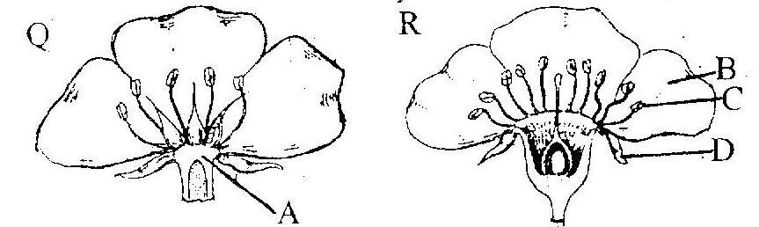
C
D
B
Q
- What is the role of the specimens to the plants? (1 mark)
……………………………………………………………….………………………………………..
……………………………………………………………….………………………………………..

- Differentiate the specimen Q from specimen R. (2 marks)
……………………………………………………………….………………………………………..
……………………………………………………………….………………………………………..
……………………………………………………………….………………………………………..
……………………………………………………………….………………………………………..
- Name the parts labelled A, B and C. (3 marks)
A………………………………………………………
B………………………………………………………
C………………………………………………………
- Explain what happens to the floral structures after fertilization. (4 marks)
……………………………………………………………….………………………………………..
……………………………………………………………….………………………………………..
……………………………………………………………….………………………………………..
……………………………………………………………….………………………………………..
……………………………………………………………….………………………………………..
……………………………………………………………….………………………………………..
- With a reason, state the class of plants from which the specimens were obtained.
Class (1 mark)
……………………………………………………………….………………………………………..
Reason (1 mark)
……………………………………………………………….………………………………………..
……………………………………………………………….………………………………………..
……………………………………………………………….………………………………………..
……………………………………………………………….………………………………………..

