Name………………………………………………… Index No. …………………….

School ………………………………………………... Date……. …………………….

Sign……. …………………….

231/3
BIOLOGY
PAPER 3
PRACTICAL
Time: 2 Hours

INSTRUCTIONS TO CANDIDATES

- Answer all the questions.
- Spend the first 15 minutes of the 1 ¾ hours allowed for this paper reading the whole paper carefully before commencing your work.
- Answers MUST be written in the spaces provided in the QUESTION PAPER ONLY.

FOR EXAMINERS USE ONLY

QUESTION | Max Score | Candidate Score
1 | 14
2 | 14
3 | 12
TOTAL SCORE | 40

This paper consists of 8 printed pages.
Candidates should check the question paper to ensure that all pages are printed as indicated

1. Label test tubes J K L M. Measure 5ml of the Hydrogen perixode provided and pour into each test tube. Peel specimen N provided and obtain four cube of about 1cm³. Grind one of the cubes put in test tubes J add water and boil for about 5 minutes. Grind other two cubes place them in test tube K and M respectively. The remaining cube put it in L.

a) Record the observation in (1mk
J…………………………………………………………………………………………..
K………………………………………………………………………………………….
L…………………………………………………………………………………………..
M…………………………………………………………………………………………..
b) Compare the observations made in (2mks)

(i) K and J
…………………………………………………………………………………………..
………………………………………………………………………………………….
…………………………………………………………………………………………..

ii) K and M (2mks)
…………………………………………………………………………………………..
………………………………………………………………………………………….
…………………………………………………………………………………………..

c) Account for your answer in b(i) (ii) (4mks)
…………………………………………………………………………………………..
………………………………………………………………………………………….
…………………………………………………………………………………………..
…………………………………………………………………………………………..
………………………………………………………………………………………….
…………………………………………………………………………………………..
…………………………………………………………………………………………..
………………………………………………………………………………………….
…………………………………………………………………………………………..
…………………………………………………………………………………………..
………………………………………………………………………………………….
…………………………………………………………………………………………..
…………………………………………………………………………………………..
………………………………………………………………………………………….
…………………………………………………………………………………………..
…………………………………………………………………………………………..
………………………………………………………………………………………….

d) Write a word equation for the reaction taking place in tube M. (2mks)
…………………………………………………………………………………………..
………………………………………………………………………………………….
…………………………………………………………………………………………..

2. Below are photographs labelled J and K of organs obtained from different animals.The organs perform similar functions.
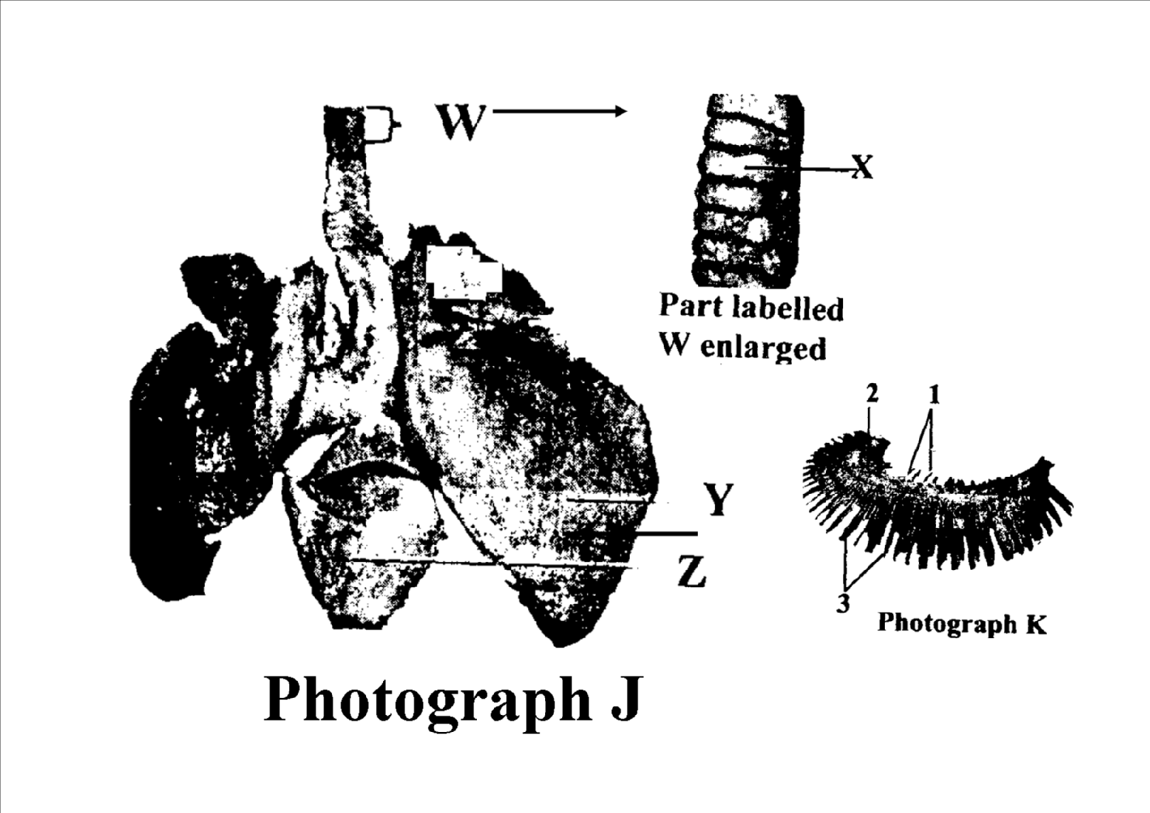
a) Identify the organs (2mks)

J…………………………………………………………………………………………..
…………………………………………………………………………………………….
K…………………………………………………………………………………………..
…………………………………………………………………………………………….

b) State the functions performed by the organs. (2mks)
…………………………………………………………………………………………..
………………………………………………………………………………………….
…………………………………………………………………………………………..
…………………………………………………………………………………………..
c) Name the parts labelled X Y and Z in photograph. (3mks)

J…………………………………………………
X……………………………………………….
Y……………………………………………….
Z……………………………………………….

d) i) Identify the parts labelled 1,2 and 3 in photograph K. (3mks)

1………………………………………………
2……………………………………………….
3……………………………………………….

ii) Using observable features state how the parts labelled 1 and 3 you identified in (d)(i) above are adapted to their functions. (4mks)

1………………………………………………

3……………………………………………….

3. Below are diagrams of specimens J K and L that have been obtained from different regions of the same mammalian body. Examine them.
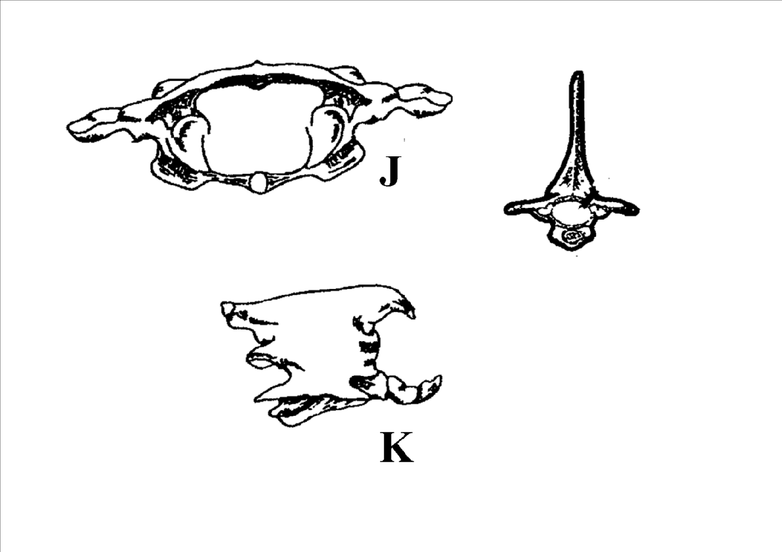
a) i) Identify the diagrams

J …………………………………

K ………………………………..

L ………………………………..

ii) State one functions for each of the diagrams

J …………………………………

K ………………………………..

L ………………………………..

b) i) State two adaptations of L to its function in above. (2mks)
…………………………………………………………………………………………..
…………………………………………………………………………………………..
…………………………………………………………………………………………..
…………………………………………………………………………………………..

ii) Name the structure that fits into the large opening of J, K and L (1mk)
…………………………………………………………………………………………..
…………………………………………………………………………………………..

c) Name three features that difference late specimen L from specimen J and K. (3mks)
…………………………………………………………………………………………..
…………………………………………………………………………………………..
…………………………………………………………………………………………..
…………………………………………………………………………………………..
…………………………………………………………………………………………..
…………………………………………………………………………………………..

End

