NAME:……………………………………………………… INDEX NO:…………………………
SCHOOL:………………………………………………….. DATE:……………………………….
SIGN:………………………………..

231/3
BIOLOGY
PAPER 3
(PRACTICAL)
TIME: 1³/₄ HOURS

INSTRUCTIONS TO CANDIDATES

1. Answer all the questions in the spaces provided.
2. You are required to spend the first 15 minutes of 1³/₄ hours allowed for this paper reading the whole paper carefully before commencing your work.
3. Candidates may be penalized for recording irrelevant and incorrect spelling especially of technical terms.

FOR EXAMINERS USE ONLY.

QUESTIONS | MAXIMUM SCORE | CANDIDATE’S SCORE
1 | 12
2 | 15
3 | 15
TOTAL | 40

This paper consists of 8 printed pages.
Candidates should check the question paper to ensure that all pages are printed as indicated and that no questions are missing.

1. You are provided with liquid X and substance Q
(a) Place three drops of liquid X onto a white tile. Add four drops of iodine solution and record your observation. (lmk)
..................................................................................................................................................................................................................................................................................................
..................................................................................................................................................................................................................................................................................................

(b) Pour 2ml of liquid X into a test-tube. Add equal amounts of Benedict’s solution boil the mixture. Record your observation (lmk)
..................................................................................................................................................................................................................................................................................................
..................................................................................................................................................................................................................................................................................................

(c) Label three boiling tubes as set-ups A, B, and C. Place 3m1of liquid X into each of the set-ups.
Divide substance Q into three equal portions.
To set-up A, add one portion of substance Q and shake.
• Place the second portion of substance Q into a test tube. Add 1ml of water to it and boil for four minutes. Add it to set-up B and shake.
• To set —up C, add the third portion of substance Q. Add 8 drops of 2M
hydrochloric acid and shake.
Place the three set-ups in a warm water bath maintained at 37°C for 30minutes.
Cool the set-ups by dipping the boiling tubes in cold water
Place 2m1 of the contents of each set-up into three separate test tubes. Add equal amount of Benedict’s solution to each of the three test-tubes and boil.
Record your observations (3mks)
Set-up A
..................................................................................................................................................................................................................................................................................................
..................................................................................................................................................................................................................................................................................................

Set-up B
..................................................................................................................................................................................................................................................................................................
..................................................................................................................................................................................................................................................................................................

Set-up C
..................................................................................................................................................................................................................................................................................................
..................................................................................................................................................................................................................................................................................................

(d) Account for your observations in the set-up (3mks)
Set-up A
..................................................................................................................................................................................................................................................................................................
..................................................................................................................................................................................................................................................................................................

Set-up B
..................................................................................................................................................................................................................................................................................................
..................................................................................................................................................................................................................................................................................................

Set-up C
..................................................................................................................................................................................................................................................................................................
..................................................................................................................................................................................................................................................................................................

(e) Give the most likely identity of substance Q (1mk)
..................................................................................................................................................................................................................................................................................................

(f) Why was the water bath maintained at 37°C (lmk)
..................................................................................................................................................................................................................................................................................................
(g) What is the fate of the product of set up A in an organism? (lmk)
..................................................................................................................................................................................................................................................................................................
(h) Name a part in a seed where the process you have named in (g) above occurs (lmk)
2. Below are diagrams of part the urinary system. Examine them
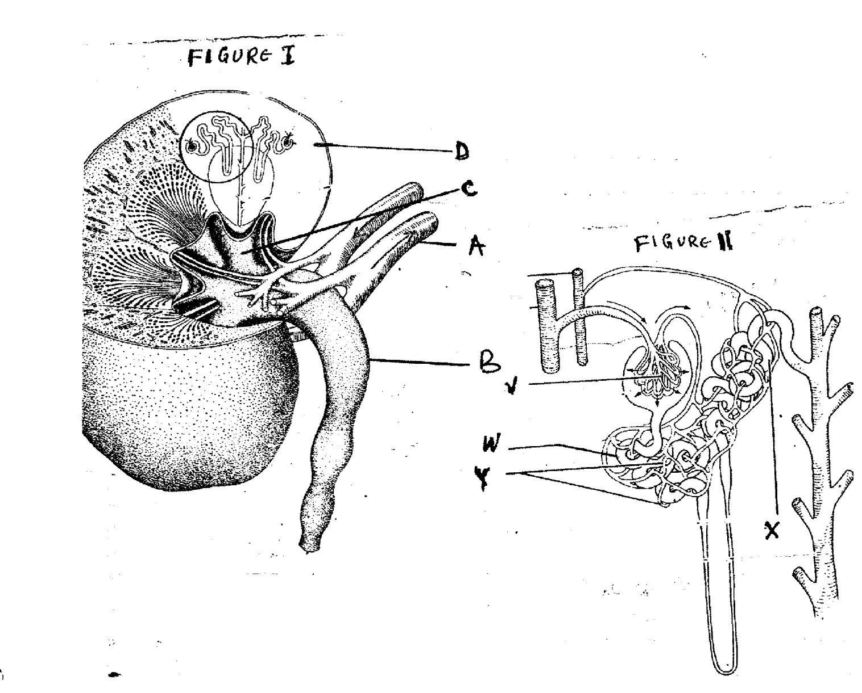
(a) (i) Name the parts labeled A, B, C and D in figure 1 (4mks)
A. ..................................................................................................................................
B. ..................................................................................................................................
C. ..................................................................................................................................
D. .................................................................................................................................
(ii) Name the parts labeled V, W, X and Y in figure 11. (4mks)
V. ................................................................................................................................
W. ...............................................................................................................................
X. ................................................................................................................................
Y. ...................................................................................................................................
(b) State two adaptations of part labeled W to its function (2mks)
..................................................................................................................................................................................................................................................................................................

(c) In the diagram, name the part where;
(i) Counter current flow occurs (lmk)
..................................................................................................................................................................................................................................................................................................

(ii) Reabsorption of water occurs (1mk)
..................................................................................................................................................................................................................................................................................................

(d) Explain what would happen to the process of urine formation in absence of anti-duiretic hormone (ADH) (3mks)
..................................................................................................................................................................................................................................................................................................
..................................................................................................................................................................................................................................................................................................
..................................................................................................................................................................................................................................................................................................

3. Examine the seedlings below and use them to answer the questions that follow:
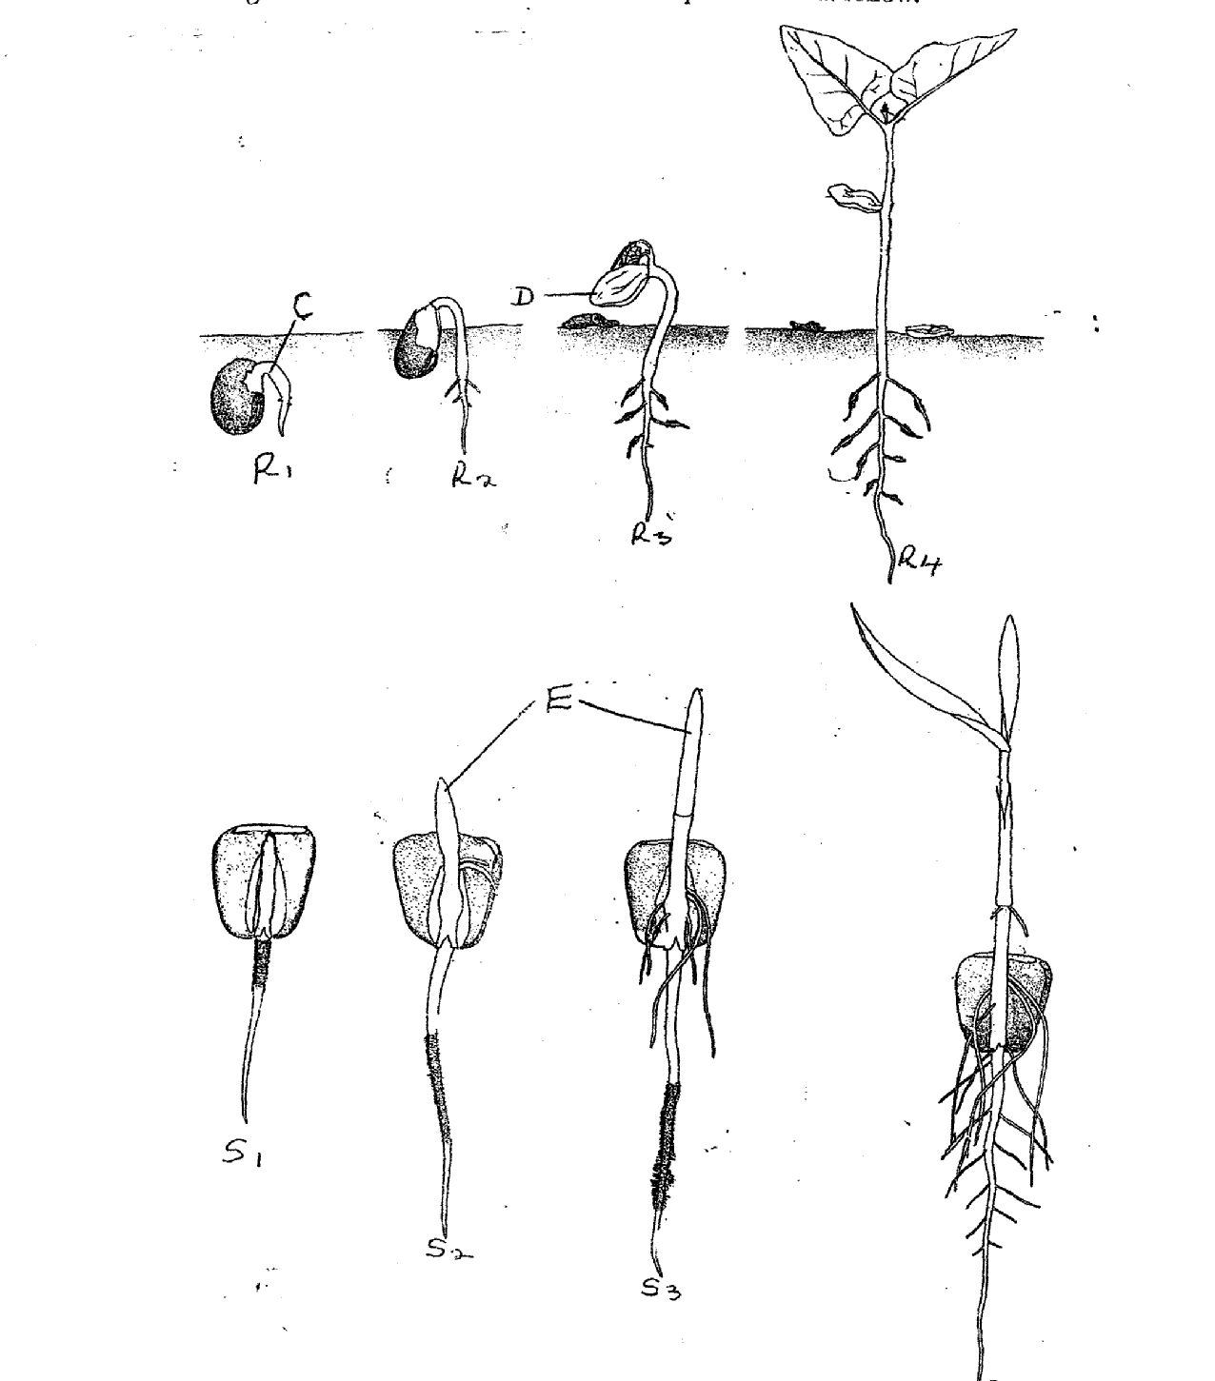
(a) Name the parts labeled C, D, E and state their importance for the seedling.
C: ....................................................................................................................... (1mk)
Importance (1mk)
..................................................................................................................................................................................................................................................................................................

D. ...................................................................................................................... (1mk)
Importance (2mks)
..................................................................................................................................................................................................................................................................................................
..................................................................................................................................................................................................................................................................................................
(ii) E. ....................................................................................................................... (lmk)
Importance. (lmk)
..................................................................................................................................................................................................................................................................................................

(b) The R series of seedlings on the roots later in its life:
(i) What is the name of the swelling: (lmk)
..................................................................................................................................................................................................................................................................................................

(ii) Name the organisms that would be found in the swellings (1mk)
..................................................................................................................................................................................................................................................................................................

(iii) Explain the relationship that exists between the named organisms and the plant.
(2mks)
..................................................................................................................................................................................................................................................................................................
..................................................................................................................................................................................................................................................................................................

(c) ( i) State the types of germination exhibited by R series of the seedlings. (1mk)
..................................................................................................................................................................................................................................................................................................

(ii) Give a reason for your answer in (c) (i) above. (1mk)
..................................................................................................................................................................................................................................................................................................

(d) State any two external factors necessary for germination. (2mks)
..................................................................................................................................................................................................................................................................................................
..................................................................................................................................................................................................................................................................................................

