Name ……………………………..………...…………. Index No……………………….…………….
School ………………………………………………... Candidate’s Signature ……………………… Date ………………...........................………..
231/3
BIOLOGY
PAPER 3
(PRACTICAL)
TIME: 1³/₄ HOURS

INSTRUCTIONS TO CANDIDATES
- Write your name and index number in the spaces provided
- Answer ALL the questions in spaces provided.
- You are required to spend the first 15 minutes of the 1 allowed for this paper reading the whole paper carefully before commencing your work.
- Additional pages must not be inserted.

FOR EXAMINER’S USE ONLY
Question | Max. Score | Candidate’s score
1 | 12
2 | 13
3 | 15
 | 40 | TOTAL SCORE

This paper consists of 6 printed pages.
Candidates should check to ensure that all the three questions are printed as indicated and no questions are missing.

- The photographs below are bones obtained from different regions of a mammalian body. The photographs are of different views.
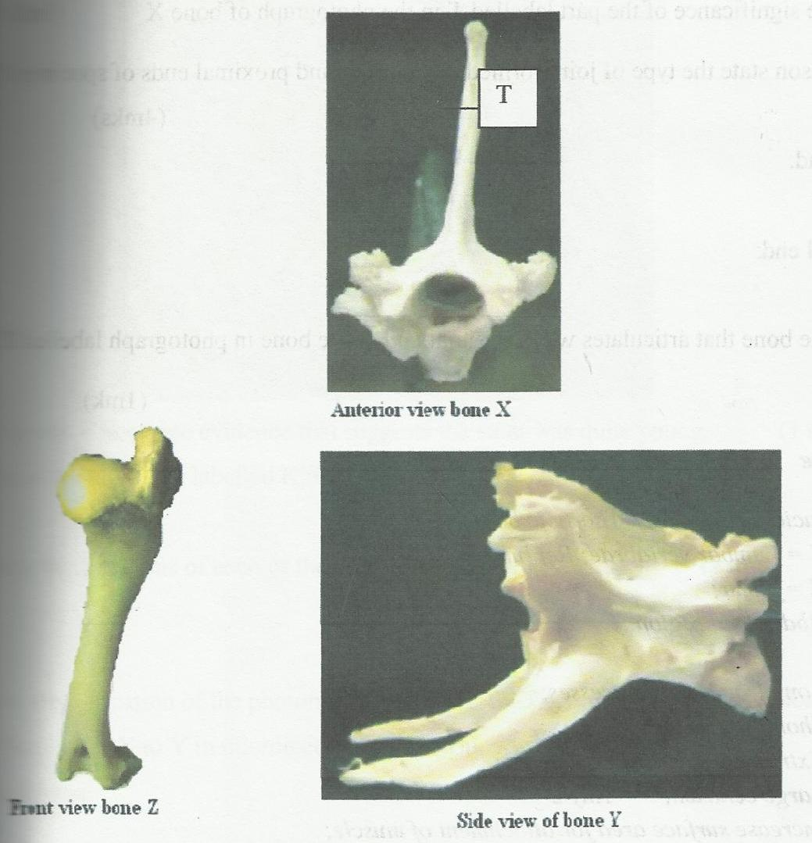
Anterior view of bone X
Front view of bone Z
Side view of bone Y
- Identify the bones. (3 marks)
X……………………………………………………………
Y……………………………………………………………
Z……………………………………………………………
- Name the regions from which bone Y was obtained from. (1 marks)
……………………………………………………………………………………………………………………………………………………………………………………………………………………………………………………………………………………………………………………………….
- State two distinguishing features of the bones in photograph labeled Y. (2 marks)
……………………………………………………………………………………………………………………………………………………………………………………………………………………………………………………………………………………………………………………………………………………………………………………………………………………………………………………………………………………………………………………………………………………
- State the significance of the part labeled T in the photograph of bone X. (1 mark)
………………………………………………………………………………………………………………………………………………………………………………………………………………………………………………………………………………………………………………………………
- With reason state the type of joint formed at the distal and proximal ends of specimen Z.( 4 marks)
- Distal end ……………………..……………………………………
Reason
………………………………………………………………………..……...…..…………………
………………………………………………………………………..……...…..…………………
- Proximal end. ……………………..……………………………………
Reason
………………………………………………………………………..……...…..…………………
………………………………………………………………………..……...…..………………………………………………………………………………………………………………………...
- Name the bone that articulates with the proximal end of the bone in photograph labelled Z. (1 mark)
……………………………………………………………………………………………………………………………………………………………………………………………………………………

- You are provided with photographs E, F,G,H,I,J,K,L and M below. Study them carefully to answer the questions that follow.
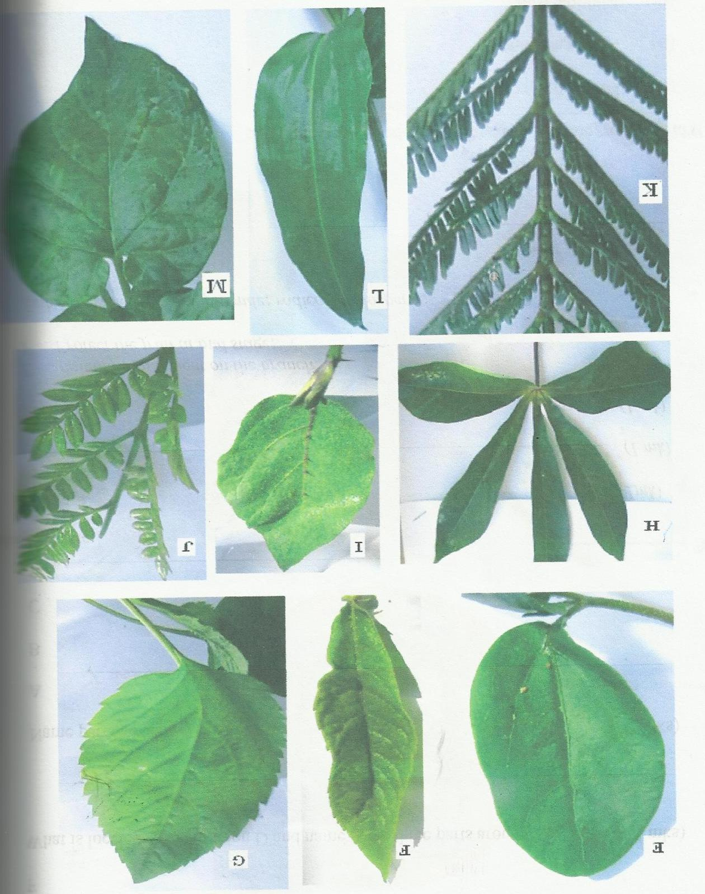
M
L
K
J
I
H
G
F
E

Using the observable features in the photographs, complete the dichotomous key given below. (4 marks)
- a) Simple leaf ………………………………Go to 2
b) Compound leaf……………………………Go to 7
- a) Leaves with parallel pains…………………Mexican marigold
b) ……………………………………….……Go to 3
- a) Leaves notched at the base ………………Phaseolus vulgaris
b) Leaves not notched at the base………… Go to 4
- a) Leaves with smooth margin ………………Croton megalocarpous
b) Leaves with serrated margin ………………Go to 5
- a) ……………………………………….……Solanumincunum.
b) Leaves smooth without hairs……………Go to 6
- a) Leaves shape cordate……………………Bidenspilosa.
b) Leaves shape linear ………………………Prunusdomestica
- a) Leaves palmate …………………………. Manihotesculentum
b) ……………………………………….……Go to 8
- a) ……………………………………….……Acacia Meansii
b) Leaflets rounded at tip…………………….Jacaranda Mimosifolia

b) Use the completed dichotomous key to identify the family to which each plant belongs. (9 marks)
Photograph Identity Steps followed
E ……………………………… …………………………………………………..
F ……………………………… …………………………………………………..
G ……………………………… …………………………………………………..
H ……………………………… …………………………………………………..
I ……………………………… …………………………………………………..
J ……………………………… …………………………………………………..
K ……………………………… …………………………………………………..
L ……………………………… …………………………………………………..
M ……………………………… …………………………………………………..

3. You are provided with suspension S.
- Using the materials provided, identify the food substances present in the suspension.
Record the procedures,observations and conclusions in the table below. (10 marks)
FOOD SUBSTANCE | PROCEDURE | OBSERVATIONS | CONCLUSION
- Using the deductions in (a) above state and explain ways in which a human body could benefit from suspension S. (5 marks)
…………………………………………………………………………………………………………
…………………………………………………………………………………………………………
…………………………………………………………………………………………………………
…………………………………………………………………………………………………………
…………………………………………………………………………………………………………
…………………………………………………………………………………………………………
…………………………………………………………………………………………………………
…………………………………………………………………………………………………………

