Name ……………………………..………...…………. Index No……………………….….………….
School ………………………………………………... Candidate’s Signature ……………………… Date ………………...........................………..

231/3
BIOLOGY
PAPER 3
(PRACTICAL)
TIME: 1³/₄ HOURS

INSTRUCTIONS TO CANDIDATES
- Write your name and index number in the spaces provided above
- Answer ALL the questions in spaces provided.
- You are required to spend the first 15 minutes of the 1 hours allowed for this paper reading the whole paper carefully before commencing your work.

FOR EXAMINER’S USE ONLY
Question | Max. Score | Candidate’s score
1 | 13
2 | 14
3 | 13
40
TOTAL SCORE

This paper consists of 6 printed pages.
Candidates should check to ensure that all pages are printed as indicated and no questions are missing.

1. Examine photographs P and M showing the two mammals and their skull (not drawn to scale).
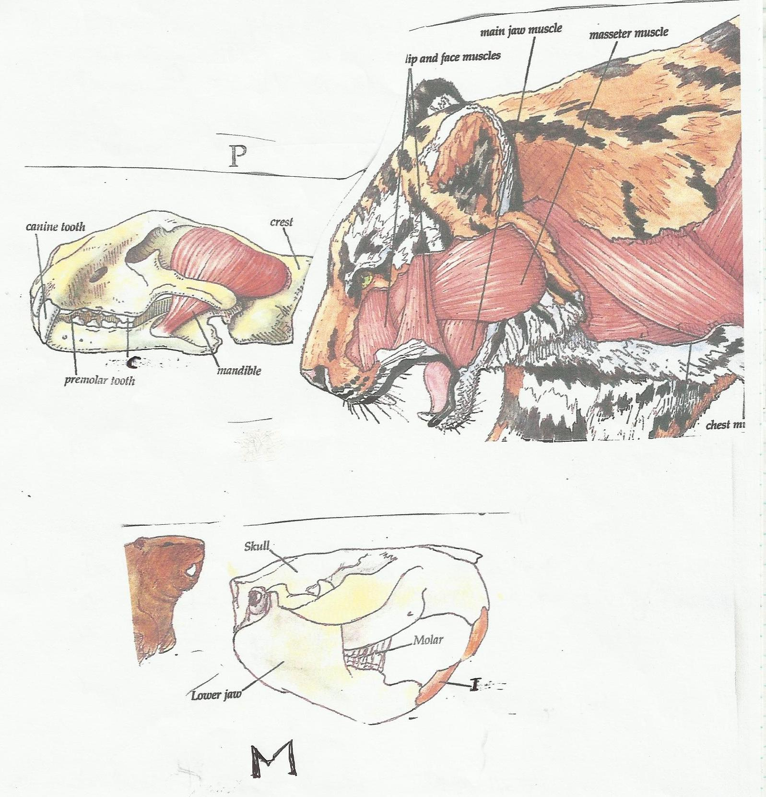
M
I
P
a) Giving reasons state the diet of the animals shown in the photographs.
P (1 mark)
…………………………………………………………………………………………………………….
Reason (2 marks)
…………………………………………………………………………………………………………….
…………………………………………………………………………………………………………….
…………………………………………………………………………………………………………….
…………………………………………………………………………………………………………….
M (1 mark)
…………………………………………………………………………………………………………….
Reasons (2 marks)
…………………………………………………………………………………………………………….
…………………………………………………………………………………………………………….
…………………………………………………………………………………………………………….
…………………………………………………………………………………………………………….
b) Label the teeth labelled C and I in photographs P and M respectively. (2 marks)
C ..……………………………………………………………………………………………………….
I …………………………………………………………………………………………………………
c) State one adaptation of the muscles labelled in photograph P to its mode of feeding. (1 mark)
…………………………………………………………………………………………………………….
…………………………………………………………………………………………………………….
d)i) Name the gap between teeth I and premolar teeth in the photograph M. (1 mark)
…………………………………………………………………………………………………………….
ii) State the importance of the gap named above. (1 mark)
…………………………………………………………………………………………………………….…………………………………………………………………………………………………………….
e) State one common characteristics that would make the above two animals to co-exist in the same environment. Though one is a predator and the other its prey. (2 marks)
…………………………………………………………………………………………………………….
…………………………………………………………………………………………………………….

2. Photographs G, R, I, S and T are plant organs. Photographs S and T show an association with insects. Study them carefully.
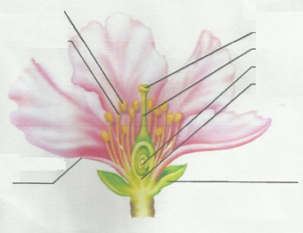
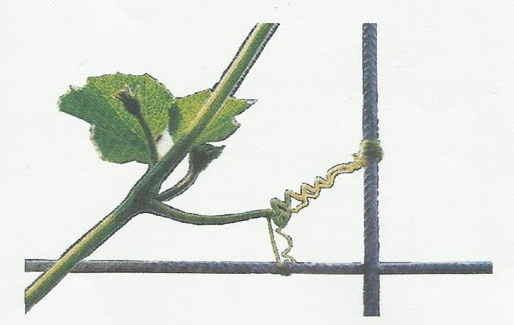

B
C
D
A
G

I
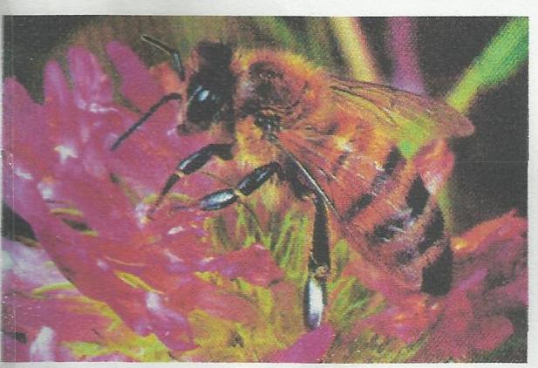
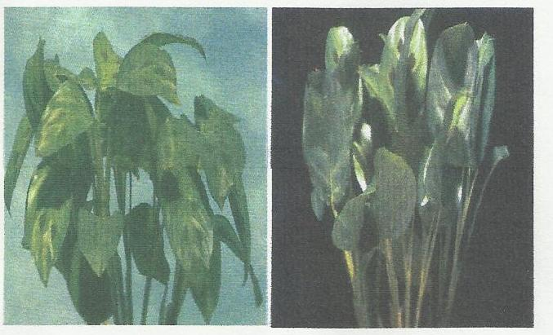
Insect
T
Insect

S
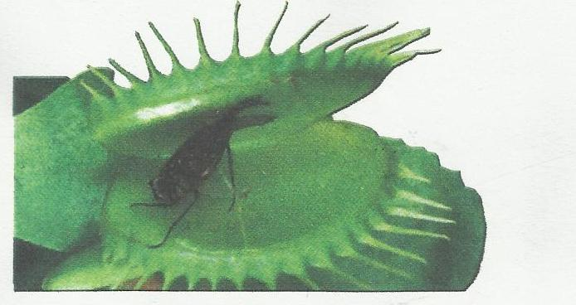
a) Name the type of response shown in photographs G, I and S. (3 marks)
G ………………………………………………
I ………………………………………………
S ………………………………………………
b) State the importance of the insects found in the photographs S and T to the plants. (2 marks)
S
…………………………………………………………………………………………………………….
T
…………………………………………………………………………………………………………….
c) Label the parts labelled A, B, C and D in photograph R. (4 marks)
A……………………………………………………
B……………………………………………………
C……………………………………………………
D……………………………………………………
d) Describe the type of ovary shown by specimen R. (1 mark)
…………………………………………………………………………………………………………….
…………………………………………………………………………………………………………….
…………………………………………………………………………………………………………….
e) Briefly explain how the process shown in photograph G is accomplished. (4 marks)
…………………………………………………………………………………………………………….
…………………………………………………………………………………………………………….
…………………………………………………………………………………………………………….
…………………………………………………………………………………………………………….
…………………………………………………………………………………………………………….
…………………………………………………………………………………………………………….

3. You are provided with a solution labelled X in solution form iodine solution, DCPIP and benedicts solution. Carry out test on the solution X to identify the type of food substances present. (9 marks)
a)
Food being tested | Procedure | Observation | Conclusion

b) i) State the fate of the food substances identified in solution X in mammals. (2 marks)
…………………………………………………………………………………………………………….
…………………………………………………………………………………………………………….
…………………………………………………………………………………………………………….
…………………………………………………………………………………………………………….
ii) Name the process in plants that leads to formation of the food substances present in solution X. (1 mark)
…………………………………………………………………………………………………………….
……………………………………………………………………………………………………………..
c) Name the hormone that regulate the amount of food substances present in solution X in a human blood. (1 mark)
…………………………………………………………………………………………………………….
…………………………………………………………………………………………………………….

