Name_________________________________________________________ Index No. ______________
Candidate’s signature _____
Date __________________

231/3
BIOLOGY
PAPER 3
PRACTICAL
1 ¾ HOURS

Kenya Certificate of Secondary Education
BIOLOGY
PAPER 3
1 ¾ HOURS

INSTRUCTIONS TO CANDIDATES
(a) Write your name and index number in the spaces provided above.
(b) Answer all the three questions in the spaces provided
(c) You are required to spend the first 15 minutes of the 1 ¾ hours allowed for this paper reading the whole paper carefully before commencing your work.
(d) Additional papers must not be inserted in this paper

For examiner’s use only
Question | Maximum score | Candidate’s score
1 | 21
2 | 07
3 | 12
Total score | 40

This paper consists of 5 printed pages
Turn Over
1. (a) Study the diagrams T₁ and S₁ carefully and answer the following questions:

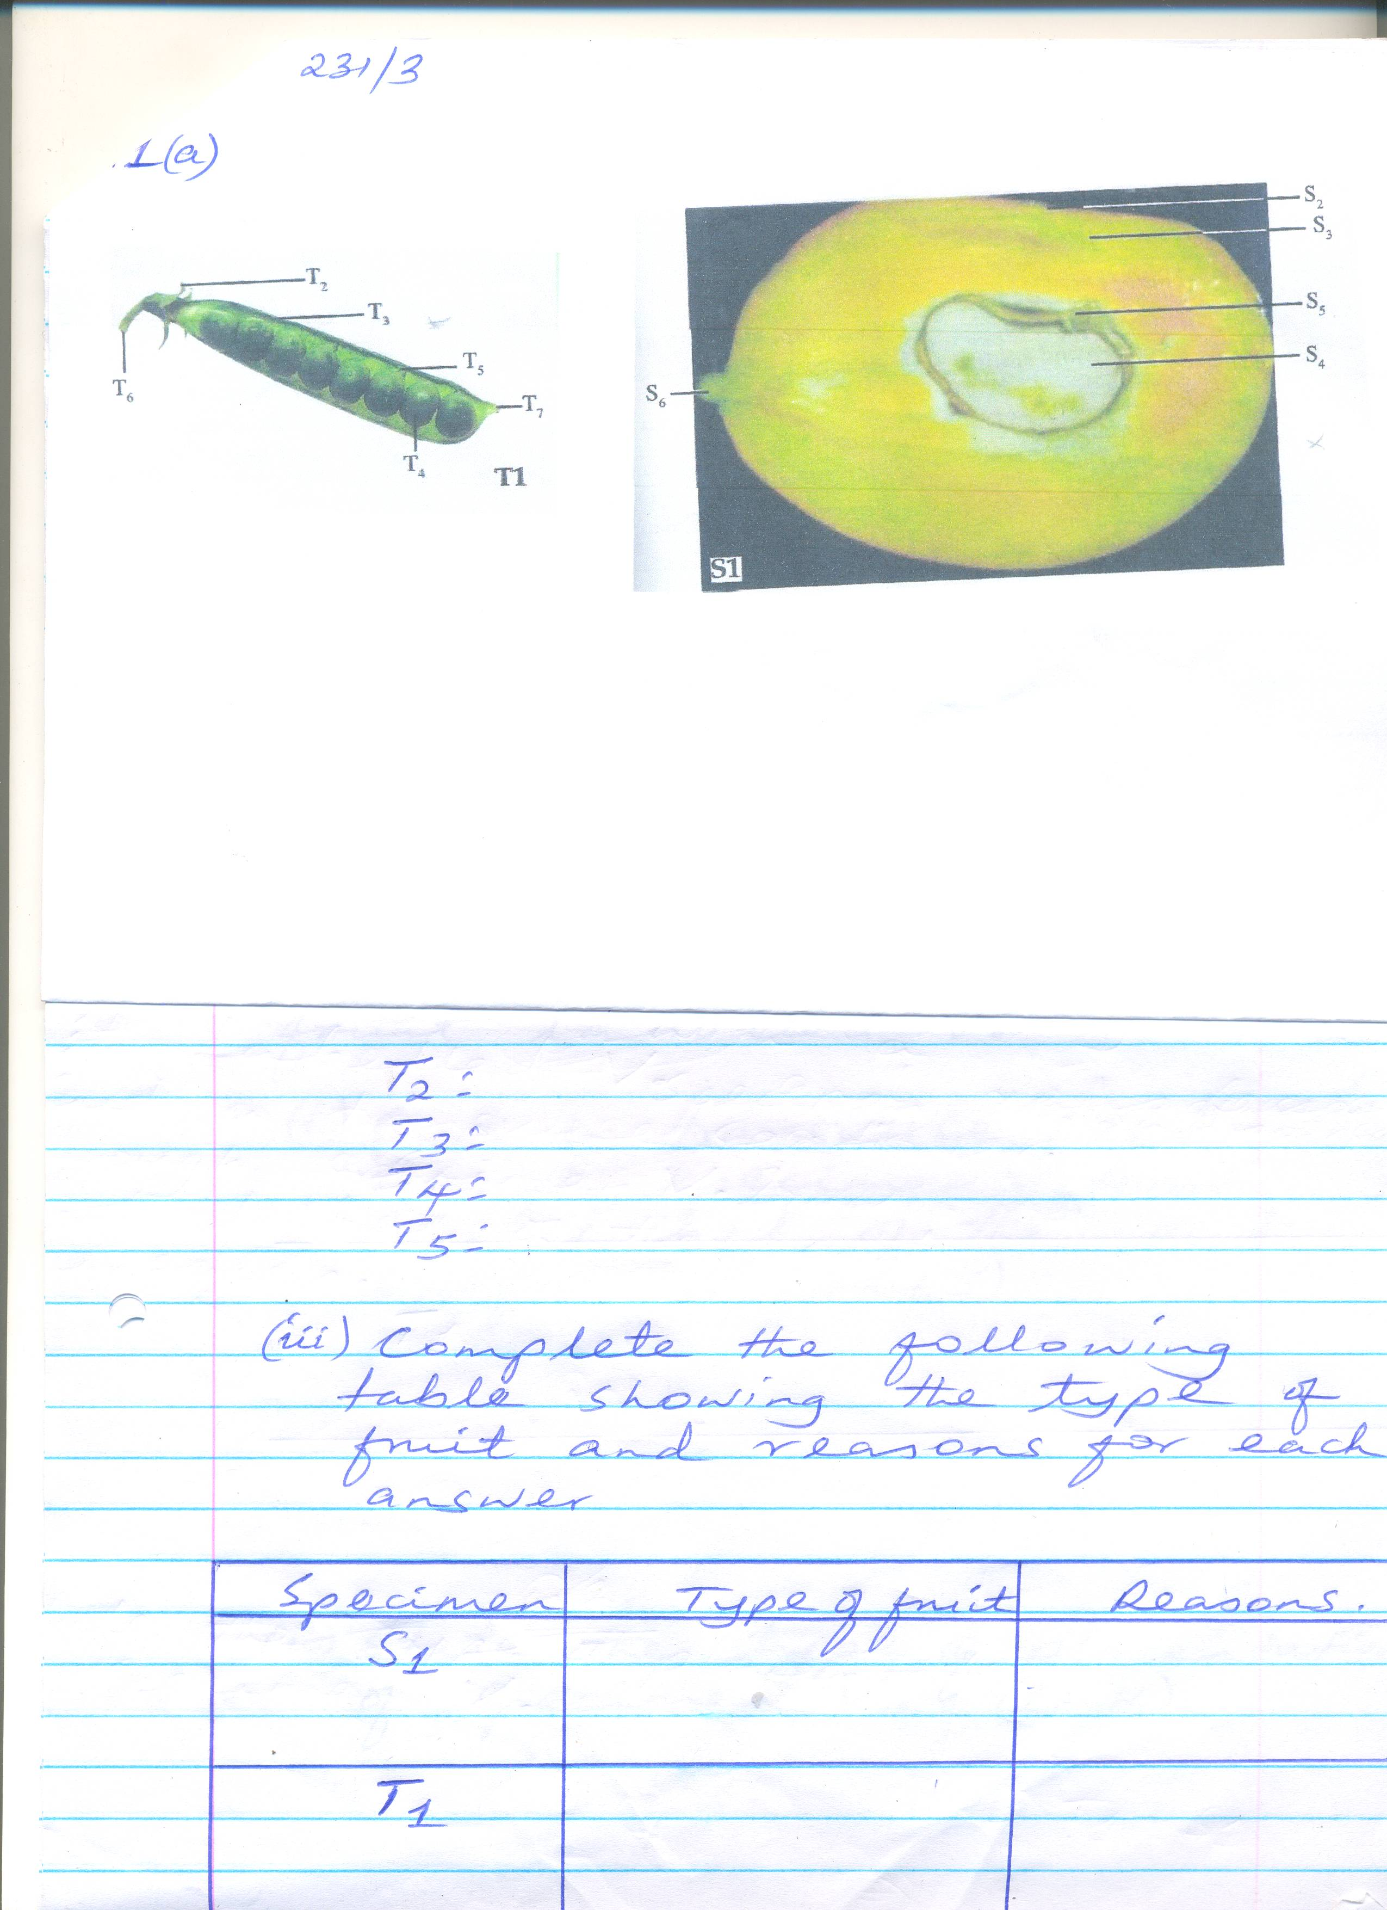

(i) Name the parts labeled S₂, S₃, S₄, S₅ and S₆. (5mks)
S2 __________________________________________________
S3 __________________________________________________
S4 __________________________________________________
S5 __________________________________________________
S6 __________________________________________________

(ii) Name the parts labeled T₂, T₃, T₄ and T₅. (4mks)
T₂ _________________________________
T₃ _________________________________
T₄ _________________________________
T₅ ________________________________

(iii) Complete the following table showing the type of fruit and reasons for each answer
Specimen | Type of fruit | Reasons
S₁
T₁

(iv) Complete the table below showing method of dispersal and reasons for each answer.

Specimen | Method of dispersal | Reasons
S₁
T₁
Max 2mks

(b) You are provided with a fruit labeled V.
(i) Cut a transverse section through specimen V. Draw and label of the cut surfaces. (4mks)

(ii) State the type of placentation of specimen V. (1mk)
_______________________________________________________________________________
_______________________________________________________________________________
_______________________________________________________________________________
(iii) Squeeze out the juice from one of the halves of specimen V. Using the reagents
provided carry out tests to identify the type of food substances present in the juice
Food substance | Procedure | Observation | Conclusion
(3mks)

2. Study the diagrams Q and R carefully and answer the following questions.

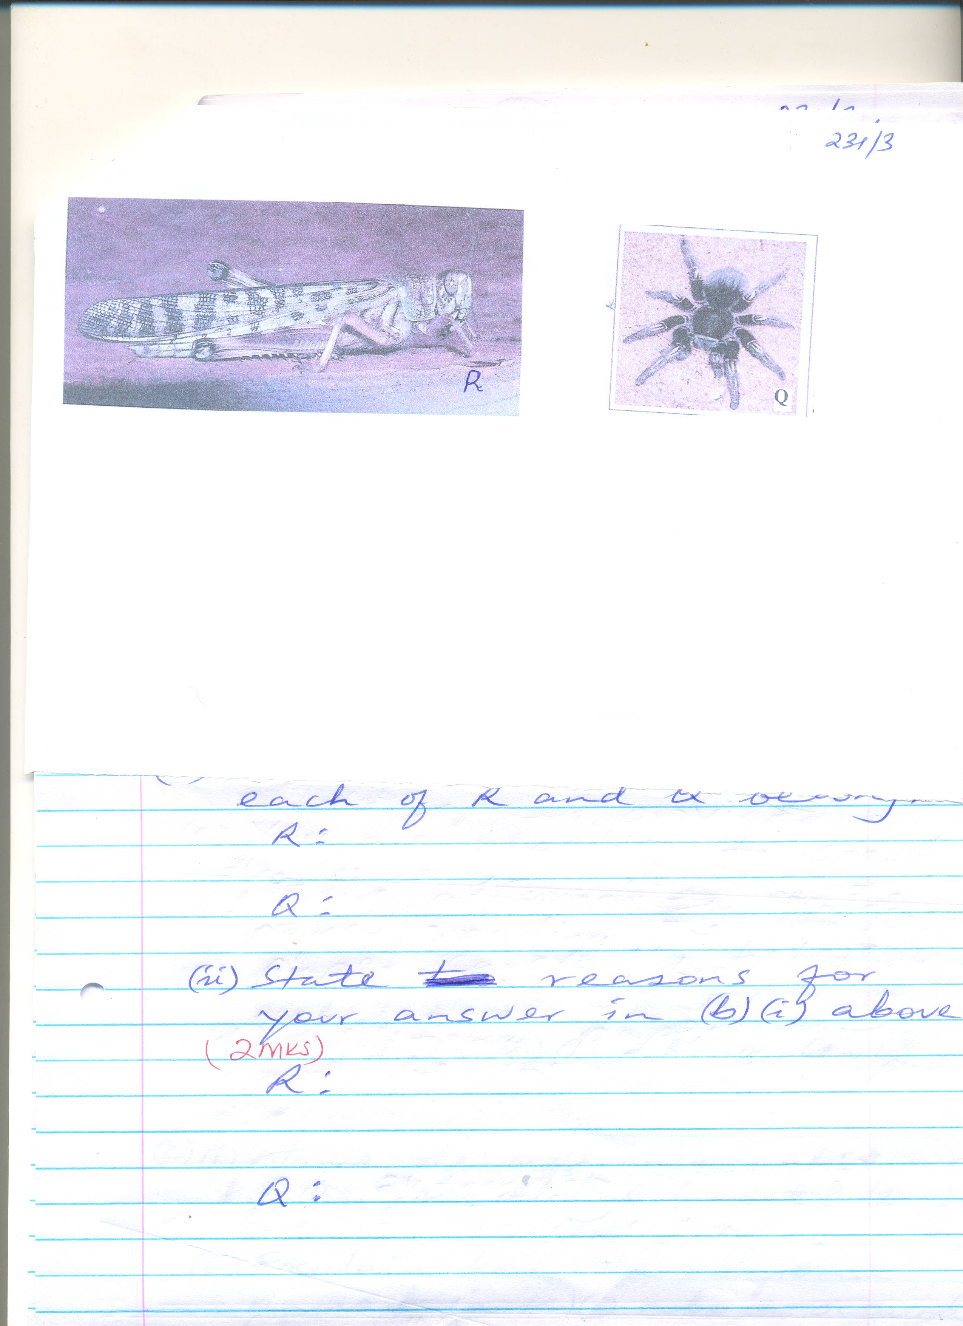

(a) (i) Name the phylum to which specimens R and Q belong. (1mk)
_______________________________________________________________________________
_______________________________________________________________________________
_______________________________________________________________________________
(ii) State two reasons for your answer in a (i) above. (2mks)
_______________________________________________________________________________
_______________________________________________________________________________
_______________________________________________________________________________
_______________________________________________________________________________
(b) (i) Name the class to which each of R and Q belong (2mks)
R _____________________________________
Q _____________________________________
(ii) State reasons for your answer in (b) (i) above (2mks)
R ______________________________________
Q ______________________________________
3. Study the diagrams set A₁, set E₁, set M₁ and set B carefully and answer the questions below

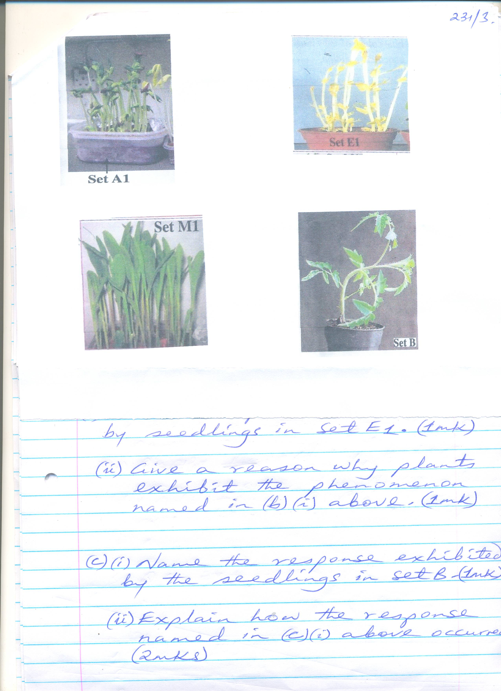

(a) State the conditions under which each set up was grown. (3mks)
Set A₁ ________________________________________
Set E₁ ________________________________________
Set B _________________________________________
(b) (i) Name the phenomenon exhibited by seedlings in set E₁ (1mk)
_______________________________________________________________________________
_______________________________________________________________________________
_______________________________________________________________________________
(ii) Give a reason why plants exhibit the phenomenon named in (b) (i) above (1mk)
_______________________________________________________________________________
_______________________________________________________________________________
_______________________________________________________________________________
(c) (i) Name the response exhibited by the seedlings in set B. (1mk)
_______________________________________________________________________________
_______________________________________________________________________________
_______________________________________________________________________________

(ii) Explain how the response named in (c) (i) above occurred (2mks)
_______________________________________________________________________________
_______________________________________________________________________________
_______________________________________________________________________________
_______________________________________________________________________________
(d) (i) State the type of germination exhibited by seedlings in set A₁ and set M₁. (2mks)
Set A1 __________________________________________________________________
Set M1 __________________________________________________________________
(ii) Give a reason for your answer in (d) (i) above (2mks)
Set A1 ___________________________________________________________________
Set M₁ ____________________________________________

