Name:…………………………………………………………………. Adm.No.: ……..…...............................
Candidate’s sign …………..…………….... Date: …………..………………

231/3

BIOLOGY

Paper 3

(Practical)

INSTRUCTIONS TO CANDIDATES
- Write your name and index number in the spaces provided above.
- Sign and write the date of examination in the spaces provided above.
- You are required to spend the first 15 minutes of the 1 ¾ hours allowed for this paper reading the whole paper before commencing your work
- Additional papers must not be inserted
- This paper consist of 4 printed pages..
- Candidates may be penalized for recording irrelevant information and incorrect spelling especially of technical terms.

For Examiner’s Use Only

Question | Maximum Score | Candidate’s score
1 | 12
2 | 11
3 | 17
Total score

This paper consists of 4printed pages. Candidates should check to ascertain that all pages are printed as indicated and that no questions are missing.

1. You are provided with a suspension labeled M which contain food substances. You are also provided with Iodine solution, Benedicts solution, dilute hydrochloric acids, dilute sodium hydrogen carbonate, copper sulphate and dilute sodium hydroxide. Carry out tests to determine the food substance . (12mks)

Food substrate being tested (1) | Prodecure (1) | Observation (1) | Conclusion (1)

PHOTOGRAPH K

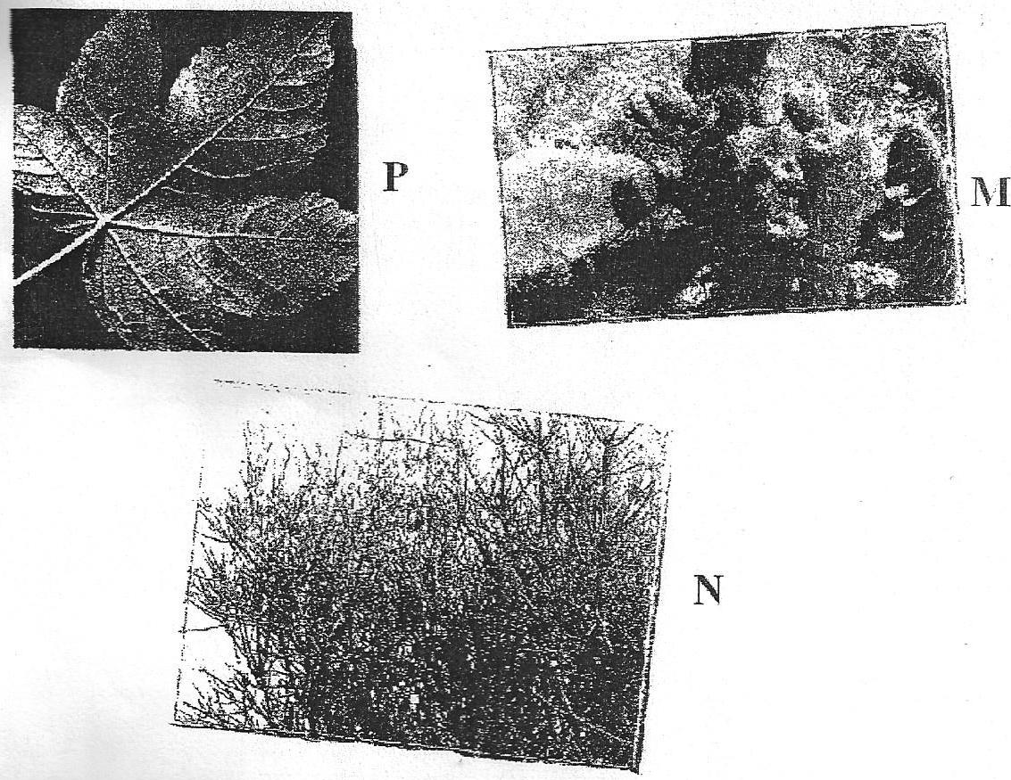

PHOTOGRAPH J

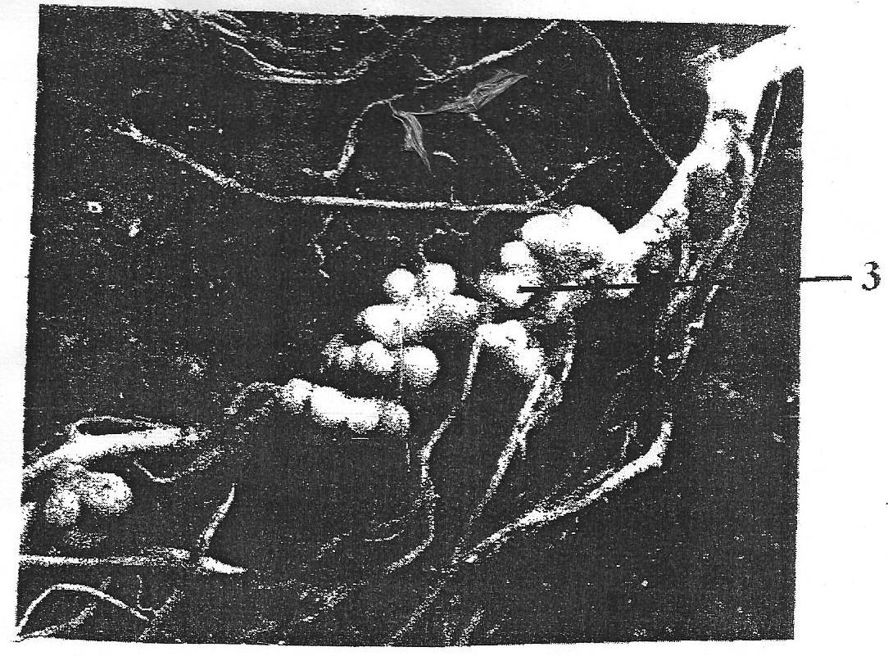

2. Photographs J and K are taken from certain organs of plants. Study them carefully and answer questions questions below.
(a) (i) With reference to photographs J, what is the name of the smelling marked 3 (1mk)
(ii) Name the organisms that would be found in these smellings (1mk)
(iii) Explain the relationship that exists between the named organisms and the plant (3mks)
(b) (i) With reference to photograph K, state the habitats of leaves labeled: (3mks)
M…………………………………………………………………………………………
N………………………………………………………………………………………....
P…………………………………………………………………………………………
(ii) Using observable features, state three ways in which leaf M is adapted to survive in its habitat (3mks)
……………………………………………………………………………………………………….
……………………………………………………………………………………………………….
……………………………………………………………………………………………………….

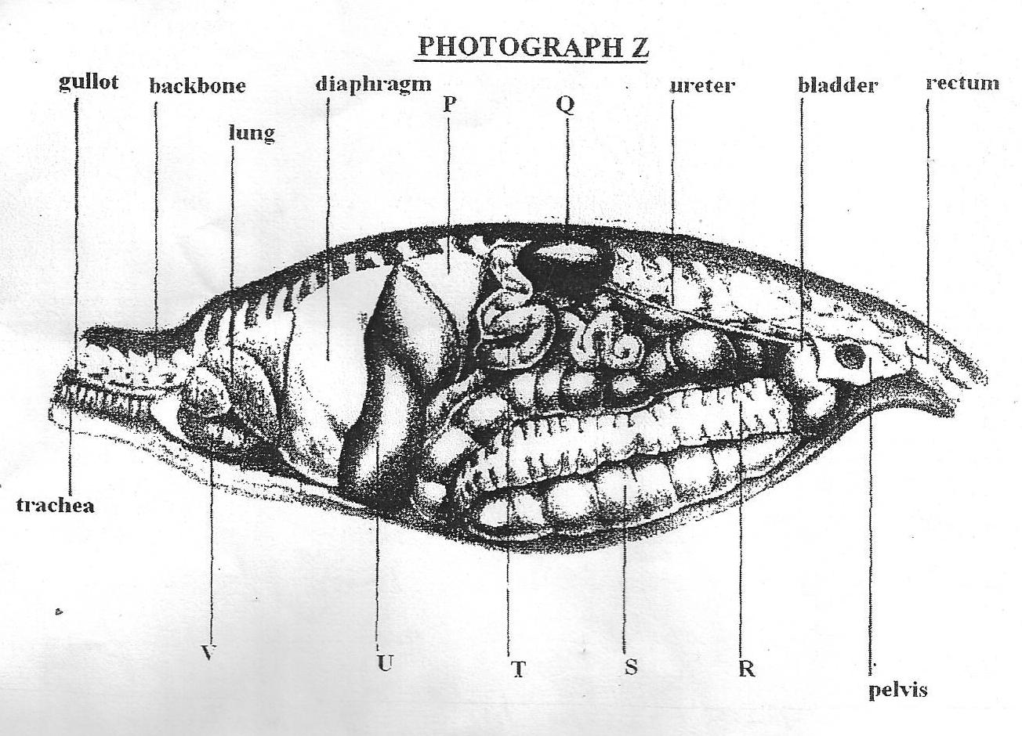

3. The photograph Z shows some of the main structure found inside the body of a mammal as seen from the side . Study it carefully.
(a) (i) Label the parts marked P – V (7mrks)
P .......................................................................................................................
Q ......................................................................................................................
R.......................................................................................................................
S ......................................................................................................................
T .....................................................................................................................
U ......................................................................................................................
V .....................................................................................................................
(ii) On the photograph, indicate where absorption of water by the body takes place. (1mrk)
(b) (i) State the function of part marked T (2mrks)
..................................................................................................................................................

...................................................................................................................................................
(ii) State two ways in which the part marked T in b (i) above is adapted to perform its function (2mks)
……………………………………………………………………………………………………........
………………………………………………………………………………………………………....
(c) State two functions of part marked Q (2mks)
……………………………………………………………………………………………………….
……………………………………………………………………………………………………….
(d) State three homeostatic function of structure U (3mks)
……………………………………………………………………………………………………….
……………………………………………………………………………………………………….
……………………………………………………………………………………………………….

