NAME: …………………………………………. INDEX NO: ……………………………….

SCHOOL: ……………………………………… CANDIDATE’S SIGNATURE: …………

DATE : ……………………………………

231/3
BIOLOGY
PAPER 3
(PRACTICAL)
TIME: 1 ¾ HOURS

INSTRUCTIONS TO CANDIDATES:
- Write your Name and Index Number in the spaces provided.
- Sign and write the Date of Examination in the spaces provided.
- Answer all the questions in the spaces provided.
- You are required to spend the first 15 minutes of the 1 ¾ hours allowed for this paper reading the whole paper carefully before commencing your work.
- Additional pages must not be inserted.
- This paper consists of 3 printed pages.
- Candidates should check the question paper to ascertain that all the pages are printed as indicated and that no questions are missing.

FOR EXAMINER’S USE ONLY
QUESTION | MAX. SCORE | CANDIDATE SCORE
1 | 16
2 | 12
3 | 12
TOTAL | 40
SECTION A (40 MARKS)
Answer all questions in this section in the spaces provided.

- You are provided with photographs of specimens labeled S1, S2, Q, X and Y. Examine them carefully and answer the questions that follow.
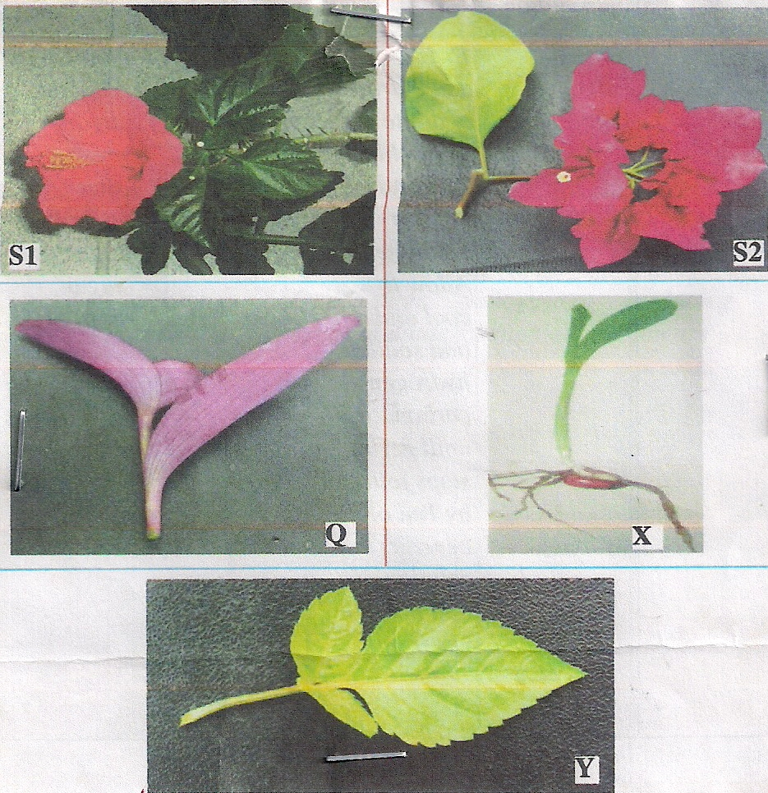

      - Using observable features in the photographs, complete the dichotomous key given below. (3mks)
- (a) Leaves parallel veined …………………………………………… …. go to 2
(b) Leaves net veined……………………………………………………… go to 3
- (a) Leaves green………………………………..…………………… Graminae
(b) Leaves purple …..…………………………………………….Commelinaceae
- (a) Leaves simple …………………………..……………………… …. go to 4
(b) ___________________………………………………………………… go to 5
- (a) Leaves margin smooth ………………………………………Nyctaginaceae
(b) ___________________……………………………………….……Malvaceae
- (a) Trifoliate leaf ……………………..……………………………….Asteraceae
(b) _____________________………………………………….…………Cassia

      - Use the completed dichotomous key to identify the family to which each specimen belongs. (10mks)
SPECIMEN STEPS FOLLOWED IDENTITY
S1 …………………………………………….. ……………….
S2 …………………………………………….. ……………….
Q …………………………………………….. ……………….
X …………………………………………….. ……………….
Y …………………………………………….. ……………….
      - State how specimen S2 is adapted to its mode of pollination. (3mks)
…………………………………………………………………………………………….………………………………………………………………………………………………………………………………………………………………………………………………….
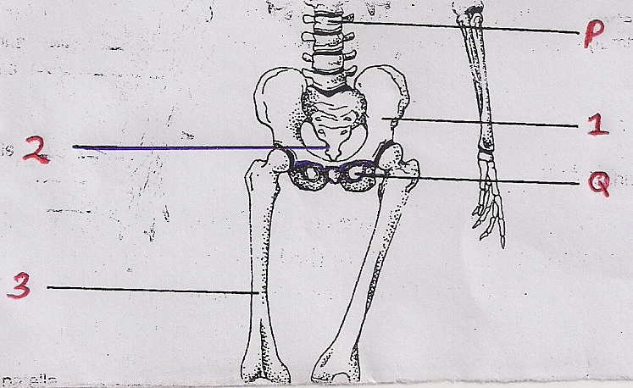
- Below is a photograph obtained from the pelvic region of a human being and showing some bones of the vertebral column. Examine it carefully and answer the questions that follow.

      - Identify the bones labeled 1, 2 and 3. (3mks)
1:…………………………………………………………………………………………….
2:…………………………………………………………………………………………….
3:…………………………………………………………………………………………….
      - (i) Name the type of joint formed at the proximal end of bone 3 as it articulates with the adjacent bone. (1mk)
………………………………………………………………………………………………
(ii) Give an observable feature on bone 3 for your answer in (b) (i) above. (1mk)
………………………………………………………………………………………………
      - (i) Identify the part labeled P. (1mk)
………………………………………………………………………………………………
(ii) Give two functions of the part identified in (c) (i) above. (2mks)
………………………………………………………………………………………………………………………………………………………………………………………………
      - Using observable features only, state how bone 1 is adapted to its functions.
(2mks)
………………………………………………………………………………………………………………………………………………………………………………………………
      - (i) Identify the part labeled Q. (1mk)
………………………………………………………………………………………………
(ii) Give the function of the part labeled Q. (1mk)
………………………………………………………………………………………………
- You are provided with a sample of food labeled X in solution form, solution Y (Benedict’s Solution), solution J (DCPIP), Solution K (Sodium hydrogen carbonate), Solution L (1% copper sulphate), solution M (Dilute hydrochloric acid) solution N (sodium hydroxide) and filter paper. Carry out tests on the food sample to identify the type of food substance present. (12mks)
Food being tested for | Procedure | Observation | Conclusion

