Name: …………………………………………………………… Index no ……..…...................................

School: ……………………………………………………....…. Candidate’s sign ……………………....

Date: ……………………………………………………………

231/3
BIOLOGY
PAPER 3
Practical

INSTRUCTIONS TO CANDIDATES:
- Write your name and index number in the spaces provided.
- Sign and write date of examination in the spaces provided above
- Answer all the questions in section A and B
- You are required to spend the first 15 minutes of the 1 ¾ hours allowed for this paper reading the whole paper carefully.

For Examiner’s Use Only:
QUESTIONS | MAXIMUM SCORE | CANDIDATES SCORE
1 | 14
2 | 15
3 | 11
TOTAL | 40

This paper consists of 4printed pages. Candidates should check to ascertain that all papers are printed as indicated and that no questions are missing

1. Examine the photographs below and answer the questions that follow.
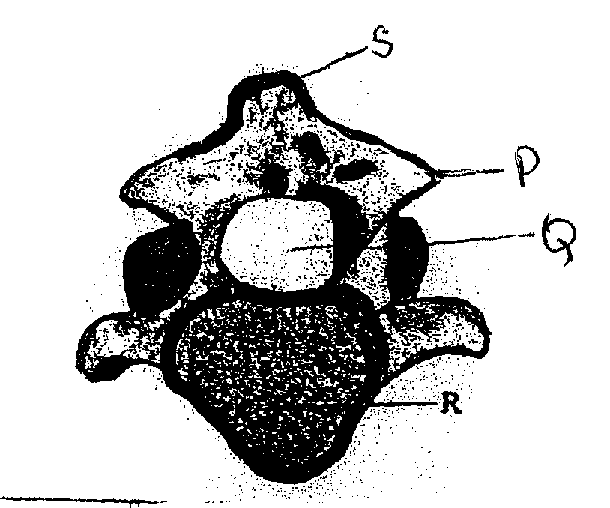
S

P

Q

R

1 (a) Label the parts M N O P (4mks)
M…………………………………………………..
N…………………………………………………..
O…………………………………………………..
P …………………………………………………..
(b) Identify the fused bones.
(1mk)
…………………………………………………………….……………………………………………….

(c) Name the;
(i) Bone that articulates at the point labeled M.
(1mk)
…………………………………………………………….……………………………………………….
(ii) The hole labeled R.
(1mk)
…………………………………………………………….……………………………………………….

(d)( i) Give the identity of bone Q and R. (2mks)
Q…………………………………………………..
R…………………………………………………..
(ii) Give one reason each for your answer in d(i) above ( 2mks)
Q …………………………………………………..

R …………………………………………………..

(e) Give three differences between bone Q and R ( 3mks)
…………………………………………………………….……………………………………………….
…………………………………………………………….……………………………………………….
…………………………………………………………….……………………………………………….
…………………………………………………………………………………………………………….
……………………………………………………………………………………………………………..

2. Below is an electron micrograph study it and answer the questions that follow.

(a) Identify the following parts. (6mks)
A………………………………….. D…………………………………..
B………………………………….. E…………………………………..
C………………………………….. F…………………………………..
(b) State the kingdom of the organism from which the micrograph was taken. (1mk)

…………………………………………………………….……………………………………………….
c) Give two reasons for your answer in (b) above. (2mks)
…………………………………………………………….……………………………………………….
…………………………………………………………….……………………………………………….
…………………………………………………………………………………………………………….
…………………………………………………………………………………………………………….

d) How many cells can be seen? (1mk)
…………………………………………………………….……………………………………………….
e) What is the function of the parts labeled G,H and J. (3mks)
G………………………………………………………….…………………..
H………………………………………………………………….…………..
J………………………………………………………..……………………..

f) State the role of the parts labeled D and F (2mks)
…………………………………………………………….……………………………………………….
…………………………………………………………….……………………………………………….
……………………………………………………………………………………………………………..
……………………………………………………………………………………………………………..
3. You are provided with bean seeds that have been soaked for 48hours.
i) Crush them using a pestle and mortar. Add 6 ml of water to the paste. Divide the mixture into
two portions then use the mixture to carry out test.

Using the following reagents-iodine solution, sodium hydroxide, Copper II sulphate solution provided . put your results in the table below.
Test | Procedure | Observation | Conclusion

ii) State the functions of the food substance(s) you have found to the seed during germination. (3mks)
…………………………………………………………….……………………………………………….
…………………………………………………………….……………………………………………….
…………………………………………………………….……………………………………………….
…………………………………………………………….……………………………………………….
…………………………………………………………….……………………………………………….
…………………………………………………………….……………………………………………….
…………………………………………………………….……………………………………………….
…………………………………………………………….……………………………………………….
……………………………………………………………………………………………………………..

……………………………………………………………………………………………………………..

