NAME: -------------------------------------------------- INDEX NO: ----------------------
231/3 CANDIDATES SIGNATURE:-
BIOLOGY DATE: ----------------------------
PAPER 3 (PRACTICAL)
TIME 1 ¾ HOURS

INSTRUCTIONS TO CANDIDATES
- Write your name and index number in the space provided above.
- Sign and write the date of examination in the space provided above.
- Answer all questions in the spaces provided in this question paper.
- You are supposed to spend the first 15 minutes of the 1 ¾ hours allowed for this paper reading the whole paper carefully before commencing your work.
- Additional pages must not be inserted.
- Candidates should check the question paper to ascertain that all the pages are printed as indicated and no questions are missing.

Questions | Maximum Score | Candidates
1 | 12
2 | 12
3 | 16
Total | 40

1a) You are provided with specimen W push a cork borer through specimen W to remove 4 cylinders of potato tissue. Cut off one end of each cylinder. From the cut end measure 40 mm lengths and cut the cylinder. Repeat this for the other three cylinders. Put 25ml of solution X in a beaker labelled X and 25ml of solution Y in a beaker labelled Y. Place two cylinders in a beaker containing solution Y and the other two in a beaker containing solution X. Leave the experiments for 45 minutes. After 45 minutes remove the cylinders and mop them up with a tissue paper. Measure and record the length of each cylinder in the table below. (8mks)

Cylinder in solution | Initial length | Final Length | Average length | % change in length
X 1

2
1
Y
2

b) Account for observations made in solution

- X (2mks)

- Y (2mks)

2. Peel the remaining potato and crush it completely using a mortar and pestle. Add 25m of solution S and stir well. Crush the potato further. Put the solution in a beaker leaving out the residue in mortar. Label the solution as B. Divide solution B in four portions in test tubes and carry out food tests using the reagents provided. Complete the table below. (12mks)

Food Substance | Procedure | Observation | Conclusion

3) Study photographs C and D and answer the questions.

PHOTOGRAPH B
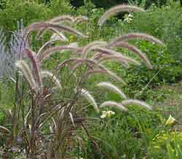

PHOTOGRAPH C

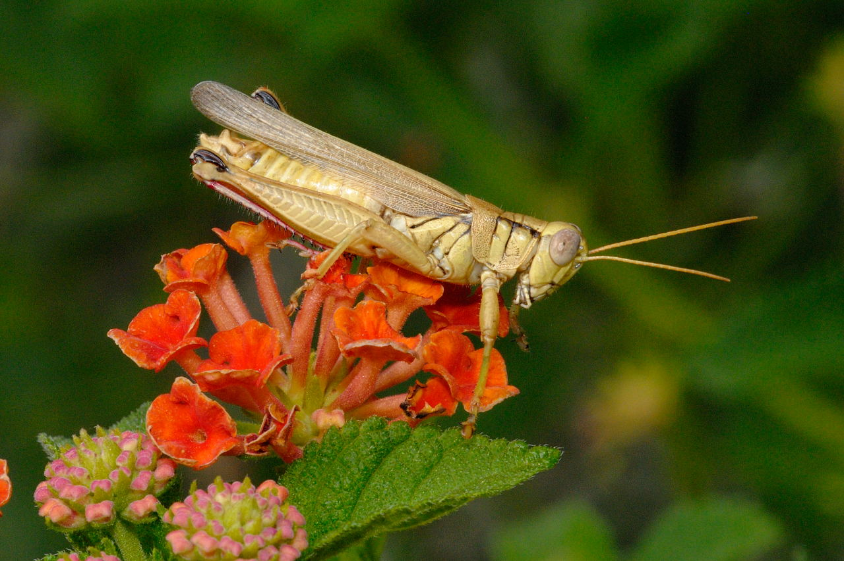

- With a reason state the agent of pollination of each of the flowers. (4mks)

Flower | Agent of pollination | Reason
C
D

- Classify the animal in photograph D using the taxonomic units below and reasons for your answer. (4mks)

Taxonomic unit |  | Reason
Phylum

Class

- The diagrams below shows a type of cell division occurring in animal shown on photograph D. Identify each of the stages A to D giving reasons for your answer. (4mks)

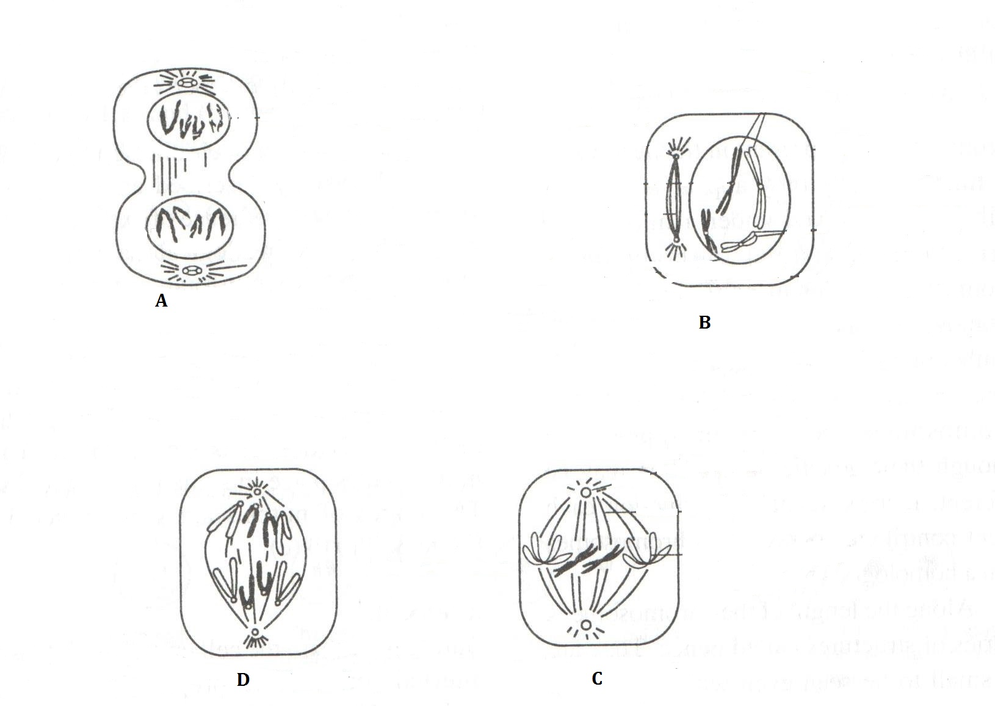

Stage Reason

A ---------------------------------------------- ----------------------------

B --------------------------------------------- -----------------------------

C. --------------------------------------------- -----------------------------

D, -------------------------------------------- -----------------------------

