NAME: ………………………………………………..………………… INDEX NO: ………………………
SCHOOL: ……………………………..……………………………….. DATE: …………………………..
CANDIDATE’S SIGNATURE: ………………….…..……………

231/3
BIOLOGY
(PRACTICAL)
PAPER 3
TIME: 1 ¾ HOURS

Kenya Certificate of Secondary Education(K.C.S.E)

BIOLOGY
Paper 3

INSTRUCTIONS TO CANDIDATES:
- Write your name school and index number in the spaces provided at the top of this page.
- Sign and write date of examination in the spaces provided above
- Answer all the questions
- You are required to spend the first 15 minutes of the 1 ¾ hours allowed for this paper reading the whole paper carefully before commencing your work.
- Answers must be written in the spaces provided in the question paper.
- Additional page must not be inserted.
- Candidate will be penalized for recording irrelevant information and wrong spelling especially of technical terms

For Examiner’s Use Only:

QUESTIONS | MAXIMUM SCORE | CANDIDATES SCORE
1 | 10
2 | 15
3 | 15
TOTAL | 40

This paper consists of 6 printed pages. Candidates should check to ascertain that all pages are printed as indicated and that no questions are missing.
1. You are provided with seven specimens of plants. They are labelled D1, D2, D3, D4, D5, D6, and D7
The dichotomous key.
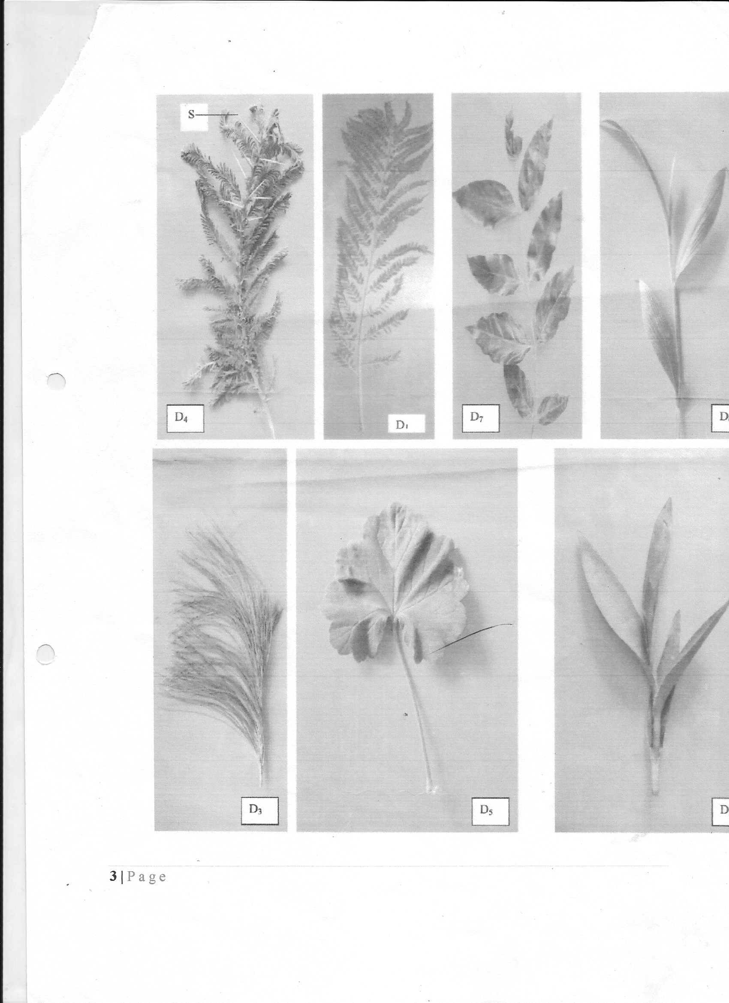

D₃
D₆
D₇
D₁
D₄

D₂
D₅

1a) Leaves needle-like…………………………………………………………Go to 2
b) Leaves broad………………………………………………………………Go to 3
2a) Leaves arranged in clusters on stem…………………………………………Pinaceae.
b) Leaves not arranged in clusters on stem…………………………………….Araucariaceae
3a) Leaves compound…………………………………………………………..Go to 4
b) Leaves simple………………………………………………………………Go to 7
4a) Leaves pinnate……………………………………………………………Go to 5
b) Leaves bipinnate………………………………………………………….Go to 6
5a) Leaflet attached to many small stalks that join to the main one……………Mimosaceae
b) Leaflets attached to one stalk……………………………………………….Rosaceae
6a) Leaflets attached to many small stalks that join the main one………………Bignonaceae.
b) Leaflets attached to one stalk………………………………………………..Compositae.
7a) Leaves green…………………………………………………………………Go to 8
b) Leaves purple………………………………………………………………..Go to 9
8a) Leaves parallel veined………………………………………………………Graminaceae
b) Leaves net veined……………………………………………………………..Geranaceae
9a) Leaves parallel veined……………………………………………………….Commelinacea
b) Leaves not veined…………………………………………………………….Euphorbiaceae

Use the ditochomous key to identify the taxonomics groups of each of the specimens in the photographs
provided. (5mks)
Specimen Steps followed Identity
D1 ……………………………………… ………………………………
D3 ……………………………………… ……………………………….
D5 ……………………………………… ……………………………….
D6 ……………………………………… ……………………………….
D7 ……………………………………… ……………………………….

(b) (i) Suggest the possible habitat that specimen D4 is adapted to (1mk)
…………………………………………………………………………………………………………
(ii) Name one observable feature that adapts D4 to the habitat you have mentioned in (b) (i)
above (1mk)
…………………………………………………………………………………………………………
(iii) State the importance of the structure labelled S oin specimen D4. (1mk)
…………………………………………………………………………………………………………
(c) (i) The stem of specimen D2 was squeezed strongly. State the expected observations. (1mk)
…………………………………………………………………………………………………………
(ii) Suggest how specimen D2 is adapted to its habitat. (1mk)
…………………………………………………………………………………………………………
- The photographs lebelled R, S, T and V are bones obtained from a mammal.

Examine them.
- Identify the bones and name the part of the mammalian body from which each bone was obtained.
(4mks)
Bone | Identify | Where found
R
S
T
V

(b) (i) Name the joint formed between bones S and T at point marked X. (1mk)
…………………………………………………………………………………………………………
(ii) Give the characteristics of the joint named in (b) (i) above. (1mk)
…………………………………………………………………………………………………………
(c) (i) Name the bone structure labeled Y. (1mk)
…………………………………………………………………………………………………………
(ii) State one function of the bone structure named in C (i) above. (1mk)
…………………………………………………………………………………………………………
(d) (i) Using observable features give two adaptations of the bone labeled R. (2mks)
…………………………………………………………………………………………………………
…………………………………………………………………………………………………………
(ii) On bone V, draw a diagram of bone R to show the articulation between the two bones. (2mks)
…………………………………………………………………………………………………………
…………………………………………………………………………………………………………
(e) Name the part labelled Z in the bone S and state its function. (2mks)
Part Z …………………………………………………………………………………………………
Function …………………………………………………………………………………………………
…………………………………………………………………………………………………
- Name the joint formed by bone T with adjacent bone at its distal end. (1mk)
…………………………………………………………………………………………………………

3. You are provided with the following:
- Solution labelled A
- Benedict’s solution labelled solution B
- Solution C
- 0.1% NaCl solution
- 1.4% / NaCl solution
- Iodine solution labelled solution E
Label three test tubes, P, Q and R. Into each test-tube, place 3ml of the solution C
- Put a drop of solution P on a white tile and add a drop of iodine (solution E)
Repeat the procedure for each test tube Q and R.
Record your observations in the table below. (3mks)

Test-tube | Observation
P
Q
R

- To test tube Q add 3 drops of 0.1% sodium chloride solution and 2ml of solution A. To test
tube R, add three drops of 1.4% sodium chloride solution and 2ml of solution A. Place the test tube P. Q and R in a water bath and maintained at 37⁰C for 30 minutes. Using a drop of the solution from each test tube, repeat the procedure in (a) above and spare the rest for next question. Record your observations in the table below. (3mks)

Test-tube | Observation at the end of experiment
P
Q
R

(c) Put 2cm³ of solution from test tube P in a clean test tube and add 2cm³ of Benedict (solution B)
shake then heat the mixture to boil in a hot water bath.
Record your final observations in the table below.
Repeat the procedure for solution Q and R. (3mks)

Test-tube | Observation after experiment
P
Q
R

(d) Why was the test tube P included in the experiment? (1mk)
…………………………………………………………………………………………………………
- Account for observations made in test tube Q and R at the end of the experiment.
(i) Test tube Q (2mks)
…………………………………………………………………………………………………………
…………………………………………………………………………………………………………
- Test tube R
…………………………………………………………………………………………………………
…………………………………………………………………………………………………………
- Suggest the identity of solution A. (1mk)
…………………………………………………………………………………………………………
(h) Why was the water bath maintained at 37⁰C? (1mk)
…………………………………………………………………………………………………………

