Name: …………………………………………………………… Index no ……..…...................................
School……………………………………………………………. Candidate’s sign ………………….…...
Date: ……………………………

231/3
BIOLOGY
PAPER 3(PRACTICAL)
TIME: 1HOUR 45MINUTES

Kenya Certificate of Secondary Education (K.C.S.E.)
Biology
Paper 3 (practical)
Time: 1hr 45minutes

INSTRUCTIONS TO CANDIDATES:
- Write your name, index number and school in the spaces provided above.
- Sign and write the date of examination in the spaces provided above
- Answer all the questions in the spaces provided
- You are required to spend the first 15 minutes of the 1 ¾ hours allowed for this paper reading the whole paper carefully before commencing your work.
- Additional pages must not be inserted.
- Candidates should check to a certaiin that all pages are printed as indicated.

For Examiner’s Use Only:
QUESTIONS | MAXIMUM SCORE | CANDIDATE’S SCORE
1 | 14
2 | 15
3 | 11
TOTAL | 40

This paper consists of 4 printed pages. Candidates should check to ascertain that all pages are printed as indicated and that no questions are missing
1. You are provided with the specimen labelled N. examine it and answer the questions that follow.
(a) Giving a reason, state the group of succulent fruits specimen N belongs to?
Group (1mk) ……………………………………………………………………………………………………………………………………………………………………………………………………………………
Reason (1mk) ………………………………………………………………………………………………………….
(b) (i) Name the dispersal agent of specimen N. (1mk)
………………………………………………………………………………………………………..
(ii) Give two observable for adaptation of specimen N to the agent named in b(i) above. (2mk) …………………………………………………………………………………………………………
…………………………………………………………………………………………………………
(c) Using a scapel, obtain a transverse section of specimen N. Draw a plan diagram of a cut surface of one half and label the parts. (5mks)

(d) Squeeze about 5mls of juice from specimen N into a test-tube.
(i) Using the juice obtained, calculate the approximate percentage of ascorbic acid (vitamin C) contained, given that 12 drops of 0.1% ascorbic acid decolourises 1cm³ of DCPIP. (3mks)

(iii) Using the remaining juice of specimen N carry out iodine test;
Record your observation. (1mk)
…………………………………………………………………………………………………………..
2. The photograph labelled 1, 2, and 3 below are bones obtained from a mammal. Examine them and answer questions that follow.
PHOTOGRAPH 3
PHOTOGRAPH 2

(a) (i) Identify the bones in photographs 1, 2, and 3 and state where found. (6mks)
 | Identify | Region where found
Photograph 1
Photograph 2
Photograph 3
(ii) Namethe parts labelled J and K (2mks)
…………………………………………………………………………………………………………
…………………………………………………………………………………………………………
(iii) State the use of each of the parts labelled S and T. (2mks)
S …………………………………………………………………………………………
T …………………………………………………………………………………………
(b) State one difference between part labelled L and photograph 2 and the same part as observed in photograph 1. (1mk)
…………………………………………………………………………………………………………
(c) State the function of the part labelled M (1mk)
…………………………………………………………………………………………………………
(d) Name the type of joint at the part labelled T (1mk)
…………………………………………………………………………………………………………
(e) Using observable features only, state any two adaptations of the bones in photograph 3 to its functions. (2mks)
………………………………………………………………………………………………………….
………………………………………………………………………………………………………….

3. Complete and use the dichotomous key below to identify the organisms. (1mk)
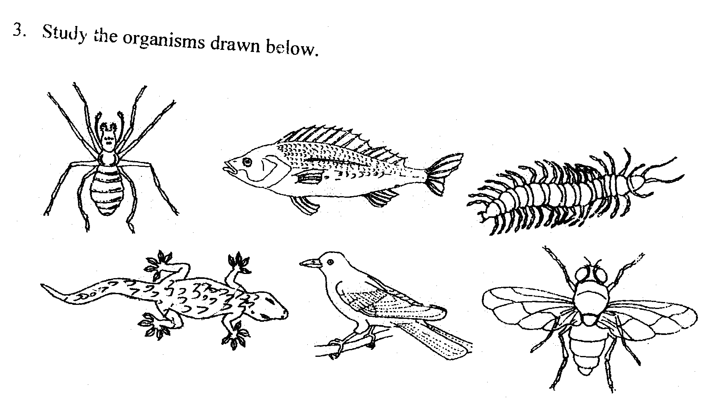

1 a Vertebrates ………………………………………………..go to 2
b ……………………………………………………………..go to 3
2 a Has scales on the body …………………………………….go to 4
b Has no scales on the body …………………………………mammalia
3 a Has cephalothorax …………………………………………Arachnida
b Has no cephalothorax ………………………………………go to 5
4 a Has fins ……………………………………………………Pisces
b Has no fins ………………………………………………….go to 7
5 a Has three pairs of legs ……………………………………..Insecta
b Has more than three pairs of legs …………………………go to 6
6 a two pairs of legs per segment ………………………………Diplopoda
b One pair of leg per segment ……………………………….Chilopoda
7 a Has feathers ……………………………………………….Aves
b Has no feathers …………………………………………….go to 8
8 a Has a tail …………………………………………………… Reptilia
b Has no tail …………………………………………………..Amphibia

(ii) (10mks)
Specimen | Steps followed | Identity
A
B
C
D
E
F

