Name: …………………………………………………………… Index no ……..…...................................

School: ……………………………………………………....…. Candidate’s sign ……………………....

Date: ……………………………………………………………

231/3
BIOLOGY
PAPER 3
JULY /AUGUST 2011
TIME: 1 ¾ HOURS

Kenya Certificate of Secondary Education (K.C.S.E.)

Biology
Practical

INSTRUCTIONS TO CANDIDATES:
- Write your name and index number in the spaces provided.
- Sign and write date of examination in the spaces provided above
- Answer all the questions in section A and B
- You are required to spend the first 15 minutes of the 1 ¾ hours allowed for this paper reading the whole paper carefully.
For Examiner’s Use Only:

QUESTIONS | MAXIMUM SCORE | CANDIDATE’S SCORE
1 | 14
2 | 14
3 | 12
TOTAL | 40

This paper consists of 4printed pages. Candidates should check to ascertain that all papers are printed as indicated and that no questions are missing

PHOTOGRAPHS FOR QUESTION 2

1 You are provided with a solution labeled S, reagents Iodine, copper sulphate, sodium hydroxide and Benedict’s solution. Use the reagents to carry out food tests on solution S.
Record your working in the table below. (12 marks)

FOOD  SUBSTANCE | PROCEDURE | OBSERVATION |  | CONCLUSION

2. The photographs labeled J, L, M, N & P different views of three different bones from
are a mammalian skeleton. Examine them.
(a) Identify and name the parts labeled: (8 marks)
1. 5.
2. 6.
3. 7.
4. 8.
(b) State the functions of the parts labeled:
1.
6.
7.
Name the type of joint found between the two bones L and M (1 mark)

…………………………………………………………………………………………………………….

PHOTOGRAPHS FOR QUESTION 3
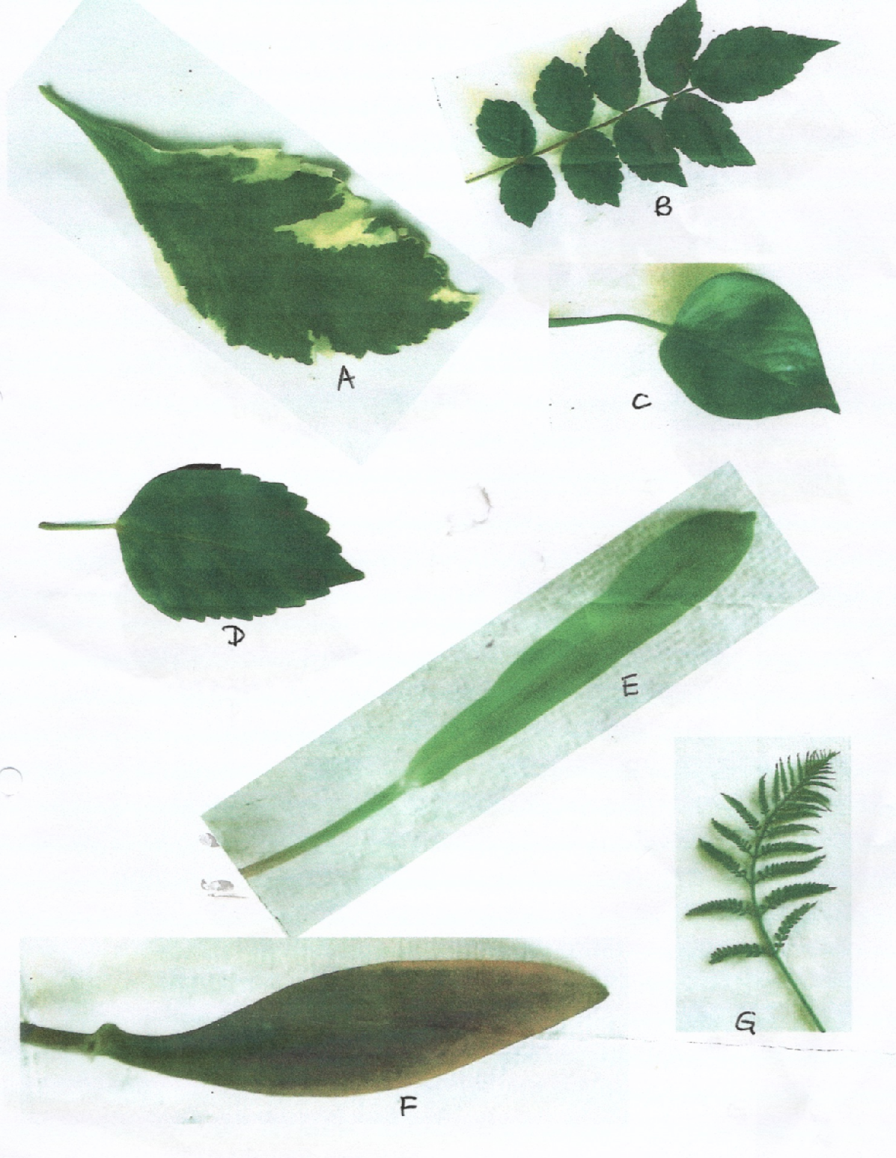

3. (a) Below is a dichotomous key constructed for the plants shown in the photograph above.
1. (a) Smooth margin leaf…………………………………………….......Go to 2
(b) Serrated margin leaf ………………………………………………Go to 4
2. (a) Leaf with network veins……………………………………………. Money plant
(b) Leaf with parallel veins …………………………………………….Go to 3
3. (a) Purple leaf…………………………………………………………… Zebrina
(b) Green leaf …………………………………………………………….Grass
4. (a) Compound leaf ………………………………………………………Go to 5
(b) Simple leaf …………………………………………………………..Go to 6
5. (a) Pinnate leaf………………………………………………………….. Pistia
(b) Bipinnate leaf……………………………………………………….. Jacaranda
6. (a) Variegated leaf ………………………………………………………Geranium
(b) Green leaf. ……………………………………………………………Hibiscus

(b) Fill the table below for the identity and steps from the key for the plants labeled A B C D EFG.
(14 marks)
Plant | Identity | Steps
A
B
C
D
E
F
G

(c) State the classes to which plants E & C belong. (2 marks)

E ………………………………………………………………………………………………………...

C………………………………………………………………………………………………………...

