Name: …………………………………………………………… Index no ……..…...................................

School: ……………………………………………………....…. Candidate’s sign ……………………....

Date: ……………………………………………………………

231/3
BIOLOGY
PAPER 3
TIME: 2 HOURS

Kenya Certificate of Secondary Education (K.C.S.E.)

INSTRUCTIONS TO CANDIDATES:
- Write your name and index number in the spaces provided.
- Sign and write date of examination in the spaces provided above
- Answer all the questions in section A and B
- You are required to spend the first 15 minutes of the 1 ¾ hours allowed for this paper reading the whole paper carefully.

For Examiner’s Use Only:
QUESTIONS | MAXIMUM SCORE | CANDIDATES SCORE
1 | 15
2 | 15
3 | 10
TOTAL | 40

This paper consists of 4printed pages. Candidates should check to ascertain that all papers are printed as indicated and that no questions are missing
- You are provided with iodine solution benedict’s solution, solution s, solution p source of heat and a warm water bath. Divide solution S into two equal halves in test tubes provided. Take one halve and carry out the food test. Fill the table below. (6mks)

Food | Procedure | Observation | conclusion

Food | Procedure | Observation | conclusion
b) (i) Take the other half of solution S add 2ml of solution P and place the contents in a warm water bath maintained at 37ºC to 40ºC for 30 minutes. After carry out the same tests as in 1(a) above and record your procedure observation and conclusions in the table below. (4mks)

(ii) Account for the results obtained in b(i) above (4mks)
……………………………………………………………………………………………………………
……………………………………………………………………………………………………………
……………………………………………………………………………………………………………
……………………………………………………………………………………………………………
(iii) Why was the solution in b(i) above kept in a water bath maintained at temperature of between
37ºC to 40ºC (1mk)
……………………………………………………………………………………………………………
……………………………………………………………………………………………………………

2. (a) Study the photographs below and complete the Biological key below.
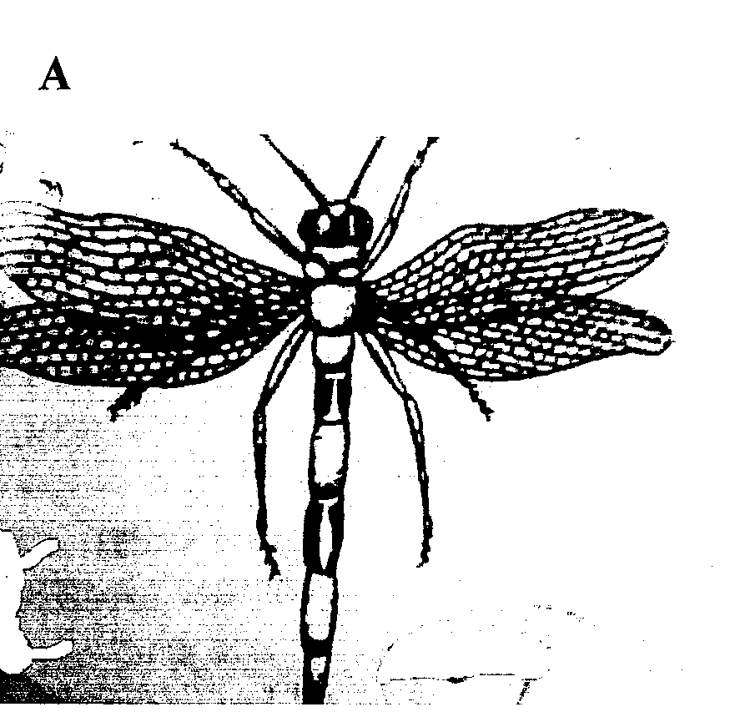
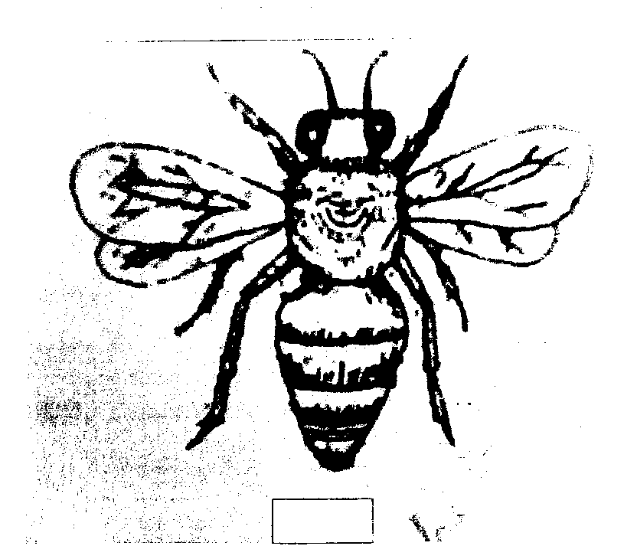
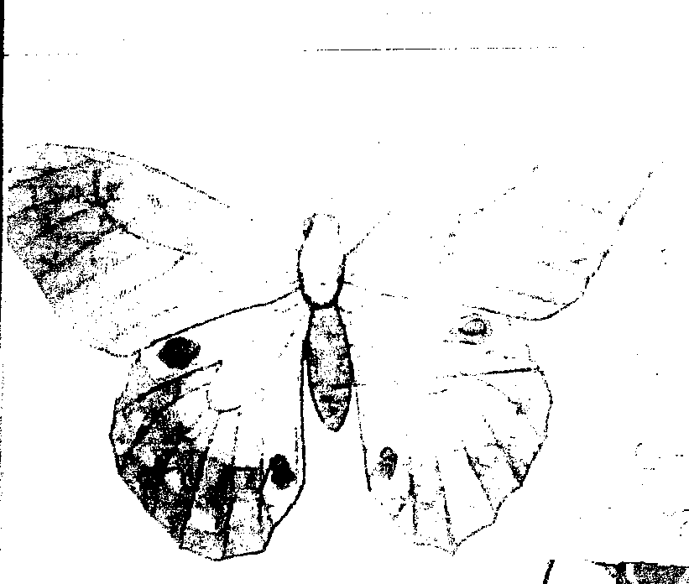
C
B

A
G
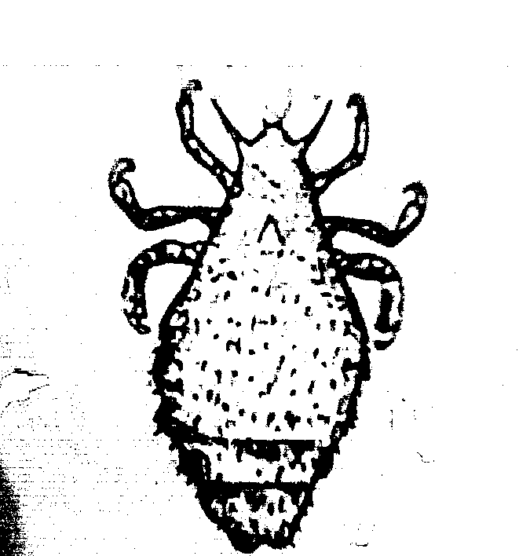

1 (a) Wigns present…………………………………………….…. go to 2
(b)________________ …………………………………………. go to 7

2 (a) Two pair of wings ………………………………………..…. go to 3
(b)_______________ ………………………………………..…. Diptera.
3 (a) Both pairs of wings membranoues. ………………………… go to 4
(b) Only hind wings membranoues……………………………. go to 6

4 (a) Long abdomen……………………………………………..…. Odonata
(b)Medium sized abdomen……………………………………… go to 5

5 (a) Both pairs of wings with coloured scales…………………… Lepidotera
(b)Wings not coloured with coloured scales…………………… Hymenoptera
6 (a) Forewings with hard and shell like…………………………… Coleoptera
(b) Front wings hard but not shell like…………………………… Orthoptera
7 (a) Body horizontally flattened……………………………………Anoplura
(b)_______________ ………………………………………….…. Siphonoptera

- Use the completed key to identify the organisms in the photograph. (8mks)
 | Identity | Steps followed
A
B
C
D
E
F
G
H

c) With reasons state the phylum to which the specimens in the photographs belong.
Phylum………………………………….. (1mk)
Reasons………………………………….. (3mks)
3. Photoographs below shows responses of plants under different conditions. Photographs B₁ and B₂
shows responses of mimosa pudica before and after and that of C₁ and C₂ arte that of Maranta Lenconeura before and after the response.
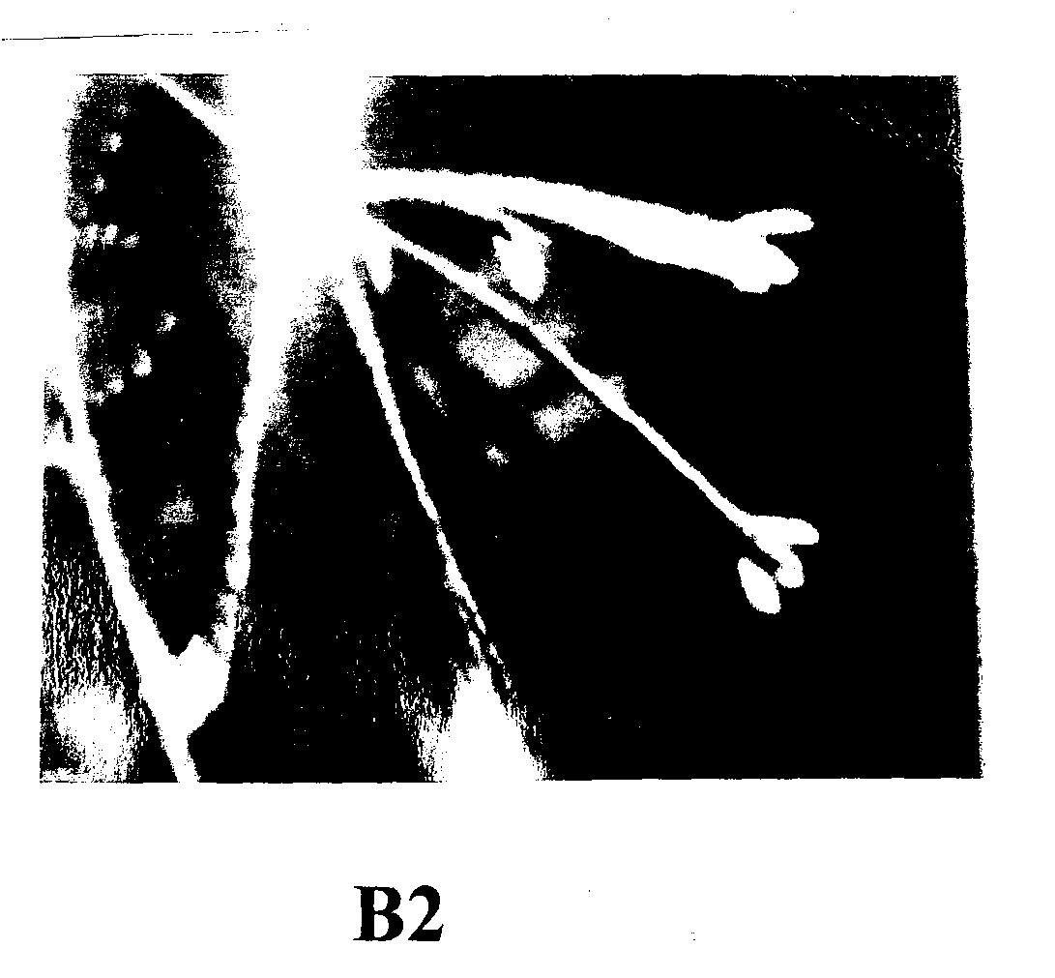
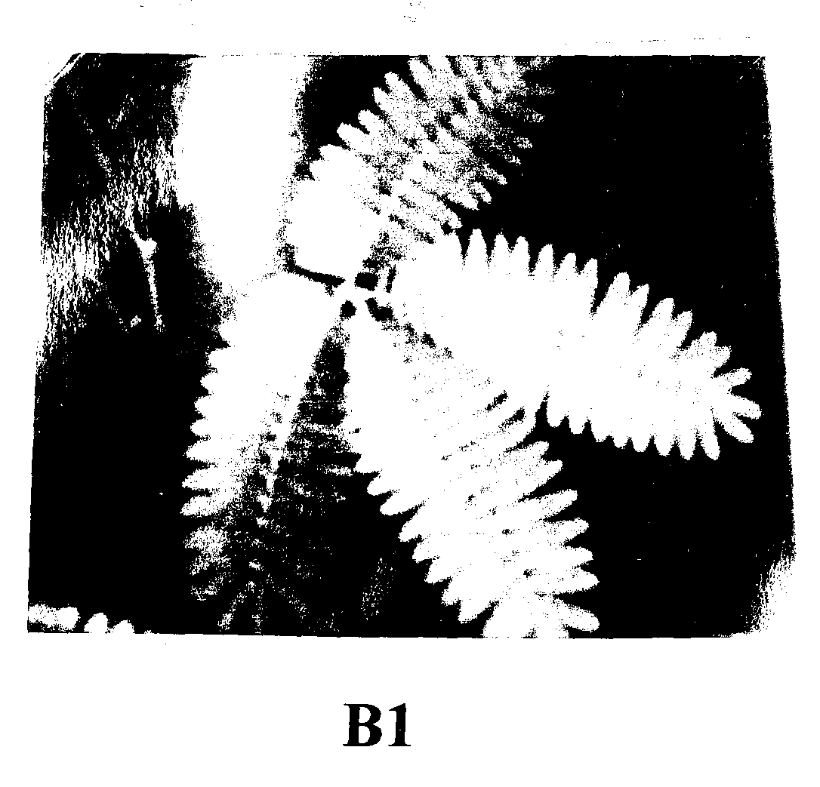

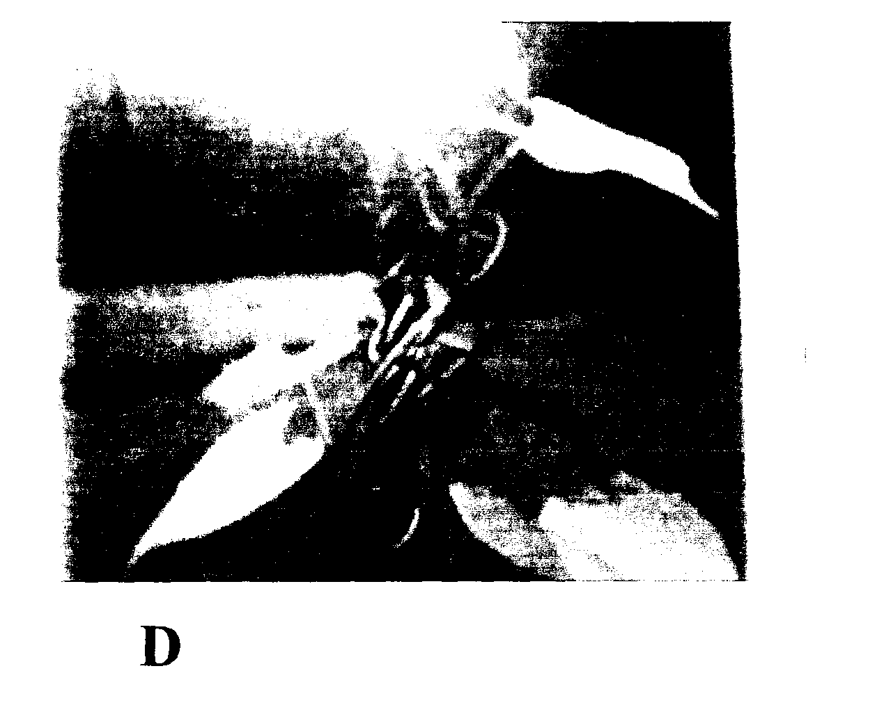

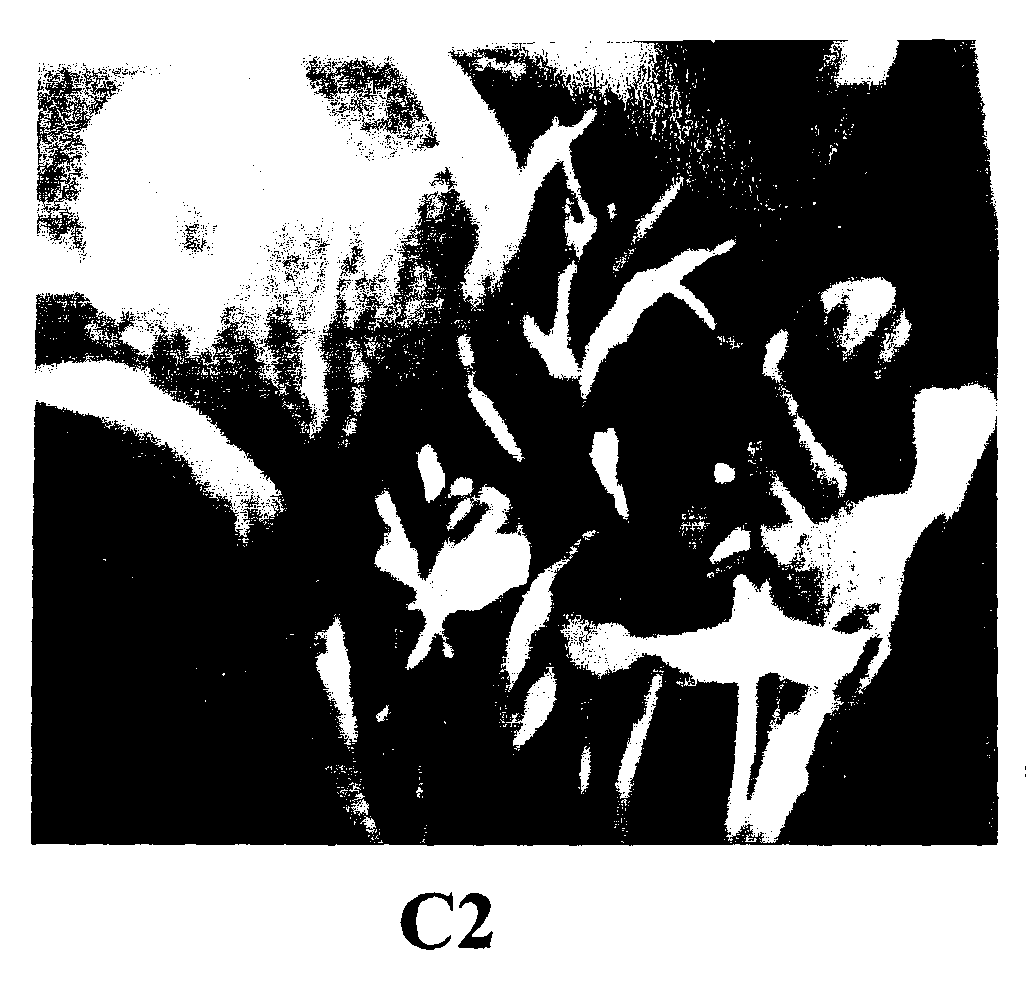
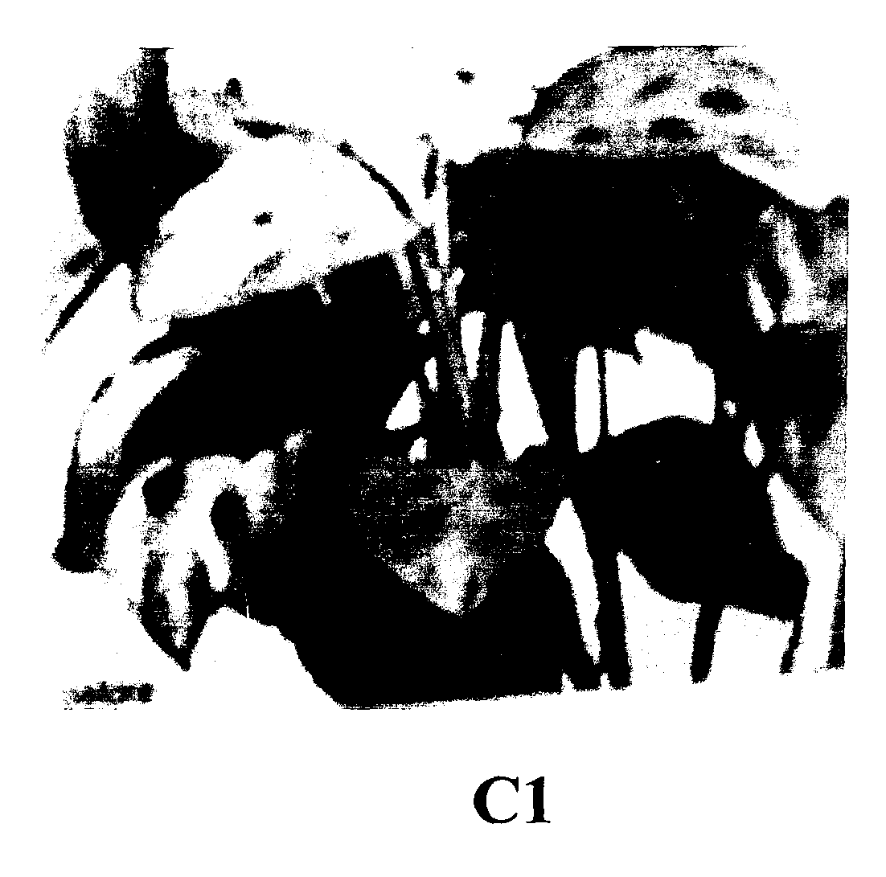

(a)Identify the kind of response shown by photographs B_{2,} C₂ and D (3mks)
B_{2,} ………………………………………..
C₂ ………………………………………..
D………………………………………..
(b) Explain how specimen D is able to coil around a hard object. (4mks)
……………………………………………………………………………………………………………
…………………………………………………………………………………………………………… ……………………………………………………………………………………………………………
……………………………………………………………………………………………………………

(c) Explain the importance of the response shown by specimen B₁ and B₂ (3mks)

…………………………………………………………………………………………………………… ……………………………………………………………………………………………………………
……………………………………………………………………………………………………………

