**NAME: ………………………………………….………………………… INDEX NO: .........................................**

**SCHOOL………………………………………………………………….. DATE………………………………… CANDIDATE’S SIGN………………………………………….…………**

**231/3**

**BIOLOGY**

**PAPER 3**

**TIME: 1 ¾ HOURS**

***Kenya Certificate of Secondary Education (K.C.S.E)***

**INSTRUCTIONS TO CANDIDATES**

* *Write your* ***name*** *and* ***index******number*** *in the spaces provided above.*
* ***Sign*** *and write the* ***date*** *of examination in the spaces provided above.*
* *You are required to spend the first 15 minutes of the 1 ¾ hours allowed for this paper reading the whole paper carefully before commencing your work.*
* *Answers must be written in the spaces provided in the question paper.*

**For Examiner’s Use only:-**

|  |  |  |
| --- | --- | --- |
| **Question** | **Maximum Score** | **Candidate’s Score** |
| **1** | **14** |  |
| **2** | **14** |  |
| **3** | **12** |  |
| **TOTAL** | **40** |  |

*This paper consists of 4 printed pages. Candidates should check to ascertain that all pages are printed as indicated and that no questions are missing.*

**1.** You are provided with 10% glucose solution and substance **labeled Y**. Also provided is a solution labeled **X.** You are to investigate the reaction between the glucose solution and **substance Y**. Measure 20.00cm3 of the glucose solution and transfer it to the boiling tube provided. Transfer all the **substance Y** provided into the solution in the boiling tube. Tightly fit the rubber bung carrying a delivery tube to the boiling tube. Place the boiling tube in a water bath kept between 35 – 380 c. Measure 1.0. Cm3of **solution X** and transfer to a test tube. Connect the delivery tube so that the open end enters the **solution X**. Allow the set – up to stand for about 30 minutes and during this time observe the changes occurring in the boiling tube and in the test tube having **solution X.**

a) Fill the table below **(2 marks)**

|  |  |
| --- | --- |
| **Tube** | **Observations** |
| **Boiling Tube** |  |
| **Test Tube** |  |

b) What conclusions can your draw from your observations in the test tube?

(**2 marks)**

………………………………………………………………………………………………………………………………………………………………………………………………………………………………………………………………………………………………………………………………………………………………………………………………

c) Name the process that took place in the test tube (**1 mark)**

………………………………………………………………………………………………………………………………………………………………………………………………

d) Shake the contents of the boiling tube and using a dropper remove a little of the

contents. Transfer a drop to a glass slide; add two drops of methylene blue stain. Cover with a cover slip and observe using a microscope of x10 or x15 eye piece lens.

(i) Draw and label the **substance Y** which is in the slide **(2 marks**)

(ii) What is the possible identity of **substance Y (1 mark)**

………………………………………………………………………………………………

e) Why was the temperature of the water bath kept between 35 – 380c **(1 mark)**

………………………………………………………………………………………………

f) If the experiment was done under the following conditions, suggest, giving reasons the expected results.

(i)Water bath was kept at 1000c

Observations: **(1 mark)**

………………………………………………………………………………………

Reasons: **(1 mark)**

………………………………………………………………………………………………

g) From the microscope

(i) Name the part **labeled Q.** **(1 mark)**

………………………………………………………………………………………

(ii) Give the function of part **labeled P.** **(1 mark)**

………………………………………………………………………………………

h) Name the form in which **substance Y** stores its excess glucose **(1 mark)**

………………………………………………………………………………………………

**Q2. (a)** Examine photograph **A,** **B1** and **B2** carefullyand answer the questions that follow. B2

was extracted from B1

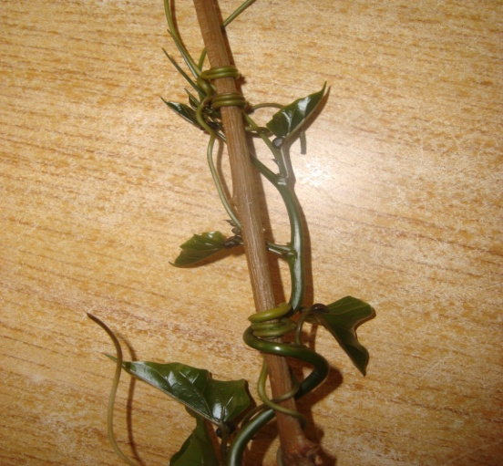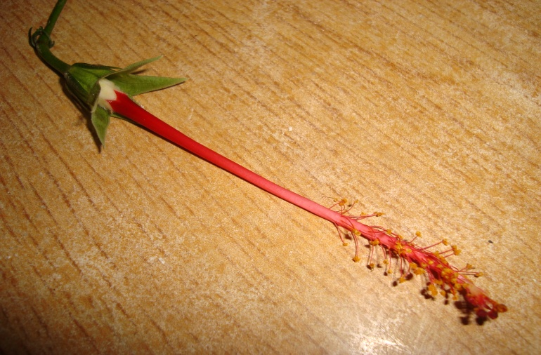

**A**

**B2**

T

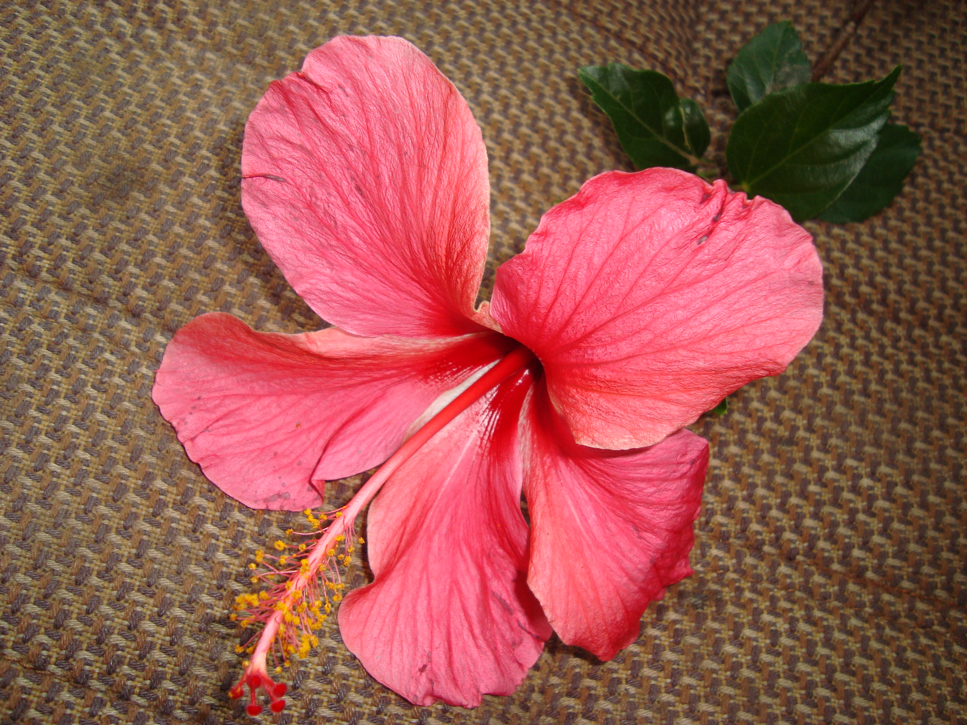

**B1**

(i) **What** name is given to the coiled part labeled **T** found on specimen **A**  **(1 mark)**

………………………………………………………………………………………………

(ii) **Name** the type of response exhibited by the coiled part on specimen **A (1mark)**

………………………………………………………………………………………

(iii) **Name** the stimulus responsible for the response named in (ii) above.  **(1mark)**

………………………………………………………………………………………………

(iv) **Explain** how the response exhibited by the coiled part on specimen **A** occurred

**(3 marks)**

………………………………………………………………………………………………

………………………………………………………………………………………………

………………………………………………………………………………………………

………………………………………………………………………………………………

(v) **State** the biological significance of the response described in (iv) above to the

survival of the specimen.  **(1mark)**

………………………………………………………………………………………………

**b)** Use photographed specimens labeled **B1** and **B2** above to answer the questions below.

(i) State the agent of pollination for the specimen above. **(1mark)**

………………………………………………………………………………………………

(ii) Give a reason for your answer. **(1mark)**

………………………………………………………………………………………………

(iii) Describe the external features of leaves of the specimen **B2**. **(3marks)**

………………………………………………………………………………………………

………………………………………………………………………………………………

………………………………………………………………………………………………

………………………………………………………………………………………………

(iv) Based on the floral parts, state the class to which specimen **B** belongs**. (1mark**)

………………………………………………………………………………………………

(v) Give a reason for your answer in (iv) above. **(1mark)**

………………………………………………………………………………………………

**Q3** Below is a section through a mammalian organ.

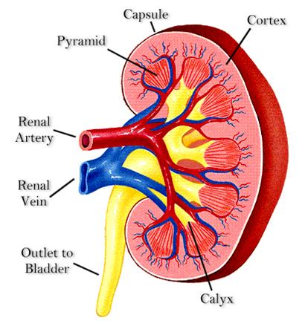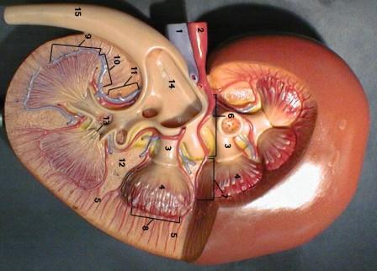

A

B

C

i) Identify the section **(1mark)**

………………………………………………………………………………………………

ii) Name the parts labeled **A, B** and **C** **(3marks)**

A ………………………………………………………………………………….

B …………………………………………………………………………………...

C …………………………………………………………………………………...

iii) State two functions of the photographed specimen. **(2marks)**

………………………………………………………………………………………………

……………………………………………………………………………………………....

iv) Label on the photograph using **G** and **L** the region where the **Glomerulus**, and

**Loop of Henle** are located respectively. **(2marks)**

………………………………………………………………………………………………

…….....................................................................................................................................

(v) Name a process that occurs in the glomerulus and Loop of Henle **(2marks)**

a) Glomerulus …………………………………………………………………………….

b) Loop of Henle ………………………………………………………………………….

(vi) Name two renal diseases **(2marks)**

……………………………………………………………………………………………… ………………………………………………………………………………………………