Name…………………………………… …………………………..………… Index No:………………………….

231/3 Candidate’s Signature …………..……………
BIOLOGY Date: …………………………
PAPER 3
(THEORY)
TIME: 2 HOURS

Kenya Certificate of Secondary Education (K.C.S.E.)
231/3
Biology
Paper 3
2 ½ Hours

INSTRUCTIONS TO CANDIDATES

- Write your name and index number in the spaces provided above
- Sign and write the date of examination in the spaces provided.
- Answer all the questions in the spaces provided.

For Examiners Use Only
Question | Maximum score | Candidate’s score
1 | 17
2 | 12
3 | 11
Total | 40

1. Examine the photograph of bones obtained from a mammal
(a) Identify them (3mks)
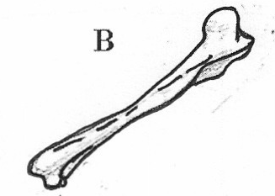
C
A
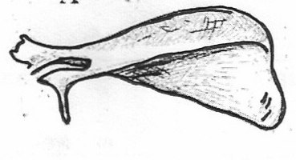

T

A……………………………………………
B……………………………………………
C……………………………………………
(b) Name the joint formed between:
(i) The distal end of bone A and C (1mk)
…………………………………………………………………………………………………….
(ii) The proximal end of bone B and the apex of A (1mk)
…………………………………………………………………………………………………….
(c) How is the specimen labeled A adapted to its functions? (4 mks)
…………………………………………………………………………………………………….
…………………………………………………………………………………………………….
…………………………………………………………………………………………………….
…………………………………………………………………………………………………….
(d) (i) Name the part labeled T on specimen C (1mk)
…………………………………………………………………………………………………….
(ii) State two functions of the part T (2mks)
…………………………………………………………………………………………………….
…………………………………………………………………………………………………….

2. You are provided with solution labeled K
(a) Using the reagents provided test for the food substances found in solution K. Record the food you have tested for, procedure observation and conclusion in the table below
Food substance | Procedure | Observation | Conclusion

(b)(i) Name an enzyme that may be required to digest the food substance found in solution
K in a human being. (1mk)
…………………………………………………………………………………………………….
(ii) State the name of the part of alimentary canal in which the enzyme named in (b)(i) above
is found (1mk)
…………………………………………………………………………………………………….

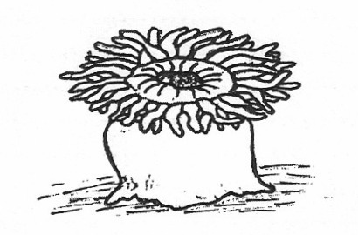
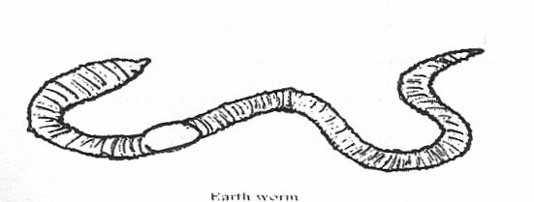
3. The photographs below show a variety of animals collected by a group of students during a field study.
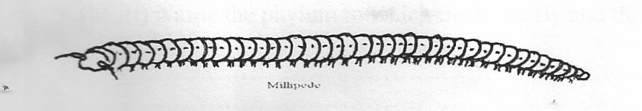

Spider
Centipede
Honey bee
Millipede
Sea
Earth worm

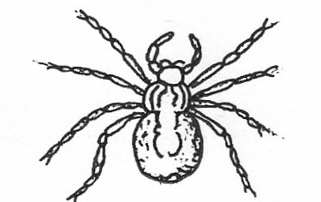
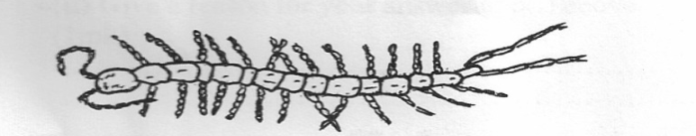
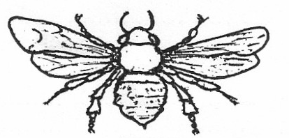

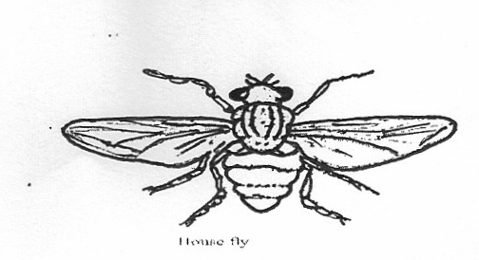
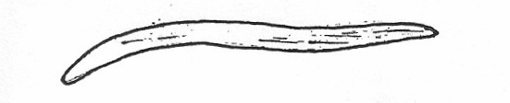

Round worm
House fly
(a) Using the observable characteristics only draw up a dichotomous key for the above animals (13mks)
The key should begin with:
1(a) Body bilaterally symmetrical………………………..go to 2
(b) Body………………………………..
…………………………………………………………………………………………………….
…………………………………………………………………………………………………….
…………………………………………………………………………………………………….
…………………………………………………………………………………………………….
…………………………………………………………………………………………………….
…………………………………………………………………………………………………….
…………………………………………………………………………………………………….
…………………………………………………………………………………………………….
…………………………………………………………………………………………………….
(b) (i) Name the phylum to which the housefly and the spider belong (1mk)
…………………………………………………………………………………………………….
…………………………………………………………………………………………………….
(c) Give a reason for your answer in b(i) above (1mk)
…………………………………………………………………………………………………….

