NAME: …………………………………………. INDEX NO: ……………………………….

SCHOOL: ……………………………………… CANDIDATE’S SIGNATURE: …………

DATE : ……………………………………

231/3
BIOLOGY
PAPER 3
(PRACTICAL)
TIME: 1¾ HOURS

INSTRUCTIONS TO CANDIDATES:
- Write your Name, Index Number and School in the spaces provided.
- Sign and write the Date of Examination in the spaces provided.
- Answer all the questions in the spaces provided.
- You are required to spend the first 15 minutes of the 1¾ hours allowed for this paper reading the whole paper carefully before commencing your work.

FOR EXAMINER’S USE ONLY
QUESTION | MAX. SCORE | CANDIDATE’S SCORE
1 | 14
2 | 17
3 | 09
TOTAL | 40

SECTION A (40 MARKS)
Answer all questions in this section in the spaces provided.

- (a) Examine the photograph below carefully and answer the questions that follow.
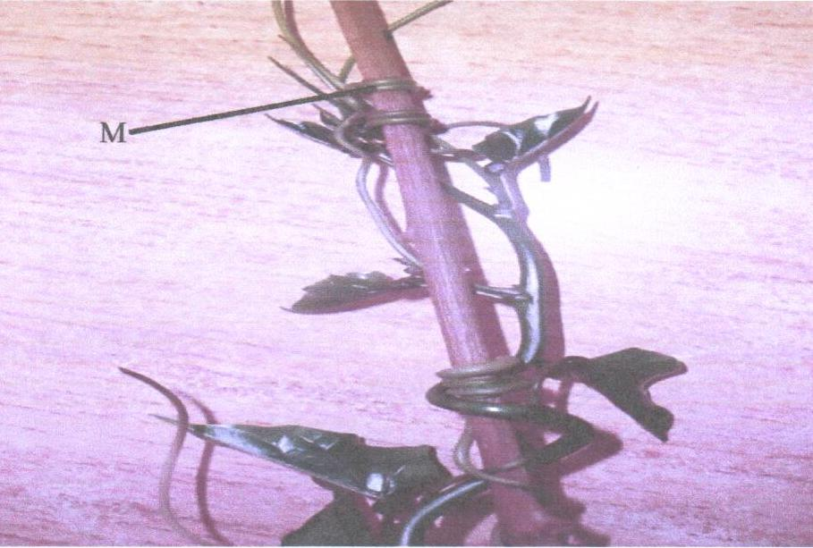
- What name is given to the coiled part labeled M found on the photograph? (1mk)
………………………………………………………………………………………………….
- Name the type of response shown in the photograph. (1mk)
………………………………………………………………………………………………….
- Name the stimulus responsible for the response named in (ii) above. (1mk)
………………………………………………………………………………………………….
- Explain the mechanism of the response. (3mks)
………………………………………………………………………………………………………………………………………………………………………………………………………………………………………………………………………………………………………
- State the biological significance of the response described in (iv) above to the survival of the specimen. (2mks)
……………………………………………………………………………………………………………………………………………………………………………………………………

- Photograph F illustrates the observations made two weeks after the plant was trimmed.
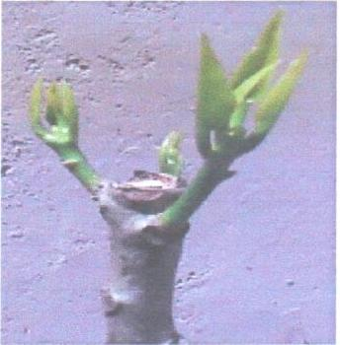
    - Name the phenomenon that was experienced by the plant before it was trimmed.
(1mk)
…………………………………………………………………………………………………...
    - Account for the observation made in the shoot after the practice. (3mks)
…………………………………………………………………………………………………………………………………………………………………………………………………………………………………………………………………………………………………………………………………………………………………………………………………………
    - Explain the application of the practice in agriculture. (2mks)
………………………………………………………………………………………………………………………………………………………………………………………………………………………………………………………………………………………………………

- You are provided with solution L and Laboratory Reagents. Use it to carry out experiments as follows:
    - Take the filter paper and carefully fold it twice through the middle. Open it up to make a funnel. Put it in a plastic funnel. Place the set up in 100ml beaker.

    - Take 15mls of solution L add 5 drops of dilute hydrochloric acid (HCL).
      - Record your observations. (1mk)
………………………………………………………………………………………………….
      - Where in the body is HCL found and what is its importance in the body? (1mk)
……………………………………………………………………………………………………………………………………………………………………………………………………

    - Using the set up, filter solution L into the 100ml beaker. Remove from the filter paper all the materials on it and place them in a Petri dish using the spatula. Dry the filter paper over flame care being taken not to burn it.
      - Record your observations. (1mk)
………………………………………………………………………………………………….
      - What conclusion do you make on the observation? (1mk)
……………………………………………………………………………………………………………………………………………………………………………………………………
      - What name is given to this test? (1mk)
…………………………………………………………………………………………………

    - Use the provided reagents to carry out food tests on the filtrate and residue by filling in the table below.
FILTRATE
FOOD BEING TESTED | PROCEDURE | OBSERVATION | CONCLUSION

RESIDUE
FOOD BEING TESTED | PROCEDURE | OBSERVATION | CONCLUSION

Briefly explain what happened if there are any difference between results of filtrate and residue.
……………………………………………………………………………………………………………………………………………………………………………………………………………………………………………………………………………………………………………………….
……………………………………………………………………………………………………….

- Below is a section through a mammalian organ.
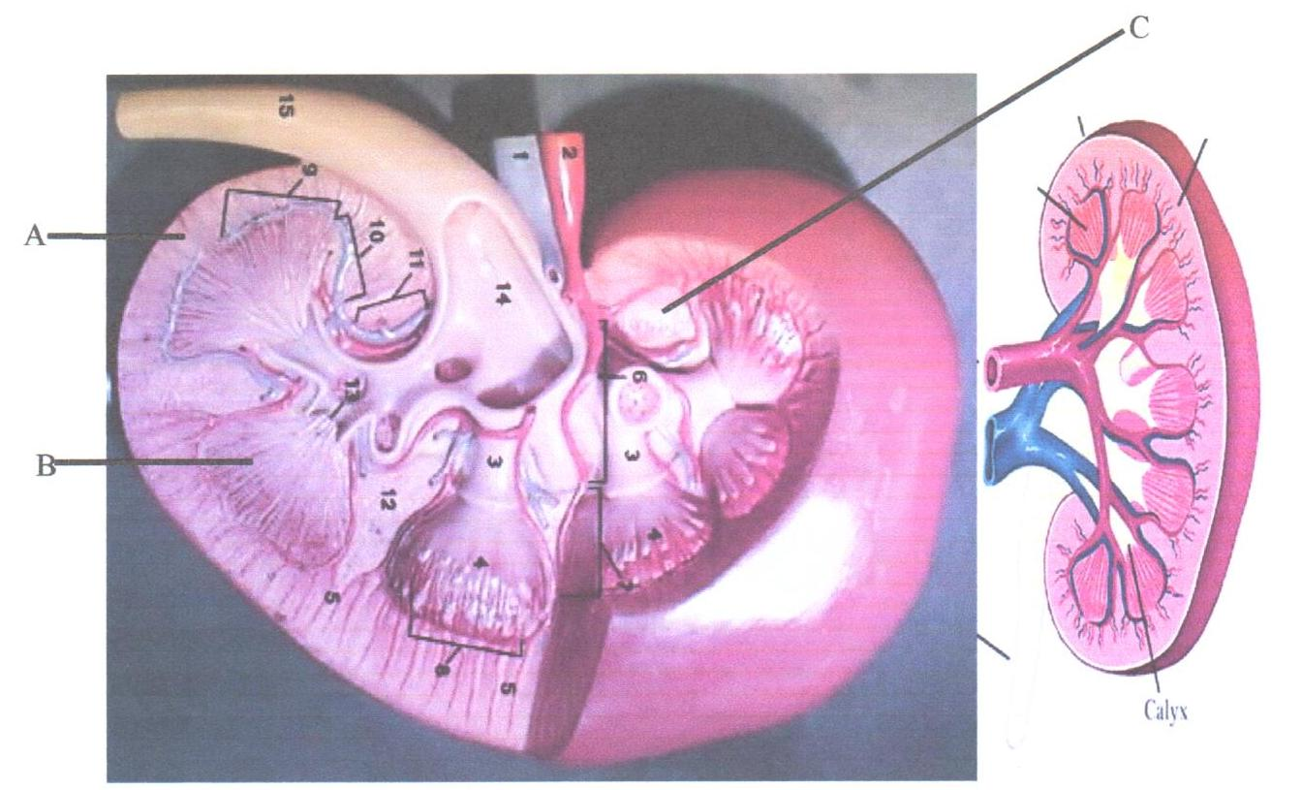
    - Identify the section. (1mk)
……………………………………………………………………………………………………...
    - Name the parts labeled 1, 2 and 15. (3mks)
1:……………………………………………………
2:……………………………………………………
15:………………………………………………….
    - State two functions of the photographed specimen. (2mks)
…………………………………………………………………………………………………………………………………………………………………………………………………………
    - Indicate on the photograph where the Glomerulus, and Distal Convoluted tubule are located? (2mks)

    - What are the differences between the organ in a kangaroo rat and tilapia? (2mks)
………………………………………………………………………………………………………………………………………………………………………………………………………………………………………………………………………………………………………………..

