NAME: …………………………………………. INDEX NO: ……………………………….

SCHOOL: ……………………………………… DATE : ……………………………………

CANDIDATE’S SIGNATURE: …………………..

231/3
BIOLOGY
PAPER 3
(PRACTICAL)
TIME: 1 ¾ HOURS

INSTRUCTIONS TO CANDIDATES:
- Write your Name and Index Number in the spaces provided.
- Sign and write the Date of Examination in the spaces provided.
- Answer all the questions in the spaces provided.
- You are required to spend the first 15 minutes of the 1 ¾ hours allowed for this paper reading the whole paper carefully before commencing your work.
- Additional pages must not be inserted.
- This paper consists of 4 printed pages.
- Candidates should check the question paper to ascertain that all the pages are printed as indicated and that no questions are missing.

FOR EXAMINER’S USE ONLY
QUESTION | MAX. SCORE | CANDIDATE’S SCORE
1 | 12
2 | 14
3 | 14
TOTAL | 40

SECTION A (40 MARKS)
Answer all questions in this section in the spaces provided.
- You are provided with specimen Q, which is a fresh potato, liquid R (Hydrogen peroxide) and reagents 1% copper sulphate, 2M sodium hydroxide and iodine solution. Use them to carry out the tests below.
      - Using a scalpel, cut two small cubes measuring 1cm x 1cm x 1cm from the fresh potato. Place one of the cubes in boiling water for 10 minutes, then remove the cube and let it cool. Place it in a boiling tube and label it A.
Place the fresh piece of potato cube in another boiling tube labelled B and then add equal amounts of hydrogen peroxide to each test tube at the same time. Write your observations.
Observations:
        - Boiling tube A (1mk)
……………………………………………………………………………………………….
        - Boiling tube B (1mk)
……………………………………………………………………………………………….
      - Explain your observation in (i) and (ii) above. (4mks)
…………………………………………………………………………………………………………………………………………………………………………………………………………………………………………………………………………………………………………………………………………………………………………………………………………………….
      - Crush a small piece of the remaining potato in a mortar. Add a little amount of distilled water to make a mixture. Use it to carry out food tests below. (6mks)
Food substance | Procedure | Observation | Conclusion
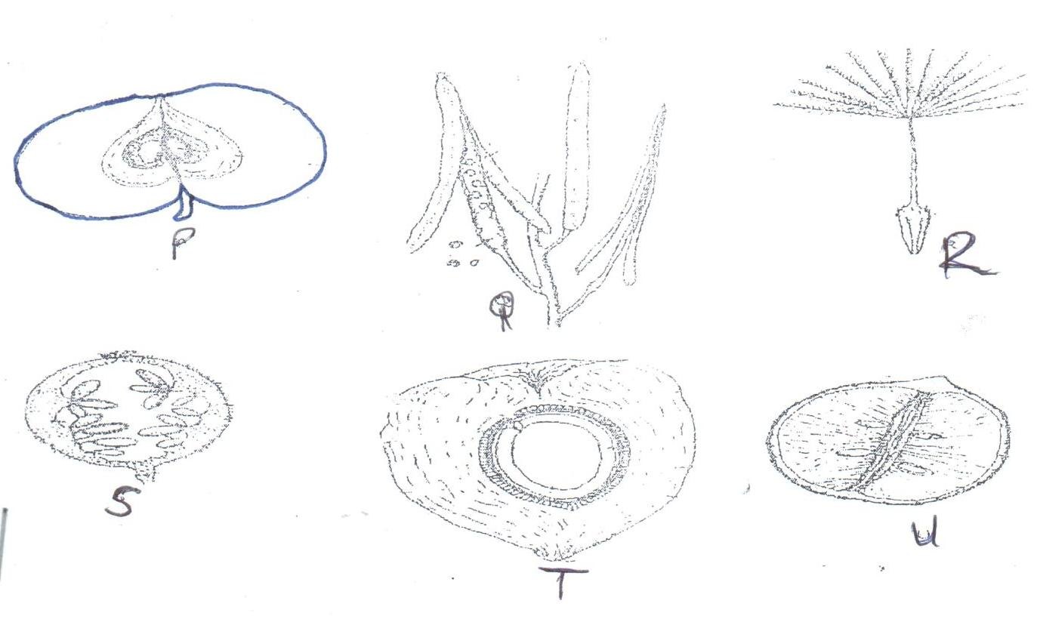
- Below are photographs labeled P, Q, R, S, T and U of fruits obtained from different plants. Examine them and answer the questions underneath.

      - With reasons, determine the modes of dispersal for the fruits labeled Q and R . (4mks)
Q:……………………………………………………………………………………………………..
Reasons:…………………………………………………………………………………………………………………………………………………………………………………………………….

R:……………………………………………………………………………………………………..
Reasons:…………………………………………………………………………………………………………………………………………………………………………………………………….

      - State the form of placentation in Q, S, T and U. (4mks)
Q:……………………………………………………………………………………………………
S:…………………………………………………………………………………………………….
T:……………………………………………………………………………………………………
U:…………………………………………………………………………………………………….

      - With a reason, identify the type of fruit represented by specimen P. (2mks)
Type of fruit:……………………………………………………………………………………….
Reason:…………………………………………………………………………………………….

      - Below is a photomicrograph of a certain process in reproduction. Study it carefully and answer the questions that follow.
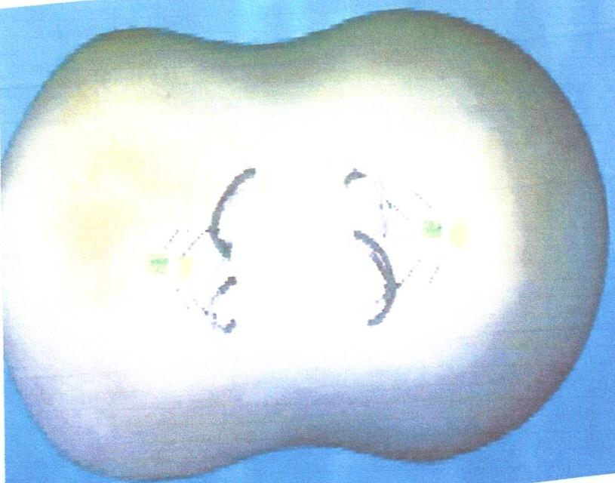

        - Identify the process shown in the photomicrograph. (1mk)
………………………………………………………………………………………………….

        - Name the exact stage and place of the process shown in the photomicrograph.(1mk)
……………………………………………………………………………………………………………………………………………………………………………………………………

        - What is the significance of the process at its completion? (1mk)
…………………………………………………………………………………………………………………………………………………………………………………………………….

- Figure 1 represents parts of two adjacent liver cells as seen under an electron microscope. Study the micrograph and answer the questions that follow.

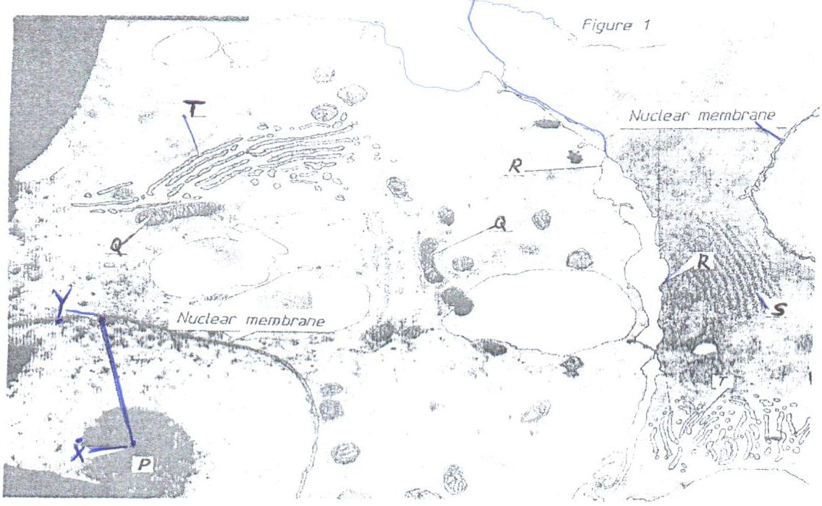

      - (i) Name the organelles labelled P, R, T. (3mks)
P:……………………………………………………………………………………………………
R:…………………………………………………………………………………………………….
T:……………………………………………………………………………………………………

(ii) State one function of each of the organelles labelled Q and S. (2mks)
Q:……………………………………………………………………………………………………
S:…………………………………………………………………………………………………….

(iii) The magnification of the cells in the micrograph is x20,000. Use a ruler to measure
the radius of the nucleus between points X and Y in millimeters.
Radius of nucleus:…………………………………..mm (1mk)

(iv) Calculate the actual radius of the nucleus before magnification in micrometers (µm)
Q: (1mk)

      - Figure 2 represents different types of muscles. Study them carefully and answer the questions that follow.
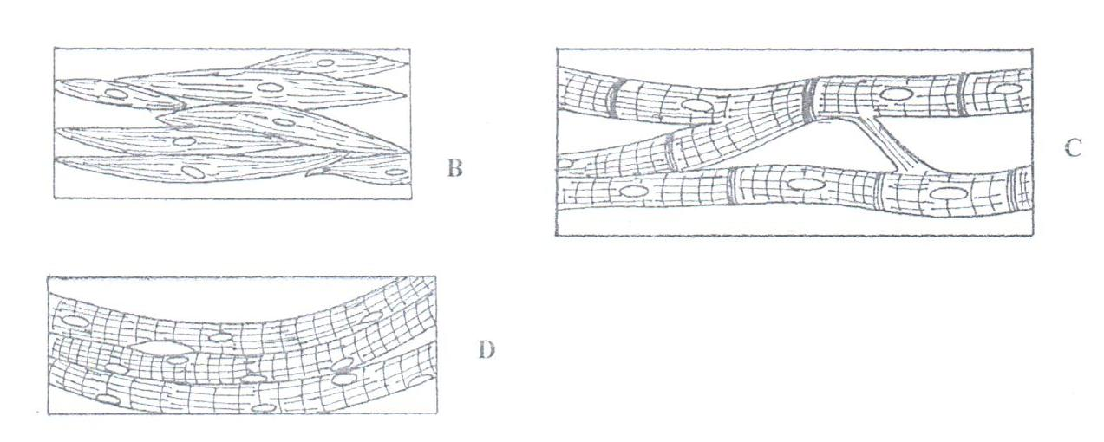

        - Identify the muscles labelled C and D. (2mks)
C:……………………………………………………………………………………………
D:……………………………………………………………………………………………

        - Using observable features only; state two differences between muscles labelled B and D. (2mks)
………………………………………………………………………………………………………………………………………………………………………………………………………………………………………………………………………………………………………………………………………………………………………………………………

        - State one function of each of the muscles labelled B and C. (2mks)
Q:……………………………………………………………………………………………
S:……………………………………………………………………………………………/

        - Give one adaptation of a muscle labelled C to its function. (1mk)
……………………………………………………………………………………………………………………………………………………………………………………………..

