Name_________________________________________________________ Index No. ______________
Candidate’s signature _____
Date __________________

231/3
BIOLOGY
PAPER 3
PRACTICAL
1 ¾ HOURS

INSTRUCTIONS TO CANDIDATES
1. Write your name and index number in the spaces provided above
2. Sign and write the date of examination in the spaces provided above
3. Answer all the questions in the spaces provided
4. You are allowed to spend the first 15 minutes of the 1 ¾ hours allowed for this paper reading the whole paper carefully before commencing your work
5. Additional pages must not be inserted

For examiner’s use only
Question | Maximum score | Candidate’s score
1 | 14
2 | 14
3 | 12
Total score | 40

This paper consists of 5 printed pages
Turn over
1. You are provided with two solids X and Y. Place solid X into a boiling tube and add 10ml of distilled
water and stir to dissolve. Label the resulting mixture as solution X. Divide the solution X into equal
portions in three test tubes all labeled A, each of which will be used for a food test in the table below.
Place solid Y into a boiling tube and add 10ml of distilled water and stir to dissolve. Label the resulting
mixture as Y. divide the solution Y into equal portions in three separate test tubes all labeled Y, each of
which will be used for a food test in the table below.

(a) Using the reagents provided carry out food tests to determine the food substances present in solutions
X and Y in each of the test tubes. In each case, record the food substance tested for, procedure,
observation and conclusion in the table below. (9mks)
Solution | Food substance | Procedure | Observation | Conclusion
A
B

(b) (i) Which of the two solids would be appropriate to be included in a diet of a family whose children suffer from kwashiorkor (1mk)
_______________________________________________________________________________
_______________________________________________________________________________
_______________________________________________________________________________
(ii) Give a reason for your answer in b (i) above (1mk)
_______________________________________________________________________________
_______________________________________________________________________________
_______________________________________________________________________________
(c) (i) Name the part of the digestive system where digestion of the food substance (s) found in y
starts (1mk)
_______________________________________________________________________________
_______________________________________________________________________________
_______________________________________________________________________________
(ii) Name the enzyme which starts the digestion of the food substance(s) in y (1mk)
_______________________________________________________________________________
_______________________________________________________________________________
_______________________________________________________________________________
(d) State one importance of the food substance in solid X (1mk)
_______________________________________________________________________________
_______________________________________________________________________________
_______________________________________________________________________________

2. You are provided with specimen labeled A, B, C and D. Examine them
(a) Make a transverse section of specimen B. Draw and label the section as observed (5mks)

(b) Giving reasons, state the agent of dispersal of the specimens (8mks)
Specimen | Agent | Reason(s)
A
B
C
D

(c) State the placentation of specimen B (1mk)
_______________________________________________________________________________
_______________________________________________________________________________
_______________________________________________________________________________
3. Study the photograph below and answer the questions that follow

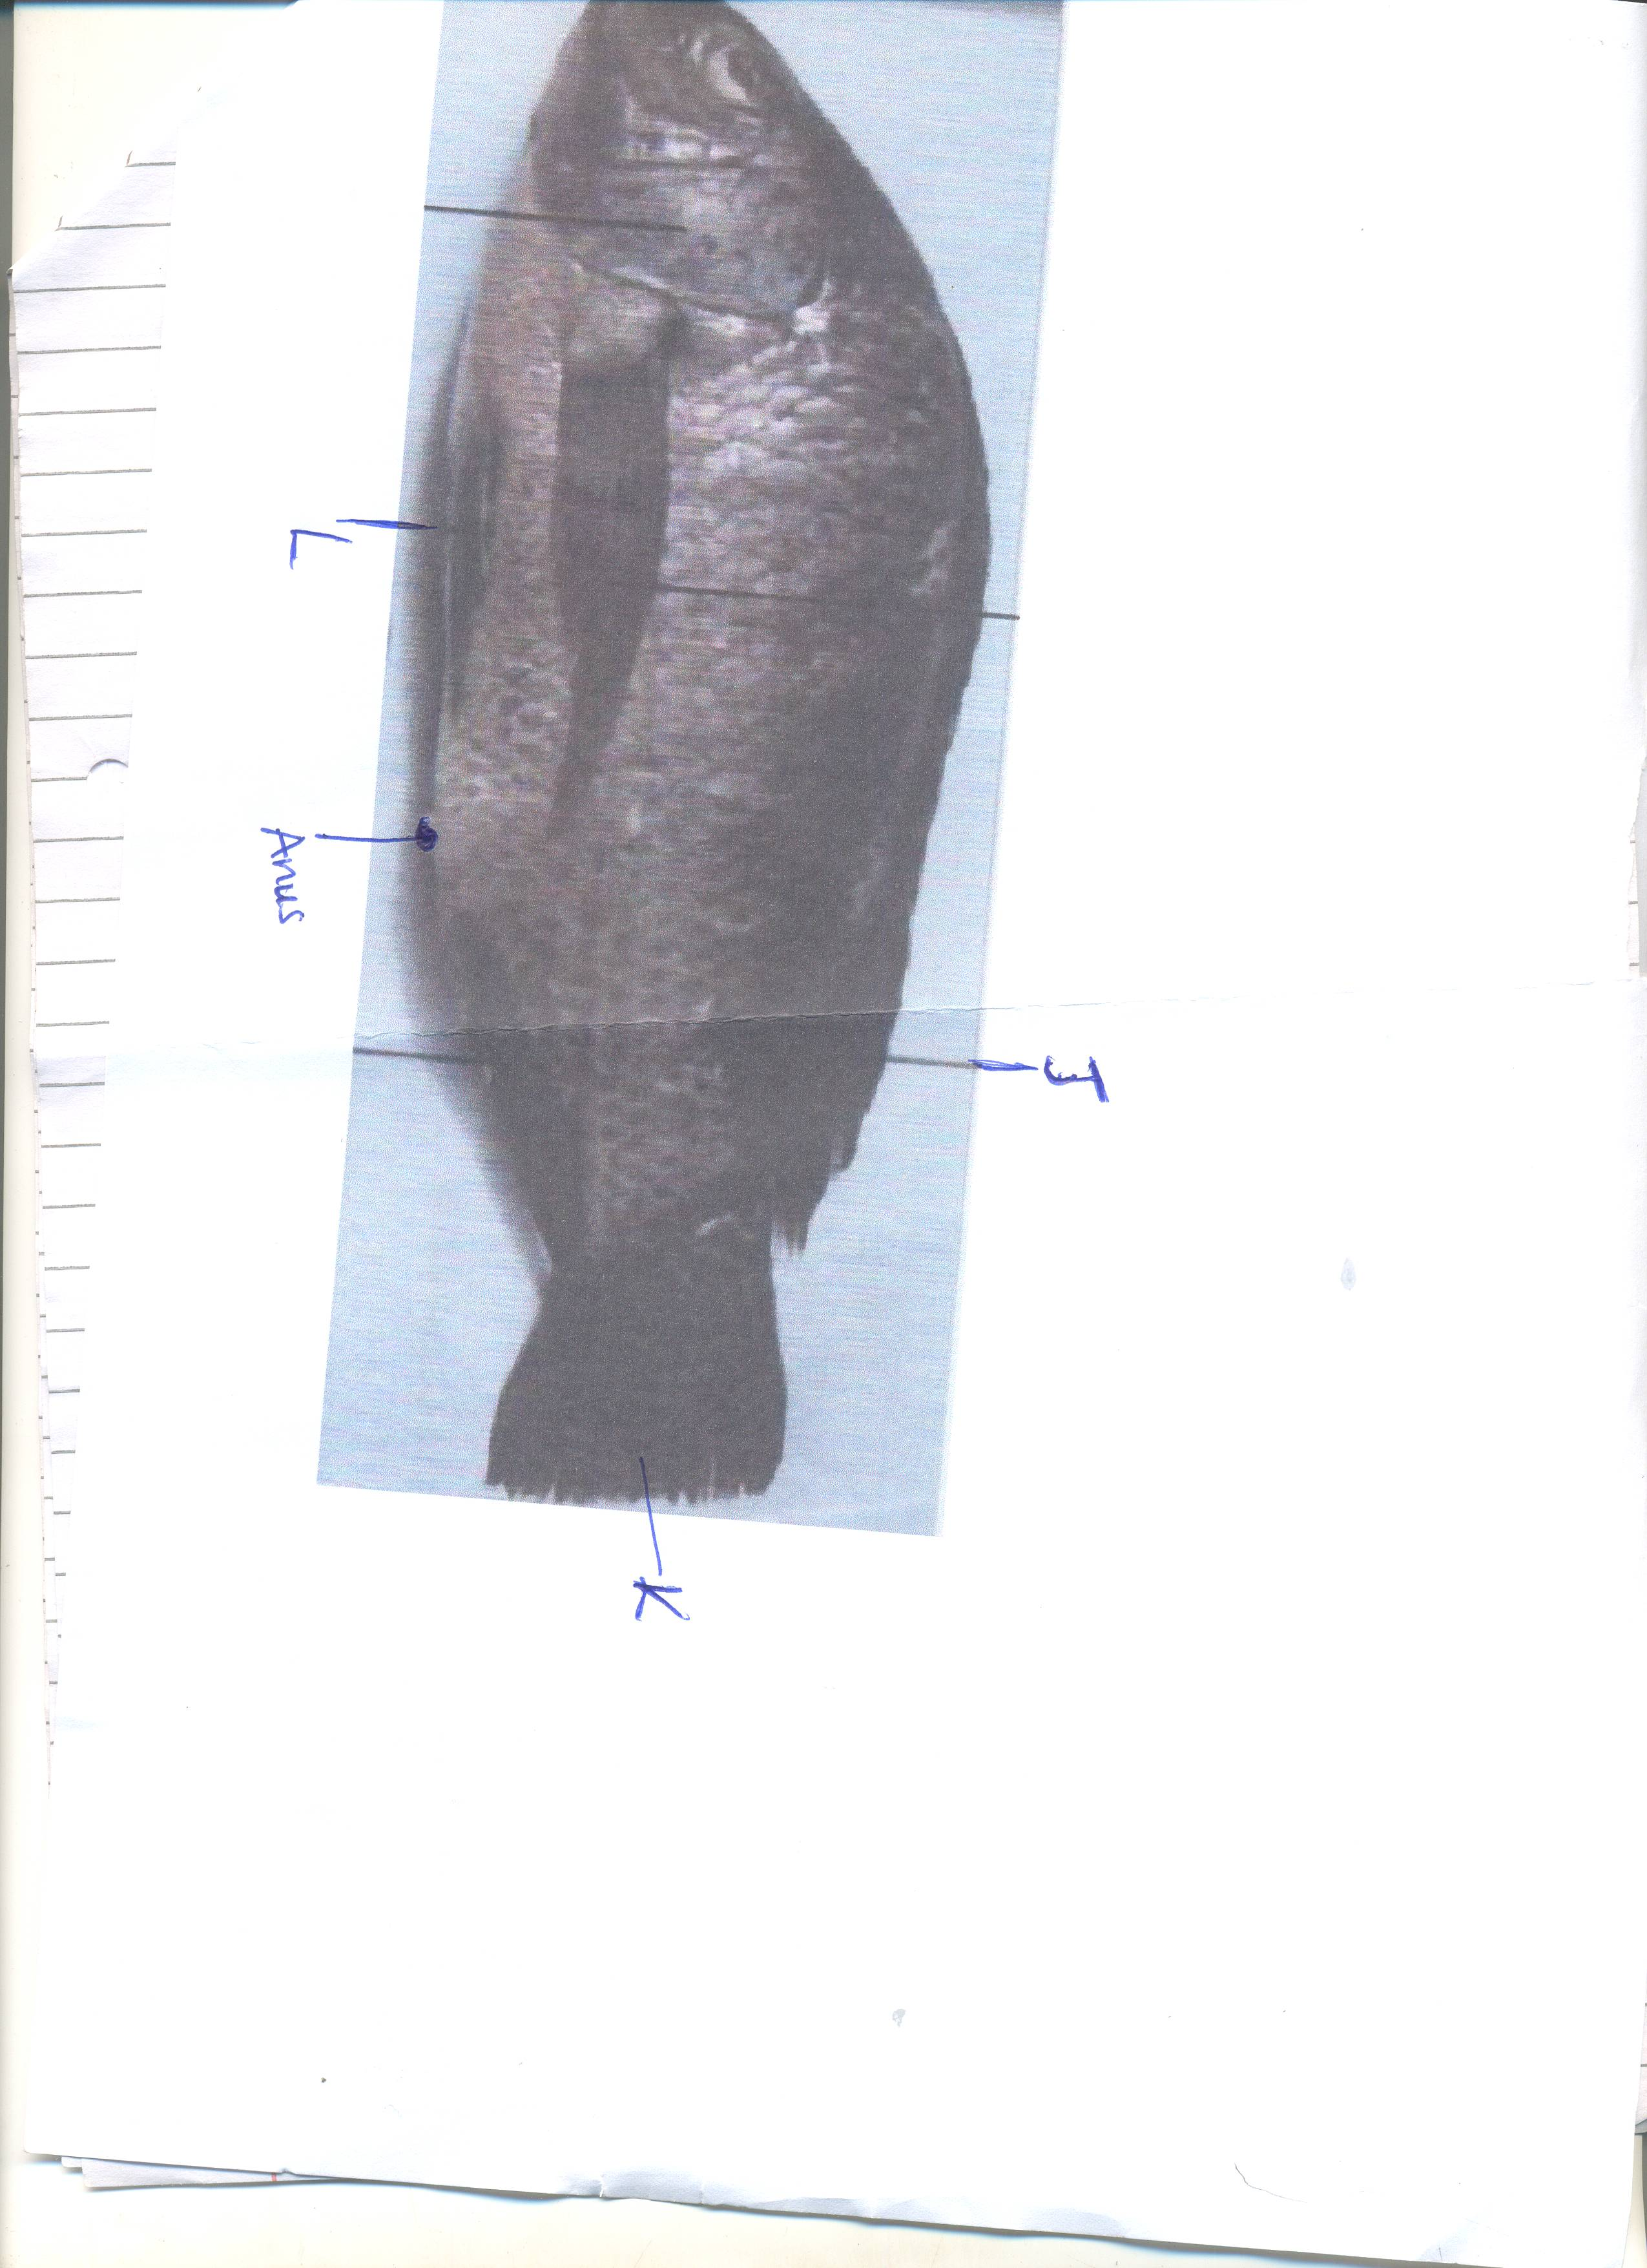

(a) (i) Name the class to which the specimen belongs (1mk)
_______________________________________________________________________________
_______________________________________________________________________________
_______________________________________________________________________________
(ii) Give two reasons for your answer in a (i) above (2mks)
_______________________________________________________________________________
_______________________________________________________________________________
_______________________________________________________________________________
_______________________________________________________________________________
(b) (i) What term is used to describe the shape of the specimen (1mk)
_______________________________________________________________________________
_______________________________________________________________________________
_______________________________________________________________________________
(ii) What is the significance of your description in b (i) above (1mk)
_______________________________________________________________________________
_______________________________________________________________________________
_______________________________________________________________________________
(c) Measure in millimeter the length of
(i) Specimen from tip of the mouth to the tip of the tail
Length ____________________________mm________________________ (1mk)
(ii) From the anus to the tip of the tail
Length _________________________mm _________________________ (1mk)
(ii) Using the measurement above, calculate the tail power (2mks)
_______________________________________________________________________________
_______________________________________________________________________________
_______________________________________________________________________________
_______________________________________________________________________________
(d) Name the parts labeled J, K, L (3mks)
J _______________________________________
K ______________________________________
L ______________________________________

