NAME::………………………………………………………CLASS:……………..ADMISSION NO:……

BIOLOGY PP2
FORM 4
TIME: 2 HOURS

INSTRUCTIONS TO CANDIDATES
- This paper consists of two sections A and B.
- Answer All the questions in Section A in the spaces provided
- In section B answer question 6. (compulsory) and either question 7 or 8 in the spaces provided after question &.
- Candidates should answer the questions in English.

SECTION A( 40 MARKS)
- The diagrams below represents two plants cell A and B placed in two different solutions. Study the diagrams and answer questions that follow.

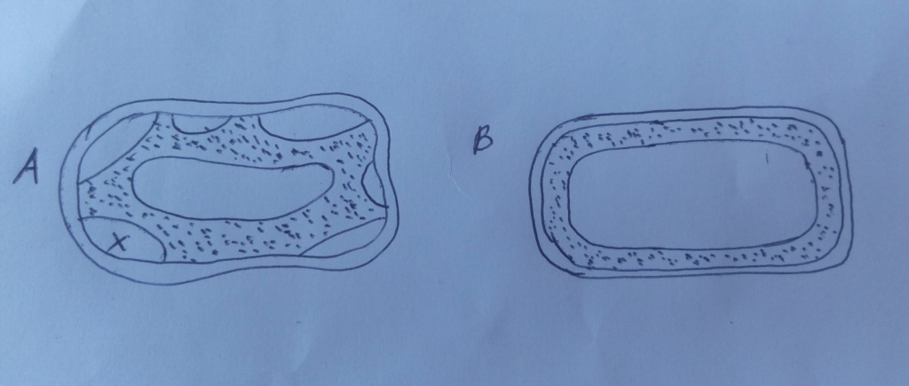

- Identify the nature of solution into which each cell was placed. (2mks)
A

B

- Name the physiological process responsible for the observed results. (1mk)

- Give the correct biological term used to describe cell A. (1mk)

- Describe what would happen if a red blood cell was placed in the solution in which cell B was placed. (2mks)

- Explain why freshwater amoeba do not burst when placed in distilled water. (2mks)

- Explain the fate of glucose after assimilation. (2mks)

- (a) Distinguish between the terms homodont and heterodont. (2mks)

(b) What is the function of carnassial teeth? (1mk)

(c) The diagram below represents the lower jaw of a mammal.

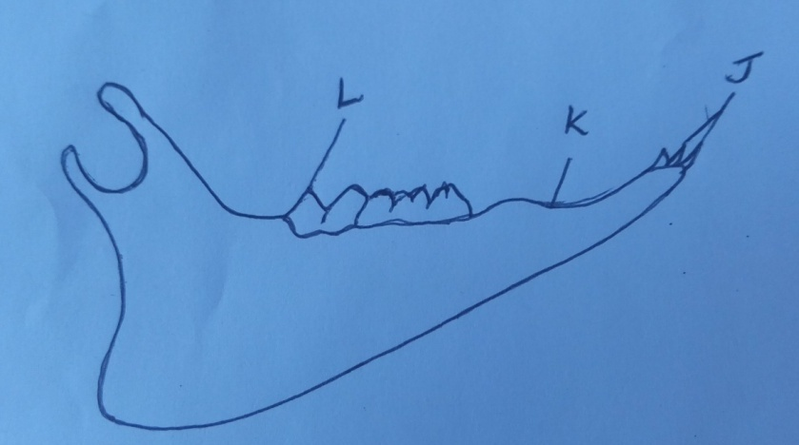

(i) Name the mode of nutrition of the mammal whose jaw is shown above. (1mk)

(ii) State one structural and one functional differences between the teeth labeled J and L. (2mks)

(iii) Name the toothless gap labeled K. (1mk)

(iv) State the function of the gap. (1mk)

(v) Name the substance that is responsible for hardening of teeth. (1mk)

(v) What do you understand by the term ‘dental formula’. (1mk)

- The diagram below represents a food web in a terrestrial ecosystem.
Green plants
Hawks
Snakes
Lions
Antelopes
Cane toad
Grasshopper
Mice
Lizards

- Which organism has the highest number of preys? (1mk)

- Construct food chains with snakes as tertiary consumers. (2mks)

- State the trophic level occupied by hawks in the food chains constructed in (b) above (1mk)

- Describe how capture-recapture method can be used in estimating the population of fishes in a lake. (4mks)

- Name the process through which:
- Producers convert chemical energy into heat energy lost to the environment. (1mk)

- Living organisms convert chemical energy into heat energy lost to the environments. (1mk)

- The figure below shows the embryo sac before fertilization.

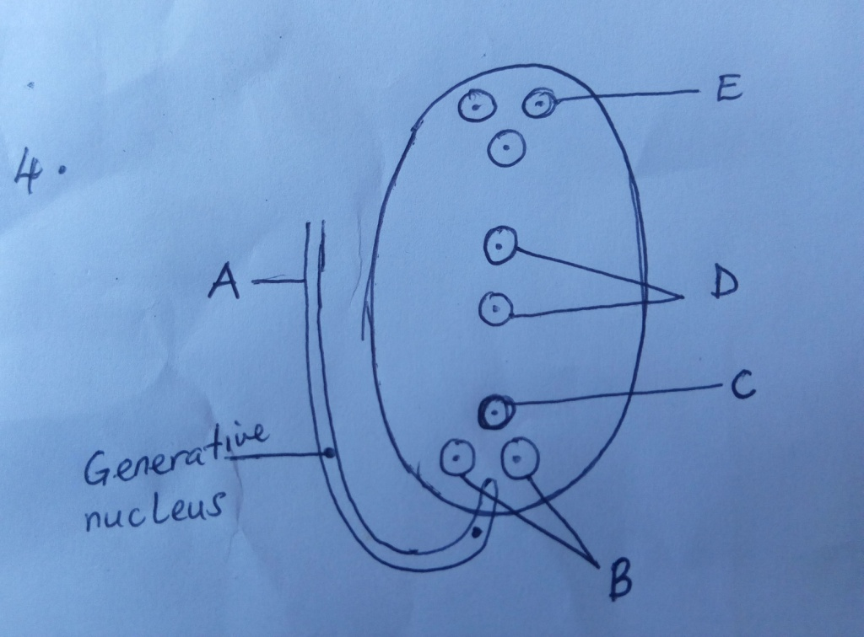

- Identify the structures labeled A and B (2MKS)

- Identify the structures labeled in the diagram that will develop into the following after fertilization.
- Embryo (1mks)

- Endosperm (1mk)

- State the ploidy of each of the following nuclei after fertilization
- C (1mk)

- D (1mk)

- Briefly outline the process of ‘double fertilization’ in flowering plants. (2mks)

- Name two substances which are found in the intercellular air spaces in a green leaf during a hot sunny day. (2mks)

- In an investigation, snapdragon plants with broad leaves (B) were crossed with narrow leaves (N). The F1 progeny had intermediate leaf breadth.
- Give a reason for intermediate leaf breadth in F1 generation (1mk)

- If the plants in the F1 Generation were selfed, state the genotypic and phonotypic ratio of the F2 generation. (show your working) (5mks)

- Hemophilia is more common in males than females. Explain this phenomenon. (2mks)

- Explain why an under dose insecticide spraying of mosquitoes may cause a serious problem on this mode of killing mosquitoes using the same spray in future. (2mks)

SECTION B(40 MARKS)
Answer question 6(compulsory) and either 6 or 7 in the spaces provided.
- Two sets of a pea seeds were germinated, set A was placed in normal day light conditions in the laboratory which set B was placed in a dark cupboard. Starting a few days later the shoots lengths were measured twice daily and their mean length recorded as shown in the table below.

Time in hours | 0 | 12 | 24 | 36 | 48 | 60 | 72 | 84
Set A (length (mm) | 12 | 14 | 20 | 23 | 28 | 31 | 47 | 54
Set B length (mm) | 17 | 23 | 28 | 35 | 48 | 62 | 80 | 94

(a) Using suitable scale draw the graphs of the mean lengths in set A and B against time (7mks)

(b) From the graph, state the man shoot length of each set of seedling at the 66th hour. (2mks)

© Account for the difference of curve B and A. (3mks)

(d) Explain what would happen to set up B if it were allowed to continue to grow under conditions of darkness. (4mks)

(e) State 3 external conditions which should be constant for both set ups. (3mks)

(f) Why is oxygen important in the process of active transport? (1mk)

7. (a) state five difference between aerobic and anaerobic respiration. (5mks)

(b) Discuss the application of anaerobic respiration in industry and at home. (15mks)

8 (a) state two functions of the mammalian skin. (2mks)

(b) Describe the structure and function of the mammalian skin. (8mks)

