NAME…………………………………………………………………………ADM……………..CLASS………

BIOLOGY PAPER 3
FORM 3
TIME: 1HR 45 MIN
40MKS

- You are provided with photographs of specimens labeled M,N and P which were obtained from an animal. Study them.
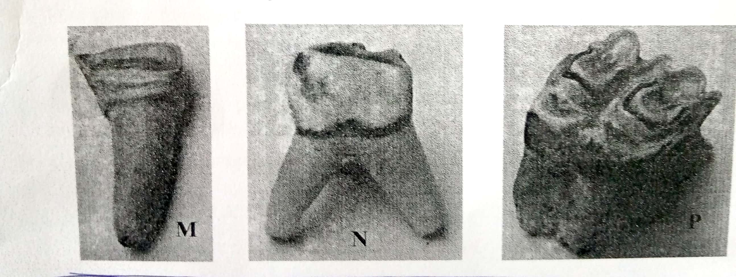

- Identify specimens: (3mks)
M

N

P

- For each specimen, name, observe features and state how each feature adapts the specimen to it functions. (6mks)
Specimen | Feature | Adaptation and function
M

N

P

- Below is a photograph depicting interaction of organisms in a certain ecosystem?
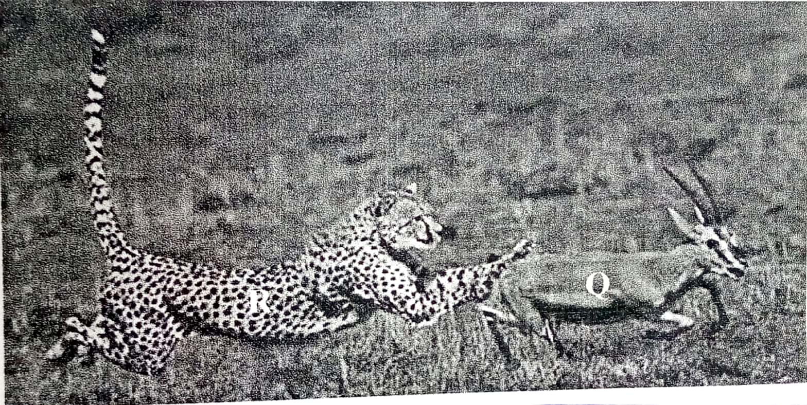

- Write down a possible food chain involving three organisms found in the photograph above. (1mk)

- Draw a well labeled pyramid of biomass using the food chain in (a) above. (3mks)

What feeding relationships are exhibited by the animals shown in the photographs? (2mks)

- Give the adaptations of animal R regarding its feeding relationship mentioned in b (ii) above. (3mks)

- A number of leaves are represented by leaves A, B, C, D and. Use the dichotomous key made using leaves A, B, C, D and E below.

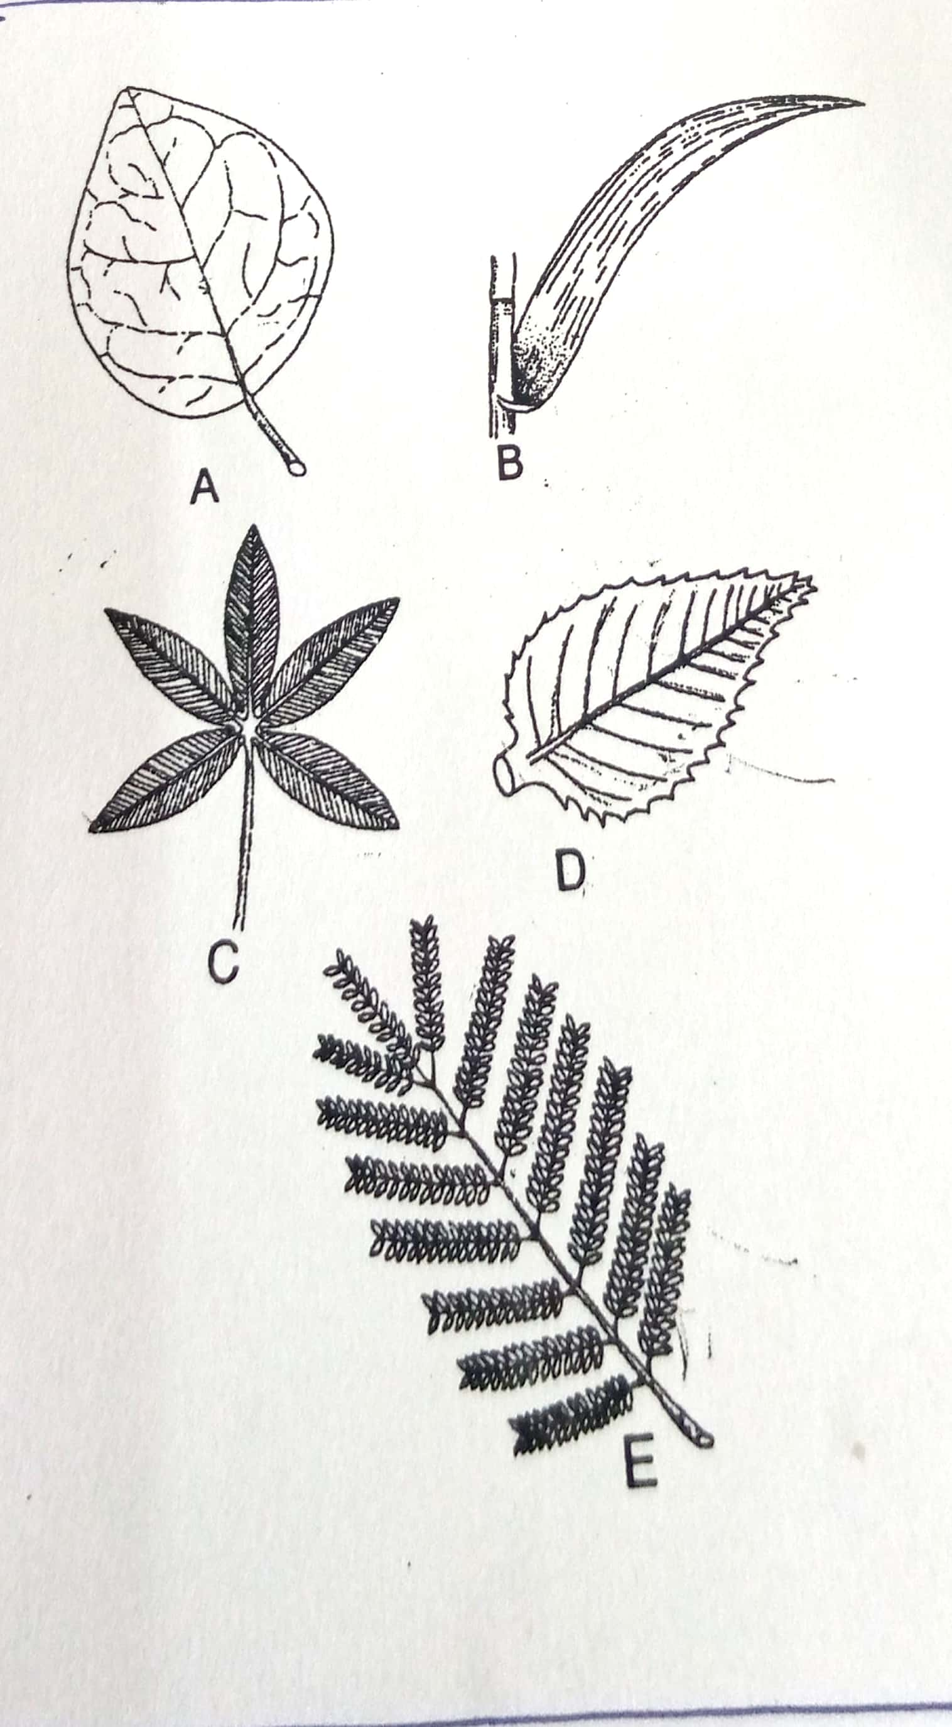

1a. Leaf veins network……………………………………go to 2
b. Leaf veins parallel……………………………………… B (maize)
2a. Leaf simple………………………………………………… go to 3
b. Leaf compound ………………………………………………go to 4
3a. Leaf margin smooth………………………………………. A (Bougainvillae)
b. Leaf margin serrated…………………………………….. D (Hibiscus)
4a. Leaf with five leaflets……………………………………. C (Bombax)
b. Leaf with many leaflets………………………………….E (Acacia)
- Using the above dichotomous key show the steps and identify at the leaves shown above. (10mks)
Leaf Steps Identity
A 1a, 2a, 3a Bougainvillae
B 1b Maize
C 1a, 2b, 4a Bombax
D 1a,2a,3b Hibiscus
E 1a,2b,4b Acacia

- You are provided with three unknown solutions labeled F, G1 and G2. G1 is the same as G2 except that G2 has been boiled. You are also provided with iodine solution, Benedict’s solution, means of heating 250ml beaker labeled for a warm water bath, thermometer, tripod stand, means of timing, test-tubes, test tube holder and test tube rack.
- Place 2ml of solution F in a test tube and add an equal volume of Benedict’s solution.
- Shake to mix and then heat to boil and write down your observation. (1mk)

- What conclusion do you make from your observation in a (i) above? (1mk)

- Place 2ml of solution F in a test tube. Add 3 drops of iodine solution and shake to mix and write down your observation. (1mk)

- What conclusion do you make from your observation in b(i) above? (1mk)
- Place 4ml of solution F in a test tube and add 10 drops of solution G1 and mix. Allow the mixtures to stand in a warm water bath between 35^{O}C – 38^{O}C for 10 minutes. Divide the resulting mixture into two portions.
- To one portion in a test tube add 3 drops of iodine solution and shake to mix and write your observation. (1mk)

- What conclusion can you make from your observation in c (i) above? (1mk)

- To the second portion in a test tube add 2ml of Benedict’s solution, shake to mix and heat to boil and write your observation. (1mk)

- What conclusion can you make from your observation in c (iii) above? (1mk)

- To about 4ml of solution F in a test tube add 10 drops of G2 and mix, allow the mixture to stand in a warm water bath between 35^{O}C – 38^{O}C for 10minutes. Divide the resulting mixture into two, carry out iodine test and Benedict’s test as described in ( c ) above and complete the table below. (4mks)
Test | Observations | Conclusion
Iodine test

Benedict’s test

