NAME…………………………………………………….…………………...ADM…………CLASS…………TEACHER.CO.KE
PHYSICS PAPER 2
TERM 1
FEB 2022
FORM FOUR
TIME: 2 HOUR
SECTION A (25 MARKS)

Answer ALL the questions in this section in the spaces provided
- Distinguish between real and virtual Image (1mk)

- A pinhole camera forms an image of size 10cm. The object is 5m tall and 20m away from the pinhole. Find the length of the pinhole camera. (2mks)

- a) The figure 1 below shows a soft iron bar that’s placed in a coil near a free suspended magnet.
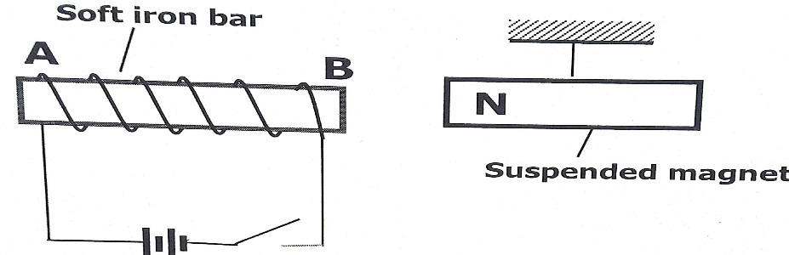

State and explain the observation made when the switch is closed. (2mks)

b.) Give a reason why attraction in magnetism is not regarded as a reliable method of testing for polarity. (1mk)

- The figure 2 below shows an isolated negative charge placed closer to a negatively charged plate. Draw the electric field patterns. (2mk)

- Two pins are hanging from a magnet as shown in the diagram below (figure 3)
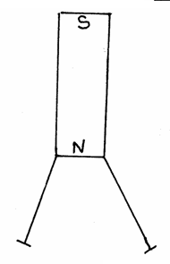fig 3
Explain why they do not hang vertically downwards. (2mks)

5. (a) State the effect of pressure on the speed of sound in air. (1mk)

(b) A boy stands 190m from a high wall and claps his hands. If he hears an echo1.3 Seconds later, calculate the speed of sound in air. (2mks)

6. State any two factors that determine the heating effect by an electric current. (2mks)

7. Figure 4 below shows an object, O placed 10 cm in front of a concave mirror whose radius of curvature, C is 40 cm.
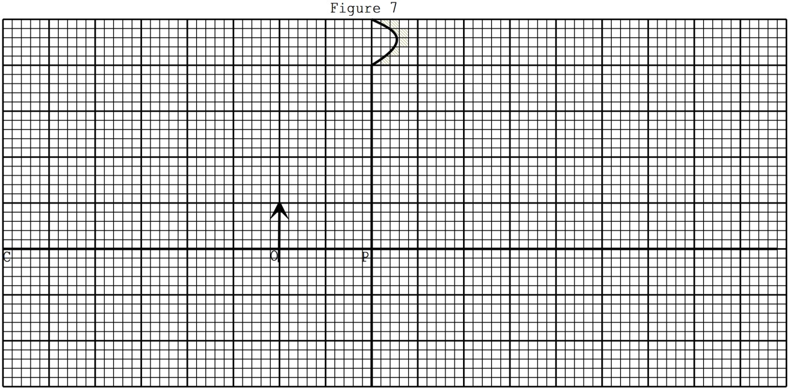
On the same figure, draw a ray diagram to show the position of the image formed. (3 mks)
8 State two advantages of an alkaline battery over lead acid battery. (2mks)

9. An electric bulb with filament of resistance 480Ω is connected to 120 V mains supply. Determine the energy dissipated in 7 min (3 mks)

10. The figure 6 below shows a cross section of a dry cell.
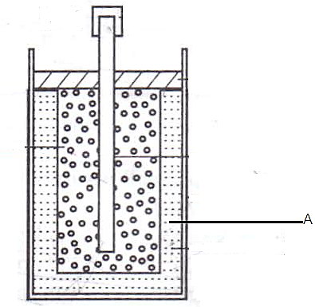Figure 6
- Name the part labeled A (1 mark)

- State the use of manganese (iv) oxide in the cell (1 mark)

SECTION II (55 marks)

11. a) i) In large currents, large resistors in parallel are preferred to low resistors in series.
Explain (1mk)

- State one condition under which ohm’s law is obeyed in a metal conductor. (1mk)

- A circuit constituting a battery, a metal wire, an ammeter and a switch connected in a series. The switch is closed and the ammeter reading noted. The metal wire is now heated. State observation on the ammeter reading and give a reason for your answer. (2mks)

b.) In the figure 7 below, the voltmeter reads 2.4V when the switch is open. When the switch is closed, the voltmeter reads 2.1V and the ammeter reads 0.15A.
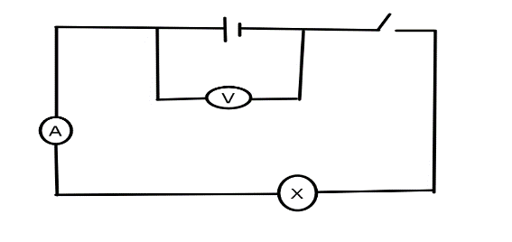
Determine the
- E.m.f of the cell (1mk)

- Internal resistance of the cell (3mks)

- Resistance of the bulb (2mks)

d.) Explain why a voltmeter of high resistance is more accurate in measuring potential difference that one of low resistance (1mk)

d.) Distinguish between electrical resistance and a resistor (1mk)

12. a) I. Define the term wavelength of a longitudinal wave (1mk)

II. The figure 8 below shows a displacement distance for a certain wave motion.

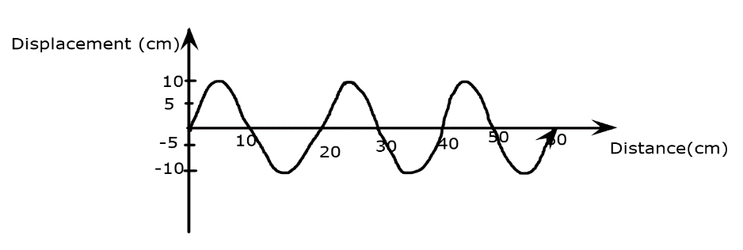

Determine
- The amplitude of the wave (1mk)

- The wavelength of the wave (1mk)

- Given that the frequency of the wave is 40Hz, determine the:
- Periodic time (T) (1mk)

- Speed of the wave (3mks)

b.) Figure 9 below shows light rays from two coherent sources S₁ and S₂ falling on screen. Dark and bright fringes are observed between A and B

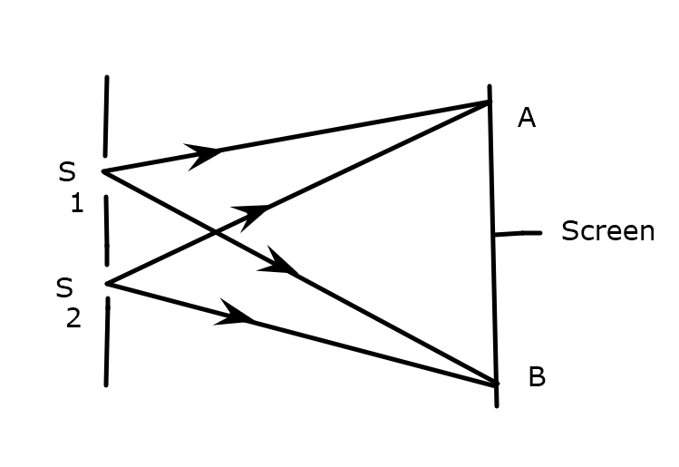

- State the function of S₁ and S₂ (1mk)

- State how
- Bright fringes are formed (1mk)

- Dark fringes are formed (1mk)

c). Figure10 below shows plane water waves incident on a plane reflector placed at an angle to the path of the waves.
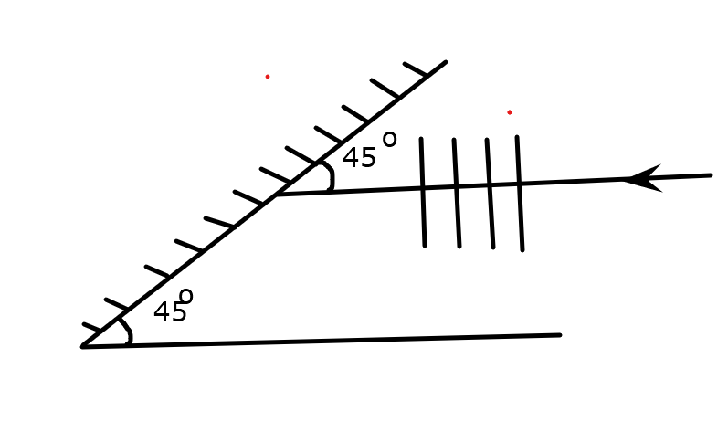

Complete the diagram to show the reflected waves (2mks)

13. a.) State Snell’s law (1mk)

b.) TheFigure 11 below shows a ray of light travelling incident on air-kerosene interface.
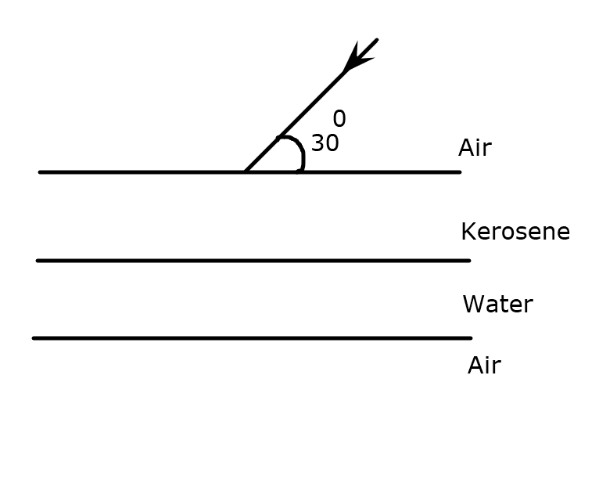

- If the speed of light in kerosene is 2.08 x10⁸ m/s, find the refractive of kerosene. (speed of light in air=3.0 x10⁸) (2mks)

ii.) Determine the angle of refraction in water (_{a}n_{w} =4/3) (4mks)

iii.) On the same diagram sketch the path of light as it traverses through the media showing the angle of refraction in air (3mks)

14. (a) State Ohm’s law. (1 mark)

(b) You are provided with the following apparatus:
- Connecting wires
- An ammeter
- Fixed resistor
- A voltmeter
- A variable resistor
- Switch
- 2 dry cells in a cell holder

(i) In the spaces below, draw the circuit that can be used using the apparatus above to verify Ohm’s Law. (3 marks)

(ii) Briefly explain how you can obtain the results to verify Ohm’s law. (4mrk)

(c)Study the circuit diagram below and answer the questions that follow.
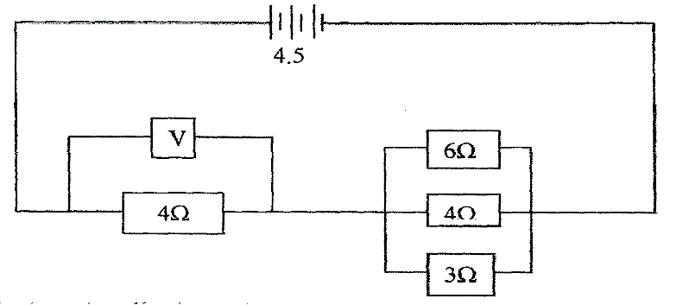

(i) Calculate the effective resistance of the circuit. (3mrks)

(ii) Find the voltmeter reading. (2mrks)

15. a) Describe two factors that affects the strength of an electromagnet (2 mks)

- State Fleming’s left hand rule (1 mks)

- Show the magnetic field pattern around this set up (2 mks)

. X

16. a) Define the term capacitance (1 mks)

b) Determine the

3µf

6µ f

9V
- Charge in 3 µF (2 mks)

- P.d across 6µF (2 mks)

