NAME……………………………………………………………………CLASS……….ADM. NO……….

TEACHER.CO.KE
FORM FOUR GEOGRAPHY PAPER 1 (312/1)
TERM 1, 2022
DURATION: 2 HOURS 45 MINUTES

INSTRUCTIONS
- This paper two sections: A and B
- Answer all the questions in section A.
- In section B answer question 6 and any other two questions.
- All answers must be written in English on the foolscaps provided.

SECTION A
1. (a) What are igneous rocks ? (2 marks)
(b) Give two examples of organically formed sedimentary rocks. (2 marks)
2. (a) Name two types of faults associated with compressional forces. (2 marks)
(b) State three characteristics of the Gregory Rift valley of Kenya. (3 marks)
3. (a) Name two types of grasslands found in Africa. (2 marks)
(b) State three reasons why some mountain tops have no vegetation. (3 marks)
4. The diagram below shows some karst underground features. Use it to answer question (a).
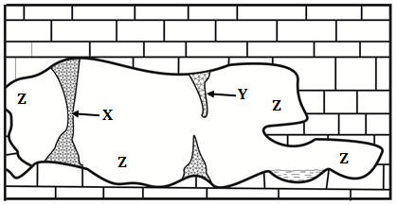
(a) Name the features marked X, Y and Z. (3 marks)
(b) State three conditions required for the formation of Karst landscapes. (3 marks)
5. (a) What is soil degeneration? (2 marks)
(b) State three factors that determine soil colour. (3 marks)

SECTION B
6. Study the map of Kijabe (1:50,000 sheet 134/3) provided and use it to answer the following questions.
(a) (i) What type of map is Kijabe? (1 mark)
(ii) Give the position of Kijabe railway station by latitude and Longitude. (2 marks)
(iii) Identify two human made features at grid square 2794. (2 marks)
(b) (i) What is the four figure grid reference of Kagwe Carbacid plant? (2 marks)
(ii) Citing evidence from the map, give three social services offered in the area covered by the map. (3 marks)
(c) Describe the distribution of natural vegetation in the area covered by the map. (5 marks)
(d) (i) Using a vertical scale of 1cm to represent 100 metres, draw an accurate cross section along northing 00 from easting 24 to easting 30. (4 marks)
(ii) On the cross section, mark and name:
- Kijabe Hill
- A railway line
- A district boundary
- A river valley (4 marks)
(iii) Calculate the vertical exaggeration of the cross section. (2 marks)

7. (a) (i) Differentiate between equinox and solstice. (2 marks)
(ii) Describe how a solar eclipse occurs (4 marks)
(b) (i) State the characteristics of the earth’s core. (5 marks)
(ii) Explain two reasons for the shape of the earth. (4 marks)
(c) (i) What is International Dateline? (2 marks)
(ii) Explain how the revolution of the earth causes seasons. (8 marks)

8. (a) Define the term earthquake. (2 marks)
(b) The diagram below represents the occurrence of an earthquake in the crust.
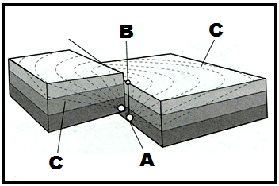
(i) Name the parts marked A, B, and C. (3 marks)
(ii) Apart from the movement of tectonic plates, state three other natural causes of earthquakes. (3 marks)
(iii) Explain two ways in which the movement of tectonic plates causes earthquakes. (4 marks)
(c) Name five features formed due to extrusive vulcanicity. (5 marks)
(d) Explain four positive influences of volcanic features to human activities. (8 marks)

9. (a) (i) What is a lake? (2 marks)
(ii) Give five processes that lead to formation of Lakes. (5 marks)
(b) Describe how Lake Victoria was formed (6 marks)
(c) Explain three reasons why some Rift Valley Lakes in Kenya are saline. (6 marks)
(d) Explain three ways in which lakes influence the climate of the surrounding areas. (6 marks)

10. The diagram below shows some glacial features in low lands.
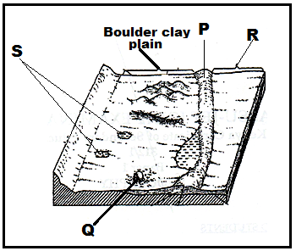

(a) (i) Name the parts marked P, Q R and S. (4 marks)
(ii) Outline three factors that cause glacial deposition in lowlands. (3 marks)

(b) Describe how a fiord is formed. (6 marks)

(c) Explain how glaciation influences the following features influence human activities.

- Mining (2 marks)

- Agriculture (4 marks)

- Fishing (2 marks)
(d) Students of Nanyuki High School carried out a field study on glaciation on Mt. Kenya
(i) State two reasons why they conducted a reconnaissance. (3 marks)
(ii) Give two methods that they would use to collect data. (3 marks)

