NAME………………………………Adm No……….Class……. Stream………
Signature……….…..….Date…………………..
MARKS HERE
TEACHER.CO.KE
FORM TWO
TERM ONE OPENER EXAM 2022
COMPUTER STUDIES

TIME: 2HOURS

INSTRUCTION: ANSWER ALL THE QUESTIONS IN THE SPACES PROVIDED
- Define the following terms.
- Computer 2mks
………………………………………………………………………………………………………………………………………………………………………………
……………………………………………………………………………………..
- Datum 2mks
………………………………………………………………………………………………………………………………………………………………………………………………………………………………………………………………………
- Information 2mks
………………………………………………………………………………………………………………………………………………………………………………………………………………………………………………………………………
- Computer system 2mks
………………………………………………………………………………………………………………………………………………………………………………………………………………………………………………………………………
- Operating system 2mks
………………………………………………………………………………………………………………………………………………………………………………………………………………………………………………………………………

- Give THREE differences between a CRT and a Flat panel screen. 3mks
………………………………………………………………………………………………………………………………………………………………………………………………………………………………………………………………………………………………………………………………………………………………………………………………………………………………………………………………………………………………
- Mention FOUR reasons why laptops are more expensive than desktop computers with the same specifications. 4mks
………………………………………………………………………………………………………………………………………………………………………………………………………………………………………………………………………………………………………………………………………………………………………………………………………………………………………………………………………………………………
- a) Write the acronym UPS in full. 1mk
………………………………………………………………………………………………
b) Explain the uses of UPS. 3mks
………………………………………………………………………………………………………………………………………………………………………………………………………………………………………………………………………………………………
- a) State THREE precautions that should be taken to protect data loss in a computer. 4mks
……………………………………………………………………………………………………………………………………………………………………………………………………………………………………………………………………………………………………………………………………………………………………………………………………………………………………………………………………………………………..
b) List FOUR causes of computer data loss. 4mks
………………………………………………………………………………………………………………………………………………………………………………………………………………………………………………………………………………………………………………………………………………………………………………………………………………………………………………………………………………………………
- List FIVE differences between a microcomputer and a supercomputer. 5mks
………………………………………………………………………………………………………………………………………………………………………………………………………………………………………………………………………………………………………………………………………………………………………………………………………………………………………………………………………………………………………………………………………………………………………………………………………………………………………………………………………………………………
- a) List THREE ways by which computers can be classified. 3mks
………………………………………………………………………………………………………………………………………………………………………………………………………………………………………………………………………………………………
………………………………………………………………………………………………
- b) Give TWO examples classified under each category mentioned in question.7a above. 3mks
………………………………………………………………………………………………………………………………………………………………………………………………………………………………………………………………………………………………
………………………………………………………………………………………………
- Suggest how computers have been made user-friendly for persons that are physically challenged in the following areas. 4mks
- Without hands
………………………………………………………………………………………………………………………………………………………………………………………………………..…….
- Impaired vision
……………………………………………………………………………………………………………………………………………………………………………………………………………………………………………………………………………………………………………………………………………………………………………………………………………………………....
- a) Explain THREE health problems that can be caused by prolonged use of computers. 3mks
……………………………………………………………………………………………………………………………………………………………………………………………………………………………………………………………………………………………………………………………………………………………………………………………………………………………..
- For each problem listed 10(a) mention one way in which they can be prevented. 3mks
……………………………………………………………………………………………………………………………………………………………………………………………………………………………………………………………………………………………………………………………………………………………………………………………………………………………..
- State the differences between impact and non-impact printers. 4mks
………………………………………………………………………………………………………………………………………………………………………………………………………………………………………………………………………………………………………………………………………………………………………………………………………………………………
- a) Define a keyboard. 2mks
………………………………………………………………………………………………………………………………………………………………………………………………………………………………………………………………………………………………
- Mention TWO advantages of using a keyboard. 2mks
…………………………………………………………………………………………………………………………………………………………………………………………………………………………………………………………………………………………………………………………………………………………………………
- A student wants to upgrade her operating system. State five factors she/he should consider. 5mks
………………………………………………………………………………………………………………………………………………………………………………………………………………………………………………………………………………………………
………………………………………………………………………………………………………………………………………………………………………………………………………………………………………………………………………………………………
- State FOUR functions of an operating system. 4mks
………………………………………………………………………………………………………………………………………………………………………………………………………………………………………………………………………………………………
………………………………………………………………………………………………………………………………………………………………………………………………
- Use the diagram below to answer the questions that follow.
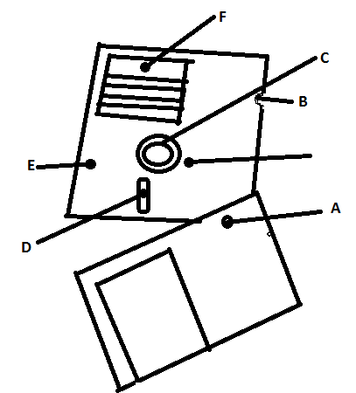
- Name the device. 1mk
……………………………………………………………………………………………………………………………………………………………………………………
- Name the parts labeled A to E. 5mks
A…………………………………. C………………………………….
B………………………………… D………………………………….
E………………………………….

