NAME:……….………………………………………………..CLASS:………ADM NO:……..
TEACHER.CO.KE
CHEMISTRY PAPER 2
TERM 1 OPENER EXAM
FORM 4
TERM 1 – 2022
TIME: 2HRS
INSTRUCTION.
Answer all questions in the spaces provided.
- The table below shows some elements in the periodic table. Use it to answer the question that follow. (The letter are not the actual symbols of the elements)
P |  |  |  | T |  | M |  | U
 |  |  | Q |  |  |  | V
S |  |  |  |  |  |  |  | R

- Identify the elements in the same group. (2mks)

- Give the name of the family to which elements P and S belong. (1mk)

- Write the electron configuration of ions of elements; (2mks)
- V

- Q

- Given that isotopes of element S are as follows ³⁹S(93.1%), ^{x}S(0.01%) and 41S(6.89%), calculate x given that the relative atomic mass of element S is 39.1349. (3mks)

- Elements Q and V react to form a compound.
- Write an equation for the reaction. (1mk)

- What is the nature of the compound formed in (i) above. Explain. (2mks)
=

- Element T forms covalent bond with element V. Using dot (.) and cross (x) diagram show bonding in the compound formed. (2mks)
- i. The following set up was carried out by students in form two in the open air in the presence of sunlight to investigate a certain property of the halogen. Study it answer the questions.
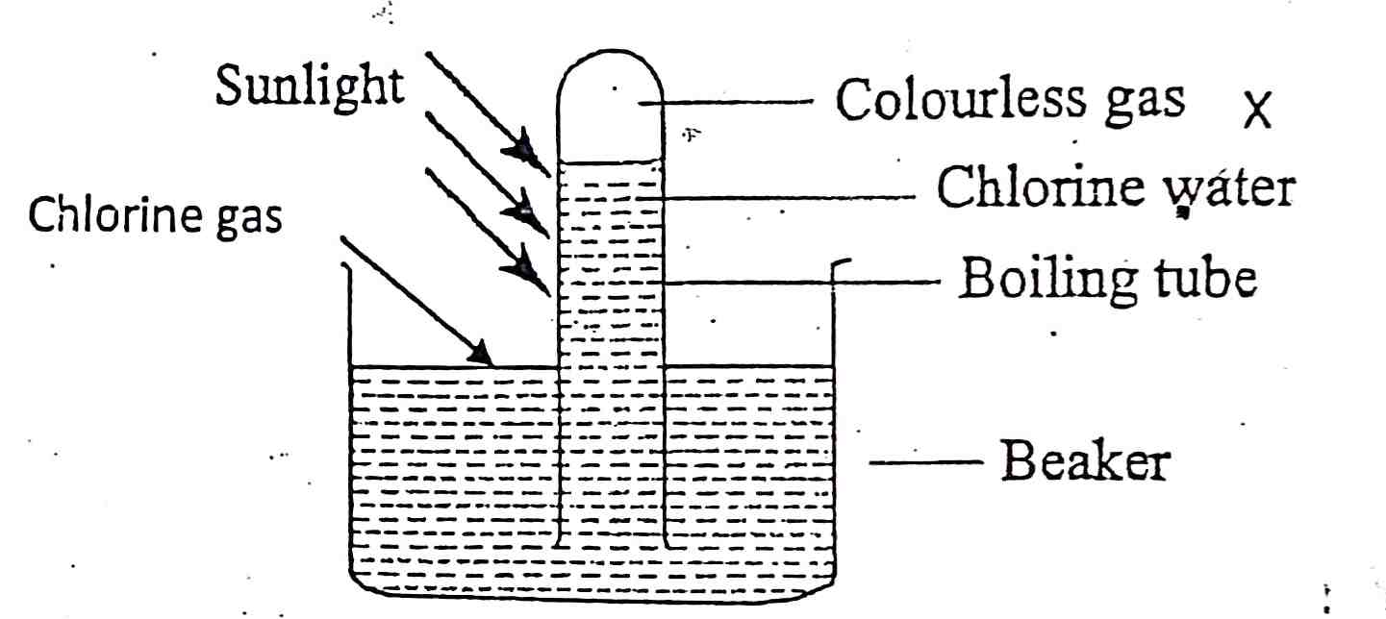

- Which property of the halogen was being investigated? (1mk)

- Name the gas which was colourless. (1mk)

- Chlorine water is yellow in colour. However, in the presence of light it is decolourised. Explain. (2mks)

- Comment on the effect of chlorine water on red and blue litmus paper. (2mks)

ii. The following diagram represents a section of the plant for the large scale manufacture of hydrochloric acid.
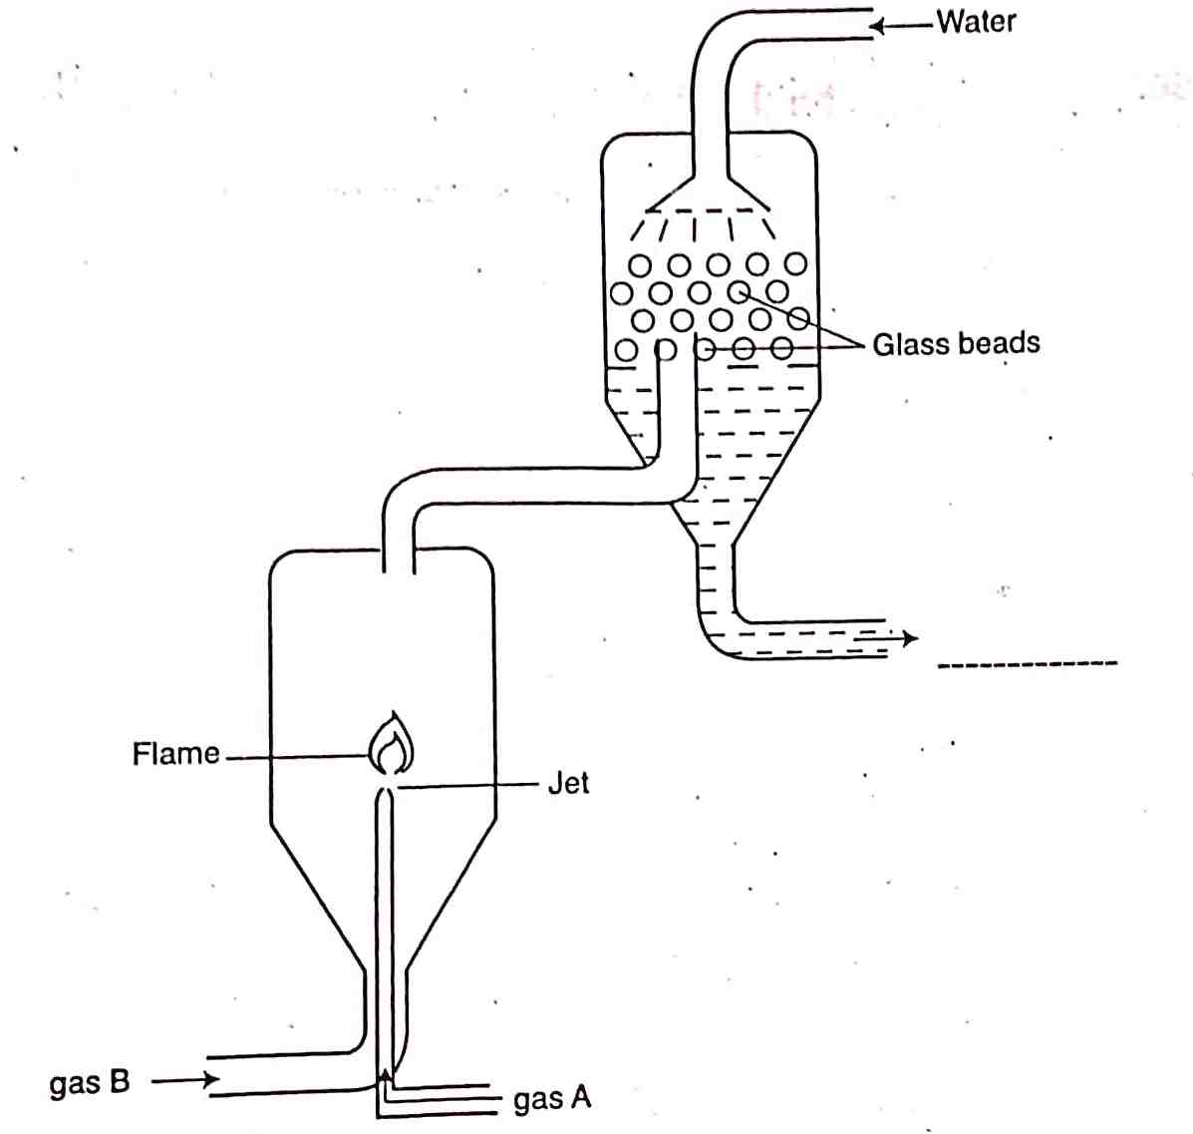
- Name gases A and B. (2mks)

- State the role of glass beads in the plant. (1mk)

- Explain why gas A is introduced into the reaction chamber through a jet. (1mk)

- Write the chemical equation for the reaction between gas A and B. (1mk)

- Determine the volume of hydrochloric acid gas formed when 3600cm³ of gas B react with gas A at stp (MGV at stp = 22.4dm³) (2mks)

- CFC’S and DDT are chlorine compounds with long life span and so affects both plants and animal life. Write their full names. (2mks)
CFC

DDT

- i. Butane and bromine react according to the equation below.
CH₃CH₂CH₂CH₃ + Br₂ CH₃CH₂CH₂CH₂Br + HBr
- Name the type of reaction taking place in the equation above. (1mk)

- State the condition under which the above reaction takes place. Explain. (2mks)

- Name the following compounds:

H H H CH₃ H

- H C C C C C H

H H CH₃ H H (1mk)

H H Cl H

- H C C C C H

Cl CH₃ H H (1mk)

(1mk)
- H₂C = CH CH₂ CH₂ CH CH₃

CH₃
ii. Study the reaction scheme shown and answer the questions that follow.

R
S
T
Polymer z
CH₂CH₂
CH₃CH₃
CH₃CH_{2O}SO2H
V+H₂SO₄(aq)
U
HBr(g)
Br₂(g)
Process W
Reagent A
Nickel catalyst
KMnO₄/H⁺(aq)
H₂SO₄(l)
+H₂O
Process X
Process J
H₂SO₄(l)

- Identify reagent A. (1mk)

- Name process;
- X (1mk)

- W (1mk)

- Write the equation for the process J. (1mk)

- Name products: (3mks)
S

T

V

- Draw and name the structure of:
- Polymer Z (1 ½ mks)

- Product U (1 ½ mks)
- i. Use the flow chart drawn to answer the questions that follow:

Deep blue solution
Calcium hydroxide
Substance C
White solid R
Ammonia
Potassium nitrate
Nitric (v) acid
P
Compound K
NH₃
NaOH(aq)
CuSO₄(aq)
Heat
H₂SO₄(l)
Gas W
Step II

- Identify:
- Compound C (1mk)

- Compound K (1mk)

- Write the equation for the following:
- Calcium hydroxide and substance C. (1mk)

- Gas W and ammonia. (1mk)

- Identify the catalyst in step II. (1mk)

- Write the formula of the deep blue solution and compound K. (2mks)

- State the type of reaction that produces P. (1mk)

- State one use of compound K. (1mk)

ii. When compound N is heated, a red-brown gas is evolved and a yellow residue is left on cooling.
- Name:
- The red-brown gas. (1mk)

- The ions present in the residue. (1mk)

- Write equation for decomposition of solid N. (1mk)

- i. Candle wax is mainly a compound consisting of two elements. Name the two elements. (2mks)

b) The set – up below was used to investigate the burning of a candle. Study it and answer the questions that follow.

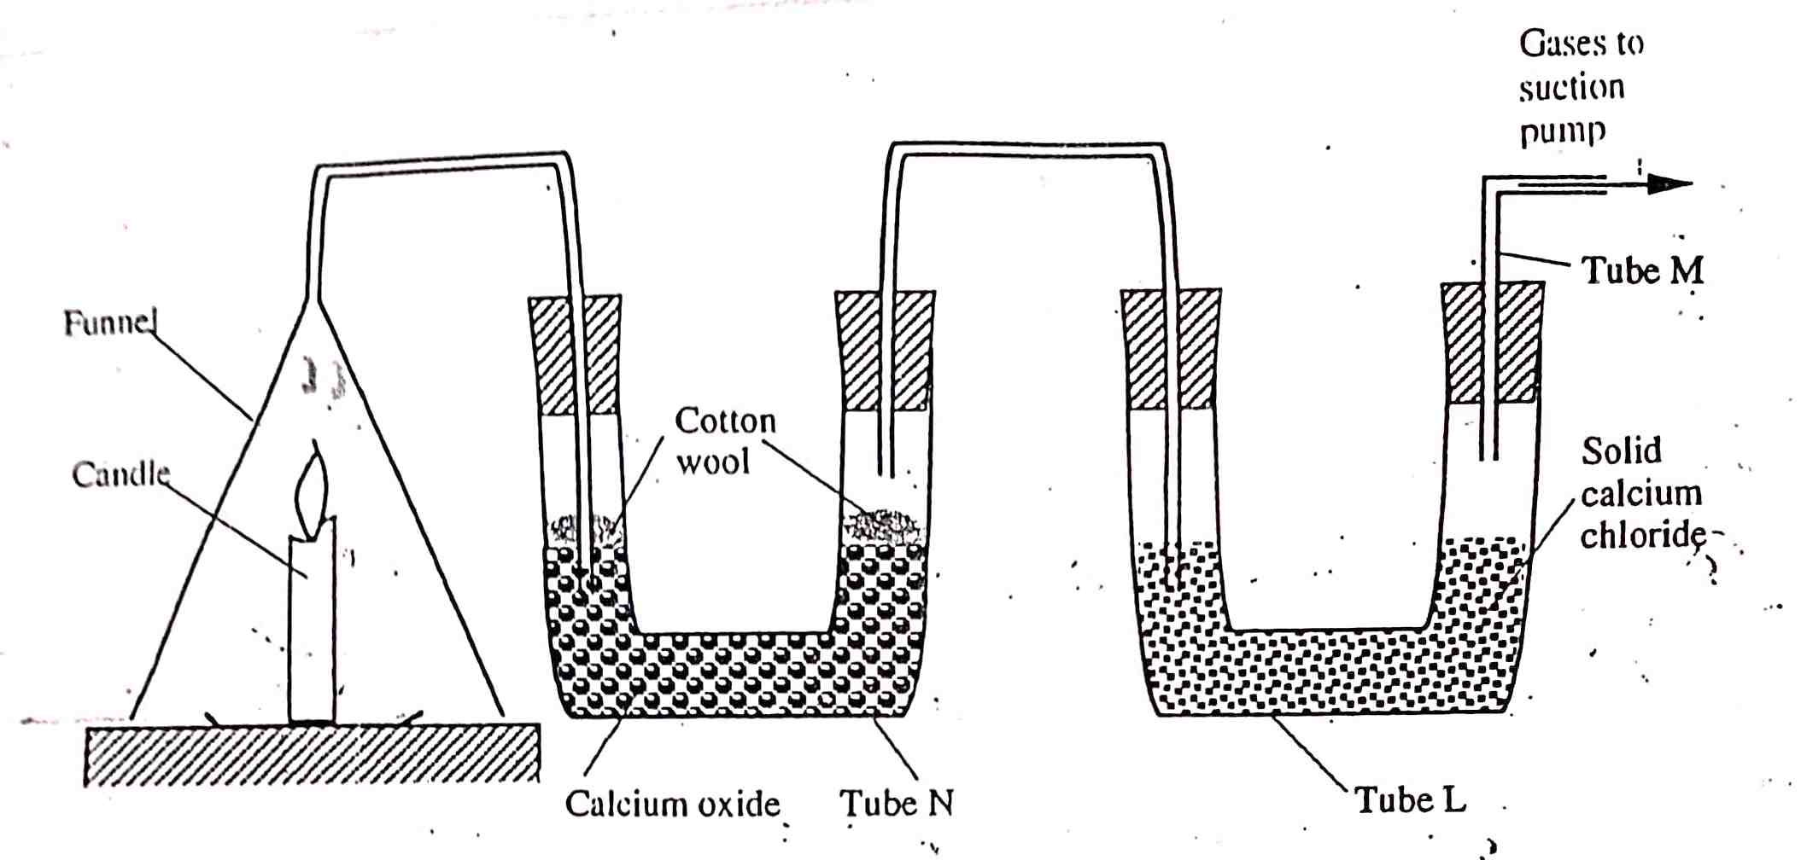

- What would happen to the burning candle if the pump was turned off? Give reasons. (3mks)

- State and explain the changes in mass that are likely to occur in tube N by the end of the experiment. (3mks)

- Name two gases that come out through tube M. (2mks)

- What is the purpose of calcium chloride in tube L? (1mk)

- Name another substance that could be used in the place of calcium oxide in tube N. (1mk)

- The flow chart below shows some of the processes involved in large scale production of sulphuric (VI) acid. Use it to answer the questions that follow.

Reaction chamber
Absorption chamber

Sulphur (IV) oxide
Substance A
Oleum
Water
Sulphur (VI) oxide
Oxygen

- Describe how oxygen is obtained from air on a large scale. (3mks)

- i. Name substance A. (1mk)

ii. Write an equation for the process that takes place in the absorption chamber. (1mk)

- Vanadium (V) oxide is a commonly used catalyst in the contact process.
- Name another catalyst which can be used for this process. (1mk)

- Give two reasons why vanadium (V) oxide is the commonly used catalyst. (2mks)

- State and explain the observations made when concentrated sulphuric (VI) acid is added to crystals of copper (II) Sulphate in a beaker. (1mk)

- The reaction of concentrated sulphuric (VI) acid with sodium chloride procduces hydrogen chloride gas. State the property of concentrated sulphuric (VI) acid illustrate in this reaction. (1mk)

- Name four uses of sulphuric (VI) acid. (2mks)

